A
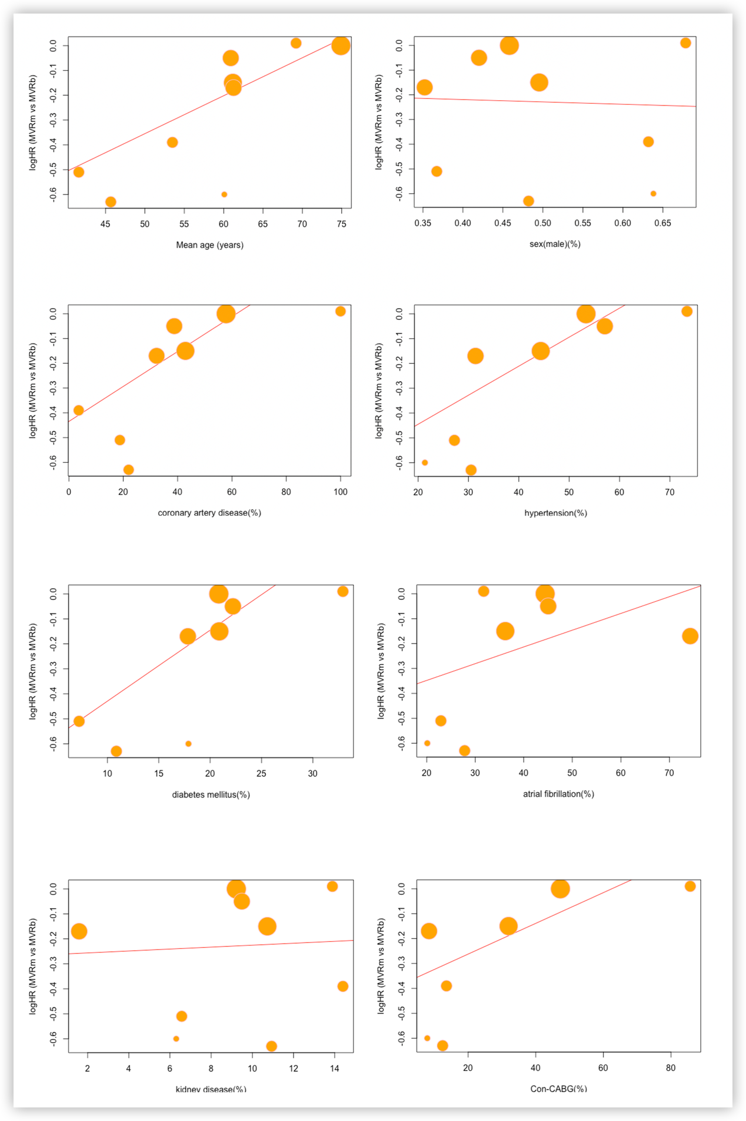
Supplementary figure 2A: Bubble plots of meta-regression in study-covariate against long-term mortality. Con-CABG, concomitant coronary artery bypass grafting. MVRm, mechanical mitral valve replacement; MVRb, bioprosthetic mitral valve replacement. HR, hazard ratio.
B
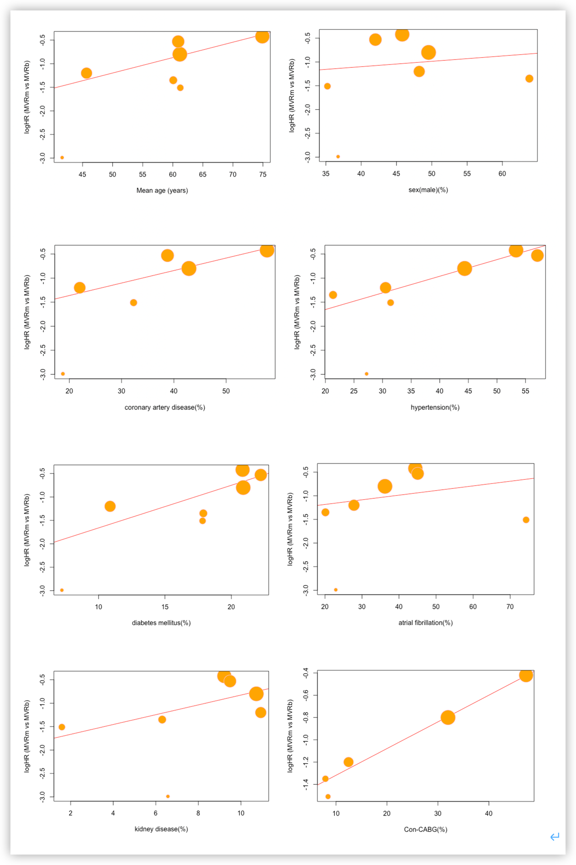
Supplementary figure 2B: Bubble plots of meta-regression in study-covariate against mitral reoperation. Con-CABG, concomitant coronary artery bypass grafting. MVRm, mechanical mitral valve replacement; MVRb, bioprosthetic mitral valve replacement. HR, hazard ratio.

