Real-world data on the adverse metabolic effects of second-generation antipsychotics and their potential determinants in adult patients: a systematic review of population-based studies.
Advances in Therapy
Supplementary data

Miquel Bernardoª, Fernando Rico-Villademoros^{b}, Clemente García-Rizo^{c}, Rosa Rojo^{d}, Ricardo Gómez-Huelgas^{e}

ªDepartment of Psychiatry, Hospital Clínic, University of Barcelona, Idibaps, Cibersam, Barcelona, Spain.
^{b}Institute of Neurosciences, University of Granada, Granada, Spain; Cociente S.L., Madrid, Spain.
^{c}Department of Psychiatry, Hospital Clínic, University of Barcelona, Barcelona, Spain.
^{d}Faculty of Health Sciences, Alfonso X El Sabio University, Villanueva de la Cañada, Madrid, Spain.
^{e}Internal Medicine Department, Instituto de Investigación Biomedica de Malaga-IBIMA, Regional University Hospital of Malaga, Malaga, Spain.

Corresponding author
Miquel Bernardo, MD, PhD
Email: bernardo@clinic.cat

Supplementary table 1. Search strategy 3
Supplementary table 2. Characteristics of the studies included in the systematic review 4
Supplementary table 3. Quality evaluation of the cohort studies 14
Supplementary table 4. Quality evaluation of case-control studies 15
Supplementary table 5. Potential determinants of the occurrence of diabetes in patients receiving SGAs 16
Supplementary table 6. Potential determinants of the occurrence of dyslipidemia in patients receiving SGAs 19
Supplementary table 7. Potential determinants of the occurrence of hypertension in patients receiving SGAs 20

Supplementary figure 1a: Risk of diabetes in adults who received second-generation antipsychotics in head-to-head comparisons (time-to-event outcomes) 21
Supplementary figure 1b: Risk of diabetes in adults who received second-generation antipsychotics in head-to-head comparisons (binary outcomes) 21
Supplementary figure 2. Risk of diabetes in adults who received second-generation antipsychotics in other comparisons (binary outcomes) 22
Supplementary figure 3. Risk of diabetes in adults who received second-generation antipsychotics in other comparisons (time-to-event outcomes) 23
Supplementary figure 4. Risk of obesity/weight gain in adults who received second-generation antipsychotics compared to those who received first-generation antipsychotics 24
Supplementary figure 5. Risk of obesity/weight gain in adults who received second-generation antipsychotics compared to those who received lithium 25

Supplementary table 1. Search strategy
Search strategy for MEDLINE and EMBASE
#6
#3 AND #4 AND ([article]/lim OR [article in press]/lim OR [conference paper]/lim OR [conference review]/lim OR [data papers]/lim OR [editorial]/lim OR [erratum]/lim OR [letter]/lim OR [note]/lim OR [review]/lim OR [short survey]/lim)
#5
#3 AND #4
#4
longitudinal:ti,ab,kw OR prospective:ti,ab,kw OR retrospective:ti,ab,kw OR cohort:ti,ab,kw OR 'case control':ti,ab,kw OR 'population-based':ti,ab,kw OR 'claims-based':ti,ab,kw OR incidence:ti,ab,kw OR incident:ti,ab,kw OR hazard:ti,ab,kw OR 'data base':ti,ab,kw OR 'database':ti,ab,kw OR registry:ti,ab,kw OR register*:ti,ab,kw
#3
#1 AND #2
#2
metabolic:ti,ab,kw OR cardiometabolic:ti,ab,kw OR diabetes:ti,ab,kw OR prediabetes:ti,ab,kw OR hyperinsulinemia:ti,ab,kw OR hyperglycemia:ti,ab,kw OR hyperglycaemia:ti,ab,kw OR 'insulin resistance':ti,ab,kw OR glucose:ti,ab,kw OR glycemi*:ti,ab,kw OR lipid:ti,ab,kw OR lipids:ti,ab,kw OR hyperlipidemia:ti,ab,kw OR hyperlipidaemia:ti,ab,kw OR dyslipidemia:ti,ab,kw OR dyslipidaemia:ti,ab,kw OR hypertriglyceridemia:ti,ab,kw OR hypertriglyceridaemia:ti,ab,kw OR triglycerides:ti,ab,kw OR hypercholesterolemia:ti,ab,kw OR hypercholesterolaemia:ti,ab,kw OR cholesterol:ti,ab,kw OR overweight:ti,ab,kw OR obesity:ti,ab,kw OR weight:ti,ab,kw OR waist:ti,ab,kw OR hypertension:ti,ab,kw OR 'blood pressure':ti,ab,kw
#1
antipsychotic*:ti,ab,kw OR amisulpride:ti,ab,kw OR aripiprazole:ti,ab,kw OR asenapine:ti,ab,kw OR brexpiprazole:ti,ab,kw OR cariprazine:ti,ab,kw OR clozapine:ti,ab,kw OR iloperidone:ti,ab,kw OR lurasidone:ti,ab,kw OR olanzapine:ti,ab,kw OR paliperidone:ti,ab,kw OR quetiapine:ti,ab,kw OR risperidone:ti,ab,kw OR sertindole:ti,ab,kw OR ziprasidone:ti,ab,kw OR zotepine:ti,ab,kw
Search strategy for PSYCINFO
AB,TI,MESH(antipsychotic* OR amisulpride OR aripiprazole OR asenapine OR brexpiprazole OR cariprazine OR clozapine OR iloperidone OR lurasidone OR olanzapine OR paliperidone OR quetiapine OR risperidone OR sertindole OR ziprasidone OR zotepine)
AND
AB,TI,MESH(metabolic OR cardiometabolic OR diabetes OR prediabetes OR hyperinsulinemia OR hyperglycemia OR hyperglycaemia OR 'insulin resistance' OR glucose OR glycemi* OR lipid OR lipids OR hyperlipidemia OR hyperlipidaemia OR dyslipidemia OR dyslipidaemia OR hypertriglyceridemia OR hypertriglyceridaemia OR triglycerides OR hypercholesterolemia OR hypercholesterolaemia OR cholesterol OR overweight OR obesity OR weight OR waist OR hypertension OR 'blood pressure')
AND
AB,TI,MESH(longitudinal OR prospective OR retrospective OR cohort OR 'case control' OR 'population-based' OR 'claims-based' OR incidence OR incident OR hazard OR 'data base' OR 'database' OR registry OR register*)

Supplementary table 2. Characteristics of the studies included in the systematic review
Author, Year | Study design | Country, Database (Time frame) | Age (years) | Diagnosis  (Tool) | Exposure (type) | Exposure (definition) | Control | n exposure/  cases* | n  control | LOT | Outcomes (type) | Statistical analysis (type) | APS  Polypharmacy | Financial
Lund, 2001 | RC | US, Iowa Medicaid program (1990-1998) | NR | Schizophrenia (ICD-9) | Clo | ≥1 Rx APS | FGAs | 531 | 2296 | NR | Diabetes, dyslipidemia, hypertension | Logistic regression | Unclear | Supported by The Iowa Medicaid Drug Utilization Review Comission
Gianfranceso, 2002 | RC | US, 2 mixed indemnity and managed care health plans  (1996-1997) | 39 to 43 (m) | Psychotic disorders  (ICD-9-CM) | Ris, Ola, Clo | >60 days with an APS | Without APS (not treated) | 994 | 1738 | 5.6 to 13.8 months (m) | Diabetes | Logistic regression | Analysis | Supported by Janssen Pharmaceutica Products LP
Caro, 2002 | RC | Canada, Regie de l'Assurance Maladie du Québecq (1997-1999) | <45 to ≥65 | Other disorders (ICD-9) | Ola | ≥1 Rx APS | Ris | NR | NR | NR | Diabetes | Cox regression | Unclear | Supported by Janssen
Koro, 2002 | CC | UK, General Practice Research Database (1987-2000) | All | Schizophrenia (e-records) | Ola, Ris | ≥1 Rx APS within 3 months of the index date | FGAs Without APS (no Rx within 3 months of the index date) | 7 | 11 | NR | Diabetes | Logistic regression | Unclear | Supported by Bristol Myers Squibb
Kornegay, 2002 | CC | UK, General Practice Research Database (1994-1998) | 18-64 | Other disorders (e-records) | SGAs | APS use in the 6-months prior to index | Without APS (no use in the past years) | 424 | 1522 | NR | Diabetes | Logistic regression | Unclear | Supported by the FDA
Gianfranceso, 2003 | RC | US, Blue Cross/Blue Shield claims database (1997-2000) | 33 to 40 (m) | Psychotic disorders  (ICD-9-CM) | Ris, Ola, Que | >60 days with an APS | Without APS (not treated) | 2860 | 10296 | 7.5 to 9.9 months (m) | Diabetes | Logistic regression | Analysis | Supported by AstraZeneca
Citrome, 2004 | CC | US, Integrated Research Database (from New York State Psychiatric Hospital System)  (2000-2002) | 43 to 44 (m) | Severe mental disorders  (DSM-IV) | Clo, Ris, Ola, Que, ≥2 SGAs | New Rx APS | FGAs | NR | NR | 121d all | Diabetes | Logistic regression | Analysis | Partial support of the maintenance of database Lilly, Janssen and Pfizer
Farwell, 2004 | RC | US, Regenstrief Medical Record System-Indianapolis (1972-2000) | ≥18 | Psychiatric disorders (general)  (NR) | Ola, Ris | Rx of the APS | FGAs | 363 | 1976 | 2.3 yrs SGA  6.0 yrs FGA | Diabetes, weight gain | Logistic regression | Unclear | Bristol-Myers Squibb
Ollendorf, 2004 | RC | US, PharMetrics Patient-Centric Database (1995-2001) | 37 to 40 (m) | Schizophrenia (ICD9-CM) | SGA, Ola | ≥1 claim for an APS | FGAs, Ris, Que, Clo | 1826 | 617 | NR | Diabetes | Cox regression | Unclear | Funded by Lilly
Barner, 2004 | RC | US, Central Texas Veterans Health Care System  (1995-2002) | ≥18 | Severe mental disorders  (ICD-9) | Ola, Ris, Que | Unclear | FGAs | NR | NR | 3.9-5.6m SGA  4.7-7.3m FGA | Diabetes | Logistic regression | Unclear | Funded by Lilly
Leslie, 2004 | RC | US, Department of Veterans Affairs  (1999-2000) | NR | Schizophrenia (NR) | Clo, Ola, Que, Ris | >3 month Rx of APS | FGAs | NR | NR | NR | Diabetes, ketoacidosis | Cox regression | Excluded | Supported in part by the Department of Veterans Affairs, the National Institute of Mental Health Clinical Antipsychotic Trials of Intervention Effectiveness, and Bristol-Myers Squibb
Lambert (Diabetes), 2005 | CC | US, California Medicaid (1995-2000) | ≥18 | Schizophrenia (ICD-9) | Ola, Ris, Clo, Que | ≥1 Rx APS | FGAs | 576 | 1857 | NR | Diabetes | Logistic regression | Analysis | Supported by Bristol-Myers Squibb
Lambert (Dyslipidemia), 2005 | CC | US, California Medicaid (1997-2000) | >=18 | Schizophrenia (ICD-9) | Ola, Ris, Clo, Que | ≥1 Rx APS | FGAs | 879 | 5502 | NR | Dyslipidemia | Logistic regression | Excluded | Supported in part by Bristol-Myers Squibb
Miller, 2005 | RC | US, MEDSTAT’s Market-Sacan database (1999-2000) | 40 to 52 (m) | Psychiatric disorders (general)  (ICD-9) | Clo, Ola, Que, Ris | Stable on APS >3-months | FGAs | 84 | 1981 | NR | Diabetes | Cox regression | Unclear | Supported in part by the Department of Veterans Affairs and the National Institute of Mental Health Training Program
Lambert, 2006 | RC | US, Veterans Health Administration (1999-2001) | NR | Schizophrenia (ICD-9) | Ola, Ris, Que | ≥1 Rx APS | FGAs, haloperidol | 5981 | 3008 | NR | Diabetes | Cox regression | Unclear | Supported in part by a research contract from Bristol-Myers Squibb
Guo, 2006 | CC | US, PharMetrics (exluding Medicaid patients) (1998-2002) | All | Bipolar disorder (ICD-9) | Ola, Que, Ris, Zip, Clo | >= 3 month´s exposure to APS or >= 3 Rx | FGAs | 186 | 258 | NR | Diabetes | COX regression | Unclear | Grant from Bristol-Myers-Squibb Pharmaceutical Research Institute
Gianfrancesco (Ohio Medicaid), 2006 | RC | US, Ohio Medicaid program (1999-2003) | 38 to 46 (m) | Psychiatric disorders (general)  (ICD-9) | Clo, Ris, Ola,Que, Zip | Two contiguous Rx | Without APS (not treated or not treated for extended periods of time) | 3313 | 37867 | 7.8 to 31 months (m) | Diabetes | Logistic regression | Excluded | Funded by AstraZeneca
Gianfranceso (PharMetrics), 2006 | RC | US, PharMetrics (1999-2002) | 33 to 36 (m) | Severe mental disorders  (ICD-9-CM) | Ris, Ola, Que | ≥2 Rx APS | Without APS (not treated for period encompassed by the data) | 12409 | 33263 | 7.4-10.7 months (m) | Diabetes | Logistic regression | Excluded | NR
Olfson, 2006 | CC | US, California Medicaid (Medi-Cal) (2001-2004) | 18-64 | Other disorders (ICD-9) | Ari, Zip, Que, Ris, Ola, Clo | ≥1 Rx APS | Without APS (no Rx prior 60 days from the index date) | 80 | 467 | NR | Dyslipidemia | Logistic regression | Unclear | Grant from Bristol-Myers-Squibb
Guo, 2007 | CC | US, Multistate managed care claims database (PharMetrics, Watertown, MA)  (1998-2002) | <65 | Bipolar disorder (ICD-9) | Ola, Que, Ris, Zip, Clo | Minimum of 3 months of exposure to APS | FGAs | 51 | 79 | NR | Diabetes | Cox regression | Unclear | Bristol-Myers Squibb Pharmaceutical Research Institute, Wallingford, Connecticut
Jerrell, 2007 | RC | US, South Carolina  (2003-2004) | 18-54 | Schizophrenia (ICD) | Ari, Zip, Que, Ris, Ola | A new Rx of APS | FGAs | 117 | NR | NR | Hypertension, dyslipidemia | Logistic regression | Unclear | State Mental Health Data Infrastructure Grant (SAMHSA SM54192) to the South Carolina Department of Mental Health
Yood, 2009 | RC | US, Kaiser Permanente Health Plan; HealthCore Integrated Research Network (HealthCore); PharMetrics (2002-2005) | ≥18 | Other disorders (ICD-9) | SGAs | At least 45 days of exposure to APS | FGAs | 4528 | 5991 | NR | Diabetes | Cox regression | Unclear | Funded by Bristol-Myers Squibb and Otsuka Pharmaceutical Development and Commercialization
Kisely, 2009 | CC | Canada, The Seniors’ Pharmacare dabase; The physician billings; The Canadian Institute of Health Information Discharge Abstract Database; Mental Health Outpatient Data Information System  (2001-2003) | ≥65 | Psychiatric disorders (general)  (ICD-9) | Ola, Ris, Que | At least one psychiatric record in Discharge Abstract Database physician billings or Mental Health Outpatient Data Information System | Non exposed | 20 | 8 | NR | Diabetes, hypertension | Logistic regression | Unclear | NR
Lipscombe, 2009 | CC | Canada, Several population-based health databases from Ontario (2002-2006) | ≥65 | Other disorders (ICD-10) | SGAs and patients with diabetes | Prevalent users of APS (more than 1 Rx of APS before the index date) | Without APS (remote user >180 days from the index date) | 265 | 2028 | NR | Hyperglycemia | Logistic regression | Unclear | Supported by a Team Grant from the Canadian Institutes of Health Research (CIHR) and by a CIHR Interdisciplinary Capacity Enhancement Grant
Jerrell, 2010 | RC | US, South Carolina Medicaid (2003-2005) | 18-54 | Schizophrenia (ICD9) | Ari, Zip, Que, Ola, Ris | Newly Rx of APS | FGAs, haloperidol | NR | NR | NR | Obesity, dyslipidemia, hypertension | Logistic regression | Unclear | Data analyses were supported by State Mental Health Data Infrastructure Grant)
Nielsen, 2010 | RC | Denmark, Danish Central Psychiatric Research Registry  (1997-2007) | m: 29 | Schizophrenia (ICD-10) | Ola, Que, Ser, Ami, Ris, Zip, Sul, Clo | ‘Initial’ APS: At least 180 DDD of the same antipsychotic drug within the first 365 days after first antipsychotic prescription. | Unclear (non-exposed to the specific APS) | NR | NR | NR | Diabetes | Cox regression | Unclear | Funded by Aalborg Psychiatric Hospital
Jalbert, 2011 | CC | US, Minimun Data Set (MDS) from Medicaid-, Medicare-certified nursing home and Medicaid analytic extract (MAX)  (2001-2002) | ≥65 | Other disorders (e-record) | SGAs | Exposure to APS | Without APS (no Rx prior to the index date) | 80 | 276 | 147 days (m) | Diabetes | Logistic regression | Unclear | None
Liao, 2011 | RC | Taiwan, National Health Research Institute (1997-2001) | ≥20 | Schizophrenia (ICD-9) | SGAs | Exposure to APS | Non schizophrenia | 1224 | 4896 | NR | Diabetes, hypertension, dyslipidemia | Cox regression | Unclear | Partly by the National Science Council, Executive Yuan, Taiwan, Republic of China, China Medical University Hospital and Taiwan Department of Health Clinical Trial and Research Center for Excellence and Cancer Research Center of Excellence
Lipscombe, 2011 | CC | Canada, Ontario Diabetes Database (2002-2006) | ≥65 | Other disorders (ICD-10) | SGAs | Current user of APS: treatment duration overlapped with the index date | Without APS (remote user >180 days from the index date) | 112 | 1017 | NR | Hyperglycemia | Logistic regression | Unclear | Team Grant from the Canadian Institutes of Health Research (CIHR) and by a CIHR Interdisciplinary Capacity Enhancement Grant, Ottawa, Ontario, Canada
Moisan, 2013 | CC | Canada, Quebec Health Insurance Board (RAMQ) and Quebec hospitalization registry  (2000-2007) | ≥65 | Other disorders (ICD-9) | Clo, Ola, Que, Ris | Rx APS | FGAs | 11 | 133 | NR | Diabetes | Logistic regression | Analysis | Bristol-Myers Squibb
Erickson, 2012 | CC | US, Medicare Advantage Prescription Drug (MAPD) and a HMO database (2004-2008) | ≥65 | Other disorders (ICD-9) | SGAs | Exposure to SGAs | Without APS (not defined) | NR | NR | NR | Diabetes, dyslipidemia | Logistic regression | Unclear | NR
Hsu, 2012 | RC | Taiwan, National Health Research Institute (2006-2008) | ≥18 | Schizophrenia (ICD-9) | SGAs | "Use" of APS | FGAs, general population | 4417 | 762010 | NR | Dyslipidemia | Cox regression | Unclear | NR
Wu, 2012 | RC | Taiwan, Random sample of National Health Insurance (NHI) program (2006-2008) | ≥18 | Depression (ICD9-CM) | SGAs | NR | Without APS (not defined) | NR | NR | NR | Hypertension | Cox regression | Unclear | NR
Citrome, 2013 | RC | US, Truven Health MarketScan (2003-2010) | 18-64 | Other disorders (ICD-9) | Ari | ≥ 2 Rx or a 60-day supply of the SGA | Ari | 9917 | 9917 | NR | Diabetes | Cox. regression, PS: Matching | Unclear | Bristol-Myers Squibb and Otsuka Pharmaceutical Development and Commercialization
Lipscombe, 2014 | RC | Canada & UK, Administrative health data from 7 Canadian provinces and the UK Clinical Practice Research Datalink  (1998-2010) | ≥18 | Other disorders (ICD-9 and ICD-10) | Ola, Que | New Rx of APS | Ris | 47699 | 76212 | NR | Hyperglycemia | Cox regression, PS: Analysis | Unclear | Funded by the Canadian Institutes of Health Research
Lin, 2016 | RC | Taiwan, Psychiatric Inpatient Medical Claim Dataset (PIMC) (1998-2012) | m: 40 | Depression (ICD-9) | SGAs | Rx SGA continuously for more than 8 weeks | Non exposed (No Rx of SGAs) | 1179 | 7713 | 502 d | Diabetes | Cox regression, PS: Matching | Unclear | Supported in part by Hospital and social welfare organizations administration commission and Changhua Hospital Program
Stroup, 2016 | RC | US, Medicaid Analytic eXtract (MAX) (2001-2009) | 18 to 64 | Schizophrenia (ICD-9) | Clo | Rx APS within 30 days | Other oral APS | 4492 | 4492 | NR | Diabetes, dyslipidemia | Cox regression, PS: Matching | Unclear | NR
Hayes, 2016 | RC | UK, The Health Improvement Network (THIN)  (1995-2013) | 38 to 46 (M) | Bipolar disorder (ICD-10) | Ola, Que | >28-day prescription | Lithium | 1477 | 2148 | 1.48 yrs (m) | Diabetes, weight gain, hypertension | Cox regression, PS: Analysis | Unclear | Medical Research Council
Rajkumar, 2016 | RC | Denmark, Danish linkaged registries (1977-2013) | 0-36 | Schizophrenia (ICD-8) | Ola, Ari, Clo | Starting Rx APS | APS-naïve patients | 2115 | 7652 | NR | Diabetes | Cox regression | Unclear | Funded by the European Community’s Seventh Framework Programme
Tu, 2019 | RC | Taiwan, National Health Insurance Research Database (NHIRD)  (2000-2011) | 18-29 | Other disorders (Board-certified psychiatrist) | SGAs | Rx APS | Without APS (exposure <30 cDDD) | 74364 | NR | NR | Diabetes | COX regression | Unclear | Taipei Veterans General Hospital & Ministry of Science and Technology of Taiwan
Ami, amisulpride; APS, antipsychotic; Ari, aripiprazole; CC, case control study; Clo, clozapine; CM, clinical modification; DDD, defined daily dose; DM, diabetes mellitus; DSM, Diagnostic and Statistical Manual of Mental Disorders; Dx, diagnose; FDA, Food and Drug Administration FGAs, first generation antipsychotic; ICD, International Classification of Disease; LOT, length of treatment; m, mean; n, number of subjects; NR, not reported; Ola, olanzapine; PS, propensity score; Que, quetiapine; RC, retrospective cohort study; Ris, risperidone; Rx, prescription; Ser, sertindole; SGAs, second generation antipsychotics; Sul, sulpride; UK, United Kingdom; US, United States; Zip, ziprasidone.
*For case-control studies, this figure corresponds to the number of cases; for cohort studies the figure corresponds to the number of subjects exposed to the antipsychotic

Supplementary table 3. Quality evaluation of the cohort studies
First author | Year | Selection | Comparability | Outcome
Lund | 2001 | ⬇⬇⬇⬇ | ⬇ | ⬇⬇
Gianfranceso | 2002 | ⬇⬇⬇⬇ | ⬇ | ⬇⬇
Caro | 2002 | ⬇⬇⬇⬇ | ⬇ | ⬇⬇
Gianfrancesco | 2003 | ⬇⬇⬇⬇ | ⬇ | ⬇⬇
Farwell | 2004 | ⬇⬇⬇⬇ | ▬ | ⬇⬇
Ollendorf | 2004 | ⬇⬇⬇⬇ | ⬇ | ⬇
Barner | 2004 | ⬇⬇⬇ | ⬇ | ⬇
Leslie | 2004 | ⬇⬇ | ⬇ | ⬇⬇
Miller | 2005 | ⬇⬇⬇⬇ | ⬇ | ⬇⬇
Lambert | 2006 | ⬇⬇⬇ | ⬇ | ⬇⬇
Gianfrancesco (Ohio Medicaid) | 2006 | ⬇⬇⬇⬇ | ⬇ | ⬇⬇
Gianfrancesco (PharMetrics) | 2006 | ⬇⬇⬇⬇ | ⬇ | ⬇⬇
Jerrell | 2007 | ⬇⬇⬇ | ▬ | ⬇
Yood | 2009 | ⬇⬇⬇⬇ | ⬇ | ⬇⬇
Jerrell | 2010 | ⬇⬇⬇ | ⬇ | ⬇
Nielsen | 2010 | ⬇⬇⬇⬇ | ⬇ | ⬇⬇
Liao | 2011 | ⬇⬇⬇⬇ | ⬇ | ⬇⬇
Hsu | 2012 | ⬇⬇⬇ | ⬇ | ⬇
Wu | 2012 | ⬇⬇⬇ | ⬇ | ⬇⬇
Citrome | 2013 | ⬇⬇⬇⬇ | ⬇ | ⬇⬇
Lipscombe | 2014 | ⬇⬇⬇⬇ | ⬇⬇ | ⬇⬇
Lin | 2016 | ⬇⬇⬇ | ⬇⬇ | ⬇⬇
Stroup | 2016 | ⬇⬇⬇ | ⬇⬇ | ⬇⬇
Hayes | 2016 | ⬇⬇⬇⬇ | ⬇⬇ | ⬇⬇
Rajkumar | 2016 | ⬇⬇⬇⬇ | ▬ | ⬇⬇
Tu | 2019 | ⬇⬇⬇⬇ | ⬇ | ⬇⬇
Shadowed areas represent dimensions categorized as of poor quality

Supplementary table 4. Quality evaluation of case-control studies
Author | Year | Selection | Comparability | Outcome
Koro | 2002 | ⬇⬇⬇ | ⬇ | ⬇⬇⬇
Kornegay | 2002 | ⬇⬇⬇ | ⬇ | ⬇⬇⬇
Citrome | 2004 | ⬇⬇⬇ | ⬇ | ⬇⬇⬇
Lambert (Diabetes) | 2005 | ⬇⬇⬇ | ⬇ | ⬇⬇⬇
Lambert (Dyslipidemia) | 2005 | ⬇⬇⬇ | ⬇ | ⬇⬇⬇
Guo | 2006 | ⬇⬇⬇ | ⬇ | ⬇⬇⬇
Olfson | 2006 | ⬇⬇⬇ | ⬇ | ⬇⬇⬇
Guo | 2007 | ⬇⬇⬇ | ⬇ | ⬇⬇⬇
Kisely | 2009 | ⬇⬇⬇ | ⬇ | ⬇⬇⬇
Lipscombe | 2009 | ⬇⬇ | ⬇ | ⬇⬇⬇
Jalbert | 2011 | ⬇⬇⬇ | ▬ | ⬇⬇⬇
Lipscombe | 2011 | ⬇⬇ | ⬇ | ⬇⬇⬇
Erickson | 2012 | ⬇⬇⬇ | ⬇ | ⬇⬇⬇
Moisan | 2013 | ⬇⬇⬇ | ⬇ | ⬇⬇⬇
Shadowed areas represent dimensions categorized as of poor quality

Supplementary table 5. Potential determinants of the occurrence of diabetes in patients receiving SGAs
Author | Year | Study design | Age (years) | Exposure (type) | Control (type) | Statistical analysis | Control for covariates | Potential determinants
Gianfrancesco | 2002 | RC | 39 to 43 (m) | Ris | Without APS (not treated) | Logistic regression | SA: APS treatment duration, APS dosage, concurrent APS, age, gender, observation period length, use of other psychotropics, type of health care coverage, type of psychosis | Other factors associated (OR) with DM: dosage for Ola (1.22) but not for Ris (0.81), age (1.03, observation period (1.16), other psychotropic drugs (1.002)
Kornegay | 2002 | CC | 18-64 | SGAs | Without APS (no use in the past years) | Logistic regression | SA: Alcoholism, lithium use, use of systemic steroids, multiple antipsychotic use, BMI, hypertension, current thiazide use, current oral contraceptive Rx, history of myocardial infarction, angina, stroke, smoking status and psychiatric diagnosis | Potential determinants only reported as bivariate comparison of cases and controls; factors associated BMI, hypertension, history of MI/angina
Gianfrancesco | 2003 | RC | 33 to 40 (m) | Ris | Without APS (not treated) | Logistic regression | SA: Age, sex, length of observation period (which corresponded to length of antipsychotic treatment episode for treated psychosis patients), use of other psychotropic drugs, use of b-blockers, type of healthcare coverage, type of psychosis, and prior treatment for weight gain | Other factors associated (OR) with DM: length of treatment (1.07), beta-blocker use (2.11), bipolar/manic (0.44), MDD (0.45)
Farwell | 2004 | RC | ≥18 | Ola | FGA | Logistic regression | SA: Demographic data, comorbid psychiatric diagnoses, the preexisting diagnosis of obesity, benztropine use, and prior outpatient health care utilization | Obesity OR 2.6, 95%CI 1.4-4.8
Ollendorf | 2004 | RC | 37 to 40 (m) | SGAs | FGA | Cox regression | SA: age, gender, health plan type, geographic region, calendar year of drug initiation, number of DM screening tests, number of laboratory tests overall, and other psychiatric diagnoses recorded in the pretreatment or follow-up periods as well as other medical diagnoses known to be risk factors or concomitant conditions with DM | Age, number of DM and other laboratory tests, and the presence of a bipolar disorder diagnosis all conferred moderately protective effects with respect to DM risk (data not provided). Each increase in calendar year of therapy initiation, however, was associated with a more than threefold increase in DM risk independent of therapeutic choice (HR 3.581, 95% CI 3.492-3.659; P < .0001).
Barner | 2004 | RC | ≥18 | Ola | FGA | Logistic regression | SA: antipsychotic agent used, BMI category increase, previous hyperlipidemia, increase in hypertension status category, persistence, type of mental health comorbidity, age, sex, and race | Factors associated: increasing age (OR 1.21, 95%CI 1.02-1.45, p=0.0324), non-white (OR 1.76, 95%CI 1.17-2.64, p=0.0062), previous hyperlipidemia (OR 1.61, 95%CI 1.06-2.43, p=0.0242)
Citrome | 2004 | CC | 43 to 44 (m) | Clo | FGA | Logistic regression | SA: Age, gender.  M: calendar year, race, age group and diagnosis | A stratified analysis by gender showed a larger effect sizes in men than in women for every single APS
Lambert (Diabetes) | 2005 | CC | ≥18 | Ola | FGA | Logistic regression | SA: Adjusted by ethnicity and drugs known to affect the risk of diabetes. M: age and gender | Other factor associated with diabetes were ethnicity (a race different than white), ACE inhibitors (OR 1.8, 95%CI 1.6-2.0), beta-blockers (OR 1.3, 95%CI 1.1-1.5), corticosteroids (OR 1.7, 95%CI 1.5-1.9), SSRIs (OR 1.2, 95%CI 1.1-1.3), thiazides (OR 1.4, 95%CI 1.2-1.7), tricyclics (OR 1.2, 95%CI 1.1-1.3)
Miller | 2005 | RC | 40 to 52 (m) | Clo | FGA | Cox regression | SA: Age, gender, mental health diagnoses, and clinical comorbidity. | Age (HR 1.05, 95%CI 1.04-1.06), bipolar disorder (HR 1.36, 95%CI 1.07-1.71), Other psychosis (HR 0.60, 95%CI 0.39-0.93), PTSD (HR 1.69, 95%CI 1.02-2.81), Schizophrenia (HR 1.62, 95%CI 1.23-2.13), and clinical comorbidity (HR 1.15, 95%CI 1.10-1.22)
Lambert | 2006 | RC | NR | Ola | FGA (haloperidol) | Cox regression | SA: sex, age, race/ethnicity, marital status, exposure to other medications that may cause diabetes, and number of basic or comprehensive metabolic panels that included glucose testing performed during follow-up. | A stratified analysis by age group showed that the occurrence of APS-induced diabetes was associated with age. Only statistically significant in those <45 years for Ola and Ris. Que associated with a greater likelihood but not significant (HR 2.98, 95%CI 0.95-9.31)
Guo | 2006 | CC | All | Ola | FGA | Cox regression | SA: age, sex, bipolar follow-up, use of medication, risk of diabetes, psychiatric comorbidities, medical comorbidities.  M: Age, sex, year bipolar diagnosis. | Anticonvulsants (HR 1.36, 95%CI 1.14-1.62), impulse control disorder (HR 1.63, 95%CI 1.08-2.47), hypertension (HR 2.74, 95%CI 2.34-3.22), obesity (HR 2.24, 95%CI 1.90-2.66), CVD (HR 1.47, 95%CI 1.12-1.93), CHD (HR 2.56, 95%CI 1.62-4.05), dyslipidemia (HR 2.70, 95%CI 1.83-4.01)
Gianfrancesco (Ohio) | 2006 | RC | 38 to 46 (m) | Clo | Without APS (not treated or not treated for extended periods of time) | Logistic regression | SA: age, sex, duration of treatment/observation, APS dose, use other potential diabetogenic drugs, statins, excess weight problem, substance abuse or depends, switch and another APS, type of psychosis.  M: age, sex, date of diagnosis. | Contributed to a higher risk of diabetes: age, nonwhite race, preexisting excess weight problem, prior statin use, substance dependence or abuse, use of selective serotonin-reuptake inhibitors, β-blockers, or thiazide diuretics, medium or high APS dosage
Gianfranceso (PharMetrics) | 2006 | RC | 33 to 36 (m) | Ris | Without APS (not treated for period encompassed by the data) | Logistic regression | SA: Age, sex, type of psychosis (schizophrenia, bipolar disorder, major depression), observation period length, use of other drugs having potential diabetogenic effects, prior excess weight problem, substance abuse/dependence, switch from other antipsychotic, and type of insurance. | Age, schizophrenia, observation period length, use of beta-blockers and thiazide diuretics, and prior excess weight problem were consistently significant and associated with higher odds of diabetes (specific ORs are not reported)
Guo | 2007 | CC | <65 | Ola | FGA | Cox regression | SA: age; sex; duration of bipolar disorder follow-up; use of lithium, anticonvulsants, antidepressants, and other drugs; and psychiatric and medical comorbidities. M: age, sex, month and year of diagnosis. | Substance abuse (HR 1.49, 95%CI 1.03-2.15), hypertension (HR 1.64, 95%CI 1.21-2.22), weight gain (HR 2.52, 95%CI 1.88-3.38)
Yood | 2009 | RC | ≥18 | Ari | FGA | Cox regression | SA: Age, sex, index date, study site, anti-psychotic use after the index date, exposure to other pharmacotherapy, obese/overweight, schizophrenia, bipolar disorder | Schizophrenia (HR 1.31, 95%CI 1.04-1.66), obesity (HR 2.28, 95%CI 1.81-2.88), exposure to beta clockers (HR 1.40, 95%CI 1.18-1.67), fibrates (HR 2.85, 95%CI 2.14-3.79), statins (HR 1.92, 95%CI 1.57-2.36), thiazide diuretics (HR 1.78, 95%CI 1.49-2.13), thiazide-related diuretics associated with an increased risk of diabetes.
Nielsen | 2010 | RC | m: 29 | Ola, Que, Ser, Ami, Ris, Zip, Sul, Clo | Unclear (non exposed to the specific APS) | Cox regression | SA: Sex, age of first Rx APS- Other significant associated in the multivariate analysis. | Higher age (HR 1.03, 95%CI 1.02–1.03), antihypertensive (HR 1.87, 95%CI 1.13–3.09), or lipid-lowering drugs (HR 4.67, 95%CI 2.19–10.00)
Liao | 2011 | RC | ≥20 | SGAs | Non schizophrenia | Cox regression | SA: Demographic factors, including age (matching), sex, occupation, population density, and income. | Increase with age (p for trend <0.0001), hypertension (HR 3.16, 95%CI 2.26-4.46), hyperlipidemia (HR 6.90, 95%CI 5.01-9.49).
Moisan | 2013 | CC | ≥65 | Clo | FGA | Logistic regression | SA: Adjusted for obesity and type of mental disorder in the 365-day period before antipsychotic treatment initiation, for residency area, beneficiary type, and specialty of prescribing physician at antipsychotic treatment initiation, and for the following variables measured during the observation period: number of different drugs used (antipsychotics excluded), number of medical visits for any cause, hospitalization for any cause (yes or no), and proportion of time during which the person had possession of any of the drugs considered to predispose to weight gain or to DM or hyperglycemia.  M: Age, sex, date of the cohort entry. | A longer exposure to any antipsychotic (for each 30-day period, OR 1.009, 95%CI 1.006 to 1.011)
Lin | 2016 | RC | m: 40 | SGAs | Non exposed (No Rx of SGAs) | Cox regression | SA: demographic and clinical variables. M:PS | Age (HR 1.04, 95%CI 1.03-1.05), and hyperlipidemia (HR 2.32, 95%CI 1.47-3.68)
Tu | 2019 | RC | 18-29 | SGAs | Without APS (exposure <30 cDDD) | Cox regression | SA: demographic, psychiatric diagnosis and medical comorbidities | Reported for the whole population (i.e. adolescents and young adults): dyslipidemia (HR 4.32, 95%CI 3.96-4.71), obesity (HR 2.82, 95%CI 2.55-3.12), hypertension (HR2.57, 95%CI 2.33-2.83), and autism spectrum disorder (HR 1.30, 95%CI 1.06-1.60)
ACE, Angiotensin converting enzyme inhibitors; Ami, amisulpride; APS, antipsychotic; Ari, aripiprazole; BMI, Body mass index; CC, case control study; Clo, clozapine; DDD, defined daily dose; CHD, coronary heart disease; CI, confidencial interval; CVD, Cardiovascular disease; DM, diabetes mellitus; DSM, Diagnostic and Statistical Manual of Mental Disorders; Dx, diagnose; FGAs, first generation antipsychotic; HR: Hazard ratio; m, mean; Multi, multivariate; NR, not reported; OR, odds ratio; Ola, olanzapine; PS, propensity score; PTSD, Post traumatic stress disorder; Que, quetiapine; RC, retrospective cohort study; Ris, risperidone; Rx, prescription; SA, statistical analysis; Ser, sertindole; SSRIs; selective serotonine reuptake inhibitors; SGAs, second generation antipsychotics; Sul, sulpride; UK, United Kingdom; US, United States; Zip, ziprasidone.

Supplementary table 6. Potential determinants of the occurrence of dyslipidemia in patients receiving SGAs
Author |  | Year | Study design | Age (years) | Exposure (type) | Control (type) | Statistical analysis (type) | Type of adjustment for covariates | Other potential determinats
Lambert (Dyslipidemia |  | 2005 | CC | ≥18 | Clo | FGAs | Logistic regression | SA: Adjusted by ethnicity and drugs known to affect the risk of hyperlipidemia, preexisting type 2 diabetes, pre-existing hypothyroidism. M: Age and gender | African-American ethnicity (OR 1.13, 95%CI 1.01-1.26), pre-existing diabetes (OR 1.42, 95%CI 1.22-1.66), hypothyroidism (OR 1.41, 95%CI 1.25-1.58), anticonvulsants (OR 0.03, 95%CI 0.68-0.98), and corticosteroids (OR 1.24, 95%CI 1.06-1.46)
Liao |  | 2011 | RC | ≥20 | SGAs | Non schizophrenia | Cox regression | SA: Demographic factors, including age (matching), sex, occupation, population density, and income. | Increase with age (p for trend <0.0001), diabetes (HR 5.29, 95%CI 4.05-6.92), hypertension (HR 4.57, 95%CI 3.59-5.83).
Hsu |  | 2012 | RC | ≥18 | SGAs | General population | Cox regression | SA: age groups, sex, insurance amount, region and urbanicity | NS
Hsu |  | 2012 | RC | ≥18 | SGAs | FGAs | Cox regression | SA: age groups, sex, insurance amount, region and urbanicity | Increased age, diabetes (HR 2.59, 95%CI 170-3,95), hypertension (HR 1.71, 95%CI 1.15-2.55) and some socioeconomic factors
CC, case control study; Clo, clozapine; FGAs, first generation antipsychotic; HR, Hazard ratio; M, matching; NS, non significant; OR, odds ratio; RC, retrospective cohort study; SA, statistical analysis; SGAs, second generation antipsychotics.

Supplementary table 7. Potential determinants of the occurrence of hypertension in patients receiving SGAs
Author | Year | Study design | Age (years) | Exposure (type) | Control (type) | Statistical analysis (type) | Type of adjustment for covariates | Other potential
Jerrell | 2010 | RC | 18-54 | Zip | FGA (haloperidol) | Logistic regression | SA: Age, gender, ethnicity | OR Female sex 1.38 (1.09-1.74)
Liao | 2011 | RC | ≥20 | SGAs | Non schizophrenia | Cox regression | SA: Demographic factors, including age (M), sex, occupation, population density, and income. | HR Increase with age , schizophrenia 1.14 (0.97-1.34), diabetes 1.90 (1.53-2.37), hyperlipidemia 3.14 (2.64-3-74).
Wu | 2012 | RC | ≥18 | SGAs | Without APS (not defined) | Cox regression | SA: Age, Sex, Antidepressant use, Mood stabilizer use, diabetes, hyperlipidemia, insurance | HR Age (the association increase with age), male (1.24, 1.01-1.53).
APS, antipsychotic; CC, case control study; FGAs, first generation antipsychotic; HR, Hazard ratio; M, matching; OR, odds ratio; RC, retrospective cohort study; SA, statistical analysis; SGAs, second generation antipsychotics; Zip, ziprasidone.

Supplementary figure 1a: Risk of diabetes in adults who received second-generation antipsychotics in head-to-head comparisons (time-to-event outcomes)
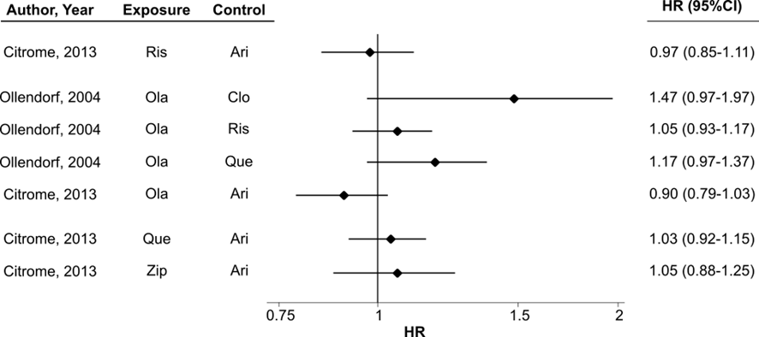
Ari, aripiprazole; CI, confidence interval; Clo, clozapine; HR, hazard ratio; Ola, olanzapine; Que, quetiapine; Ris, risperidone; Zip, ziprasidone.

Supplementary figure 1b: Risk of diabetes in adults who received second-generation antipsychotics in head-to-head comparisons (binary outcomes)
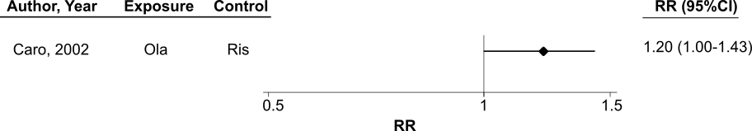
CI, confidence interval; Ola, olanzapine; Ris, risperidone; RR, relative risk.

Supplementary figure 2. Risk of diabetes in adults who received second-generation antipsychotics in other comparisons (binary outcomes)
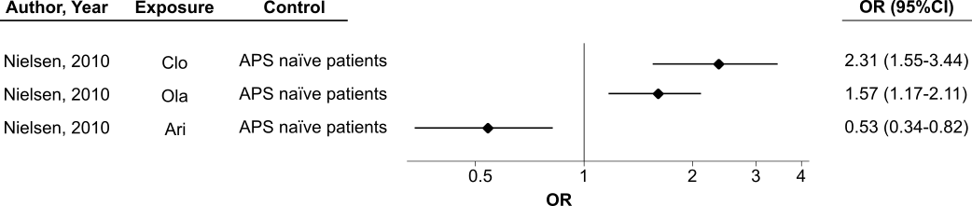
ªNielsen et al. 2010 reported two different outcomes related to the occurrence of diabetes. In this figure, we present the effect of the current treatment with an APS (i.e., at least one APS prescription within the last three months before diabetes onset, death, or the end of the registry) on the occurrence of diabetes. The remaining second-generation antipsychotics (i.e. risperidone, quetiapine, ziprasidone and other SGAs) were not significantly associated with diabetes, but the authors did not report specific results.
APS, antipsychotic; Ari, aripiprazole; CI, confidence interval; Clo, clozapine; Ola, olanzapine; OR, odds ratio.

Supplementary figure 3. Risk of diabetes in adults who received second-generation antipsychotics in other comparisons (time-to-event outcomes)
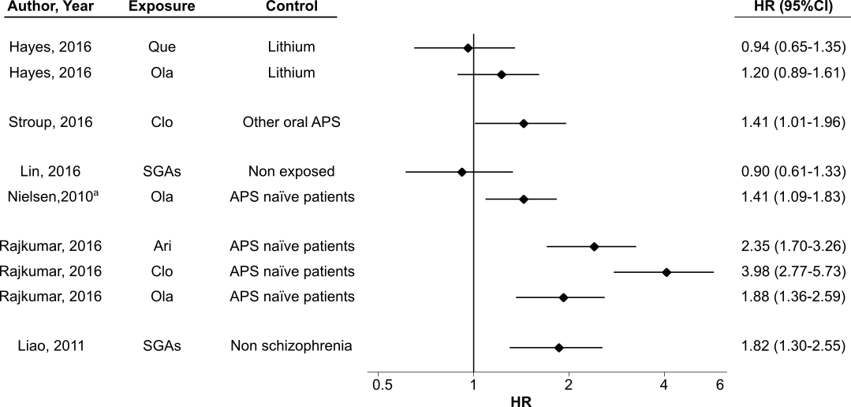ªNielsen et al. (2010) reported two different outcomes related to the occurrence of diabetes. In this figure, we include the effect of the initial treatment with an APS (i.e., first APS prescription) on the time to onset of diabetes during the first year of treatment The remaining second-generation antipsychotics (i.e. clozapine, risperidone, quetiapine, ziprasidone, aripirpazole and other SGAs) were not significantly associated with diabetes, but the authors did not report specific results.
Ari, aripiprazole; CI, confidence interval; Clo, clozapine; HR, hazard ratio; Ola, olanzapine; Que, quetiapine; Ris, risperidone; SGAs, second-generation antipsychotics; Zip, ziprasidone.

Supplementary figure 4. Risk of obesity/weight gain in adults who received second-generation antipsychotics compared to those who received first-generation antipsychotics
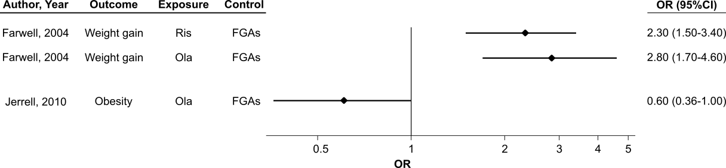
CI, confidence interval; FGAs, first-generation antipsychotics; OR, odds ratio; Ola, olanzapine; Ris, risperidone

Supplementary figure 5. Risk of obesity/weight gain in adults who received second-generation antipsychotics compared to those who received lithium
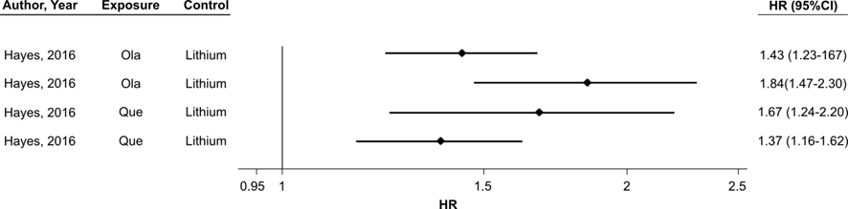
For each antipsychotic, the first result corresponds to a weight gain >7% and the second result corresponds to a weight gain >15%
CI, confidence interval; HR, hazard ratio; Ola, olanzapine; Que, quetiapine

