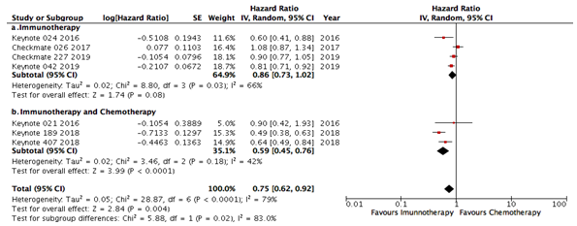
Supplemental Figure 1. Pooled analysis of overall survival for anti-PD1drugs, alone or in combination, in first line therapy for non-small carcinoma lung cancer patients. In (a) studies with immunotherapy in monotherapy and in (b) studies with immunotherapy combined with chemotherapy.

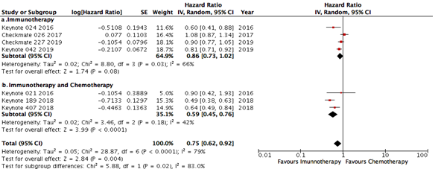
Supplemental Figure 2. Pooled analysis of overall survival for anti-PD-L1drugs, alone or in combination, in first line therapy for non-small carcinoma lung cancer patients. In (a) studies with immunotherapy in monotherapy and in (b) studies with immunotherapy combined with chemotherapy.

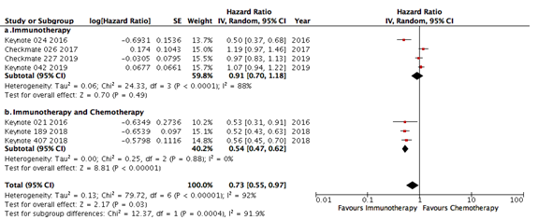
Supplemental Figure 3. Pooled analysis of progression free survival for anti-PD1 drugs, alone or in combination, in first line therapy for non-small carcinoma lung cancer patients. In (a) studies with immunotherapy in monotherapy and in (b) studies with immunotherapy combined with chemotherapy.

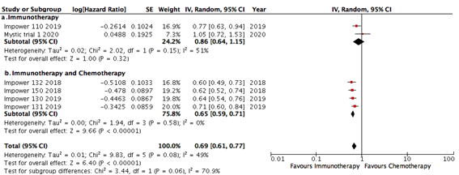
Supplemental Figure 4. Pooled analysis of progression free survival for anti-PD-L1 drugs, alone or in combination, in first line therapy for non-small carcinoma lung cancer patients. In (a) studies with immunotherapy in monotherapy and in (b) studies with immunotherapy combined with chemotherapy.

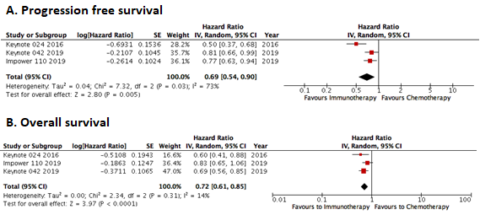
Supplemental Figure 5. Pooled analysis of progression free survival (A) and overall survival (B) for patients with tumors with PD-L1 expression>50% treated in first line therapy for metastatic non-small carcinoma lung cancer.

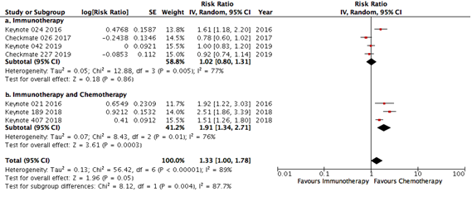
Supplemental Figure 6. Pooled analysis of overall response rate, for anti-PD1 drugs, alone or in combination, in first line therapy for non-small carcinoma lung cancer patients. In (a) studies with immunotherapy in monotherapy and in (b) studies with immunotherapy combined with chemotherapy.

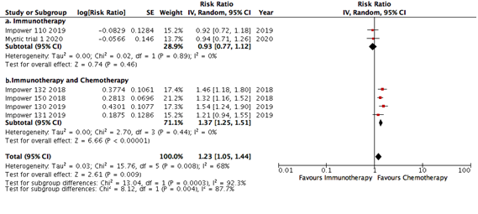
Supplemental Figure 7. Pooled analysis of overall response rate, for anti-PD-L1 drugs, alone or in combination, in first line therapy for non-small carcinoma lung cancer patients. In (a) studies with immunotherapy in monotherapy and in (b) studies with immunotherapy combined with chemotherapy

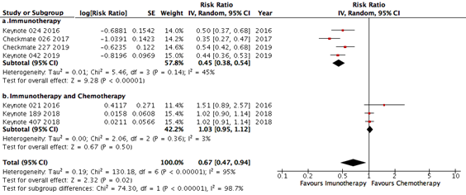
Supplemental Figure 8. Pooled analysis of grade 3-5 AEs for anti-PD-1 drugs, alone or in combination, in first line therapy for non-small carcinoma lung cancer patients. In (a) studies with immunotherapy in monotherapy and in (b) studies with immunotherapy combined with chemotherapy

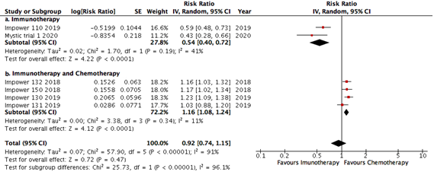
Supplemental Figure 9. Pooled analysis of grade 3-5 AEs for anti-PD-L1 drugs, alone or in combination, in first line therapy for non-small carcinoma lung cancer patients. In (a) studies with immunotherapy in monotherapy and in (b) studies with immunotherapy combined with chemotherapy

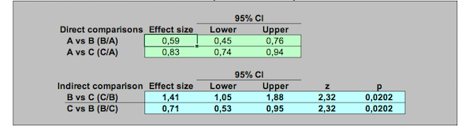
Supplemental Figure 10. Indirect analysis statistical approach to compare overall survival between anti-PD1 and anti-PD-L1 in monotherapy (upper image - A) and in combination with chemotherapy (below image - B). In each line of the comparisons, A is the control group, B is the PD-1 group and C is the PD-L1 group.

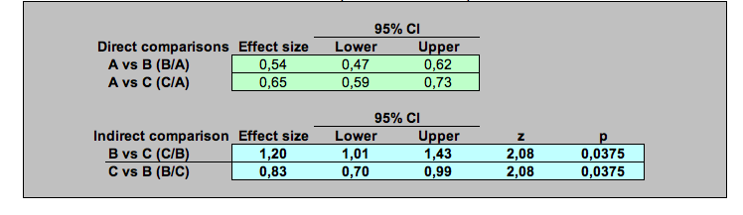
Supplemental Figure 11. Indirect analysis statistical approach to compare progression free survival between anti-PD1 and anti-PD-L1 in monotherapy (upper image - A) and in combination with chemotherapy (below image - B). In each line of the comparisons, A is the control group, B is the PD-1 group and C is the PD-L1 group.
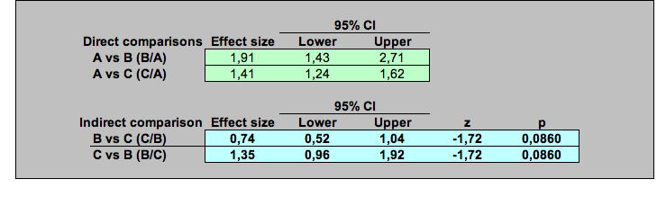
Supplemental Figure 12. Indirect analysis statistical approach to compare overall response ratel between anti-PD1 and anti-PD-L1 in monotherapy (upper image - A) and in combination with chemotherapy (below image - B). In each line of the comparisons, A is the control group, B is the PD-1 group and C is the PD-L1 group.

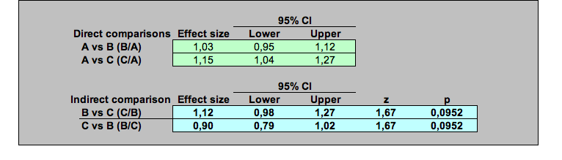
Supplemental Figure 13. Indirect analysis statistical approach to compare the rate of grade 3-5 AEs between anti-PD1 and anti-PD-L1 in monotherapy (upper image - A) and in combination with chemotherapy (below image - B). In each line of the comparisons, A is the control group, B is the PD-1 group and C is the PD-L1 group.

