SUPPLEMENTAL DATA

Step | Search | EMBASE (n. of results) | PubMed (n. of results) | Cochrane Library (n. of results)
1 | (non small cell* OR nonsmall cell* OR large cell* OR squamous cell* OR squamous small cell* OR nonsquamous cell* OR nonsquamous small cell* OR epidermoid) AND (cancer* OR carcin* OR tumor* OR tumour* OR neoplas* OR oncol* OR malignan*)
2 | (lung OR lungs OR pulmonary OR bronchial OR bronchus)
3 | 1 AND 2
4 | (lung OR lungs OR pulmonary OR bronchial) AND (adenocarcin* OR adenocancer*)
5 | NSCLC*
6 | 3 OR 4 OR 5 | 282433 | 158904 | 1849491
7 | (randomised OR randomized OR controlled) AND (clinical trial OR trial)
8 | (anaplastic lymphoma kinase OR ALK OR ALK-positive OR ALK-rearranged OR ALK-translocated)
9 | (first-line OR front-line OR untreated OR treatment-naive)
10 | (TKI OR tyrosine kinase inhibitors OR ALK-inhibitor OR ALK inhibitor OR crizotinib OR ceritinib OR alectinib OR lorlatinib OR brigatinib OR ensartinib)
11 | 7 AND 8 AND 9 AND 10 | 486 | 85 | 254
12 | 6 AND 11
13 | Animals NOT Humans
14 | (news OR comment OR letter OR editorial OR case report OR case reports)
15 | 12 NOT (17 OR 18) | 423 | 81 | 243
16 | Total number of results (PubMED + EMBASE + Cochrane) | 747
17 | Duplicates identified and deleted | 246
18 | Non duplicated results | 501

Supplemental data 1- Table - Search terms and results for each electronic database.

Database/Information source | Interface/Address | Search Date
Electronic Databases
Cochrane Central Register of Controlled Trials (CENTRAL) and Cochrane Database of Systematic Reviews (CDSR) | Cochrane Library/Wiley: https://www.cochranelibrary.com | 16th Dec 2021
PubMed | https://www.ncbi.nlm.nih.gov/pubmed | 16th Dec 2021
Embase (including MEDLINE) | https://www.embase.com | 17th Dec 2021
Conference Proceedings / Abstracts from International Meetings
American Society of Clinical Oncology (ASCO) | Searched via the Embase database (if the conference was indexed in Embase) or via  the conference website or journal webpages (if free to access) | 14th Dec 2021
European Lung Cancer Conference (ELCC) | Searched via the Embase database (if the conference was indexed in Embase) or via the conference website or journal webpages  (if free to access) | 14th Dec 2021
European Society for Medical Oncology (ESMO) | Searched via the Embase database (if the conference was indexed in Embase) or via  the conference website or journal webpages (if free to access) | 14th Dec 2021
World Conference on Lung Cancer (WCLC) of the International Association for the Study of Lung Cancer (IASLC) | Searched via the Embase database (if the conference was indexed in Embase) or via  the conference website or journal webpages (if free to access) | 15th Dec 2021
Supplemental data 2 - Table - Data sources searched

First author and year of publication | N. of OS events: control vs experimental arm |  | HR (95% CI) and p value for OS analysis (experimental vs control) | N./% of ORR events: control vs experimental arm |  | N./% of DCR events: control vs experimental arm |  | N./% of any CNSRR events: control vs experimental arm |  | N./% of measurable CNSRR events: control vs experimental arm
Peters et al 2017 (…) | NA | NA | 0.76 (95% CI: 0.48-1.2). p=0.24 | 114 | 126 | 135 | 138 | 15 | 38 | 11 | 17
Hida et al 2017 (…) | NA | NA | NA | 79% (IRF) 70% (IA) | 92% (IRF) 85% (IA) | 92% (IRF) 88% (IA) | 96% (IRF) 99% (IA) | NA | NA | NA | NA
Camidge et al 2020 (…) | 37 | 33 | 0.92 (95% CI: 0.57-1.47). p=0.771 | 62% | 74% | NA | NA | 16% | 66% | 26% | 78%
Soria et al 2017 (…) | 59 | 48 | 0.73 (95% CI: 0.5-1.08). p=0.056 | 50 | 137 | NA | NA | 11 | 25 | 6 | 16
Zhou et al 2019 (…) | 13 | 8 | 0.28 (95% CI :0.12-0.68). p=0.0027 | 48 | 114 | 56 | 121 | 5 | 32 | 2 | 16
Horn et al 2021 (…) | 13 | 8 | 0.28 (95% CI: 0.12-0.68). p=0.0027 | 98 | 106 | NA | NA | NA | NA | 4 | 7
Shaw et al 2020 (…) | 28 | 23 | 0.72 (95% CI: 0.41-1.25). p= NA | 85 | 113 | 129 | 135 | 38 | 25 | 3 | 14
Supplemental data 3 - Table - Other outcomes of selected randomized clinical trials in patients with ALK-translocated lung cancer. CI: confidence interval; CNSRR: central nervous system response rate; DCR: disease control rate; HR: hazard ratio; IA: investigator assessed; IRF: independent review facility; NA: not available; ORR: overall response rate; OS: overall survival

First author and year of publication | Age subgroups | HR (95% CI) for PFS analysis according to age (experimental vs control) | Sex subgroups | HR (95% CI) for PFS analysis according to sex (experimental vs control) | Race subgroups | HR (95% CI) for PFS analysis according to race (experimental vs control) | Smoking status subgroups | HR (95% CI) for PFS analysis according to smoking status (experimental vs control) | PS subgroups | HR (95% CI) for PFS analysis according to PS (experimental vs control) | Baseline CNS involvement subgroups | HR (95% CI) for PFS analysis according to baseline CNS involvement at baseline (experimental vs control)
Peters et al 2017 (…) | <65 years | 0.48 (0.34-0.7) | Male | 0.61 (0.38-0.98) | Asian | 0.46 (0.28-0.75) | Active smokers | 1.16 (0.35 -3.9) | ECOG 0 | 0.4 (0.21-0.77) | Present | 0.4 (0.25-0.64)
Peters et al 2017 (…) | ≥65 years | 0.45 (0.24-0.87) | Female | 0.39 (0.25-0.6) | Non-Asian | 0.49 (0.32-0.75) | Never smokers | 0.44 (0.29-0.66) | ECOG 1 | 0.48 (0.32-0.71) | Absent | 0.51 (0.33-0.8)
Hida et al 2017 (…) | <75 years | 0.34 (0.21-0.56) | Male | 0.35 (0.16-0.77) | All Asian | NA | Active and former smokers | 0.18 (0.08-0.42) | ECOG 0 | NA | Present | 0.08 (0.01-0.61)
Hida et al 2017 (…) | ≥75 years | 0.28 (0.06-1.19) | Female | 0.31 (0.17-0.57) | All Asian | NA | Never smokers | 0.5 (0.28-0.89) | ECOG 1 | NA | Absent | 0,39 (0.23-0.64)
Camidge et al 2020 (…) | <65 years | 0.43 (0.29-0.65) | Male | 0.46 (0.29-0.74) | Asian | 0.38 (0.22-0.65) | Active smokers | NA | ECOG 0 | 0.25 (0.12-0.52) | Present | 0.25 (0.14-0.46)
Camidge et al 2020 (…) | ≥65 years | 0.6 (0.3-1.09) | Female | 0.49 (0.31-0.79) | Non-Asian | 0.54 (0.36-0.83) | Never smokers | 0.46 (0.29-0.73) | ECOG 1 | 0.53 (0.36-0.8) | Absent | 0,65 (0.44-0.97)
Soria et al 2017 (…) | <65 years | 0.58 (0.42-0.8) | Male | 0.41 (0.27-0.63) | Asian | 0.66 (0.41-1.06) | Active smokers | 0.48 (0.3-0.77) | WHO 0 | 0.59 (0.37-0.96) | Present | 0.7 (0.44-1.12)
Soria et al 2017 (…) | ≥65 years | 0.45 (0.24-0.86) | Female | 0.63 (0.43-0.93) | Caucasic | 0.44 (0.3-0.66) | Never smokers | 0.56 (0.38-0.8) | WHO 1+2 | 0.52 (0.37-0.74) | Absent | 0,48 (0.34-0.69)
Zhou et al 2019 (…) | <65 years | 0.24 (0.14-0.42) | Male | 0.17 (0.09-0.34) | All Asian | NA | Active smokers | 0.01 (0-NE) | ECOG 0 | 0.4 (0.1-1.62) | Present | 0.11 (0.05-0.28)
Zhou et al 2019 (…) | ≥65 years | 0,21 (0.04-1.08) | Female | 0.35 (0.16-0.78) | All Asian | NA | Never smokers | 0.3 (0.16-0.55) | ECOG 1 | 0.2 (0.11-0.36) | Absent | 0,34 (0.18-0.65)
Horn et al 2021 (…) | <65 years (mITT) | 0.42 (0.27-0.64) | Male (mITT) | 0.44 (0.25-0.77) | Asian (mITT) | 0.32 (0.19-0.55) | Active smokers | NA | ECOG 0 | NA | Present | 0.55 (0.3-1.01)
Horn et al 2021 (…) | ≥65 years (mITT) | NA | Female (mITT) | 0.45 (0.25-0.81) | Non-Asian (mITT) | 0.61 (0.34-1.11) | Never smokers | 0.39 (0.23-0.65) | ECOG 1 | NA | Absent | 0,4 (0.23-0.7)
Shaw et al 2020 (…) | <65 years | 0.22 (0.13-0.37) | Male | 0.31 (0.18-0.54) | Asian | 0.47 (0.27-0.88) | Active and former smokers | 0.36 (0.2-0.63) | ECOG 0 | NA | Present | 0.2 (0.1-0.43)
Shaw et al 2020 (…) | ≥65 years | 0.35 (0.2-0.64) | Female | 0.26 (0.16-0,44) | Non-Asian | 0.19 (0.11-0.32) | Never smokers | 0.24 (0.14-0.4) | ECOG 1 | NA | Absent | 0,32 (0.2-0.49)
Supplemental data 4 - Table - Subgroup analysis for PFS in the selected randomized clinical trials. CI: confidence interval; CNS: central nervous system; ECOG: eastern cooperative oncology group; HR: hazard ratio; mITT: modified intention to treat population; NA: not available; NE: not estimable; PFS: progression free survival; PS: performance status; WHO: world health organization

Subgroup analysis on PFS |  | RR (95% CI) | p-value | Heterogeneity
Age | < 65 | 0.39 (0.29-0.52) | Interaction: p=0.60 | 66.7%; p=0.014
Age | ≥ 65 | 0.44 (0.32-0.59) | Interaction: p=0.60 | 0%; p=0.69
Gender | Female | 0.41 (0.32-0.53) | Interaction: p=0.75 | 39.7%; p=0.15
Gender | Male | 0.39 (0.29-0.51) | Interaction: p=0.75 | 44.1%; p=0.094
Race | Asian | 0.45 (0.35-0.58) | Interaction: p=0.80 | 14.9%; p=0.35
Race | Non-Asian | 0.43 (0.29-0.62) | Interaction: p=0.80 | 69.3%; p=0.019
ECOG PS | 0 | 0.42 (0.27-0.64) | Interaction: p=0.97 | 32.7%; p=0.28
ECOG PS | 1-2 | 0.42 (0.28-0.65) | Interaction: p=0.97 | 74.3%; p=0.029
Baseline CNS involvement | Present | 0.30 (0.18-0.51) | Interaction: p=0.17 | 76.4%; p=0.001
Baseline CNS involvement | Absent | 0.45 (0.37-0.55) | Interaction: p=0.17 | 22.1%; p=0.30
Smoking status | Active smokers (+ former smokers) | 0.39 (0.28-0.55) | Interaction: p=0.79 | 50.3%; p=0.056
Smoking status | Never smokers | 0.41 (0.33-0.51) | Interaction: p=0.79 | 29.1%; p=0.21
Supplemental data 5 - Table - Pooled results for the PFS subgroup analysis. CNS: central nervous system; ECOG PS: Eastern Cooperative Oncology Group performance status; RR: relative risk.

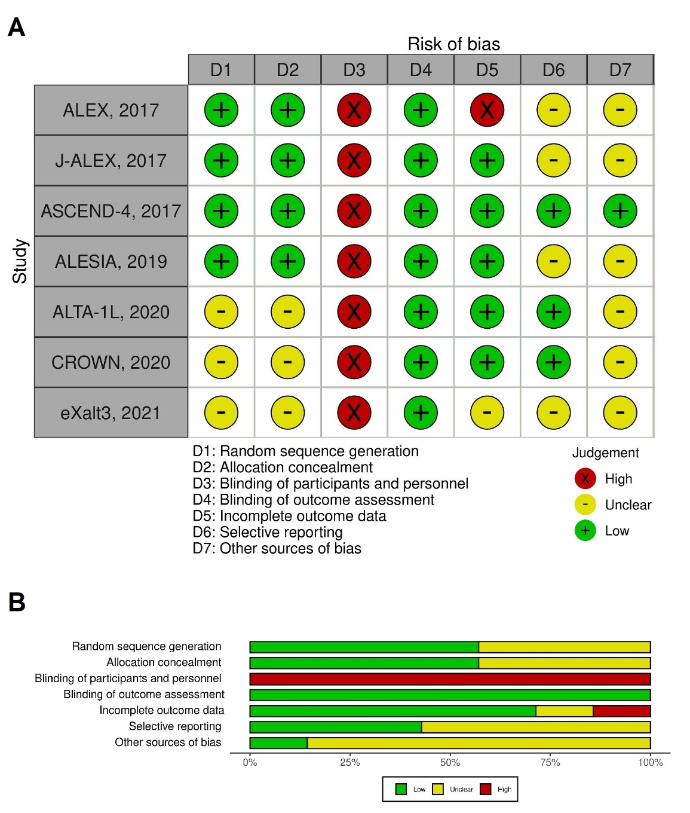
Supplemental data 6 - Table - Risk of bias graph: review authors' judgements about each risk of bias item presented as percentages across all included studies. A: risk of bias for each study; B: percentages of each risk of bias item.

