Adapted PRISMA for reporting systematic reviews of qualitative and quantitative evidence

Section/topic | Description | page
TITLE
Title | - Propose a short take-home title. The title should explicitly state that the review included different type of evidence. | 1
ABSTRACT
Structured summary | - Provide a structured summary including, as applicable: background; objectives; data sources; study eligibility criteria,  participants, and interventions; study appraisal and synthesis methods; results; limitations; conclusions and implications of key findings; systematic review registration number. | 1
INTRODUCTION AND OBJECTIVES
Rationale | - Describe the rationale for the review (e.g., a health problem) in the context of what is already known (e.g., an existing literature review paper or a reference book chapter). | 2
Objectives | - Formulate questions and/or objectives (qualitative, quantitative or both) being addressed by your review. | 4
METHODS
Protocol and registration | - Indicate if a review protocol exists, if and where it can be accessed (e.g., Web address), and, if available, provide registration information including registration number. | 4
Justification | - Justify the use of a review of qualitative and quantitative evidence. | 4
Eligibility criteria | - Specify the inclusion and exclusion criteria and the rationale for supporting these criteria. | 5
Information sources | - Describe all Information sources(e.g.,databaseswithdatesofcoverage,contactwithstudyauthorstoidentifyadditional studies) in the search and date last  - Searched. | 5
Search | - Present full electronics each strategy for at least one database (e.g., in an appendix), including any limits used, such that it could be repeated.  - Describe the process for removing duplicates.  - Specify the involvement of a librarian, if applicable. | 5
Study selection | - Describe the process for selecting studies (e.g., screening based on titles and abstracts, and eligibility based on full-text, number of reviewers, software used). | 5
Data collection process | - Describe the method of data extraction from included studies (e.g., number of reviewers involved, piloted forms, etc.).  - List the data extracted.  - If applicable, state any processes for obtaining and confirming data from investigators of included studies (e.g., initial mailto the first author and reminder email). | 6
Appraisal | - Describe the process for appraising included studies (e.g., tools used, number of reviewers involved), and specifically for assessing the methodological quality or risk of bias of included qualitative, quantitative, and mixed methods studies.  - Specifyhowresultsofthisappraisalareusedinthesynthesis.Forexample,fordescriptivepurpose(includeallstudieswith  Description of their methodological quality or risk of bias) or for analytical purpose (contrast synthesis of ‘lower quality’ studies vs. ‘higher quality’ studies using sensitivity analysis). | 6
Synthesis | - Describe the synthesis design used.  - Describeandjustifythesynthesismethod(s)used(e.g.,quantitativecontentanalysis,meta-analysis,thematicsynthesis,etc.). | 6
Additional analysis | - Describe methods of additional analyses (e.g., sensitivity or subgroup analyses), if done. | N/A
RESULTS
Study selection | - Give numbers of studies screened, assessed for eligibility ,and included in the review, with reasons for exclusions at each | 7
 | stage.  - Summarize in a flow diagram (see Appendices).  - Give numbers of quantitative, qualitative and mixed methods studies included. | 7
Study characteristics | - For each study, present characteristics for which data were extracted (e.g., tables of characteristics of included studies – see Appendices) and provide the citations.  - Specify common information across all included studies.  - Describe the studies including their heterogeneity (variability associated with differences between studies). | 7
Result of appraisal | Present data on the methodological quality or risk of bias of included studies based on the appraisal done. | N/A
Results of synthesis | - Present results of synthesis.  - If qualitative synthesis:  - In the text, briefly summarize the main themes or categories and refer to the appendix.  - Appendix (table, figure, or matrix): For each study, present the themes or categories identified.  - If quantitative synthesis:  - In the text, briefly summarize the data and refer to the appendix.  - Appendix (table, figure, or matrix): For all key variables, present, for each study: (a)simple summary data for each intervention group and (b) effect estimates and confidence intervals, ideally with a forest plot.  - If qualitative and quantitative syntheses:  - Present both  - If applicable, present the results of the integration of both syntheses. | 8-17
Additional analysis | - Give results of additional analyses, if done (e.g., sensitivity or sub group analyses). | N/A
DISCUSSION
Summary of evidence | - Provide an overall summary of results (take-home messages) from the qualitative and/or quantitative synthesis.  - State the main results for each main theme or category, and/or key process/outcome variable.  - Consider their relevance and importance for knowledge users (e.g., health care providers, managers, and decision/policy makers).  - Take into account the methodological quality across studies (when applicable).  - Describe insight gained from the integration of qualitative and quantitative evidence. | 18-20
Contribution | - Describe the contribution of the review (compared to what is already known) with respect to:  - Review methods,  - Scientific knowledge,  - Practice, program planning and evaluation, policymaking, or else. | 20
Limitations | - Specify any element that may affect the cumulative evidence.  - Discuss limitations at the study and process/outcome levels (e.g., lack of rich data for qualitative synthesis, methodological quality/risk of bias, and their potential consequences on the results).  - Discuss limitations at the review level (e.g., dependent reviewers, incomplete retrieval of relevant studies - selective publication of reports regarding studies with positive results), and limited reporting (selective reporting of information about included studies)), and their potential consequences on the results. | 20
Conclusions | - Provide a general interpretation of the results in the context of other evidence, including implications for knowledge users (e.g., major recommendation).  - State implications for future research. | 21
ACKNOWLEDGEMENTS
Acknowledgements | - Describe sources of funding and other support (e.g., supply of data) and the role of funders in the review.  - Acknowledge any information about potential conflict of interest. | Title page
REFERENCES
References | - List all the references cited in the text. | 22-24
APPENDICES (tables, figures, boxes, …)
Flow diagram | 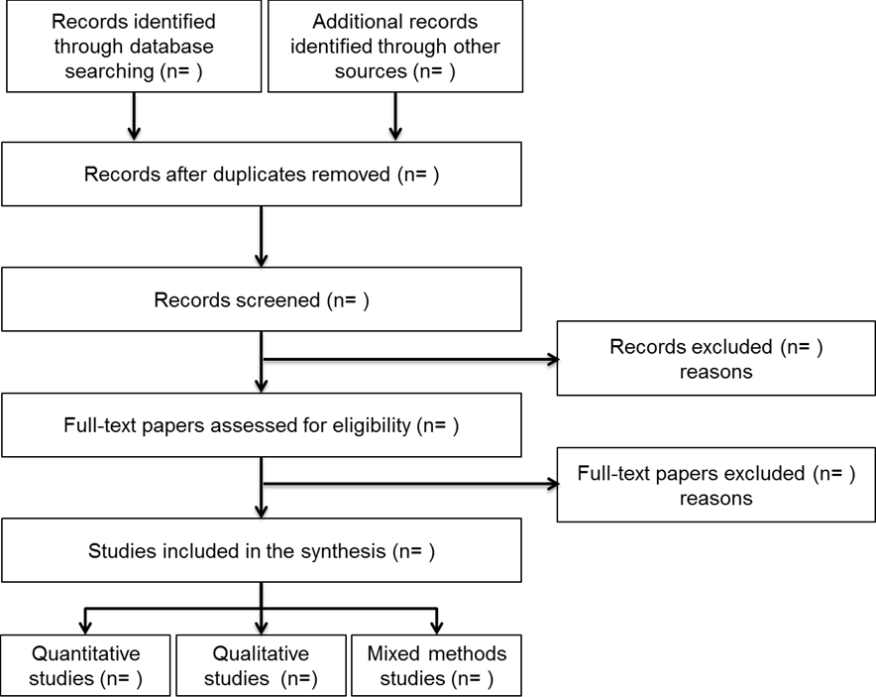 | Figure1
Table of characteristics of included studies | - Summarize key characteristics of the included studies in a table such as:  - Source (first author, year),  - Study design,  - Number of participants and participants (e.g., age, sex, other),  - Setting (e.g., types and number of organizations),  - Intervention/exposure (if applicable), or relevant considerations for non-intervention studies,  - Outcomes (if applicable), or relevant considerations for non-intervention studies,  - Quality rating (if applicable),  - Further comments on key characteristics of the study (according to the review question),  Different tables may be needed: For example, tables for quantitative studies, for qualitative studies, and for mixed methods studies. | Table1
Tables and figures on results of the synthesis | - Provide illustrations for results of the synthesis such as:  - Quantitative synthesis: statistical summary, descriptive table, forest plots, etc.  - Qualitative synthesis: list of categories, list of themes and subthemes, concept maps, framework ,etc. | Figure2

Adapted from: Moher D, Liberati A, Tetzlaff J, Altman DG, The PRISMA Group (2009). Preferred Reporting Items for Systematic Reviews and Meta-Analyses: The PRISMA Statement. PLoS Med 6(6): e1000097. doi:10.1371/journal.pmed100

