S1 File. Search strategies for database
Pubmed:
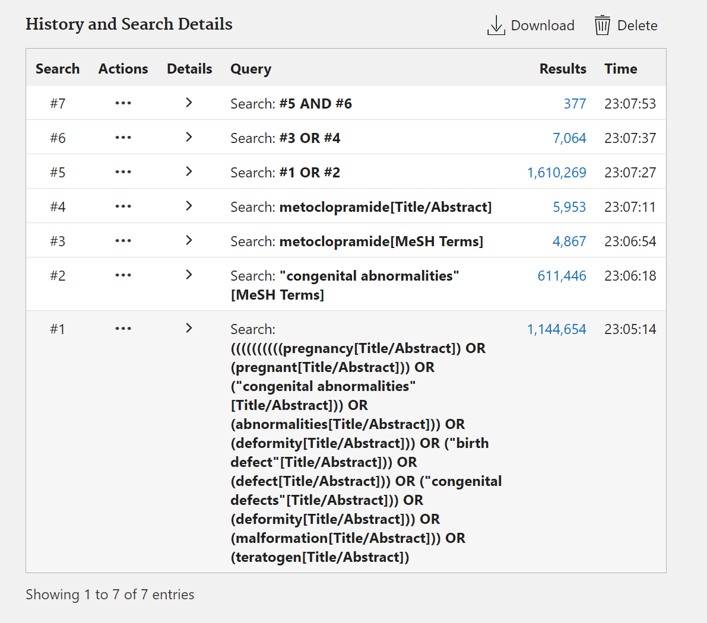

Embase:

Web of science:
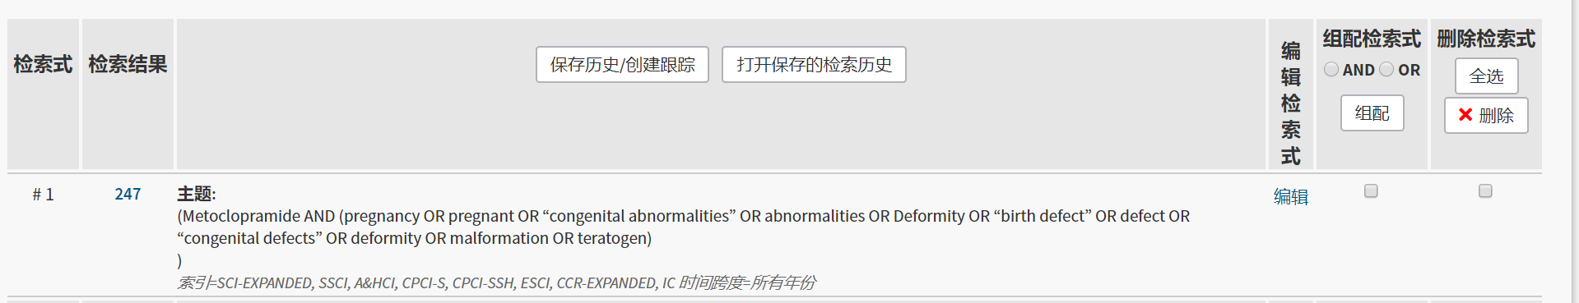

Cochrane library:


