Supplemental Table 1. PubMed search strategy.

# | Searches | Results
#1 | "percutaneous coronary intervention"[Mesh] OR "coronary intervention*, percutaneous":[tiab] OR "intervention*, percutane  -ous coronary":[tiab] OR "pci":[tiab] OR "percutaneous coronary revascularization":[tiab] OR "coronary revascularization*, percu  -taneous":[tiab] OR "percutaneous coronary revascularizations":  [tiab] OR "revascularization*, percutaneous coronary":[tiab] OR "drug eluting stent*":[tiab] OR "des":[tiab] | 87881
#2 | "Dual Anti-Platelet Therapy"[Mesh] OR "dual antiplatelet therap  -y":[tiab] OR "dapt":[tiab] OR "aspirin":[tiab] OR "clopidogrel":  [tiab] OR "prasugrel":[tiab] OR "ticagrelor":[tiab] OR "p2y12 in  -hibitor":[tiab] OR "anti-platelet therapies, dual":[tiab] OR "anti-  platelet therapy, dual":[tiab] OR "dual anti-platelet therapy":[ti  -ab] OR "dual anti-platelet therapies":[tiab] | 59916
#3 | "Randomized Controlled Trial"[Publication Type] OR "controll  -ed clinical trial":[tiab] OR "clinical trials, randomized":[tiab] OR "trials, randomized clinical":[tiab] OR "randomized clinical studies":[tiab] | 517822
#4 | "Systematic Review"[Publication Type] OR "Meta-Analysis"  [Publication Type] OR "Review"[Publication Type] OR "meta-  analysis":[ti] OR "systematic review":[ti] OR "literature review"  :[ti] OR "expert consensus":[ti] OR "case report":[ti] | 3005415
#5 | #1 AND #2 AND #3 NOT #4 | 976

Supplemental Table 2. EMBASE search strategy.
# | Searches | Results
#1 | 'percutaneous coronary intervention':kw OR 'coronary inter  -vention*, percutaneous':ab,ti OR 'intervention*, percutaneous coronary':ab,ti OR 'pci':ab,ti OR 'percutaneous coronary revascularization*':ab,ti OR 'coronary revascularization*, percutaneous':ab,ti OR 'revascularization*, percutaneous coronary':ab,ti OR 'drug eluting stents':kw OR 'drug-eluting stent':ab,ti OR 'des':ab,ti | 123664
#2 | 'dual antiplatelet therapy'/exp OR 'dapt':ab,ti OR 'aspirin':ab,ti OR 'clopidogrel':ab,ti OR 'prasugrel':ab,ti OR 'ticagrelor':ab,ti OR 'p2y12 inhibitor':ab,ti OR 'anti-platelet therapies, dual':ab,  ti OR 'anti-platelet therapy, dual':ab,ti OR 'dual anti-platelet  therapy':ab,ti OR 'dual anti-platelet therapies':ab,ti | 96001
#3 | 'randomized controlled trial'/exp OR 'controlled clinical trial':ab,ti OR 'clinical trials, randomized':ab,ti OR 'trials, randomized clinical':ab,ti OR 'randomized clinical studies':  ab,ti | 621793
#4 | 'systematic review'/exp OR 'meta analysis'/exp OR 'review'  /exp OR 'meta-analysis':ti OR 'systematic review':ti OR 'literature review':ti OR 'expert consensus':ti OR 'case report'/exp OR 'case report':ti | 5354446
#5 | #1 AND #2 AND #3 NOT #4 | 883

Supplemental Table 3. Cochrane Library search strategy.
# | Searches | Results
#1 | MeSH descriptor percutaneous coronary intervention explode all trees OR (coronary intervention*, percutaneous):ti,ab,kw OR (intervention*, percutaneous coronary):ti,ab,kw OR (pci):ti,ab,kw OR (percutaneous coronary revascularization*):  ti,ab,kw OR (coronary revascularization*, percutaneous):ti,  ab,kw OR (revascularization*, percutaneous coronary):ti,ab,  kw OR (drug eluting stent*):ti,ab,kw OR (drug-eluting stent):  ti,ab,kw OR (des):ti,ab,kw | 17508
#2 | (dual antiplatelet therapy):ti,ab,kw OR (dapt):ti,ab,kw OR (aspirin):ti,ab,kw OR (clopidogrel):ti,ab,kw OR (prasugrel):ti,  ab,kw OR (ticagrelor):ti,ab,kw OR (p2y12 inhibitor):ti,ab,kw OR (anti-platelet therapies, dual):ti,ab,kw OR (anti-platelet therapy, dual):ti,ab,kw OR (dual anti-platelet therapy):ti,ab,  kw OR (dual anti-platelet therapies):ti,ab,kw | 18055
#3 | 'MeSH descriptor randomized controlled trial explode all trees OR (controlled clinical trial):ti,ab OR (clinical trials, randomized):ti,ab OR (trials, randomized clinical):ti,ab OR (randomized clinical studies):ti,ab | 184792
#4 | #1 AND #2 AND #3 | 641

Supplemental Table 4. Definition of outcomes in each trial.
Study name | Primary outcome | Stent thrombosis | Major bleeding
RESET ^{[15]} | Composite of cardiovascular death, MI, ST, target-vessel revascularization, or major bleeding | Definite or probable ST by ARC criteria | TIMI major or minor bleeding
OPTIMIZE ^{[16]} | Composite of all-cause death, MI, stroke, or major bleeding | Definite or probable ST by ARC criteria | Modified major REPLACE-2 and severe or life-threatening GUSTO criteria
GLOBAL LEADERS^{[6]} | Composite of all-cause death  or new Q-wave myocardial infarction | Definite or probable ST by ARC criteria | BARC type 3 or 5 bleeding
REDUCE ^{[17]} | Composite of all-cause death, MI, ST, stroke, target-vessel revascularization, or major bleeding | Definite or probable ST by ARC criteria | BARC 2,3,5
STOP-DAPT 2^{[7]} | Composite of cardiovascular death, MI, ST, stroke, or TIMI major or  minor bleeding | Definite or probable ST by ARC criteria | TIMI major or  minor bleeding
SMART-CHOICE^{[8]} | Composite of all-cause  death, MI, or stroke | Definite or probable ST by ARC criteria | BARC 2-5
TWILIGHT^{[9]} | BARC type 2, 3, or 5 bleeding | Definite or probable ST by ARC criteria | BARC type 3 or 5 bleeding
TICO^{[10]} | Composite of major bleeding, death, MI, ST, stroke, or target-vessel revascularization | Definite or probable ST by ARC criteria | TIMI major or minor bleeding
Abbreviations: ARC; Academic Research Consortium, BARC; Bleeding Academic Research Consortium, GUSTO; Global Utilization of Streptokinase and Tissue Plasminogen Activator for Occluded Coronary Arteries, MI; myocardial infarction, REPLACE-2; Randomized Evaluation of PCI Linking Angiomax to Reduced Clinical Events, ST; stent thrombosis, TIMI; Thrombolysis in Myocardial Infarction

Supplemental Table 5. Quality assessments of GRADE evidence for each outcome.
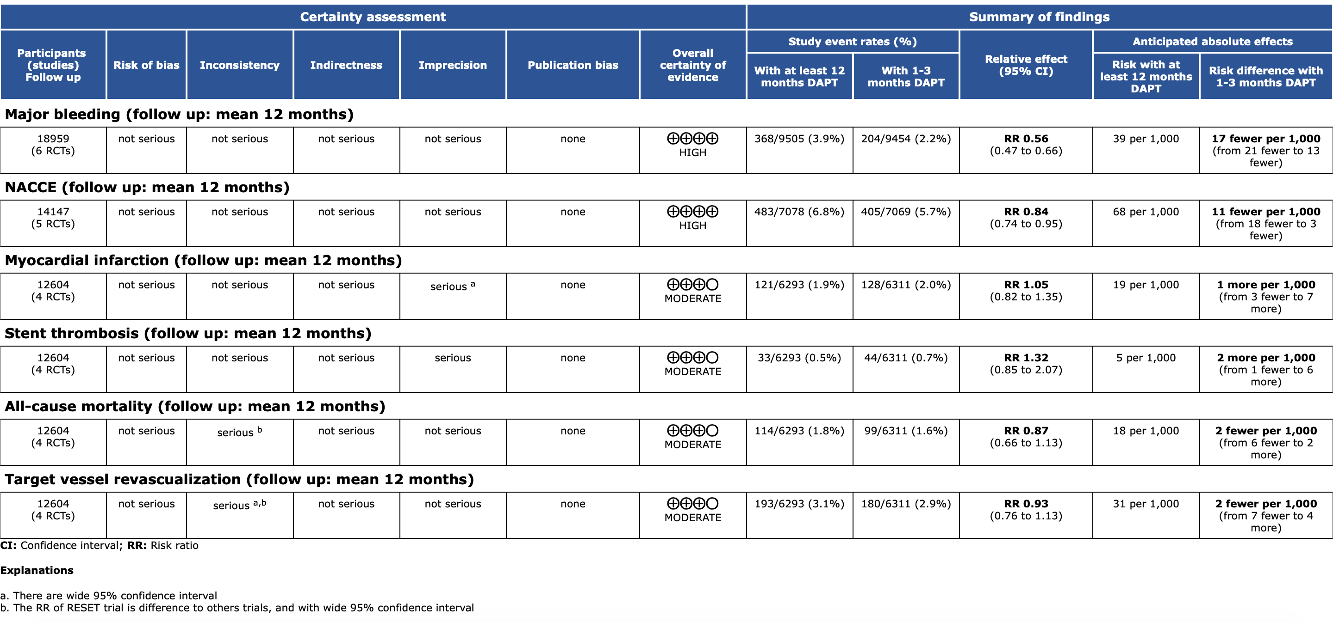

Supplemental Table 6. The Begg’s and Egger’s Test in STATA of each outcome.

Endpoints | P (Begg’s test) | P (Eegg’s test)
myocardial infarction | 1.000 | 0.493
stent thrombosis | 0.734 | 0.224
all-cause death | 0.734 | 0.440
target vessel revascularization | 0.308 | 0.280
Major bleeding | 1.000 | 0.509
MACCE | 1.000 | 0.908
NACCE | 0.806 | 0.819

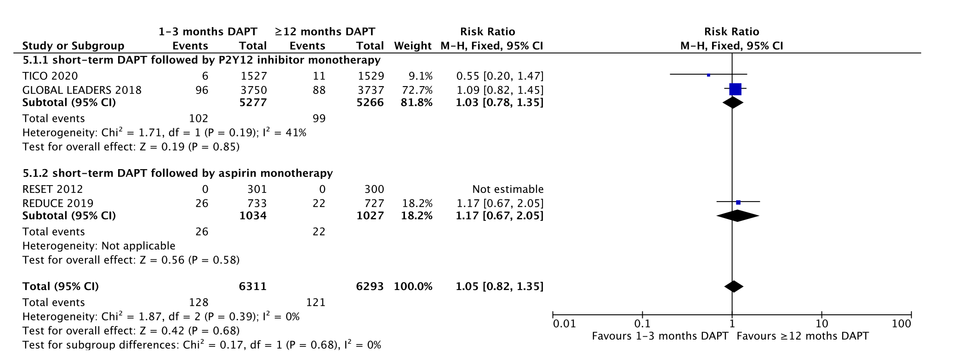

Supplemental Figure S1. The forest plot of subgroup analysis for myocardial infraction.
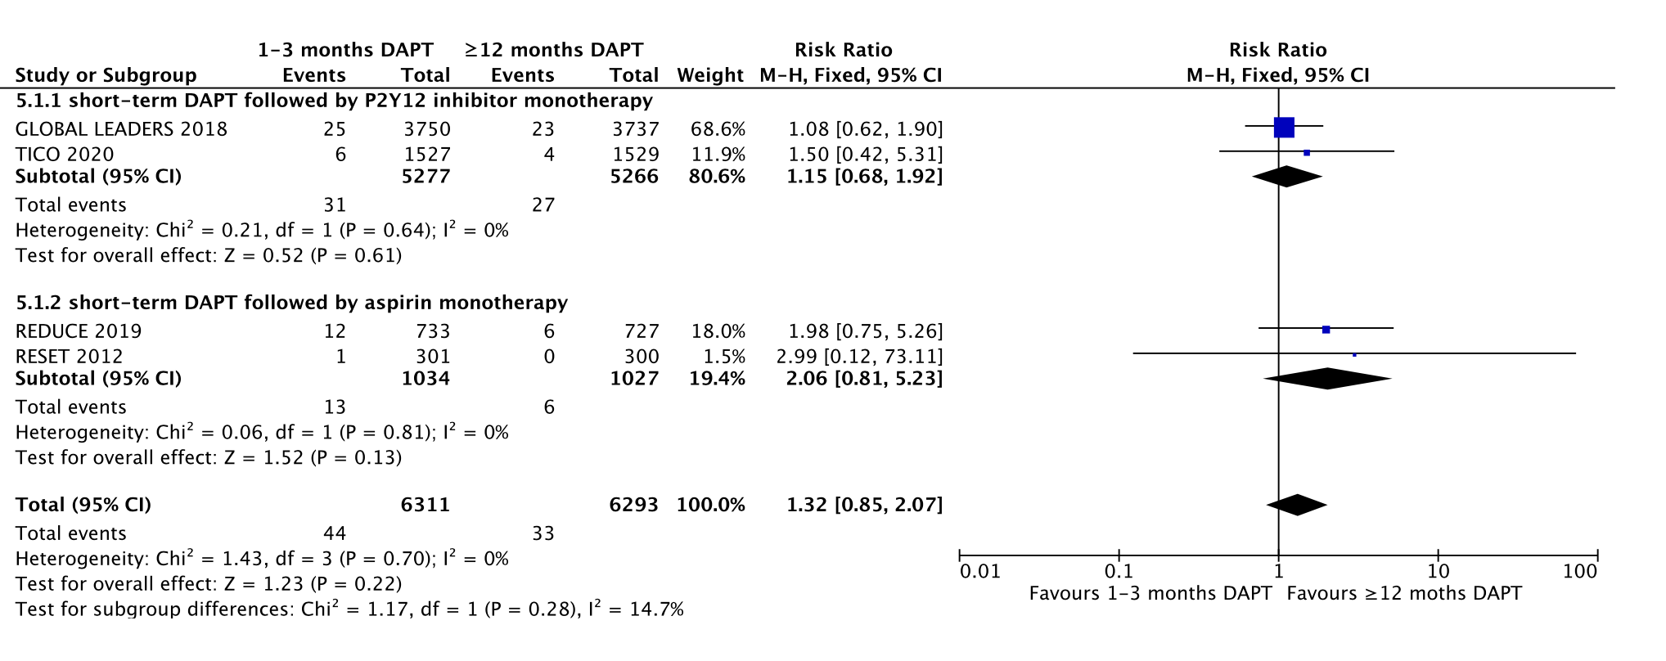
Supplemental Figure S2. The forest plot of subgroup analysis for stent thrombosis.

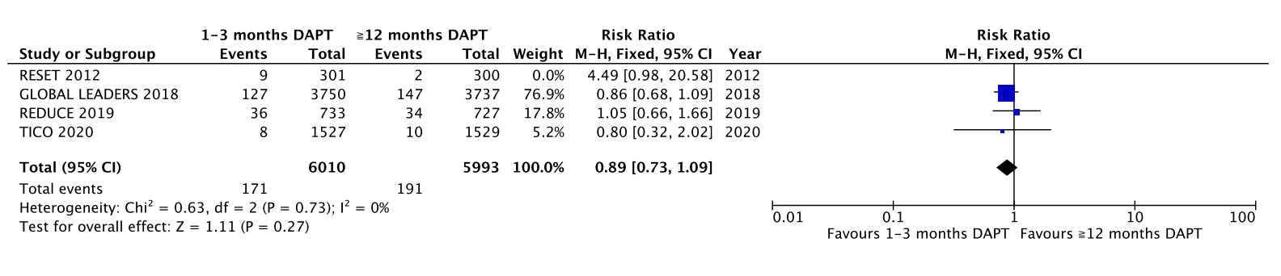

Supplemental Figure S3. The forest plot of target vessel revascularization after excluded the RESET trial.

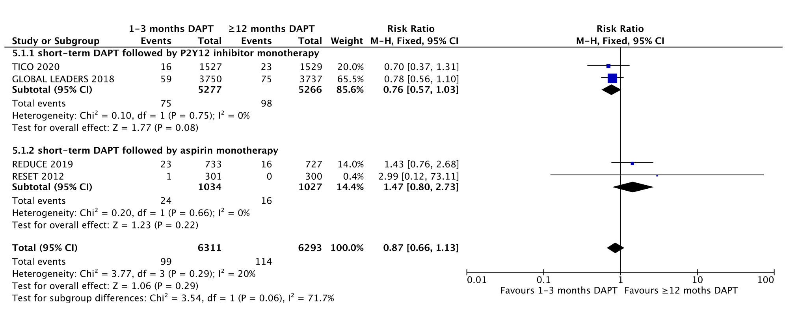
Supplemental Figure S4. The forest plot of subgroup analysis for all-cause death.

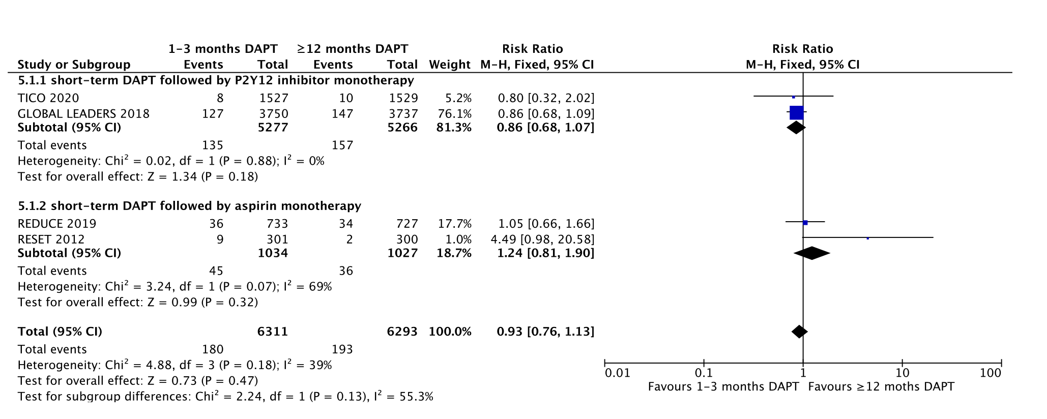

Supplemental Figure S5. The forest plot of subgroup analysis for stent thrombosis.

A B
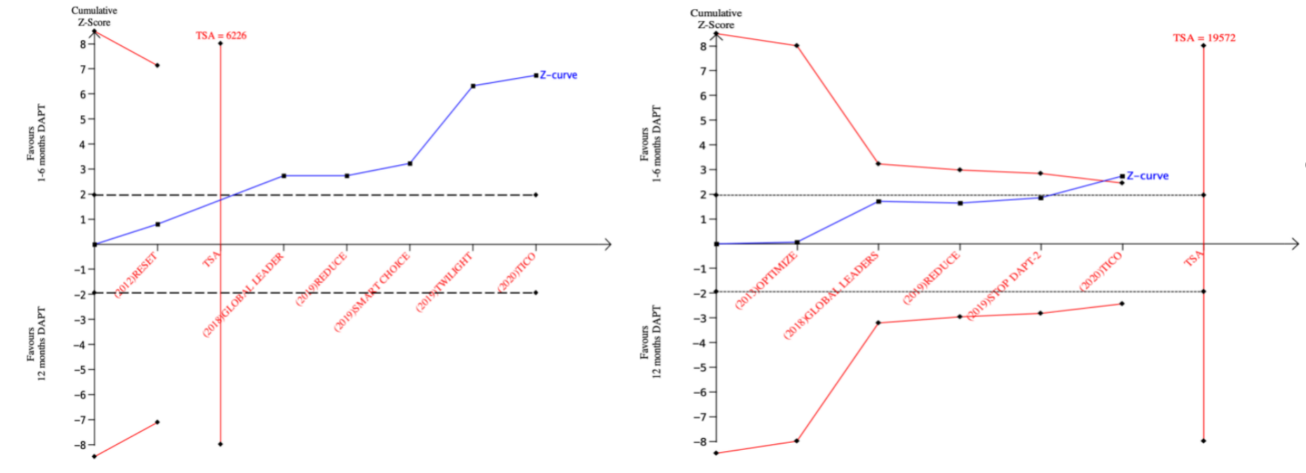
C D
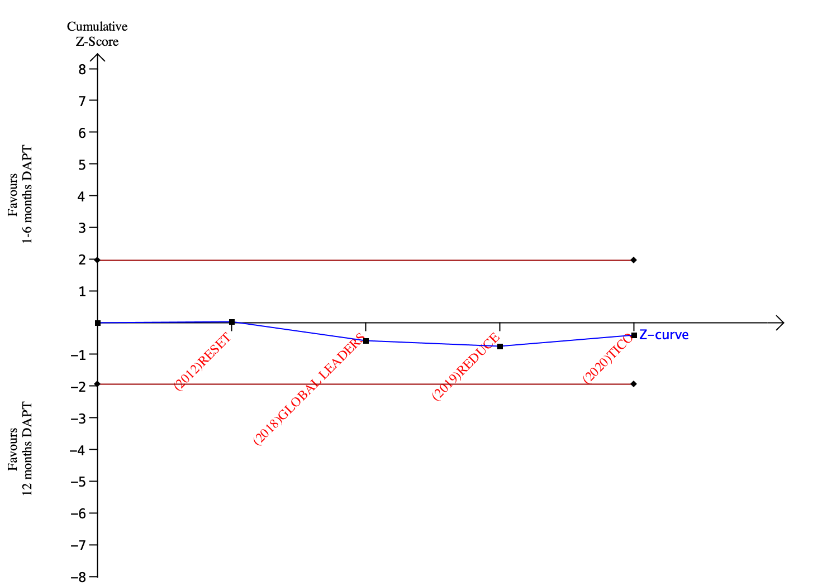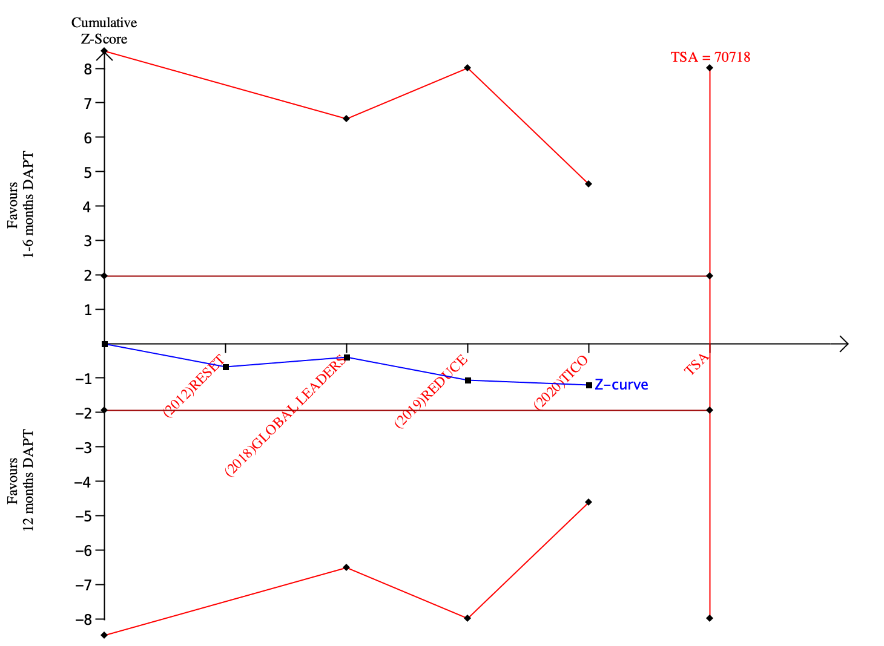
E F
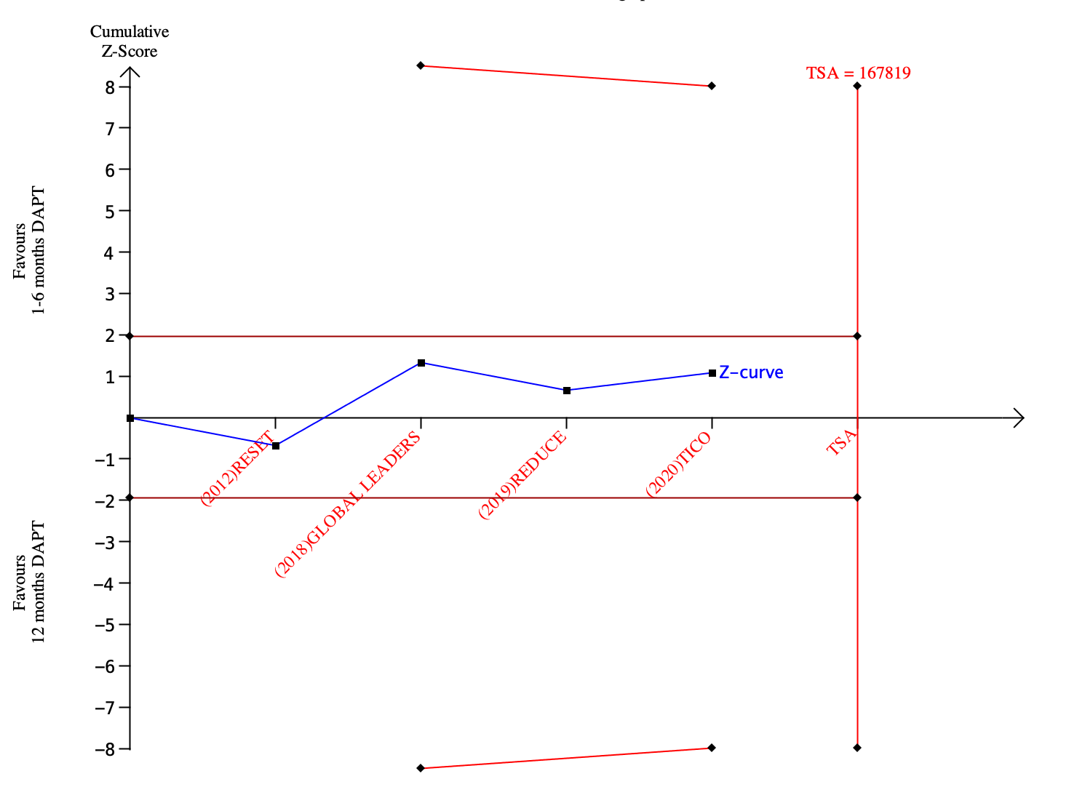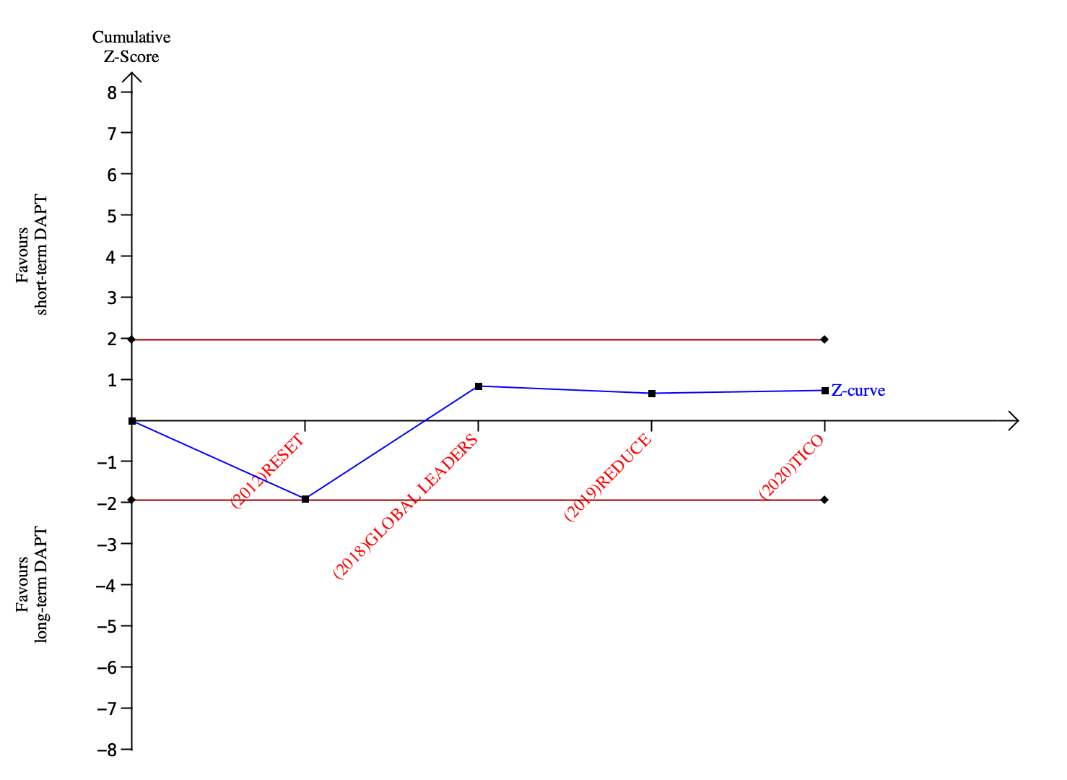

Supplemental Figure S6. The results of TSA between short-term and long-term DAPT groups. (A) major bleeding, (B) NACCE, (C) myocardial infarction, (D) stent thrombosis, (E) all-cause death, (F) target vessel revascularization.

Supplemental Figure S7. Bias risk assessment of the studies.

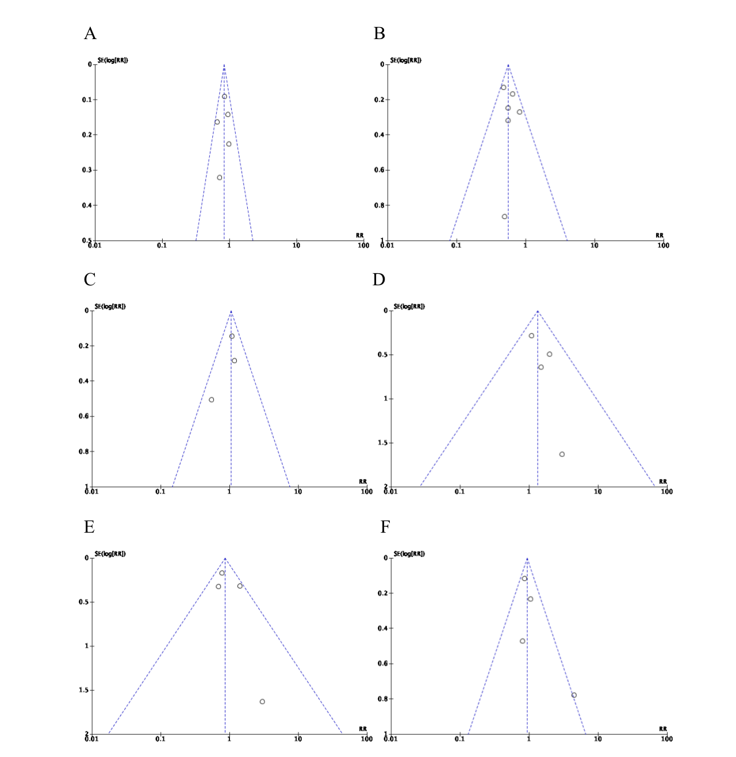

Supplemental Figure S8. The funnel plots of each outcome. (A) NACCE, (B) major bleeding, (C) myocardial infraction, (D) stent thrombosis, (E) all-cause mortality, (F) target vessel revascularization.

