Figures S3. Funnel plot of the meta-analysis of prevalence estimates of anxiety, depression, trauma-related and sleep disorders in health-care workers during COVID-19 pandemic (studies of quality 4 and 5)
Each plotted point represents the standard error and the prevalence estimate for a single study. The triangle represents the region where 95% of the data points would lie in the absence of a publication bias and heterogeneity. The vertical line represents the average prevalence estimate found in the meta-analysis.

A. Anxiety
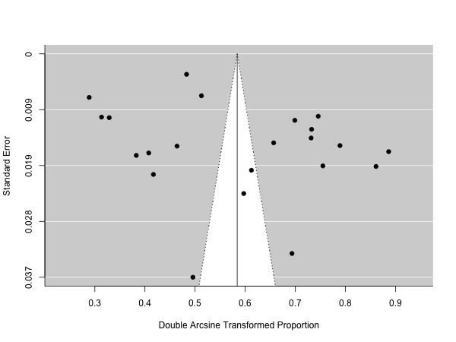

B. Depression and depressive symptoms
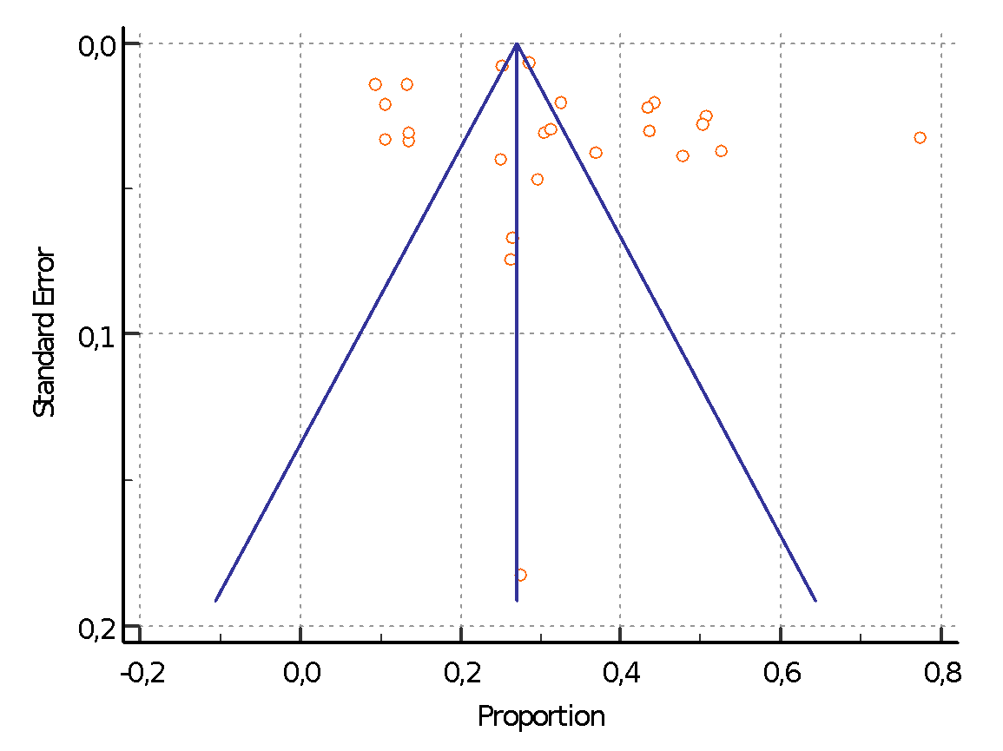

C. Trauma-related disorders
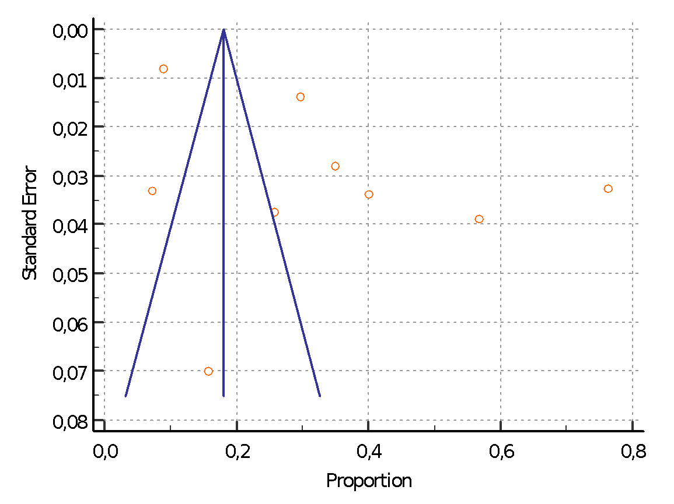
D. Sleep disorders
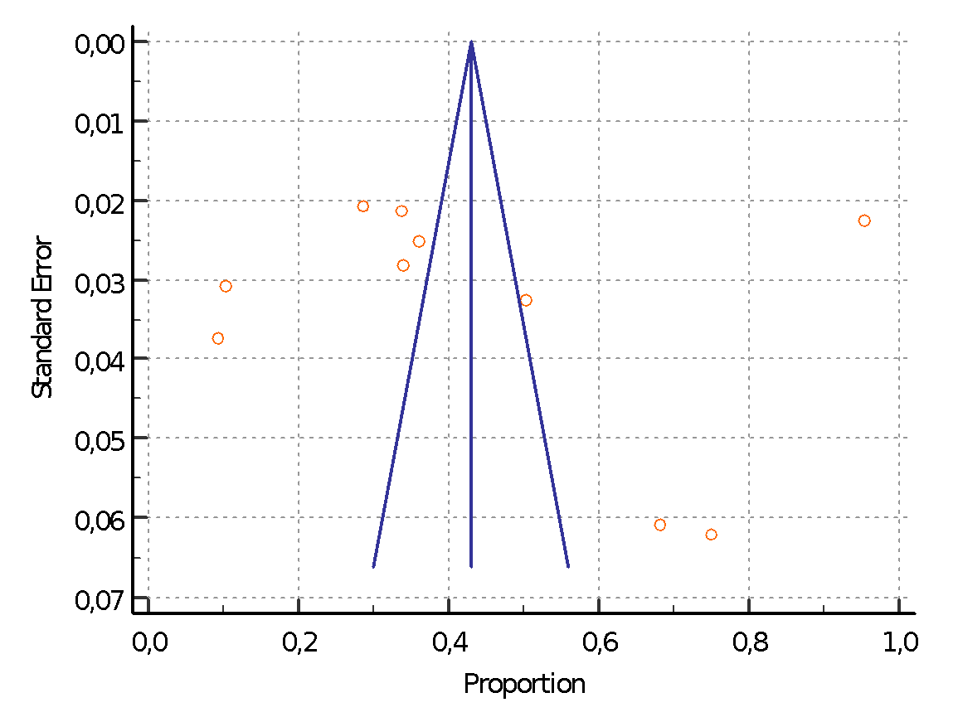

Figures S4: additional analyses

Subgroup analyses and metaregressions were done according to the following variables:
- quality of the study (see quality assessment paragraph, methods, in main manuscript).
- country (China, rest of Asia, Europe, USA, Africa). China was considered separately due to a lack of representation of other countries compared to China in previous studies.
- gender (female vs male).
- profession (nurses vs others).
- scale (most used scales in our samples of studies vs others).
- sample size.

A. Anxiety - supplementary materials - quality 4 & 5

Meta-Regression (% female)

Metric: Freeman-Tukey Double Arcsine Proportion

Model Results

Covariate Coefficients Lower bound Upper bound Std. error p-Value

Intercept 0.646 0.254 1.038 0.200 0.001

Porportion Female -0.081 -0.590 0.427 0.260 0.754

Omnibus p-Value : 0.754

Meta-Regression (% nurses)

Metric: Freeman-Tukey Double Arcsine Proportion

Model Results

Covariate Coefficients Lower bound Upper bound Std. error p-Value

Intercept 0.577 0.425 0.729 0.077 < 0.001

NurseProp 0.012 -0.225 0.249 0.121 0.919

Omnibus p-Value : 0.19

Subgroup analysis (quality 4 vs quality 5)

Binary Random-Effects Model

Metric: Proportion

Model Results

Subgroups Studies Estimate Lower bound Upper bound Std. error p-Val z-Val

Subgroup 4 14 0.315 0.224 0.406 0.046 < 0.001 6.779

Subgroup 5 8 0.318 0.250 0.387 0.035 < 0.001 9.085

Overall 22 0.316 0.260 0.372 0.029 < 0.001 10.970

Heterogeneity

Studies Q (df) Het. p-Val I^2

Subgroup 4 3639.515 (13) < 0.001 99,64 %

Subgroup 5 978.389 (7) < 0.001 99,28 %

Overall 5076.422 (21) < 0.001 99,59 %

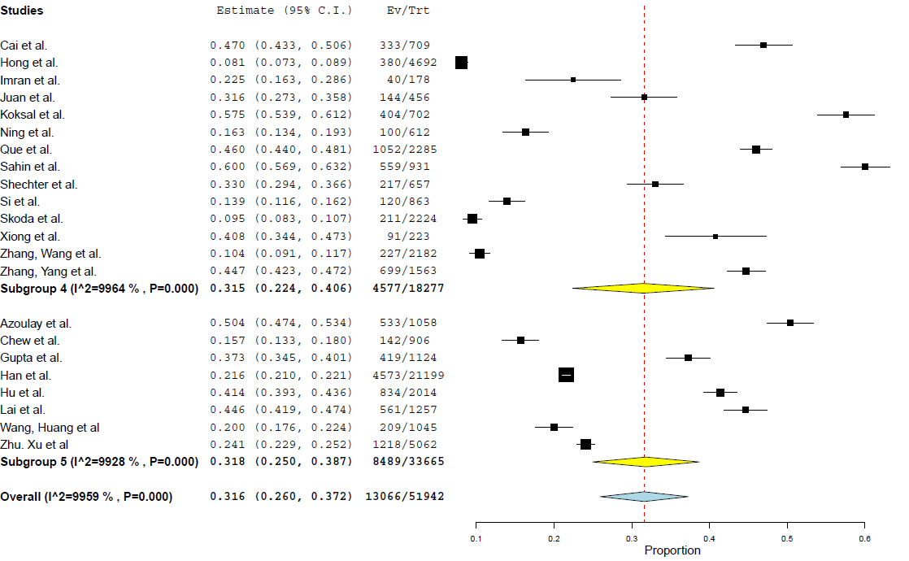

Subgroup analysis (country)

Binary Random-Effects Model

Metric: Proportion

Model Results

Subgroups Studies Estimate Lower bound Upper bound Std. error p-Val z-Val

Subgroup 1 14 0.292 0.229 0.356 0.032 < 0.001 9.023

Subgroup 2 5 0.386 0.200 0.573 0.095 < 0.001 4.055

Subgroup 4 1 0.330 0.294 0.366 0.018 NA NA

Subgroup 3 2 0.299 -0.102 0.700 0.204 0.144 1.463

Overall 22 0.316 0.260 0.372 0.029 < 0.001 10.970

Heterogeneity

Studies Q (df) Het. p-Val I^2

Subgroup 1 3189.327 (13) < 0.001 99,59 %

Subgroup 2 660.131 (4) < 0.001 99,39 %

Subgroup 4 NA NA NA

Subgroup 3 608.253 (1) < 0.001 99,84 %

Overall 5076.422 (21) < 0.001 99,59 %

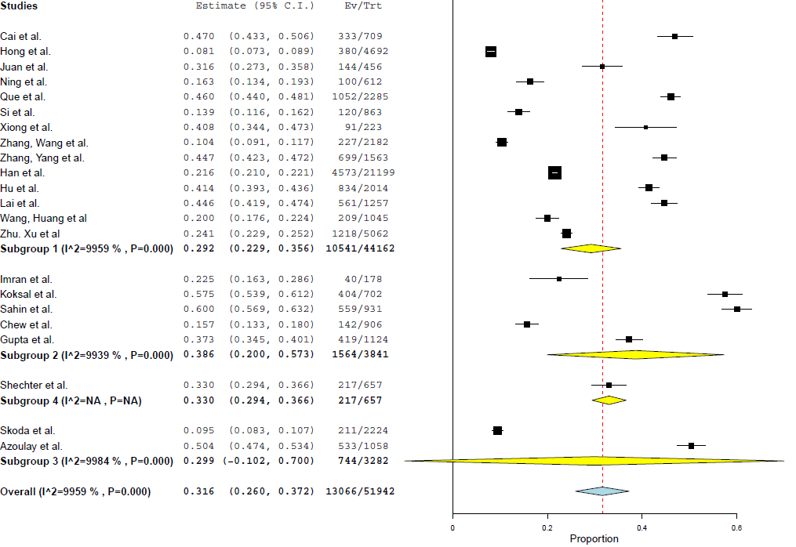

Metaregression (use of GAD-7 vs other scales)

Model Results

Subgroups Studies Estimate Lower bound Upper bound Std. error p-Val z-Val

Subgroup 1 11 0.344 0.240 0.449 0.053 < 0.001 6.445

Subgroup 0 11 0.288 0.218 0.358 0.036 < 0.001 8.068

Overall 22 0.316 0.260 0.372 0.029 < 0.001 10.970

Heterogeneity

Studies Q (df) Het. p-Val I^2

Subgroup 1 3433.284 (10) < 0.001 99,71 %

Subgroup 0 1573.505 (10) < 0.001 99,36 %

Overall 5076.422 (21) < 0.001 99,59 %

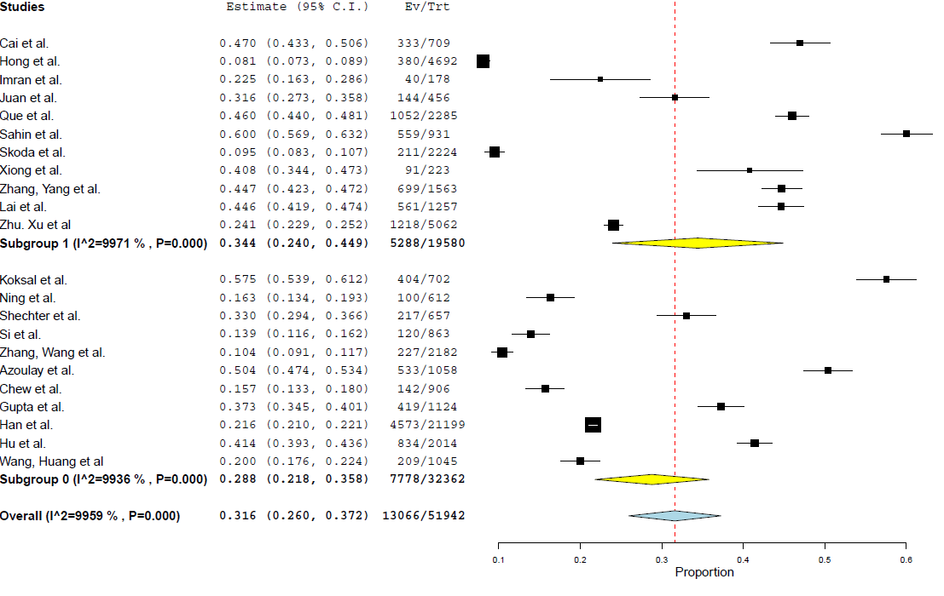

Meta-Regression (sample size)

Metric: Freeman-Tukey Double Arcsine Proportion

Model Results

Covariate Coefficients Lower bound Upper bound Std. error p-Value

Intercept 0.606 0.522 0.689 0.043 < 0.001

sampleSize -0.000 -0.000 0.00 < 0.001 0.296

Omnibus p-Value : 0.296

B. Depression- supplementary materials - quality 4 & 5

Meta-Regression (% female)

Metric: Freeman-Tukey Double Arcsine Proportion

Model Results

Covariate Coefficients Lower bound Upper bound Std. error p-Value

Intercept 0.594 0.252 0.936 0.174 < 0.001

ProportionFemale -0.002 -0.453 0.450 0.230 0.994

Omnibus p-Value : 0.994

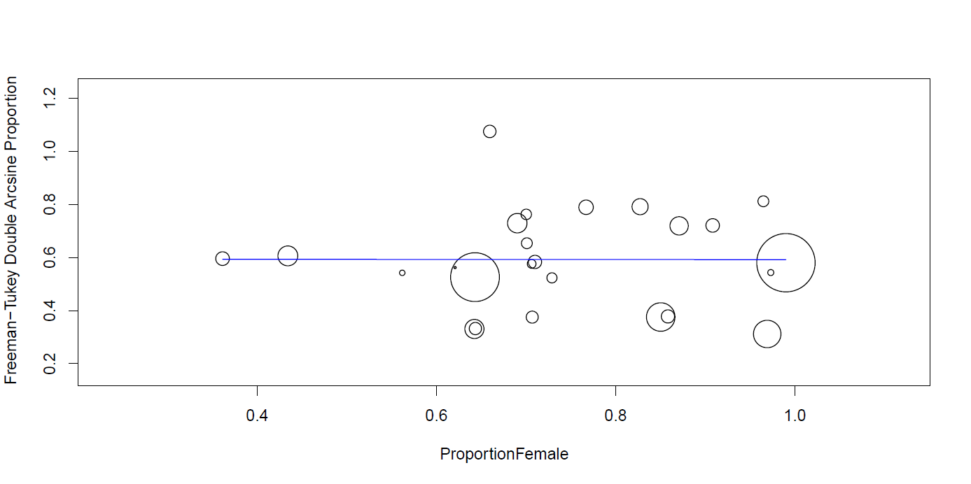

Meta-Regression (% nurses)

Metric: Freeman-Tukey Double Arcsine Proportion

Model Results

Covariate Coefficients Lower bound Upper bound Std. error p-Value

Intercept 0.582 0.450 0.714 0.067 < 0.001

ProportionNurse 0.020 -0.189 0.228 0.106 0.854

Omnibus p-Value : 0.854

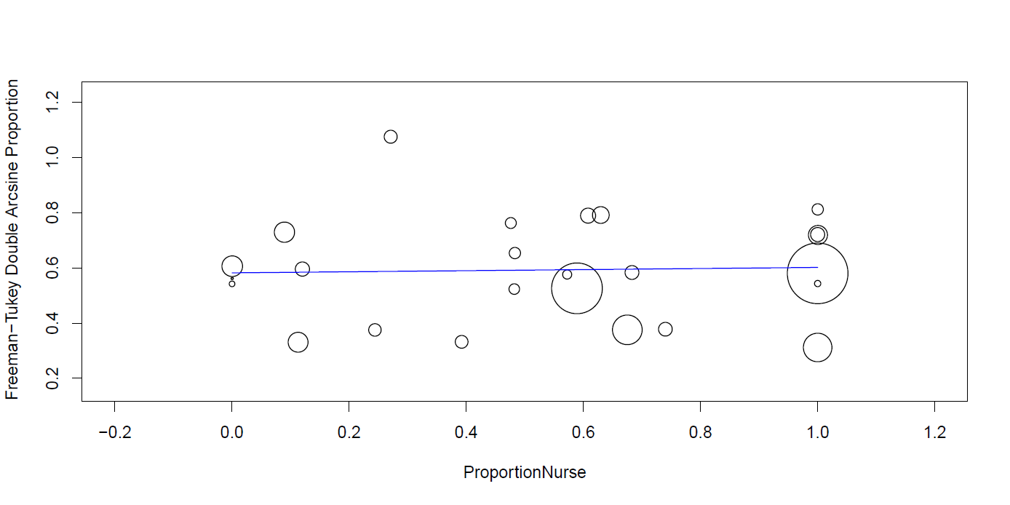

Meta-Regression (country type & scale)

Metric: Freeman-Tukey Double Arcsine Proportion

Model Results

Covariate Level Studies Coefficients Lower bound Upper bound Std. error p-Value

Intercept 0.588 0.493 0.683 0.048 < 0.001

quality 4 17

5 8 -0.069 -0.224 0.085 0.079 0.378

Location 1 17

2 6 0.070 -0.092 0.232 0.083 0.398

3 1 0.066 -0.300 0.432 0.187 0.725

4 1 0.177 -0.177 0.530 0.180 0.328

Omnibus p-Value: 0.650

Subgroup analysis (quality 4 vs 5)

Binary Random-Effects Model

Metric: Proportion

Model Results

Subgroups Studies Estimate Lower bound Upper bound Std. error p-Val z-Val

Subgroup 4 17 0.342 0.262 0.422 0.041 < 0.001 8.358

Subgroup 5 8 0.279 0.194 0.364 0.043 < 0.001 6.447

Overall 25 0.322 0.267 0.376 0.028 < 0.001 11.581

Heterogeneity

Studies Q (df) Het. p-Val I^2

Subgroup 4 4738.289 (16) < 0.001 99.66 %

Subgroup 5 1787.056 (7) < 0.001 99.61 %

Overall 6561.569 (24) < 0.001 99.63 %

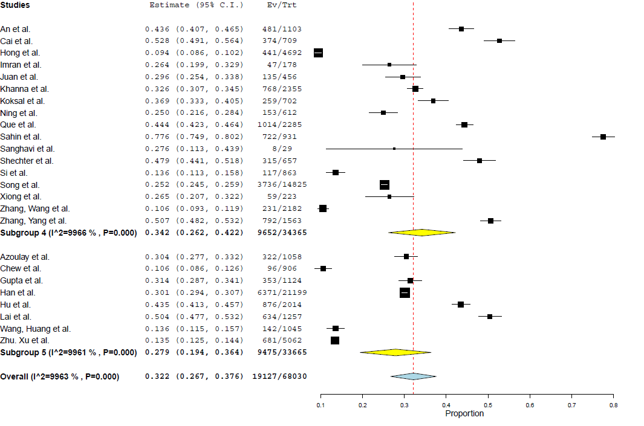

Subgroup analysis (by region)

Binary Random-Effects Model

Metric: Proportion

Model Results

Subgroups Studies Estimate Lower bound Upper bound Std. error p-Val z-Val

Subgroup 1 17 0.300 0.241 0.359 0.030 < 0.001 9.905

Subgroup 2 6 0.359 0.167 0.551 0.098 < 0.001 3.664

Subgroup 4 1 0.479 0.441 0.518 0.019 NA NA

Subgroup 3 1 0.304 0.277 0.332 0.014 NA NA

Overall 25 0.322 0.267 0.376 0.028 < 0.001 11.581

Heterogeneity

Studies Q (df) Het. p-Val I^2

Subgroup 1 4527.271 (16) < 0.001 99.65 %

Subgroup 2 1550.641 (5) < 0.001 99.68 %

Subgroup 4 NA NA NA

Subgroup 3 NA NA NA

Overall 6561.569 (24) < 0.001 99.63 %

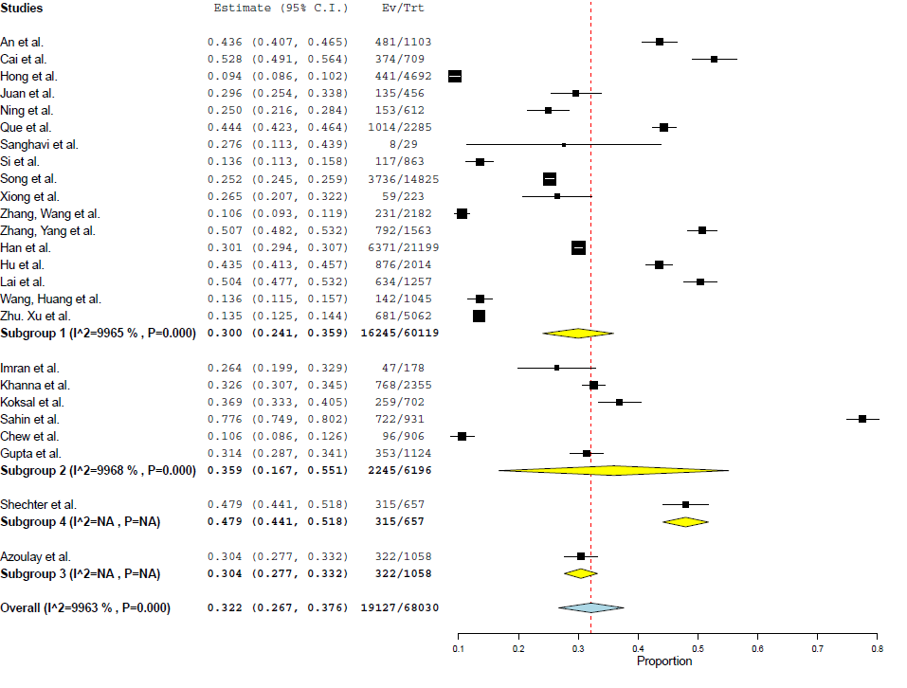

Meta-Regression (sample size)

Metric: Freeman-Tukey Double Arcsine Proportion

Model Results

Covariate Coefficients Lower bound Upper bound Std. error p-Value

Intercept 0.607 0.525 0.688 0.042 < 0.001

SampleSize -0.000 -0.000 0.000 < 0.001 0.499

Omnibus p-Value: 0.499

C - Sleep disorders - supplementary materials - quality 4 & 5

Meta-Regression (% female and % nurses)

Metric: Freeman-Tukey Double Arcsine Proportion

Model Results

Covari Level Studies Coefficients Lower bound Upper bound Std. error p-Value

Intercept 1.788 1.032 2.544 0.386 < 0.001

proportionFemale 2.729 -5.184 -0.273 1.253 0.029

PropNurse 0.606 -0.175 1.386 0.398 0.128

Quality 4 8

5 2 -0.080 -0.240 0.080 0.081 0.326

location 6 1

1 7 0.577 -0.269 1.424 0.432 0.181

2 2 0.758 0.059 1.457 0.357 0.034

Omnibus p-Value: 0.000

Meta-Regression (% women)

Metric: Freeman-Tukey Double Arcsine Proportion

Model Results

Covariate Coefficients Lower bound Upper bound Std. error p-Value

Intercept 1.372 0.961 1.784 0.210 < 0.001

proportionFemale -1.017 -1.568 -0.466 0.281 < 0.001

Omnibus p-Value: 0.000

Meta-Regression (China vs other countries)

Metric: Freeman-Tukey Double Arcsine Proportion

Model Results

Covariate Level Studies Coefficients Lower bound Upper bound Std. error p-Value

Intercept 0.972 0.722 1.222 0.127 < 0.001

location 6 1

1 7 -0.466 -0.732 -0.200 0.136 < 0.001

2 2 -0.057 -0.362 0.248 0.156 0.716

Omnibus p-Value: 0.000

Meta-Regression (% nurses)
Metric: Proportion
Model Results
Covariate Coefficients Lower bound Upper bound Std. error p-Value
Intercept 0.553 0.370 0.735 0.093 < 0.001
PropNurse -0.399 -0.715 -0.083 0.161 0.013
Omnibus p-Value: 0.013

Meta-Regression (sample size)

Metric: Proportion

Model Results

Covariate Coefficients Lower bound Upper bound Std. error p-Value

Intercept 0.557 0.327 0.788 0.118 < 0.001

sampleSize -0.000 -0.000 0.000 < 0.001 0.059

Omnibus p-Value: 0.059

C - PTSD & ASD - supplementary materials - quality 4 & 5

Metaregression (% nurse)

Meta-Regression

Metric: Freeman-Tukey Double Arcsine Proportion

Model Results

Covariate Coefficients Lower bound Upper bound Std. error p-Value

Intercept 0.824 0.479 1.170 0.176 < 0.001

propNurse -0.393 -0.933 0.148 0.276 0.154

Omnibus p-Value: 0.154
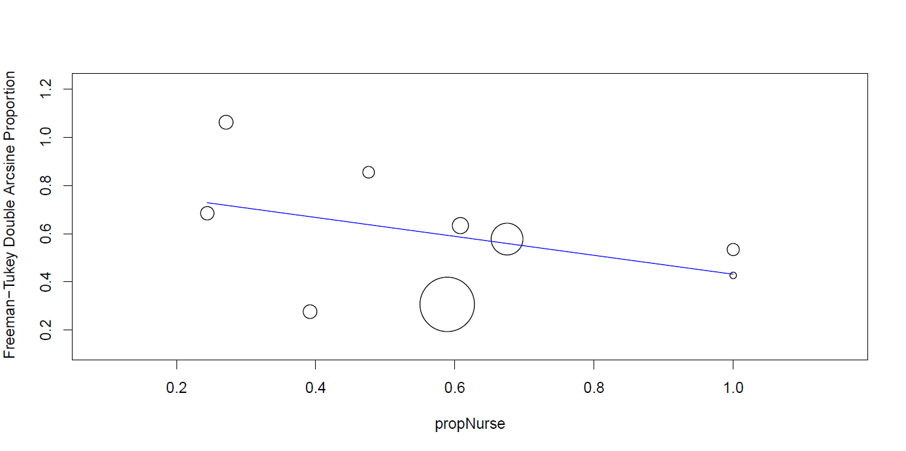

Metaregression (% female)

Metric: Freeman-Tukey Double Arcsine Proportion

Model Results

Covariate Coefficients Lower bound Upper bound Std. error p-Value

Intercept 0.803 -0.278 1.885 0.552 0.145

propFemale -0.275 -1.689 1.139 0.721 0.703

Omnibus p-Value: 0.703
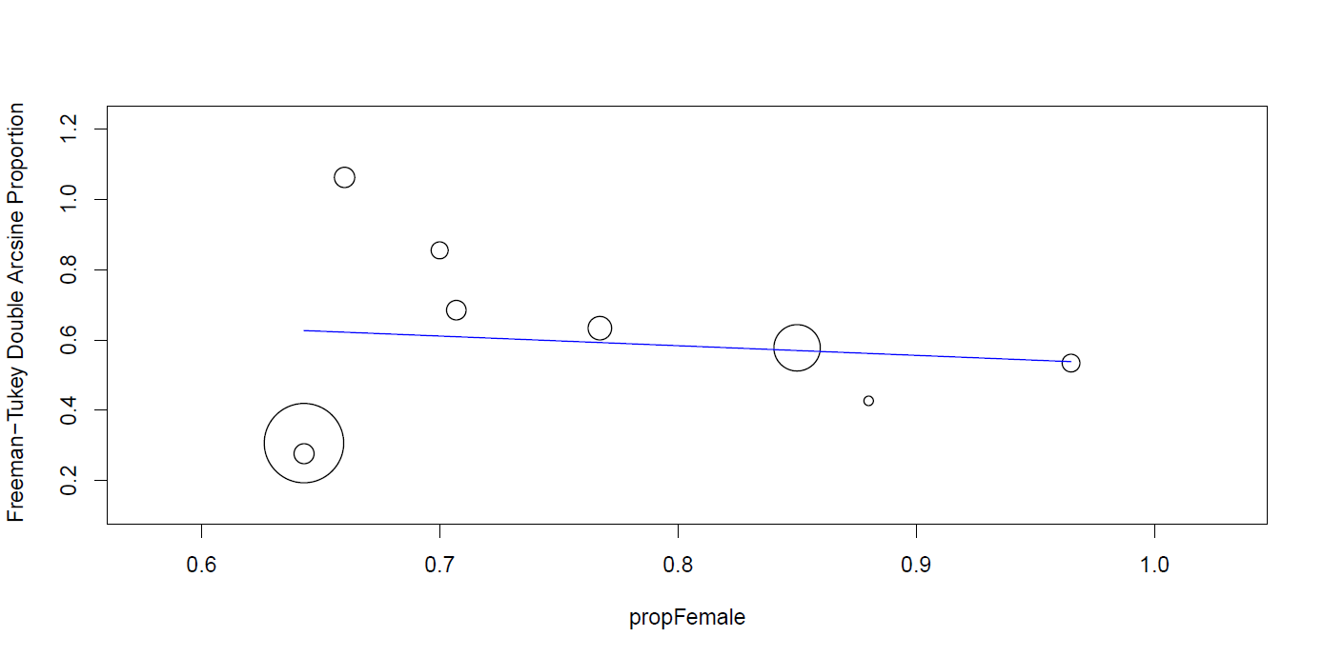

Metaregression (ASD vs PTSD)

Metric: Freeman-Tukey Double Arcsine Proportion

Model Results

Covariate Level Studies Coefficients Lower bound Upper bound Std. error p-Value

Intercept 0.525 0.369 0.680 0.080 < 0.001

DGasd 0 6

1 3 0.334 0.079 0.589 0.130 0.010

location 1 6

2 2 -0.022 -0.277 0.233 0.130 0.866

4 1 0.157 -0.277 0.590 0.221 0.478

Scale 1 6

0 3 -0.161 -0.417 0.095 0.131 0.219

Omnibus p-Value: 0.004

Subgroup analysis (ASD=1)

Binary Random-Effects Model

Metric: Proportion

Model Results

Subgroups Studies Estimate Lower bound Upper bound Std. error p-Val z-Val

Subgroup 0 6 0.215 0.112 0.318 0.053 < 0.001 4.088

Subgroup 1 3 0.561 0.299 0.823 0.134 < 0.001 4.201

Overall 9 0.331 0.198 0.463 0.068 < 0.001 4.884

Heterogeneity

Studies Q (df) Het. p-Val I^2

Subgroup 0 1307.030 (5) < 0.001 9962 %

Subgroup 1 457.307 (2) < 0.001 9956 %

Overall 4132.293 (8) < 0.001 9981 %

Forest plot subgroup ASD vs PTSD
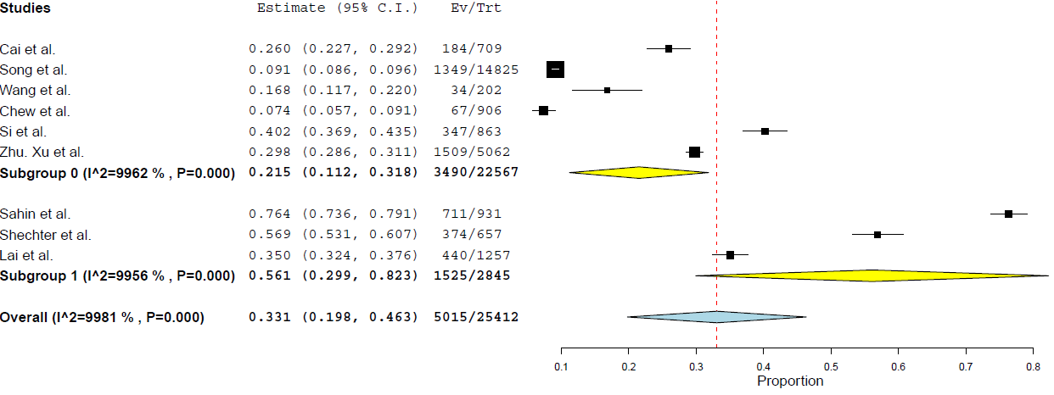
Forest plot ASD & PTSD, all studies
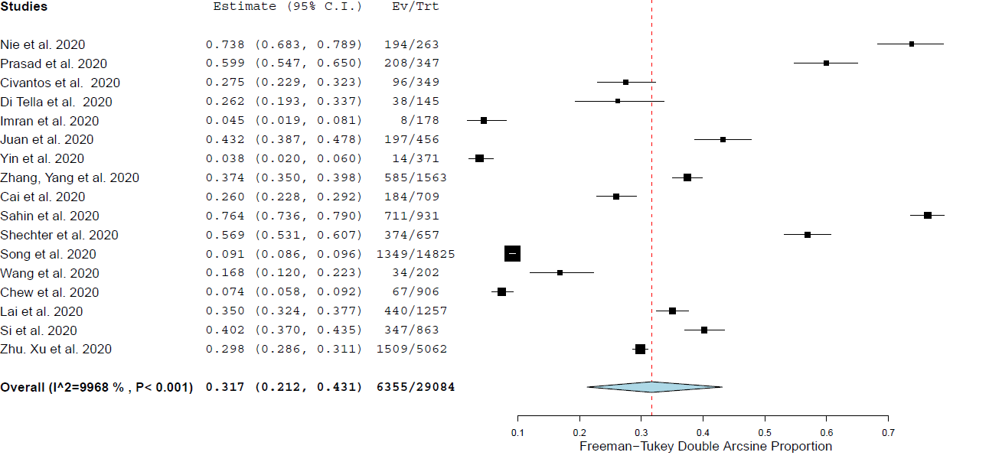

Metaregression (sample size)

Metric: Proportion

Model Results

Covariate Coefficients Lower bound Upper bound Std. error p-Value

Intercept 0.384 0.234 0.535 0.077 < 0.001

SampleSize -0.000 -0.000 0.000 < 0.001 0.191

Omnibus p-Value : 0.191

E. Time effect (studies quality ≥ 4/5)

Anxiety
 | All studies |  | China
 | January-February | March-May | January-February | March-May
Number of studies | 12 | 8 | 12 | 1
Estimate | 0.321 | 0.351 | 0.321 | 0.104
Lower bound | 0.249 | 0.208 | 0.249 | 0.091
Upper bound | 0.393 | 0.493 | 0.393 | 0.117

Depression
 | All studies |  | China
 | January-February | March-May | January-February | March-May
Number of studies | 12 | 10 | 12 | 3
Estimate | 0.324 | 0.366 | 0.324 | 0.272
Lower bound | 0.242 | 0.230 | 0.242 | 0.007
Upper bound | 0.406 | 0.502 | 0.406 | 0.538

Sleep
 | All studies |  | China
 | January-February | March-May | January-February | March-May
Number of studies | 6 | 4 | 6 | 1
Estimate | 0.228 | 0.568 | 0.228 | 0.339
Lower bound | 0.139 | 0.384 | 0.139 | 0.319
Upper bound | 0.317 | 0.752 | 0.317 | 0.359

