Journal of Neuro-Oncology Supplementary Material

Association of Extent of Resection and Functional Outcomes in Diffuse Low-Grade Glioma: Systematic Review & Meta-Analysis

Mustafa Elsheikh¹, Elsie Bridgman¹, Jose Pedro Lavrador², Simon Lammy¹, Michael Tin Chung Poon^{3,4}

1 - Department of Neurosurgery, Institute of Neurological Sciences, Queen Elizabeth University Hospital, Glasgow, United Kingdom
2 - Department of Neurosurgery, King’s College Hospital, King's College Hospital NHS Foundation Trust, London, United Kingdom
3 – Centre for Medical Informatics, Usher Institute, University of Edinburgh, Edinburgh, UK
4 – Department of Clinical Neurosciences, Royal Infirmary of Edinburgh, Edinburgh, UK

Corresponding Author:
Michael Poon, PhD, Department of Clinical Neurosciences, Royal Infirmary of Edinburgh, 50 Little France Crescent, Edinburgh BioQuarter, Edinburgh, EH16 4SB, UK michael.poon@ed.ac.uk

1 | ((diffuse astrocytoma) OR oligodendroglioma OR (pleomorphic xanthoastrocytoma) OR (chordoid glioma of third ventricle)).mp
2 | ((grade adj2 II) OR (grade adj2 2) OR (low adj2 grade) OR low-grade OR diffuse).mp AND (glioma* OR astrocytoma* OR oligoastrocytoma*).mp
3 | surgery.fs OR exp surgical procedures, operative/ OR exp neurosurgery/ OR ((surg* adj2 resec*) OR craniotomy* OR debulk* OR excis* OR resec*).mp
4 | ((extent adj3 of adj3 resection) OR eor OR supratotal OR (gross adj3 total) OR gross-total OR sub?total).mp
5 | exp quality of life/ OR ((quality adj4 life) OR QoL OR HRQoL OR (health adj3 related adj3 quality) OR (health-related adj3 quality) OR (functional adj3 outcome) OR (EORTC adj2 QLQ-BN20) OR (EORTC adj2 QLQ-C30) OR SF?36 OR FACT-Br OR WHO?QOL* OR EuroQoL OR EuroQol-5D OR EQ?5D* OR SEIQoL* OR SQoL OR SQLP OR (Sintonen adj2 15D) OR NHP).mp OR exp return to work/ OR exp neuropsychological test/ OR exp cognitive dysfunction/
6 | (1 OR 2) AND (3 OR 4) AND 5
7 | Review/ OR Comment/ OR Editorial/
8 | 6 NOT 7

Table 1.1 - MEDLINE Search Strategy

1 | ((diffuse astrocytoma) OR oligodendroglioma OR (pleomorphic xanthoastrocytoma) OR (chordoid glioma of third ventricle)).mp
2 | ((grade adj2 II) OR (grade adj2 2) OR (low adj2 grade) OR low-grade OR diffuse).mp AND (glioma* OR astrocytoma* OR oligoastrocytoma*).mp
3 | surgery.fs OR exp surgical procedures, operative/ OR exp neurosurgery/ OR ((surg* adj2 resec*) OR craniotomy* OR debulk* OR excis* OR resec*).mp
4 | ((extent adj3 of adj3 resection) OR eor OR supratotal OR (gross adj3 total) OR gross-total OR sub?total).mp
5 | exp quality of life/ OR ((quality adj4 life) OR QoL OR HRQoL OR (health adj3 related adj3 quality) OR (health-related adj3 quality) OR (functional adj3 outcome) OR (EORTC adj2 QLQ-BN20) OR (EORTC adj2 QLQ-C30) OR SF?36 OR FACT-Br OR WHO?QOL* OR EuroQoL OR EuroQol-5D OR EQ?5D* OR SEIQoL* OR SQoL OR SQLP OR (Sintonen adj2 15D) OR NHP).mp OR exp return to work/ OR exp Work resumption/ OR exp neuropsychological test/ OR exp cognitive defect/
6 | (1 OR 2) AND (3 OR 4) AND 5
7 | Review/ OR Comment/ OR Editorial/
8 | 6 NOT 7

Table 1.2 - EMBASE Search Strategy

1 | ((diffuse astrocytoma) OR oligodendroglioma OR (pleomorphic xanthoastrocytoma) OR (chordoid glioma of third ventricle))
2 | ((grade adj2 II) OR (grade adj2 2) OR (low adj2 grade) OR low-grade OR diffuse) AND (glioma* OR astrocytoma* OR oligoastrocytoma*)
3 | surgery.fs OR ((surg* adj2 resec*) OR craniotomy* OR debulk* OR excis* OR resec*
4 | MeSH descriptor: [Surgical Procedures, Operative] explode all trees
5 | MeSH descriptor: [Neurosurgery] explode all trees
6 | ((extent adj3 of adj3 resection) OR eor OR supratotal OR (gross adj3 total) OR gross-total OR sub?total).mp
7 | MeSH descriptor: [Quality of Life] explode all trees
8 | ((quality adj4 life) OR QoL OR HRQoL OR (health adj3 related adj3 quality) OR (health-related adj3 quality) OR (functional adj3 outcome) OR (EORTC adj2 QLQ-BN20) OR (EORTC adj2 QLQ-C30) OR SF?36 OR FACT-Br OR WHO?QOL* OR EuroQoL OR EuroQol-5D OR EQ?5D* OR SEIQoL* OR SQoL OR SQLP OR (Sintonen adj2 15D) OR NHP).mp
9 | MeSH descriptor: [Return to Work] explode all trees
10 | MeSH descriptor: [Neuropsychological Tests] explode all trees
11 | MeSH descriptor: [Cognitive Dysfunction] explode all trees
12 | (#1 OR #2) AND (#3 OR #4 OR #5 OR #6) AND (#7 OR #8 OR #9 OR #10 OR #11)

Table 1.3 - CENTRAL Search Strategy

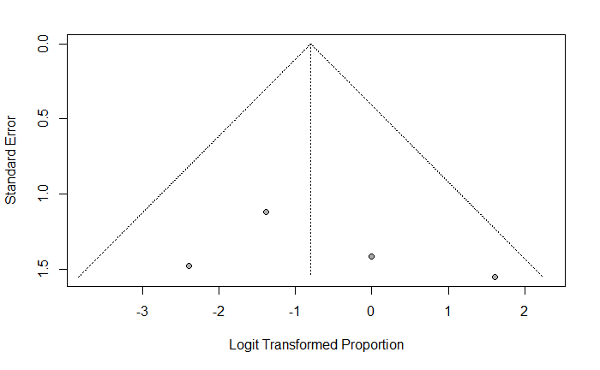Figure 3.1 - Funnel plot depiction of meta-analysis of proportion of patients who returned to work within 12 months following partial resection of DLGG

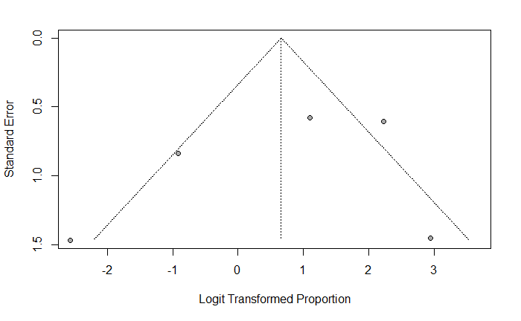Figure 3.2 - Funnel plot depiction of meta-analysis of proportion of patients who returned to work within 12 months following sub-total resection of DLGG
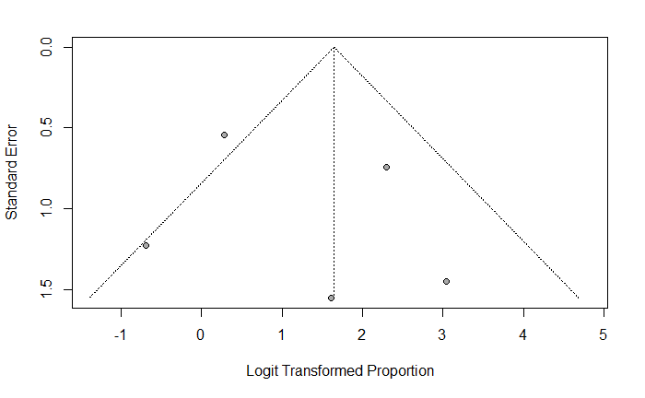Figure 3.3 - Funnel plot depiction of meta-analysis of proportion of patients who returned to work within 12 months following gross total resection of DLGG

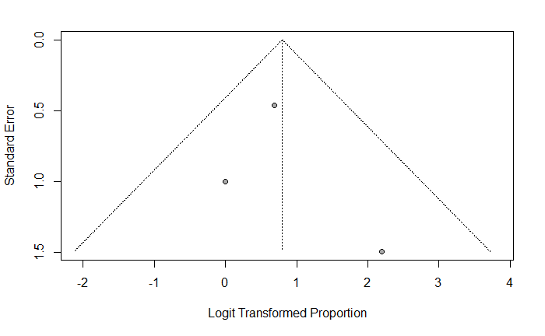

Figure 3.4 – Funnel plot depiction of meta-analysis of proportion of patients who returned to work within 12 months following supratotal resection of DLGG

