The effect of remotely-delivered lifestyle interventions on cognition in older adults without dementia: a systematic review and meta-analysis

Supplementary Materials

Supplementary Method
Statistical analyses (calculation of effect sizes)
The measure of effect size was the standardized mean difference, with approximate correction factor J (referred to as ‘c_{P}’ in the formula below) applied for small sample sizes, to yield Hedges’ g. In the main paper, the effect size g (as well as its variance) were calculated as per the formula presented for d_{ppc2} (here, ‘ppc’ refers to the intended use of this effect size measure in pretest-posttest-control studies) in Morris (2007). In the following series of equations, the following nomenclature is used:

Operator | Definition
M | Mean score on a cognitive test outcome
_{T} | Treatment group
_{C} | Comparator group
_{Post} | Immediately post-intervention
_{Pre} | Prior to intervention (i.e. baseline)
n | Number of participants in a group
ρ | Correlation between M_{pre} and M_{post}
c_{P} | Approximate common small sample bias adjustment
SD | Standard deviation
△ | Effect size

The effect size formula for d_{ppc2} follows equation (8) in Morris (2007):

$$d_{ppc2}=c_{P} \left[\frac{\left(M_{post,T}-M_{pre,T}\right)-(M_{post,C}-M_{pre,C})}{{SD}_{pre}}\right]$$

Where the pooled standard deviation is defined as equation (9):

$${SD}_{pre}= \sqrt{\frac{\left(n_{T}-1\right){SD}_{pre,T}^{2}+(n_{C}-1){SD}_{pre,C}^{2}}{n_{T}-n_{C}-2}}$$

And the small sample bias adjustment is defined according to equation (10):

$$c_{P}=1-\frac{3}{4\left(n_{T}+ n_{C}-2\right)-1}$$

The variance of d_{ppc2} is given by equation (25):

$$σ^{2}\left(d_{ppc2}\right)=2\left(c_{P}^{2}\right)\left(1-ρ\right)\left(\frac{n_{T}+ n_{C}}{n_{T} n_{C}}\right)\left(\frac{n_{T}+ n_{C}-2}{n_{T}+ n_{C}-4}\right)\left(1+\frac{△^{2}}{2\left(1-ρ\right)\left(\frac{n_{T}+ n_{C}}{n_{T} n_{C}}\right)}\right)-△^{2}$$

Note, based on convention and empirical observations, ρ (correlation between M_{pre} and M_{post}) was fixed at 0.5 throughout all analyses in the review. In this case:

$$2\left(1-ρ\right)=1$$

and is thus effectively omitted from the employed formula (given its exclusive use as a multiplier of other terms).

Details of excluded effect sizes
Two effect sizes were excluded from the main meta-analysis, as the pattern of changes in the source publication suggested an error in analysis/typesetting. A further two effect sizes were excluded from the main meta-analysis due to their being statistically dependent (i.e. derived) from other effect sizes which were already included. The latter two effect sizes were, however, included in the appropriate subgroup for the analyses of separate cognitive domains, as for these analyses they were independent of other outcomes. Lastly, two congruent Stroop outcomes could not be attributed to any specific domain of cognition, but were included in the main meta-analysis of all outcomes (see Figure S1).

Supplementary tables
Table S1: Meta-analyses for individual cognitive domains
Domain | K (N ES) | ES (g) | 95% CI | d.f. | p-value | Tau² | I²
Executive function | 6 (23) | 0.03 | [-0.11, 0.17] | 2.7* | * | 0.01 | 30.07
Episodic memory | 8 (18#) | -0.02 | [-0.31, 0.27] | 5.3 | .843 | 0.06 | 56.44
Attention | 6 (12) | 0.07 | [-0.24, 0.38] | 3.4* | * | 0.01 | 8.69
Cognitive screening | 5 (7#) | -0.12 | [-0.47, 0.24] | 3.3* | * | 0.06 | 67.93
Construction | 2 (3) | 0.14 | [-1.15, 1.44] | 1* | * | 0.00 | 0.00
Effect sizes operate so that positive values indicate improvement; The availability of a single relevant effect size precluded meta-analysis of the ‘Perception’ domain; Number of studies (K); Effect size (ES); Hedges’ Standardized Mean Difference (g); Confidence interval (CI); Degrees of freedom (d.f.); Between-study variance (Tau²); Proportion of observed dispersion due to real variation in effect sizes (I²); * = where d.f. < 4, p-values are unreliable, and are thus not reported here; # = including one effect size not included in the ‘Overall’ meta-analysis.

Supplementary figures
Figure S1: Full forest plot visualizing robust variance estimation model for all studies and outcomes (grouped by intervention type)
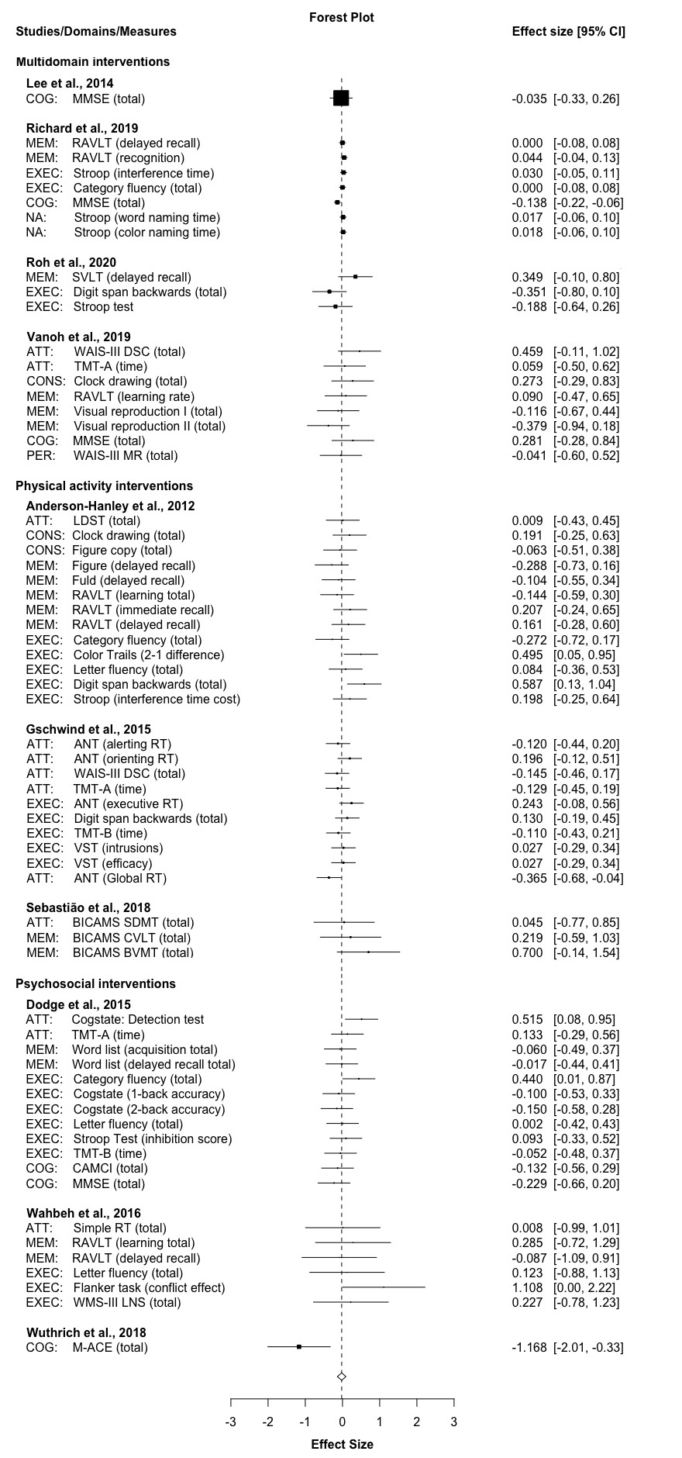
Forest plot created using the ‘robumeta’ package in R, presenting all 64 effect sizes (g) from ten studies (g = -0.02; 95% CI [-0.14, 0.09]; p = .66; see main paper Table 3 for additional model details); Attention (ATT); Attention network test (ANT); Brief international cognitive assessment for multiple sclerosis (BICAMS); Brief visuospatial memory test (BVMT); California verbal learning test (CVLT); Cognitive screening (COG); Computer assessment of mild cognitive impairment (CAMCI); Confidence interval (CI); Construction (CONS); Episodic memory (MEM); Executive function (EXEC); Letter digit substitution test (LDST); Matrix reasoning (MR); Mini-Addenbrooke’s Cognitive Examination (M-ACE); Mini-mental state examination (MMSE); Not applicable (NA); Perception (PER); Reaction time (RT); Rey auditory verbal learning test (RAVLT); Seoul verbal learning test (SVLT); Symbol digit modalities test (SDMT); Trail-making test part A (TMT-A); Trail-making test part B (TMT-B); Victoria Stroop test (VST); Weschler adult intelligence scale-III (WAIS-III); Weschler memory scale-III Letter number sequencing (WMS-III LNS).
Figure S2: Cochrane risk of bias tool 2 summary figure (Sterne et al., 2019)
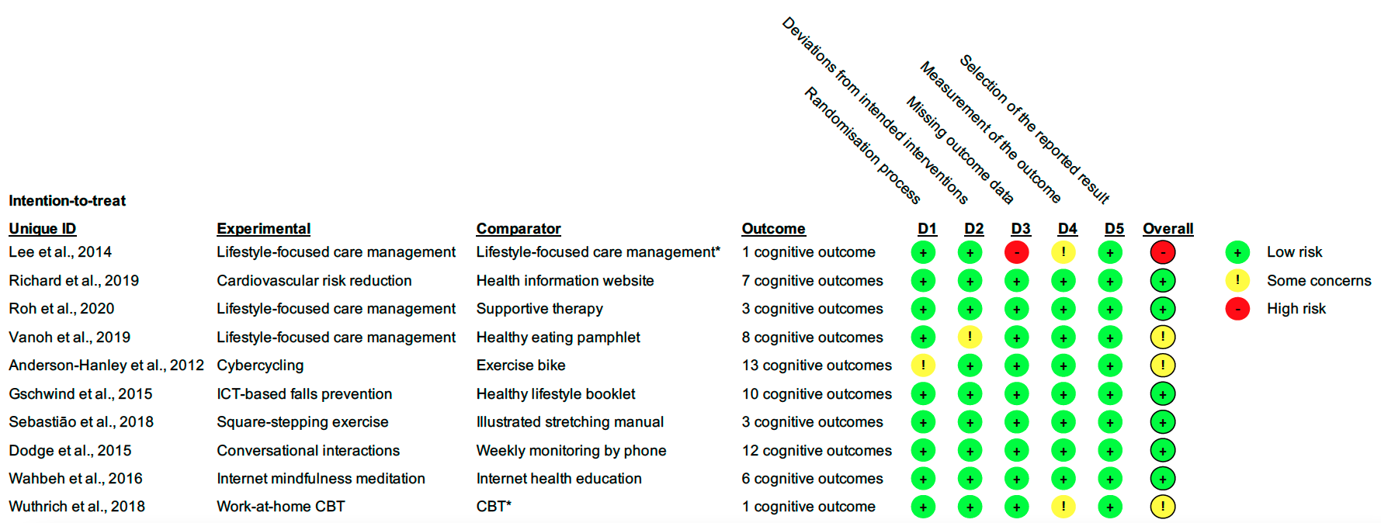
Information and communications technologies (ICT); Cognitive behavioral therapy (CBT); * = Face-to-face comparator.

References
Anderson-Hanley, C., Arciero, P. J., Brickman, A. M., Nimon, J. P., Okuma, N., Westen, S. C., Merz, M. E., Pence, B. D., Woods, J. A., Kramer, A. F., & Zimmerman, E. A. (2012, Feb). Exergaming and older adult cognition: a cluster randomized clinical trial. Am J Prev Med, 42(2), 109-119. https://doi.org/10.1016/j.amepre.2011.10.016

Dodge, H. H., Zhu, J., Mattek, N. C., Bowman, M., Ybarra, O., Wild, K. V., Loewenstein, D. A., & Kaye, J. A. (2015, 2015/06/01). Web-enabled conversational interactions as a method to improve cognitive functions: Results of a 6-week randomized controlled trial [https://doi.org/10.1016/j.trci.2015.01.001]. Alzheimer's & Dementia: Translational Research & Clinical Interventions, 1(1), 1-12. https://doi.org/https://doi.org/10.1016/j.trci.2015.01.001

Gschwind, Y. J., Eichberg, S., Ejupi, A., de Rosario, H., Kroll, M., Marston, H. R., Drobics, M., Annegarn, J., Wieching, R., Lord, S. R., Aal, K., Vaziri, D., Woodbury, A., Fink, D., & Delbaere, K. (2015). ICT-based system to predict and prevent falls (iStoppFalls): results from an international multicenter randomized controlled trial. European review of aging and physical activity : official journal of the European Group for Research into Elderly and Physical Activity, 12, 10-10. https://doi.org/10.1186/s11556-015-0155-6

Lee, K. S., Lee, Y., Back, J. H., Son, S. J., Choi, S. H., Chung, Y. K., Lim, K. Y., Noh, J. S., Koh, S. H., Oh, B. H., & Hong, C. H. (2014). Effects of a multidomain lifestyle modification on cognitive function in older adults: an eighteen-month community-based cluster randomized controlled trial. Psychother Psychosom, 83(5), 270-278. https://doi.org/10.1159/000360820

Morris, S. B. (2007, 2008/04/01). Estimating Effect Sizes From Pretest-Posttest-Control Group Designs. Organizational Research Methods, 11(2), 364-386. https://doi.org/10.1177/1094428106291059

Richard, E., Moll van Charante, E. P., Hoevenaar-Blom, M. P., Coley, N., Barbera, M., van der Groep, A., Meiller, Y., Mangialasche, F., Beishuizen, C. B., Jongstra, S., van Middelaar, T., Van Wanrooij, L. L., Ngandu, T., Guillemont, J., Andrieu, S., Brayne, C., Kivipelto, M., Soininen, H., & Van Gool, W. A. (2019). Healthy ageing through internet counselling in the elderly (HATICE): a multinational, randomised controlled trial. The Lancet Digital Health, 1(8), e424-e434. https://doi.org/10.1016/S2589-7500(19)30153-0

Roh, H. W., Hong, C. H., Lim, H. K., Chang, K. J., Kim, H., Kim, N.-R., Choi, J. W., Lee, K. S., Cho, S.-M., Park, B., & Son, S. J. (2020, 2020/02/15/). A 12-week multidomain intervention for late-life depression: a community-based randomized controlled trial. Journal of Affective Disorders, 263, 437-444. https://doi.org/https://doi.org/10.1016/j.jad.2019.12.013

Sebastião, E., McAuley, E., Shigematsu, R., Adamson, B. C., Bollaert, R. E., & Motl, R. W. (2018, Oct). Home-based, square-stepping exercise program among older adults with multiple sclerosis: results of a feasibility randomized controlled study. Contemp Clin Trials, 73, 136-144. https://doi.org/10.1016/j.cct.2018.09.008

Vanoh, D., Shahar, S., Razali, R., Ali, N. M., Manaf, Z. A., Mohd Noah, S. A., & Nur, A. M. (2019). The Effectiveness of a Web-Based Health Education Tool, WESIHAT 2.0, among Older Adults: A Randomized Controlled Trial. J Alzheimers Dis, 70(s1), S255-s270. https://doi.org/10.3233/jad-180464

Wahbeh, H., Goodrich, E., & Oken, B. S. (2016, Mar-Apr). Internet-based Mindfulness Meditation for Cognition and Mood in Older Adults: A Pilot Study. Altern Ther Health Med, 22(2), 44-53.

Wuthrich, V. M., Rapee, R. M., Draper, B., Brodaty, H., Low, L.-F., & Naismith, S. L. (2019). Reducing risk factors for cognitive decline through psychological interventions: a pilot randomized controlled trial. International Psychogeriatrics, 31(7), 1015-1025. https://doi.org/10.1017/S1041610218001485

