Non-autoimmune Diabetes Mellitus and the Risk of Virus Infections: A Systematic Review and Meta-analysis of case-control and cohort studies

Eric Lontchi-Yimagou, Charly Feutseu, Sebastien Kenmoe, Alexandra Lindsey Djomkam Zune, Solange Fai Kinyuy Ekali, Jean Louis Nguewa, Simeon Pierre Choukem, Jean Claude Mbanya, Jean Francois Gautier, Eugene Sobngwi

Appendix

- Database Search Strategies

PubMed
((((((((((((fulminant diabetes[Title/Abstract]) OR ((((((NIDDM[Title/Abstract]) OR non-autoimmune diabetes[Title/Abstract]) OR ketosis-prone diabetes[Title/Abstract]) OR non-insulin dependent diabetes[Title/Abstract]) OR type 2 diabetes[Title/Abstract]) OR T2DM[Title/Abstract]))) OR non-autoimmune diabetes type 1) OR diabetes mellitus, type 2[MeSH Terms])) AND (((virus diseases[MeSH Terms]) OR viral infection*[Title/Abstract]) OR virus*[Title/Abstract]))) AND ((((((((((((cohort studies[MeSH Terms]) OR cross-sectional studies[MeSH Terms]) OR case-control studies[MeSH Terms]) OR randomized controlled trial[Publication Type])) OR (((((control groups[Title/Abstract]) OR ((case*[Title/Abstract]) AND comparison[Title/Abstract])) OR ((cases[Title/Abstract]) AND controlled[Title/Abstract])) OR ((cases[Title/Abstract]) AND controls[Title/Abstract])) OR ((case[Title/Abstract]) AND control[Title/Abstract]))) OR (((clinical trial[Publication Type]) OR "clinical trials as topic"[MeSH Terms]) OR "double-blind method"[MeSH Terms])) OR ((((randomized[Title/Abstract]) OR randomised[Title/Abstract])) AND ((trial[Title/Abstract]) OR trials[Title/Abstract]))) OR ((control*[Title/Abstract]) AND ((((randomized[Title/Abstract]) OR randomised[Title/Abstract])) AND ((trial[Title/Abstract]) OR trials[Title/Abstract])))) OR ((((blind[Title/Abstract]) OR mask*[Title/Abstract])) AND ((((((single[Title/Abstract]) OR double[Title/Abstract]) OR doubled[Title/Abstract]) OR triple[Title/Abstract]) OR tripled[Title/Abstract]) OR treble[Title/Abstract])))) OR ((systematic review[Title/Abstract]) OR meta-analysis[Title/Abstract])))) AND english[Language])) NOT "Case Reports"[Publication Type]

Embase
('non insulin dependent diabetes mellitus'/exp OR 'non-insulin dependent diabetes':ab,ti OR 'ketosis prone diabetes':ab,ti OR 'non-autoimmune diabetes':ab,ti OR 'nonautoimmune diabetes':ab,ti OR 'niddm':ab,ti OR 't2dm':ab,ti OR 't2d':ab,ti) AND ('viral infection':ab,ti OR (virus AND diseases:ab,ti) OR 'virus diseases':ab,ti OR 'dna virus':ab,ti OR 'rna virus':ab,ti) AND [humans]/lim AND [english]/lim AND [embase]/lim NOT ([embase]/lim AND [medline]/lim) NOT 'case report'/exp

Web of Science
TS=(fulminant diabetes OR NIDDM OR non-autoimmune diabetes OR ketosis-prone diabetes OR non-insulin dependent diabetes OR type 2 diabetes OR T2DM OR non-autoimmune diabetes type 1 OR diabetes mellitus, type 2) AND TS=(virus diseases OR viral infection* OR virus*)

Cochrane Database of Systematic Reviews & Cochrane Controlled Trials Register (Ovid)
(fulminant diabetes OR NIDDM OR non-autoimmune diabetes OR ketosis-prone diabetes OR non-insulin dependent diabetes OR type 2 diabetes OR T2DM OR non-autoimmune diabetes type 1) AND (virus diseases OR viral infection OR virus*)

- Supplementary tables
  - Supplementary table 1. PRISMA 2009 checklist
Section/topic | # | Checklist item | Reported on page #
TITLE
Title | 1 | Identify the report as a systematic review, meta-analysis, or both. | 1
ABSTRACT
Structured summary | 2 | Provide a structured summary including, as applicable: background; objectives; data sources; study eligibility criteria, participants, and interventions; study appraisal and synthesis methods; results; limitations; conclusions and implications of key findings; systematic review registration number. | 2
INTRODUCTION
Rationale | 3 | Describe the rationale for the review in the context of what is already known. | 4-5
Objectives | 4 | Provide an explicit statement of questions being addressed with reference to participants, interventions, comparisons, outcomes, and study design (PICOS). | 4-5
METHODS
Protocol and registration | 5 | Indicate if a review protocol exists, if and where it can be accessed (e.g., Web address), and, if available, provide registration information including registration number. | 6
Eligibility criteria | 6 | Specify study characteristics (e.g., PICOS, length of follow-up) and report characteristics (e.g., years considered, language, publication status) used as criteria for eligibility, giving rationale. | 6
Information sources | 7 | Describe all information sources (e.g., databases with dates of coverage, contact with study authors to identify additional studies) in the search and date last searched. | 6-7
Search | 8 | Present full electronic search strategy for at least one database, including any limits used, such that it could be repeated. | Appendix
Study selection | 9 | State the process for selecting studies (i.e., screening, eligibility, included in systematic review, and, if applicable, included in the meta-analysis). | 6
Data collection process | 10 | Describe method of data extraction from reports (e.g., piloted forms, independently, in duplicate) and any processes for obtaining and confirming data from investigators. | 6
Data items | 11 | List and define all variables for which data were sought (e.g., PICOS, funding sources) and any assumptions and simplifications made. | 6
Risk of bias in individual studies | 12 | Describe methods used for assessing risk of bias of individual studies (including specification of whether this was done at the study or outcome level), and how this information is to be used in any data synthesis. | 6
Summary measures | 13 | State the principal summary measures (e.g., risk ratio, difference in means). | 6
Synthesis of results | 14 | Describe the methods of handling data and combining results of studies, if done, including measures of consistency (e.g., I²) for each meta-analysis. | 6-7

Section/topic | # | Checklist item | Reported on page #
Risk of bias across studies | 15 | Specify any assessment of risk of bias that may affect the cumulative evidence (e.g., publication bias, selective reporting within studies). | 6-7
Additional analyses | 16 | Describe methods of additional analyses (e.g., sensitivity or subgroup analyses, meta-regression), if done, indicating which were pre-specified. | 6-7
RESULTS
Study selection | 17 | Give numbers of studies screened, assessed for eligibility, and included in the review, with reasons for exclusions at each stage, ideally with a flow diagram. | 7-10
Study characteristics | 18 | For each study, present characteristics for which data were extracted (e.g., study size, PICOS, follow-up period) and provide the citations. | 7-10
Risk of bias within studies | 19 | Present data on risk of bias of each study and, if available, any outcome level assessment (see item 12). | 7-10
Results of individual studies | 20 | For all outcomes considered (benefits or harms), present, for each study: (a) simple summary data for each intervention group (b) effect estimates and confidence intervals, ideally with a forest plot. | 7-10
Synthesis of results | 21 | Present results of each meta-analysis done, including confidence intervals and measures of consistency. | 7-10
Risk of bias across studies | 22 | Present results of any assessment of risk of bias across studies (see Item 15). | 7-10
Additional analysis | 23 | Give results of additional analyses, if done (e.g., sensitivity or subgroup analyses, meta-regression [see Item 16]). | 7-10
DISCUSSION |  |  | 10-12
Summary of evidence | 24 | Summarize the main findings including the strength of evidence for each main outcome; consider their relevance to key groups (e.g., healthcare providers, users, and policy makers). | 10-12
Limitations | 25 | Discuss limitations at study and outcome level (e.g., risk of bias), and at review-level (e.g., incomplete retrieval of identified research, reporting bias). | 10-12
Conclusions | 26 | Provide a general interpretation of the results in the context of other evidence, and implications for future research. | 13
FUNDING |  |  | 13
Funding | 27 | Describe sources of funding for the systematic review and other support (e.g., supply of data); role of funders for the systematic review. | 13

From: Moher D, Liberati A, Tetzlaff J, Altman DG, The PRISMA Group (2009). Preferred Reporting Items for Systematic Reviews and Meta-Analyses: The PRISMA Statement. PLoS Med 6(6): e1000097. doi:10.1371/journal.pmed1000097
For more information, visit: www.prisma-statement.org.

  - Supplementary table 2. Characteristics of included studies
Authors | Year | Country | Ethnicity | Study design | Diagnostic technique | Type DM | Virus | N Case | N Case+ | N Control | N Control+ | Age  Case* | Age Control* | Sex case (M/F) | Sex control  (M/F)
Adegoke et al | 2008 | Nigeria | Africans | CC | ELISA | T2DM | HCV | 115 | 1 | 2013 | 45 | 55.4 (9) | 36(5) | 60/55
Al Humayed et al | 2018 | Saudi Arabia | Asians | CC | ELISA, RT-PCR | T2DM | HCV | 150 | 12 | 150 | 3 | 55.9(13,4) |  | 187/113
Ali et al | 2012 | Ethiopia | Africans | CC | Rapid screening test | T2DM | HCV | 304 | 30 | 300 | 10 | 44.3(15,3) | 26.87(8,3) | 188/116 | 170/130
Balogun et al | 2006 | Nigeria | Africans | CC | Rapid Screening test | T2DM | HCV | 90 | 0 | 90 | 1 | 58.7(10,6) | 59.6(9,9) | 45/45 | 47/43
Cadranel et al | 2008 | France | Europa | CC | ELISA, Immunoblot, PCR, Inolipa | T2DM | HCV | 1166 | 23 | 31750 | 25 | 59.3(2,61) |  | 768/793
Chehadeh et al | 2011 | Egypt | Africans | CC | ELISA, nexted-RT-PCR | T2DM | HCV | 438 | 31 | 440 | 4 | 47 | 47 | 278/160 | 255/185
Chen et al | 2006 | Taiwan | Asians | CC | ELISA | T2DM | HCV | 820 | 56 | 905 | 23 | 56.95(11,33) | 53.65(15,28) | 428/392 | 503/402
Costa et al | 2008 | Brazil | Americans | CC | ELISA,PCR, Immunoblot assay | T2DM | HCV | 206 | 3 | 206 | 2 | 55 | 54.6 | 58/148
Cuadros et al | 2015 | Egypt | Africans | CC | ELISA,CIA,RT-qPCR | T2DM | HCV | 351 | 74 | 9792 | 904 | 48 | 32 | 136/215 | 4624/5168
Farshadpour et al | 2018 | Iran | Asians | CC | ELISA, RT-PCR | T2DM | HCV | 756 | 11 | 733 | 4 | 54.4(11,6) |  | 203/353 | 257/476
Gebrekristos et al | 2018 | Ethiopia | Africans | CC | Rapid screening test, ELISA | T2DM | HCV | 230 | 64 | 230 | 13
Gisi et al | 2017 | Turkey | Asians | CC | Architect Reagent Kit | T2DM | HCV | 1149 | 26 | 1482 | 7 | 56.11(12,71) | 46.93(5,8) | 472/791 | 1464/18
Gulcan et al | 2008 | Turkey | Asians | CC | ELISA, PCR | T2DM | HCV | 617 | 19 | 314 | 4 | 57.46(11,27) | 52.04(10,13) | 224/393 | 105/199
Guney et al | 2005 | Turkey | Asians | CC | PCR | T2DM | HCV | 60 | 5 | 45 | 0 | 54.7(12,8) | 36.7(9,1) | 27/33 | 26/19
Huang et al | 2007 | Taiwan | Asians | CC | ELISA,RT-PCR | T2DM | HCV | 1237 | 96 | 8695 | 546 | 57.1(6,15) | 54.9(5,87) | 640/597 | 3652/5043
Jadoon et al | 2010 | Pakistan | Asians | CC | Rapid screening test, ELISA | T2DM | HCV | 3000 | 410 | 10000 | 496 | 48.19(10,32) | 27 | 1330/1670
Jain et al | 2007 | USA | Americans | CC | ELISA, PCR | T2DM | HCV | 163 | 55 | 1366 | 363 | 40
Juttada et al | 2019 | India | Asians | CC | RT-PCR | T2DM | HCV | 258 | 10 | 130 | 1 | 58(10,9) | 48(13,2)
Kaabia et al | 2009 | Tunisia | Africans | CC | EIA | T2DM | HCV | 1269 | 17 | 1315 | 8 | 55.6 | 46.9 | 452/817 | 425/890
Kanwal | 2016 | Paskitan | Asians | CC | ELISA | T2DM | HCV | 100 | 15 | 100 | 3 | 45,66(10,94)
Kombi et al | 2018 | DRC | Africans | CC | Rapid screening test, ELISA | T2DM | HCV | 149 | 37 | 5259 | 101 |  |  | 86/63
Korkmaz et al | 2015 | Turkey | Asians | CC | Chemilluminescence, Real-time PCR | T2DM | HCV | 727 | 24 | 505 | 7 | 54,10(9,96) | 49,63(11,0) | 206/521 | 155/350
Liu et al | 2019 | China | Asians | CC | ELISA | T2DM | HCV | 2468 | 85 | 3435 | 52 | 59,81(9,21) | 56,38(9,99) | 810/1658 | 1092/2343
Madny et al | 2014 | Sudan | Africans | CC | ELISA | T2DM | HCV | 180 | 3 | 180 | 0 | 44,8 | 38,2 | 79/101 | 150/30
Mason et al | 1999 | USA | Americans | CC | EIA | T2DM | HCV | 594 | 25 | 377 | 6 | 60,5 |  | 321/273
Million et al | 2019 | Ethiopia | Africans | CC | ELISA | T2DM | HCV | 305 | 23 | 305 | 7 | 37,7 | 36,3 | 172/133 | 182/123
Ndako et al | 2020 | Nigeria | Africans | CC | ELISA | T2DM | HCV | 180 | 24 | 100 | 9 |  |  | 71/109 | 48/52
Nwokediuko et al | 2008 | Nigeria | Africans | CC | ELISA | T2DM | HCV | 191 | 27 | 134 | 5 | 55,87(11,84) | 54,43(11,16) | 80/111 | 69/65
Ocak et al | 2006 | Turkey | Asians | CC | ELISA, RT-PCR | T2DM | HCV | 67 | 14 | 200 | 20 | 56,1(12,8) | 50,8(14,6)
Okan et al | 2002 | Turkey | Asians | CC | ELISA, RT-PCR | T2DM | HCV | 692 | 52 | 1014 | 1 | 51,9 |  | 260/432
Olokoba et al | 2010 | Nigeria | Africans | CC | ELISA | T2DM | HCV | 280 | 26 | 595 | 14 | 51,5(12) | 31,3(7,9) | 108/172 | 571/24
Parolin et al | 2006 | Brazil | Americans | CC | ELISA | T2DM | HCV | 145 | 3 | 16720 | 11 | 55,25(11,42) |  | 49/96
Picerno et al | 2002 | Italy | Europa | CC | ELISA, Immunoblot | T2DM | HCV | 254 | 6 | 223 | 3 | 51,66 (5,78) | 47,17 (6,14) | 148/106 | 143/80
Putcharoen et al | 2017 | Thailand | Asians | Cohort |  | T2DM | HCV | 123 | 14 | 1625 | 107 | 35,9 (29,2‐42,9) | 31,9 (27,3‐37,3) | 96/27 | 955/670
Rangarajan et al | 2016 | India | Asians | CC | EIA | T2DM | HCV | 500 | 13 | 500 | 6
Rao et al | 2011 | USA | Americans | CC | PCR | T2DM | HCV | 1704 | 252 | 6619 | 1140 | 53,5(5,3) | 51,8(5,8) | 1660/44 | 6317/302
Rudoni et al | 1999 |  | Europa | CC |  | T2DM | HCV | 259 | 8 | 14100 | 6
Sangiorgio et al | 2000 | Italy | Europa | CC | ELISA, Immunoblot | T2DM | HCV | 1514 | 115 | 1300 | 30 | 63,05(10,48) |  | 648/846
Saxena et al | 2003 | Saudi Arabia | Asians | CC | ELISA, Immunoblot | T2DM | HCV | 54 | 31 | 142 | 50 | 52,8(18,6) | 49,6(18,3) | 32/22 | 67/75
Simo et al | 1996 | Spain | Europa | Cohort | ELISA | T2DM | HCV | 116 | 14 | 6172 | 156 | 59,2 (13,5) | 43,8 (14,6) | 45/71 | 2864/3308
Suliman et al | 2004 | Pakistan | Asians | CC | ELISA | T2DM | HCV | 100 | 3 | 100 | 0 |  |  | 50/50 | 50/50
Wang et al | 2003 | China | Asians | CC | EIA | T2DM | HCV | 211 | 66 | 1533 | 297
Yang et al | 2003 | China | Asians | CC | ELISA | T2DM | HCV | 160 | 5 | 223 | 0
Caselli et al | 2014 | Italy | Europa | CC | PCR | T2DM | HHV8 | 168 | 96 | 108 | 19 | 65(12) | 44,4(12) | 88/80 | 74/34
Cikomola et al | 2016 | DRC | Africans | CC | ELISA | T2DM | HHV8 | 210 | 180 | 125 | 79 | 60(52-68) | 50(43-55) | 77/133 | 72/53
Cui et al | 2019 | China | Asians | CC | Immunofluorescence assay, RT-PCR | T2DM | HHV8 | 324 | 159 | 376 | 89 | 53(41-64) | 49(37-62) | 193/131 | 171/205
Incani et al | 2020 | Italy | Europa | CC | Immunofluorescence assay, PCR | T2DM | HHV8 | 31 | 15 | 23 | 9
Ingianni et al | 2007 | Italy | Europa | CC | Nexted PCR, Southern blot | T2DM | HHV8 | 114 | 27 | 108 | 13 |  |  | 53/61 | 83/23
Piras et al | 2017 | Italy | Europa | CC | PCR | T2DM | HHV8 | 646 | 374 | 363 | 98 |  |  | 360/286 | 187/148
Sobngwi et al | 2008 | France | Africans | CC | Immunofluorescence , ELISA, PCR | T2DM | HHV8 | 106 | 16 | 90 | 36 | 50(10) |  | 70/36
Sobngwi et al | 2008 | France | Africans | CC | Immunofluorescence , ELISA, PCR | KPD | HHV8 | 81 | 71 | 90 | 36 | 48(11) |  | 67/14
Chen et al | 2006 | China | Asians | CC | ELISA | T2DM | HBV | 820 | 111 | 905 | 112 | 56,95(11,33) | 53,65(15,28) | 428/392 | 503/402
Colloredo et al | 1986 | Italy | Europa | CC | RIA | T2DM | HBV | 322 | 33 | 265 | 23 | 54(10,4) | 54(10,4) | 218/176
Demir | 2008 | Turkey | Asians | CC | Real-Time PCR | T2DM | HBV | 100 | 11 | 100 | 3 | 48,7(9,8) | 46,4(13,7) | 51/49 | 42/58
Feirera et al | 2018 | UK | Europa | Cohort |  | T2DM | HBV | 154084 | 477 | 4679010 | 845 | 54,4 | 32 | 91953/68807 | 2345824/2333186
Gisi et al | 2017 | Turkey | Asians | CC | Architect Reagent Kit | T2DM | HBV | 1149 | 46 | 1482 | 16 | 56,11(12,71) | 46,93(5,8) | 472/791 | 1464/18
Gulcan et al | 2008 | Turkey | Asians | CC | ELISA, PCR | T2DM | HBV | 618 | 31 | 314 | 12 | 57,46(11,27) | 52,04(10,13) | 224/393 | 105/199
Guney et al | 2005 | Turkey | Asians | CC | PCR | T2DM | HBV | 60 | 3 | 45 | 2 | 54,7(12,8) | 36,7(9,1) | 27/33 | 26/19
Huang et al | 2007 | Taiwan | Asians | CC | ELISA | T2DM | HBV | 1237 | 155 | 8695 | 1208 | 57,1(6,15) | 54,9(5,87) | 640/597 | 3652/5043
Juttada et al | 2019 | India | Asians | CC | RT-PCR | T2DM | HBV | 258 | 35 | 130 | 1 | 58(10,9) | 48(13,2)
Kombi et al | 2018 | DRC | Africans | CC | Rapid screening test, ELISA | T2DM | HBV | 149 | 4 | 5259 | 186 |  |  | 86/63
Korkmaz et al | 2015 | Turkey | Asians | CC | Chemilluminescence, Real-time PCR | T2DM | HBV | 727 | 28 | 505 | 15 | 54,10(9,96) | 49,63(11,0) | 206/521 | 155/350
Liu et al | 2019 | China | Asians | CC | ELISA | T2DM | HBV | 2468 | 135 | 3435 | 183 | 59,81(9,21) | 56,38(9,99) | 810/1658 | 1092/2343
Lu et al | 2017 | China | Asians | CC | ELISA, Chemilluminescence | T2DM | HBV | 1365 | 184 | 1365 | 137 | 54(45-63) | 54(45-63) | 847/518 | 847/518
Mekonnen et al | 2014 | Ethiopia | Africans | CC | Rapid screening test | T2DM | HBV | 108 | 4 | 108 | 4 | 37,6(13) | 29,2(10.4) | 57/51 | 63/45
Million et al | 2019 | Ethiopia | Africans | CC | ELISA | T2DM | HBV | 305 | 26 | 305 | 14 | 37,7 | 36,3 | 172/133 | 182/123
Ndako et al | 2020 | Nigeria | Africans | CC | ELISA | T2DM | HBV | 180 | 24 | 100 | 9 |  |  | 71/109 | 48/52
OKan et al | 2002 | Turkey | Asians | CC | ELISA, PCR | T2DM | HBV | 692 | 37 | 1014 | 52 | 51,9 |  | 260/432 | 881/133
Onyekwere et al | 2002 | Nigeria | Africans | CC |  | T2DM | HBV | 100 | 20 | 80 | 14
Putcharoen et al | 2017 | Thailand | Asians | Cohort |  | T2DM | HBV | 123 | 6 | 1625 | 136 | 35,9 (29,2‐42,9) | 31,9 (27,3‐37,3) | 96/27 | 955/670
Rangarajan et al | 2016 | India | Asians | CC | EIA | T2DM | HBV | 500 | 42 | 500 | 39
Sangiorgio et al | 2000 | Italy | Europa | CC | ELISA | T2DM | HBV | 1514 | 107 | 1300 | 21 | 63,05(10,49) |  | 648/846
Shen et al | 2016 | China | Asians | CC | ELISA, RT-PCR | T2DM | HBV | 207 | 95 | 207 | 66 | 51,34(10,87) | 50,16(10,49) | 163/44 | 163/44
Suliman et al | 2004 | pakistan | Asians | CC | ELISA | T2DM | HBV | 100 | 4 | 100 | 5 |  |  | 50/50 | 50/50
Wang et al | 2003 | China | Asians | CC | ELISA | T2DM | HBV | 211 | 27 | 1533 | 193
Yang et al | 2003 | China | Asians | CC | ELISA | T2DM | HBV | 160 | 7 | 223 | 12
Zhang X et al | 2019 | China | Asians | Cohort | ELISA | T2DM | HBV | 4982 | 265 | 182710 | 7038 | 62,8(9,8) | 47,3(17,7) | 1944/3038 | 77328/105382
Zhu et al | 2016 | China | Asians | CC | ELISA, PCR | T2DM | HBV | 338 | 72 | 3039 | 472 |  |  | 185/153 | 1405/1634
Haq et al | 2017 | Canada | Americans | CC | ELISA | T2DM | CMV | 30 | 16 | 40 | 28 | 72,35 (3,8) | 73,37 (4,94) | 21/9 | 24/16
Lohr et al | 1990 | Belgium | Europa | CC | PCR, hybridisation assay | T2DM | CMV | 32 | 14 | 50 | 1 | 69(7) | 63,2(14) | 16/16 | 27/23
Lohr et al | 1992 | Belgium | Europa | CC | PCR, hybridisation assay | T2DM | CMV | 19 | 10 | 15 | 0 | 69,6(10,1) | 65,0(16,9) | 11/8 | 9/6
Roberts et al | 2005 | USA | Americans | CC | Indirect fluoresecent immunoassay | T2DM | CMV | 83 | 81 | 30 | 26 | 62 | 49
Roubalova et al | 2007 | Czech Republic | Europa | CC | ELISA, nexted PCR | T2DM | CMV | 44 | 34 | 44 | 39 | 59 |  | 24/20
Sun et al | 2005 | China | Asians | CC | ELISA | T2DM | HSV1 | 206 | 95 | 1360 | 494 | 46,1 | 36,3 | 158/48 | 1111/249
Guney et al | 2005 | Turkey | Asians | CC | ELISA | T2DM | TTV | 60 | 16 | 45 | 5 | 54,7(12,8) | 36,7(9,1) | 27/33 | 26/19
Roberts et al | 2005 | USA | Americans | CC | Indirect fluoresecent immunoassay | T2DM | Parvovirus B19 | 83 | 77 | 30 | 25 | 62 | 49
Roberts et al | 2005 | USA | Americans | CC | Indirect fluoresecent immunoassay | T2DM | Coxackie B virus | 83 | 41 | 30 | 18 | 62 | 49
Guney et al | 2005 | Turkey | Asians | CC | ELISA | T2DM | HGV | 60 | 0 | 45 | 1 | 54,7(12,8) | 36,7(9,1) | 27/33 | 26/19
McGurnaghan et al | 2021 | UK | Europa | Cohort | PCR | T2DM | SARS-CoV-2 | 319349 | 2724 | 5143951 | 4081 | 66,7(56,3-75,8) |  | 180486/138863
Ruiz et al | 2021 | Norway | Europa | Cohort |  | T2DM | H1N1 Virus | 149432 | 126 | 2842796 | 1163 | 65,2 | 53,2 | 80500/68932 | 1391511/1451285
*Mean (SD)/Median (IQR) ; CC: Case Control, DM: Diabetes mellitus; T2DM: Type 2 Diabetes mellitus; HCV: Hepatitis C Virus; HHV8: Human Herpes Virus 8 ; HBV: Hepatitis B Virus; CMV: Cytomegalovirus ; HSV1: Herpes Simplex Virus 1 ; TTV: Tranfusion ransmitted Virus ; HGV: Hepatitis G Virus; SARS-CoV-2 : Severe Acute Respiratory Syndrome Coronavirus 2; KPD: Ketosis-Prone Diabetes; DRC: Democratic Republic of the Congo

  - Supplementary table 3. Quality assessment of included studies
Authors | Year | Virus | Selection | Comparability | Exposure | Outcome | Final score | Risk of bias
Adegoke et al | 2008 | HCV | 3 | 1 | 2 |  | 6 | Moderate
Al Humayed et al | 2018 | HCV | 4 | 2 | 2 |  | 8 | Low
Ali et al | 2012 | HCV | 4 | 1 | 2 |  | 7 | Low
Balogun et al | 2006 | HCV | 3 | 2 | 2 |  | 7 | Low
Cadranel et al | 2008 | HCV | 4 | 1 | 3 |  | 8 | Low
Chehadeh et al | 2011 | HCV | 3 | 1 | 3 |  | 7 | Low
Chen et al | 2006 | HCV | 4 | 1 | 3 |  | 8 | Low
Costa et al | 2008 | HCV | 2 | 1 | 2 |  | 5 | Moderate
Cuadros et al | 2015 | HCV | 2 | 1 | 2 |  | 5 | Moderate
Farshadpour et al | 2018 | HCV | 4 | 1 | 2 |  | 7 | Low
Gebrekristos et al | 2018 | HCV | 3 | 1 | 3 |  | 7 | Low
Gisi et al | 2017 | HCV | 3 | 1 | 2 |  | 6 | Moderate
Gulcan et al | 2008 | HCV | 4 | 1 | 2 |  | 7 | Low
Guney et al | 2005 | HCV | 4 | 1 | 2 |  | 7 | Low
Huang et al | 2007 | HCV | 3 | 1 | 3 |  | 7 | Low
Jadoon et al | 2010 | HCV | 4 | 1 | 3 |  | 8 | Low
Jain et al | 2007 | HCV | 2 | 1 | 3 |  | 6 | moderate
Juttada et al | 2019 | HCV | 4 | 1 | 3 |  | 8 | Low
Kaabia et al | 2009 | HCV | 4 | 1 | 2 |  | 7 | Low
Kanwal | 2016 | HCV | 3 | 1 | 3 |  | 7 | Low
Kombi et al | 2018 | HCV | 4 | 1 | 3 |  | 8 | Low
Korkmaz et al | 2015 | HCV | 4 | 1 | 3 |  | 8 | Low
Liu et al | 2019 | HCV | 3 | 1 | 3 |  | 7 | Low
Madny et al | 2014 | HCV | 3 | 1 | 2 |  | 6 | moderate
Mason et al | 1999 | HCV | 4 | 1 | 2 |  | 7 | Low
Million et al | 2019 | HCV | 4 | 1 | 3 |  | 8 | Low
Ndako et al | 2020 | HCV | 3 |  | 2 |  | 5 | Moderate
Nwokediuko et al | 2008 | HCV | 3 | 1 | 2 |  | 6 | Moderate
Ocak et al | 2006 | HCV | 2 | 1 | 2 |  | 5 | Moderate
Okan et al | 2002 | HCV | 4 | 1 | 2 |  | 7 | Low
Olokoba et al | 2010 | HCV | 4 | 1 | 3 |  | 8 | Low
Parolin et al | 2006 | HCV | 4 | 1 | 3 |  | 8 | Low
Picerno et al | 2002 | HCV | 4 | 1 | 2 |  | 7 | Low
Putcharoen et al | 2017 | HCV | 3 | 1 |  | 2 | 6 | Moderate
Rangarajan et al | 2016 | HCV | 4 | 1 | 3 |  | 8 | Low
Rao et al | 2011 | HCV | 3 | 1 | 3 |  | 7 | Low
Rudoni et al | 1999 | HCV | 3 | 1 | 3 |  | 7 | Low
Sangiorgio et al | 2000 | HCV | 3 | 1 | 3 |  | 7 | Low
Saxena et al | 2003 | HCV | 3 | 1 |  | 2 | 6 | Moderate
Simo et al | 1996 | HCV | 4 | 1 | 2 |  | 7 | Low
Suliman et al | 2004 | HCV | 2 | 1 | 2 |  | 5 | Moderate
Wang et al | 2003 | HCV | 2 | 1 | 3 |  | 6 | Moderate
Yang et al | 2003 | HCV | 3 | 1 | 3 |  | 7 | Low
Caselli et al | 2014 | HHV8 | 4 | 1 | 2 |  | 7 | Low
Cikomola et al | 2016 | HHV8 | 3 | 1 | 2 |  | 6 | Moderate
Cui et al | 2019 | HHV8 | 4 | 1 | 3 |  | 8 | Low
Incani et al | 2020 | HHV8 | 2 | 1 | 2 |  | 5 | Moderate
Ingianni et al | 2007 | HHV8 | 4 | 1 | 3 |  | 8 | Low
Piras et al | 2017 | HHV8 | 4 | 1 | 3 |  | 8 | Low
Sobngwi et al | 2008 | HHV8 | 4 | 1 | 2 |  | 7 | Low
Sobngwi et al | 2008 | HHV8 | 4 | 1 | 2 |  | 7 | Low
Chen et al | 2006 | HBV | 4 | 1 | 3 |  | 8 | Low
Colloredo et al | 1986 | HBV | 3 | 1 | 2 |  | 6 | Moderate
Demir | 2008 | HBV | 3 | 2 | 2 |  | 7 | Low
Feirera et al | 2018 | HBV | 4 | 1 |  | 3 | 8 | Low
Gisi et al | 2017 | HBV | 3 | 1 | 2 |  | 6 | Moderate
Gulcan et al | 2008 | HBV | 4 | 1 | 2 |  | 7 | Low
Guney et al | 2005 | HBV | 4 | 1 | 2 |  | 7 | Low
Huang et al | 2007 | HBV | 3 | 1 | 3 |  | 7 | Low
Juttada et al | 2019 | HBV | 4 | 1 | 3 |  | 8 | Low
Kombi et al | 2018 | HBV | 4 | 1 | 3 |  | 8 | Low
Korkmaz et al | 2015 | HBV | 4 | 1 | 3 |  | 8 | Low
Liu et al | 2019 | HBV | 3 | 1 | 3 |  | 7 | Low
Lu et al | 2017 | HBV | 3 | 1 | 3 |  | 7 | Low
Mekonnen et al | 2014 | HBV | 3 | 1 | 2 |  | 6 | Moderate
Million et al | 2019 | HBV | 4 | 1 | 3 |  | 8 | Low
Ndako et al | 2020 | HBV | 3 |  | 2 |  | 5 | moderate
OKan et al | 2002 | HBV | 4 | 1 | 2 |  | 7 | Low
Onyekwere et al | 2002 | HBV | 3 | 1 | 3 |  | 7 | Low
Putcharoen et al | 2017 | HBV | 3 | 1 |  | 2 | 6 | moderate
Rangarajan et al | 2016 | HBV | 4 | 1 | 3 |  | 8 | Low
Sangiorgio et al | 2000 | HBV | 3 | 1 | 3 |  | 7 | Low
Shen et al | 2016 | HBV | 4 | 1 | 3 |  | 8 | Low
Suliman et al | 2004 | HBV | 2 | 1 | 2 |  | 5 | Moderate
Wang et al | 2003 | HBV | 2 | 1 | 3 |  | 6 | Moderate
Yang et al | 2003 | HBV | 3 | 1 | 3 |  | 7 | Low
Zhang X et al | 2019 | HBV | 4 | 1 |  | 3 | 8 | Low
Zhu et al | 2016 | HBV | 4 | 1 | 2 |  | 7 | Low
Haq et al | 2017 | CMV | 4 | 1 | 3 |  | 8 | Low
Lohr et al | 1990 | CMV | 3 | 1 | 3 |  | 7 | Low
Lohr et al | 1992 | CMV | 3 | 1 | 3 |  | 7 | Low
Roberts et al | 2005 | CMV | 3 | 1 | 2 |  | 6 | Moderate
Roubalova et al | 2007 | CMV | 3 | 1 | 2 |  | 6 | Moderate
Sun et al | 2005 | HSV1 | 2 | 1 | 2 |  | 5 | Moderate
Guney et al | 2005 | TTV | 4 | 1 | 2 |  | 7 | Low
Roberts et al | 2005 | Parvovirus B19 | 3 | 1 | 2 |  | 6 | Moderate
Roberts et al | 2005 | Coxackie B virus | 3 | 1 | 2 |  | 6 | Moderate
Guney et al | 2005 | HGV | 4 | 1 | 2 |  | 7 | Moderate
McGurnaghan et al | 2021 | SARS-CoV-2 | 4 | 1 |  | 3 | 8 | Low
Ruiz et al | 2021 | H1N1 Virus | 4 | 1 |  | 3 | 8 | Low

2.4. Supplementary table 4. Subgroup analyses of the association between non-autoimmune diabetes mellitus and type specific virus

 | OR (95%CI) | 95% Prediction interval | N Studies | N Cases | N controls | H (95%CI) | I² (95%CI) | P heterogeneity | P. Egger test | P.subgroup difference
CMV
Ethnicity |  |  |  |  |  |  |  |  |  | 0,334
Americans | 1.4 [0.3-7.7] | NA | 2 | 113 | 70 | 2.5 [1.2-5] | 83.7 [32.6-96.1] | NA | NA
Europa | 6.3 [0.5-80.7] | [0->1000] | 3 | 95 | 109 | 3 [1.8-4.9] | 88.6 [68.7-95.9] | NA | 0,682
Diagnostic techniques |  |  |  |  |  |  |  |  |  | < 0.001
Immunoassay | 1.4 [0.3-7.7] | NA | 2 | 113 | 70 | 2.5 [1.2-5] | 83.7 [32.6-96.1] | NA | NA
Immunoassay+ Molecular assay | 0.4 [0.1-1.4] | NA | 1 | 44 | 44 | NA | NA | NA | NA
Molecular assay | 36.8 [6.6-203.4] | NA | 2 | 51 | 65 | 1 | 0 | NA | NA
HBV
Ethnicity |  |  |  |  |  |  |  |  |  | 0,116
Africans | 1.4 [0.9-2] | [0.7-2.5] | 5 | 842 | 5852 | 1 [1-1.8] | 0 [0-70.6] | NA | 0,261
Asians | 1.3 [1.1-1.5] | [0.7-2.2] | 19 | 16115 | 207927 | 1.8 [1.4-2.3] | 68.9 [50.1-80.6] | NA | 0,502
Europa | 4.7 [1.4-16.2] | [0->1000] | 3 | 155920 | 4680575 | 7.3 [5.4-9.9] | 98.1 [96.6-99] | NA | 0,514
Study design |  |  |  |  |  |  |  |  |  | 0,499
Case control | 1.4 [1.2-1.7] | [0.6-3.1] | 24 | 13688 | 31009 | 1.9 [1.6-2.3] | 72.5 [58.7-81.7] | NA | 0,16
Cohort | 2.5 [0.5-12.7] | [0->1000] | 3 | 159189 | 4863345 | 20.9 [18-24.3] | 99.8 [99.7-99.8] | NA | 0,715
Diagnostic techniques |  |  |  |  |  |  |  |  |  | 0,139
Immunoassay | 1.3 [1.1-1.7] | [0.6-3.1] | 18 | 16362 | 209379 | 2.1 [1.6-2.6] | 76.3 [62.7-84.9] | NA | 0,793
Immunoassay + Molecular assay | 1.5 [1.2-1.9] | [1-2.4] | 4 | 1890 | 4065 | 1 [1-1.6] | 0 [0-60.2] | NA | 0,411
Molecular assay | 4.1 [1.5-11.3] | [0-7661] | 3 | 418 | 275 | 1.5 [1-2.8] | 54 [0-86.8] | NA | 0,113
HCV
Ethnicity |  |  |  |  |  |  |  |  |  | 0,087
Africans | 3.8 [2.4-5.9] | [0.8-17.4] | 13 | 4082 | 20753 | 2.5 [2-3.2] | 83.8 [73.7-90] | NA | 0,761
Americans | 2.5 [0.9-7.3] | [0-131.7] | 5 | 2812 | 25288 | 3.2 [2.3-4.6] | 90.5 [80.7-95.3] | NA | 0,098
Asians | 2.5 [2-3.2] | [1.3-5] | 20 | 13249 | 31831 | 1.9 [1.5-2.4] | 71.7 [55.7-82] | NA | 0,705
Europa | 9.2 [3-28.9] | [0.1-693.2] | 5 | 3309 | 53545 | 3.7 [2.7-5.1] | 92.7 [85.9-96.2] | NA | 0,1
Study design |  |  |  |  |  |  |  |  |  | 0,002
Case control | 3.9 [2.9-5.4] | [0.7-21.8] | 40 | 21571 | 123031 | 2.8 [2.4-3.1] | 86.8 [83-89.8] | NA | 0,016
Cohort | 1.4 [0.8-2.5] | [0-995.3] | 3 | 1881 | 8386 | 2.8 [1.7-4.8] | 87.5 [64.8-95.6] | NA | 0,108
Diagnostic techniques |  |  |  |  |  |  |  |  |  | < 0.001
Immunoassay | 3.6 [2.7-4.7] | [1.1-11.5] | 26 | 14478 | 53733 | 2.1 [1.8-2.5] | 77.5 [67.5-84.5] | NA | 0,255
Immunoassay + Molecular assay | 3.6 [2-6.6] | [0.4-32.9] | 12 | 6570 | 55165 | 3.3 [2.7-4.1] | 91.1 [86.3-94.2] | NA | 0,077
Molecular assay | 0.8 [0.7-1] | [0.3-2.2] | 3 | 2022 | 6794 | 1.7 [1-3.1] | 63.8 [0-89.6] | NA | 0,012
HHV8
Ethnicity |  |  |  |  |  |  |  |  |  | 0,61
Africans | 2.1 [0.4-12.1] | [0->1000] | 3 | 397 | 305 | 5.3 [3.6-7.6] | 96.4 [92.4-98.3] | NA | 0,712
Asians | 3.1 [2.3-4.3] | NA | 1 | 324 | 376 | NA | NA | NA | NA
Europa | 3.7 [2.9-4.6] | [2.2-6.1] | 4 | 959 | 602 | 1.6 [1-2.8] | 60.8 [0-86.9] | NA | 0,476
Type of DM |  |  |  |  |  |  |  |  |  | 0,004
KPD | 10.7 [4.9-23.3] | NA | 1 | 81 | 90 | NA | NA | NA | NA
T2D | 2.2 [1.1-4.5] | [0.2-26.1] | 7 | 1599 | 1193 | 3.2 [2.3-4.2] | 90 [81.9-94.4] | NA | 0,284
Diagnostic techniques |  |  |  |  |  |  |  |  |  | 0,571
Immunoassay | 3.5 [2.1-5.9] | NA | 1 | 210 | 125 | NA | NA | NA | NA
Immunoassay + Molecular assay | 1.9 [0.5-7.1] | [0-996.3] | 4 | 542 | 579 | 4.4 [3.1-6.2] | 94.8 [89.6-97.4] | NA | 0,67
Molecular assay | 3.8 [3-4.9] | [0.8-18] | 3 | 928 | 579 | 1.5 [1-2.9] | 58.1 [0-88.1] | NA | 0,906

- Supplementary figures

  - Supplementary figure 1. Study selection process


PRISMA 2009 Flow Diagram
Studies included in meta-analysis
(association between diabetes and Virus)
(n = 90 studies)

Full-text articles excluded, with reasons
(n = 117)
60 no relevant data
26 no sufficient data for the estimation of OR
8 case report
5 duplicates
3 Letters, editorial
15 reviews
4 not available

Articles included in qualitative synthesis
(n = 68 articles)

Full-text articles assessed for eligibility
(n = 185)
Records excluded
(n = 2716)
Records screened
(n = 2901)
Records after duplicates removed
(n = 2901)
Additional records identified through other sources
(n = 26)
Records identified through database searching
(n = 3110)

Identification

Screening

Eligibility

Included

From: Moher D, Liberati A, Tetzlaff J, Altman DG, The PRISMA Group (2009). Preferred Reporting Items for Systematic Reviews and Meta-Analyses: The PRISMA Statement. PLoS Med 6(7): e1000097. doi:10.1371/journal.pmed1000097

For more information, visit www.prisma-statement.org.
  - Supplementary figure 2. Funnel plot for publication bias for HCV infection risk in non-autoimmune DM individuals
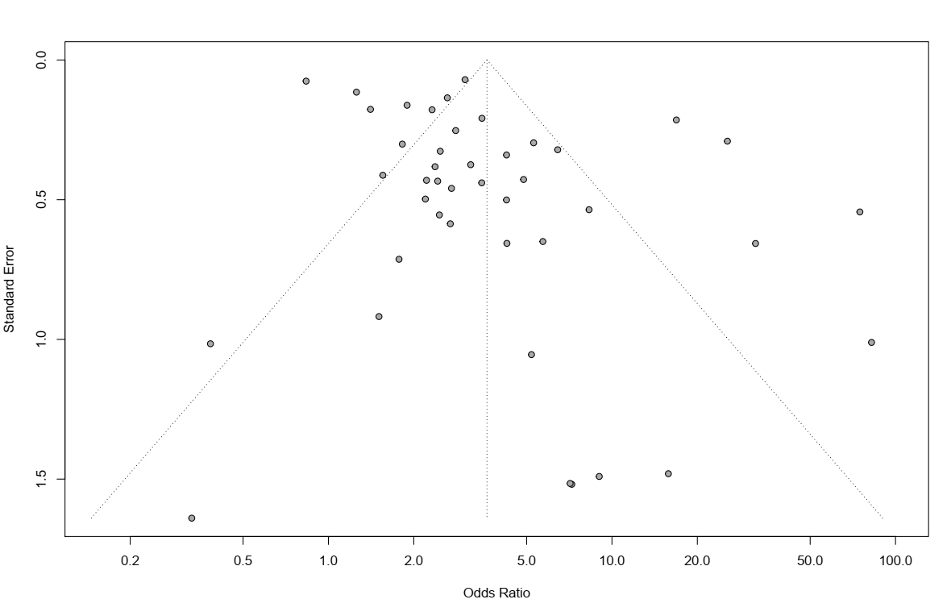

  - Supplementary figure 3. Funnel plot for publication bias for HHV8 infection risk in non-autoimmune DM individuals
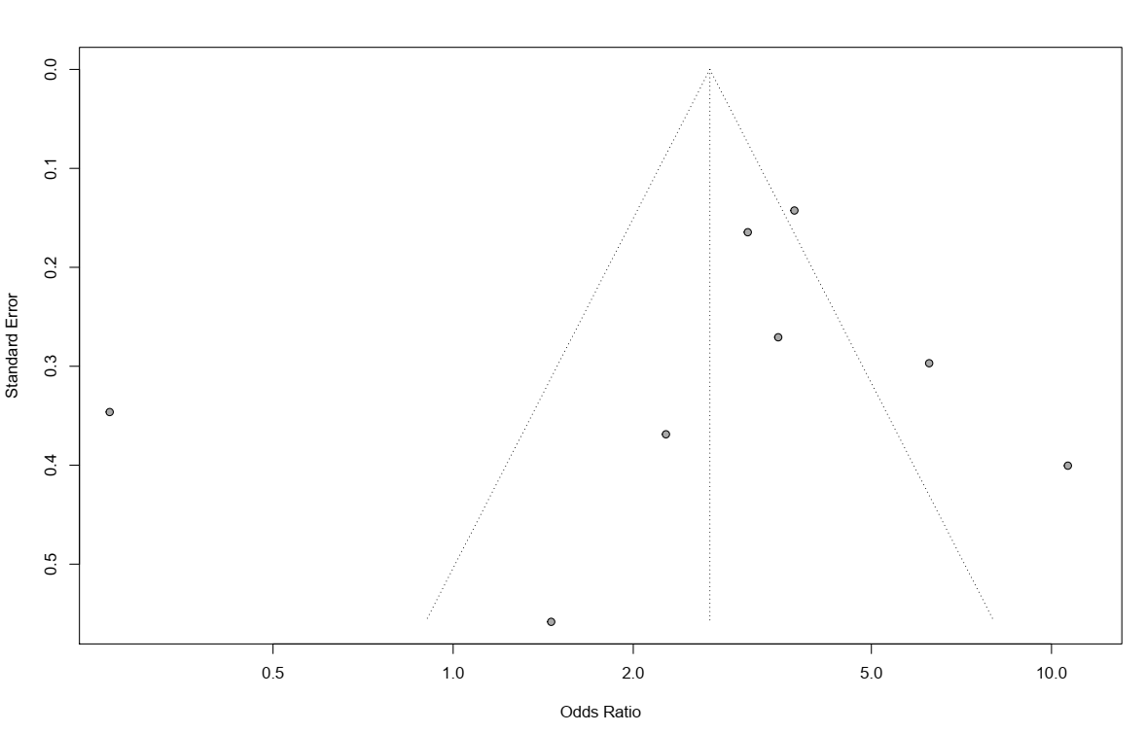

  - Supplementary figure 4. Funnel plot for publication bias for HBV infection risk in non-autoimmune DM individuals
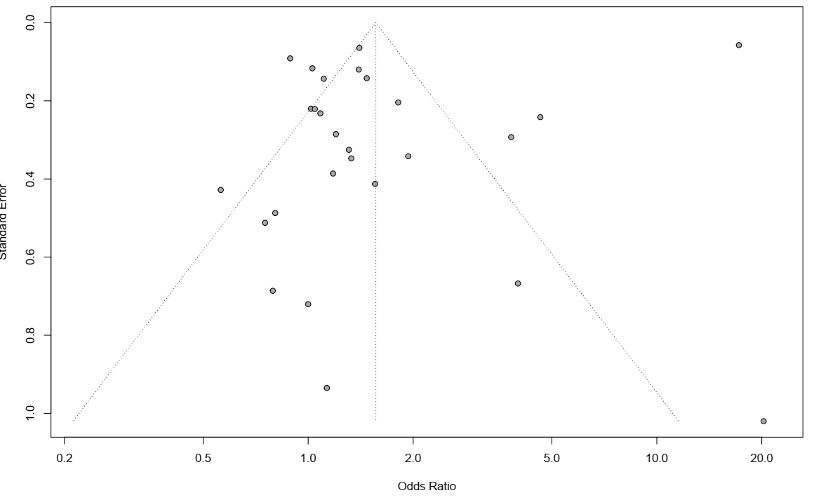

  - Supplementary figure 5. Funnel plot for publication bias for CMV infection risk in non-autoimmune DM individuals

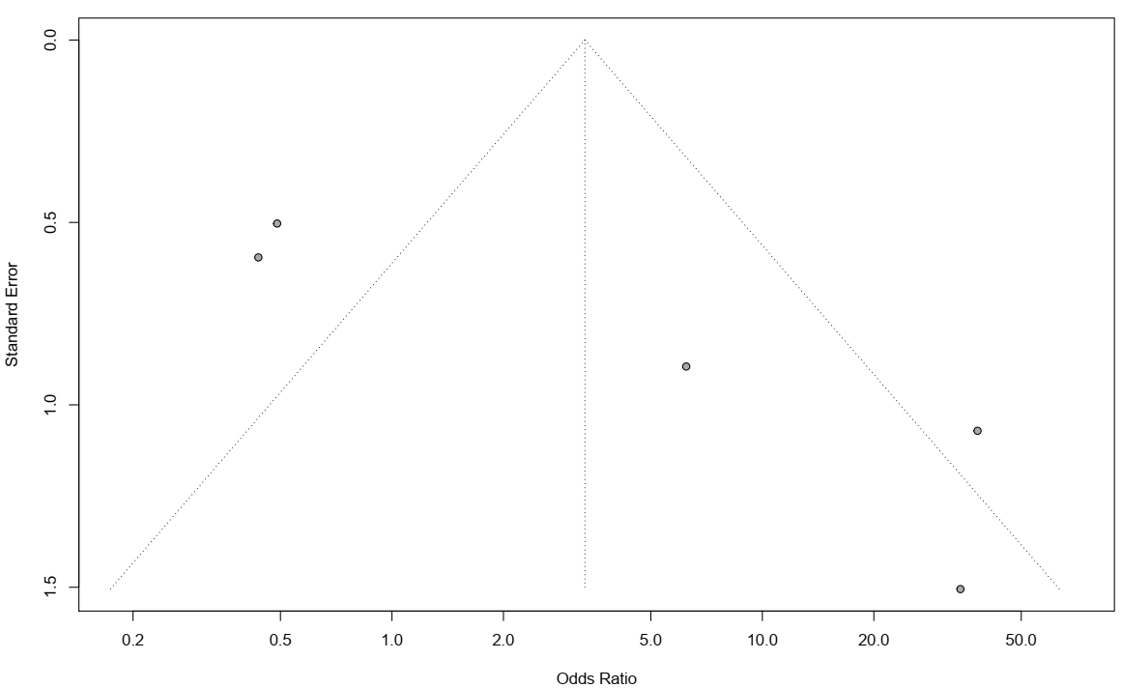

Supplementary materials figures legends and tables

Supplementary tables
S Table 1. PRISMA 2009 checklist
S Table 2. Characteristics of included studies
S Table 3. Quality assessment of included studies
S Table 4. Subgroup analyses of the association between non-autoimmune diabetes mellitus and type specific virus

Supplementary figures
S Figure 1. Study selection process
S Figure 2. Funnel plot for publication bias for HCV infection risk in non-autoimmune DM individuals
S Figure 3. Funnel plot for publication bias for HHV8 infection risk in non-autoimmune DM individuals
S Figure 4. Funnel plot for publication bias for HBV infection risk in non-autoimmune DM individuals
S Figure 5. Funnel plot for publication bias for CMV infection risk in non-autoimmune DM individuals

