Additional file 4
Sensitivity analyses
Additional file figure 1:
The substantial heterogeneity was partially explained by two studies with extreme estimates¹ ², and excluding these studies in a sensitivity analysis resulted in moderate heterogeneity without substantially altering the association (Odds Ratio 3.17, 95% Confidence Interval 1.82 to 5.53, I²=50.6%). 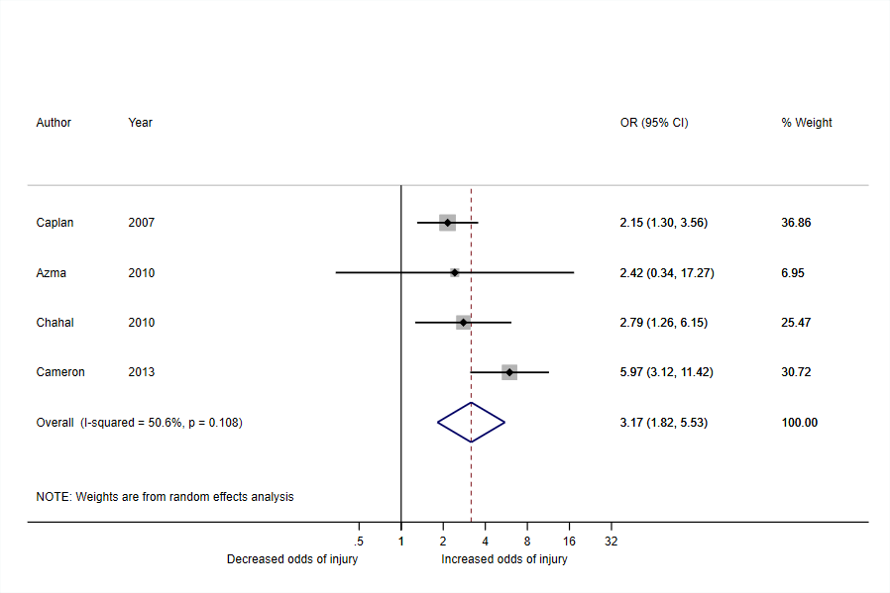

Additional file figure 2: one study³ used more than one definition of joint hypermobility as exposures, and a sensitivity analysis using data from the exposure considered less relevant for our objective resulted in a weaker association (Odds Ratio = 3.08, 95% Confidence Interval 1.55 to 6.11, I² = 76.1%).
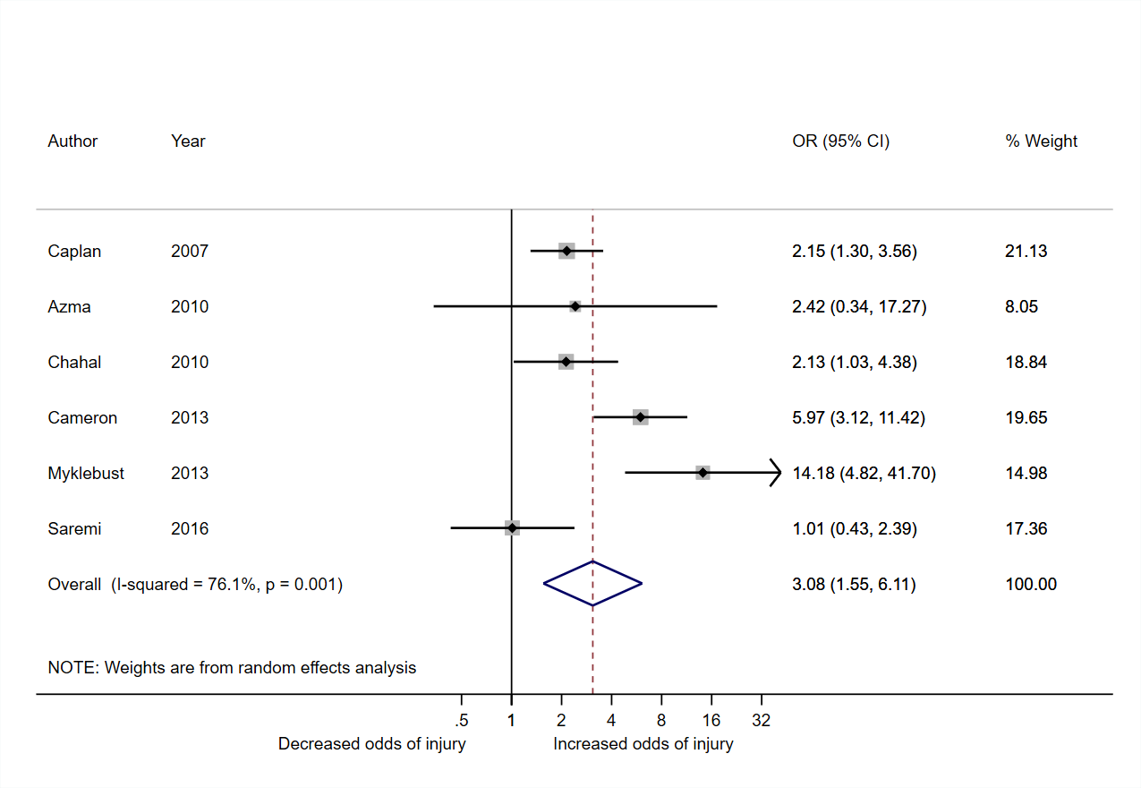

Additional file figure 3: one study¹ did not show an increased odds ratio for having shoulder injury (Odds Ratio 1.01, 95% Confidence Interval 0.43 to 2.39). Since this was the only study in the meta-analysis including fractures as an outcome, a sensitivity analysis was performed without fractures, which resulted in a stronger association (Odds Ratio = 3.54, 95% Confidence Interval 1.92 to 6.53, I² = 67.5%).

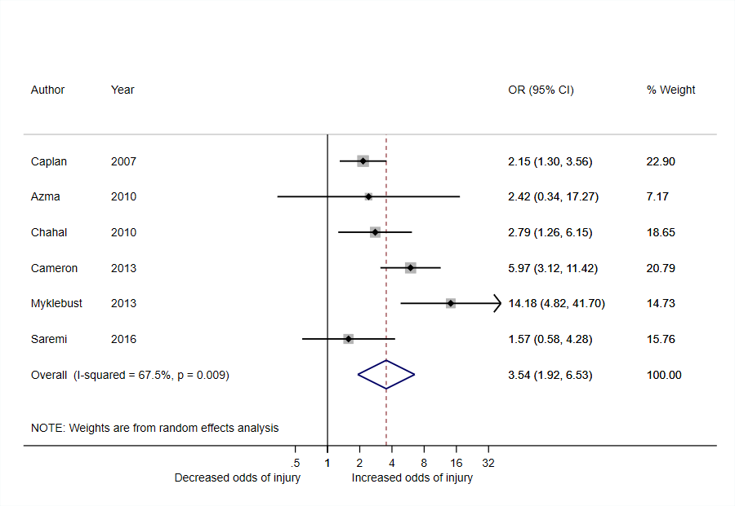

References
1. Saremi H, Yavarikia A, Jafari N. Generalized ligamentous laxity: An important predisposing factor for shoulder injuries in athletes. Iranian Red Crescent Medical Journal 2016;18 (6) (no pagination)(e38903) doi: http://dx.doi.org/10.5812/ircmj.38903
2. Myklebust G, Hasslan L, Bahr R, et al. High prevalence of shoulder pain among elite Norwegian female handball players. Scandinavian Journal of Medicine and Science in Sports 2013;23(3):288-94. doi: http://dx.doi.org/10.1111/j.1600-0838.2011.01398.x
3. Chahal J, Leiter J, McKee MD, et al. Generalized ligamentous laxity as a predisposing factor for primary traumatic anterior shoulder dislocation. Journal of Shoulder and Elbow Surgery 2010;19(8):1238-42. doi: http://dx.doi.org/10.1016/j.jse.2010.02.005

