APPENDIX 6

Figure S1 Amisulpride vs Placebo in dysthymia – Response rate
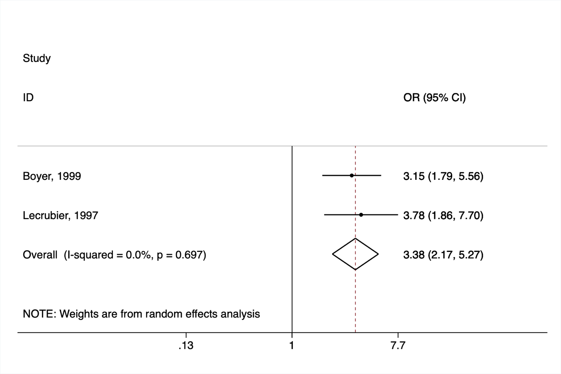

Figure S2 Amisulpride vs Placebo in dysthymia - Dropout rate due to adverse events
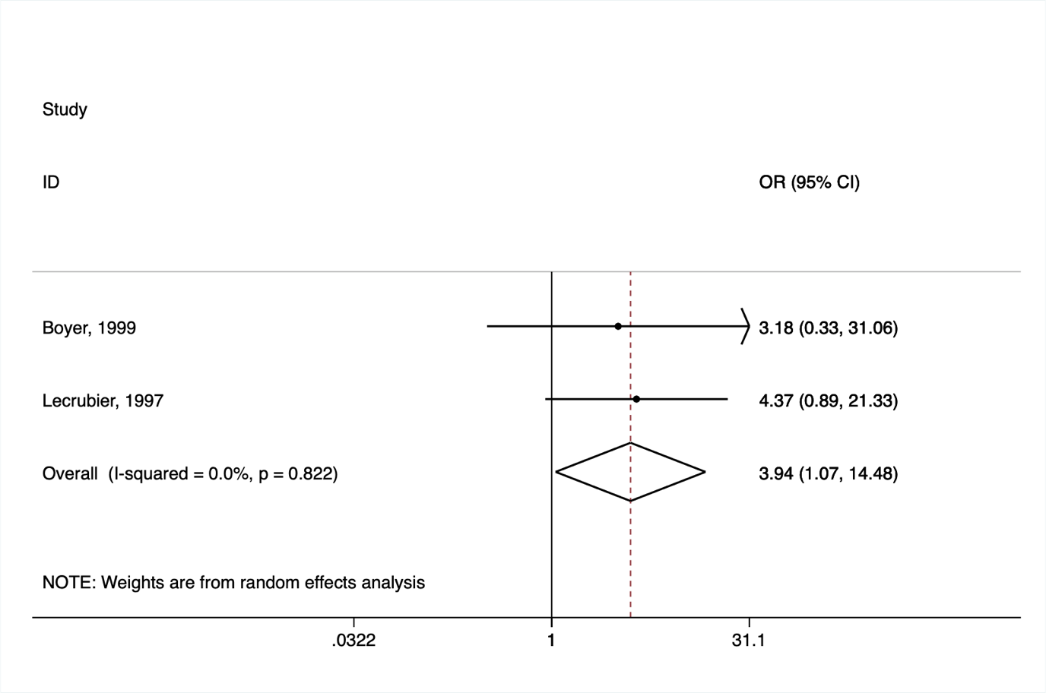

Figure S3 Amisulpride vs SSRI in dysthymia – Response rate
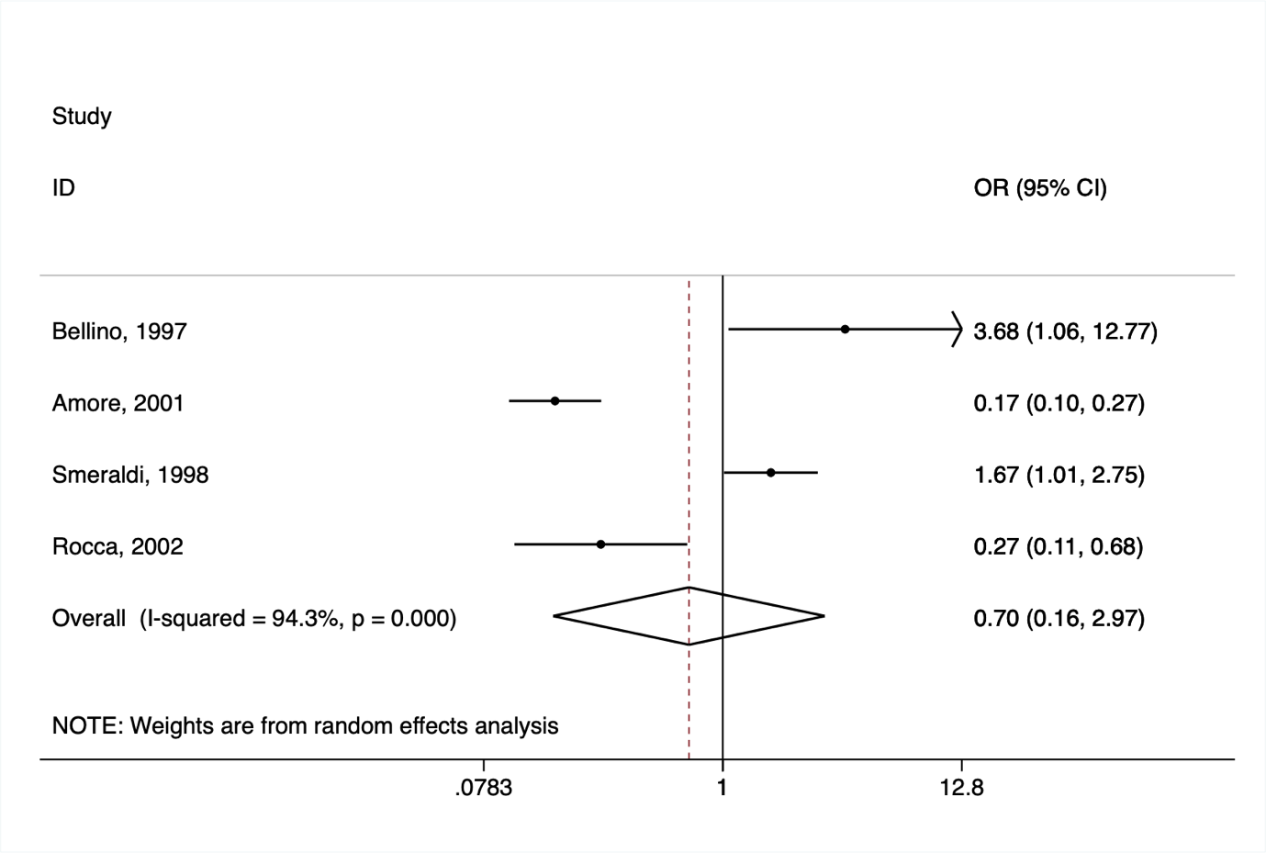

Figure S4 Amisulpride vs SSRI in dysthymia - Dropout rate due to adverse events


