Appendix A. Search strategy.
Search Terms:
myocardial ischemia/ or acute coronary syndrome/ or coronary artery disease/ or coronary occlusion/ or coronary stenosis/ or coronary thrombosis/ or myocardial infarction/ or anterior wall myocardial infarction/ or inferior wall myocardial infarction/ or non-ST elevated myocardial infarction/
(myocardial adj2 infarct*).ti,ab.
(heart adj2 attack*).ti,ab.
Creatine kinase/
(phosphokinase adj2 creatine*).ti,ab.
(creatine adj2 phosphotransferase*).ti,ab.
Troponin C/ or Troponin/ or Troponin T/ or Troponin I/
troponin.ti,ab.
1 or 2 or 3
4 or 5 or 6
7 or 8
9 and 10 and 11
limit 12 to (English language and humans and yr = "1995 -Current")

Appendix B. Article selection.
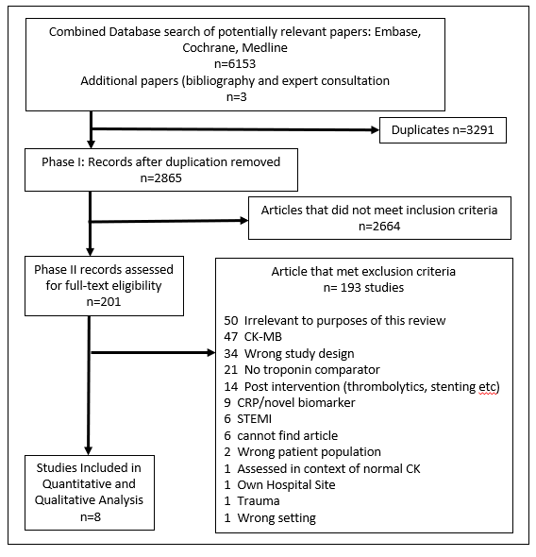

Appendix C. Sensitivity tables of selected studies.
Troponin (cTn)
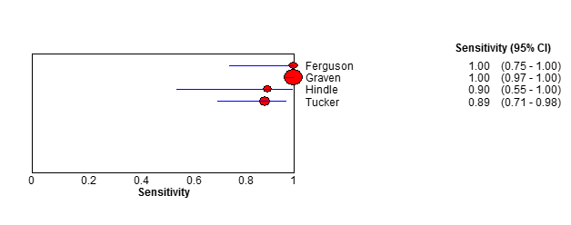
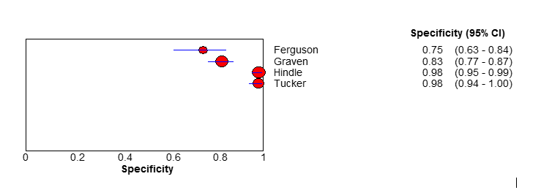
Creatine Kinase (CK)
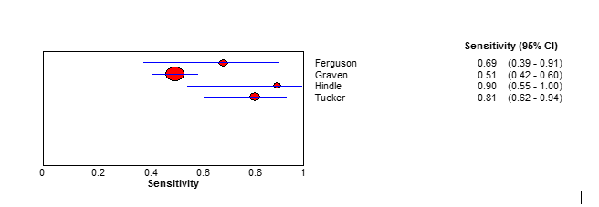
r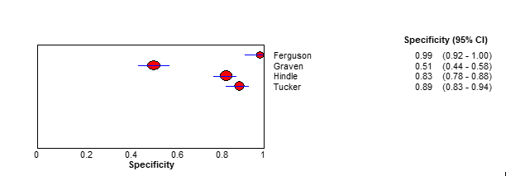
CI, confidence interval.
Appendix D. Risk of bias assessment using QUADAS- 2.
QUADAS2 tool was used to evaluate the risk of bias and applicability in the domains of patient selection, index test, reference standard, and flow and timing.
Study | Risk of Bias |  |  |  |  | Applicability
 | Patient Selection |  | Index Test | Reference Standard | Flow and timing | Patient Selection | Index Test | Reference Standard
Apple | Low |  | Low | Unclear | Low | High | Low | Low
Ben Dor | Low |  | Low | Low | Unclear | Low | High | Low
Ferguson | Low |  | Low | Low | Low | Low | Low | Low
Graven | Low |  | Low | Low | Low | Unclear | Low | Low
Hindle | High |  | Low | Unclear | High | High | Unclear | Unclear
Ishihara | Low |  | Low | Low | Low | Low | Low | Low
Tucker | Low |  | Low | Low | Low | Low | Low | Low
Wiens | Low |  | Low | Low | Low | Low | Low | Low

Proportion of studies with low, high, or. unclear risk of bias.


