Appendix 6: Sensitivity analyses

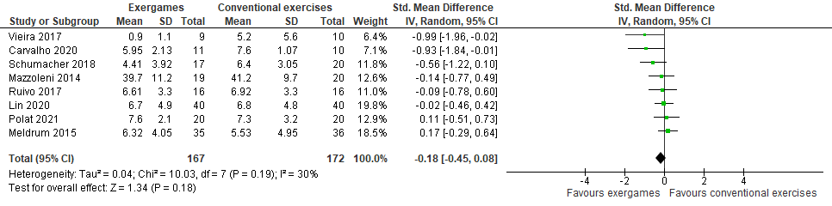
Exergames versus conventional exercises (excluding Adomaviciene et al.)

Exergames versus conventional exercises (excluding Adomaviciene et al. and Vieira et al.)
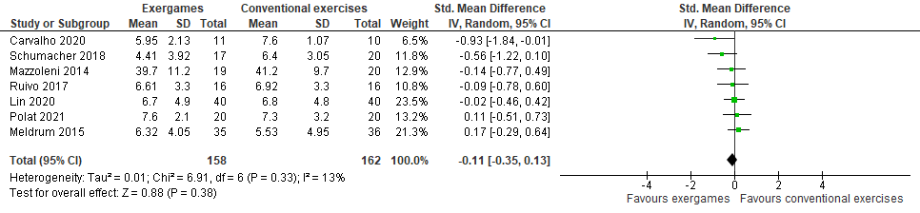

Exergames versus no intervention (excluding Thomas et al.)
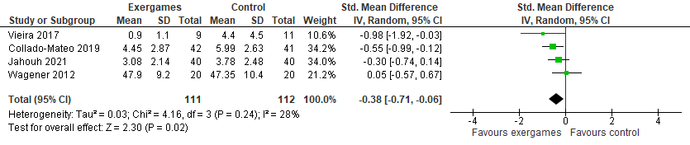

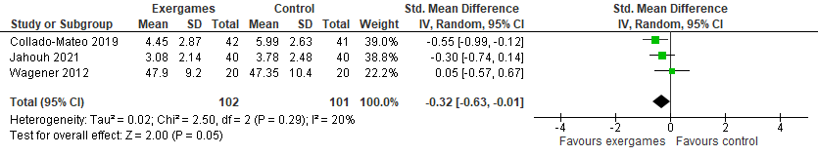
Exergames versus no intervention (excluding Thomas et al. and Vieira et al.)
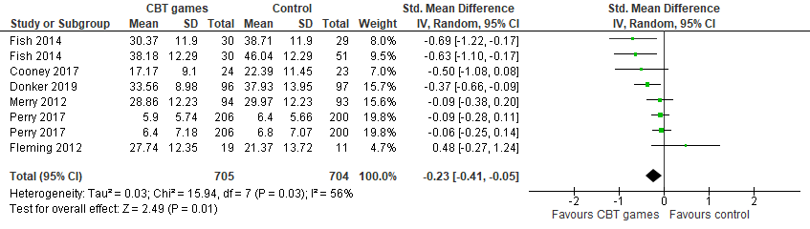
Computerized CBT games versus no intervention (excluding Donker et al.)

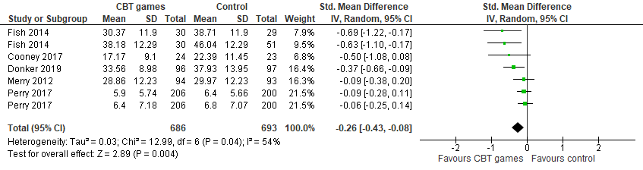
Computerized CBT games versus no intervention (excluding Donker et al. and Fleming et al.)

