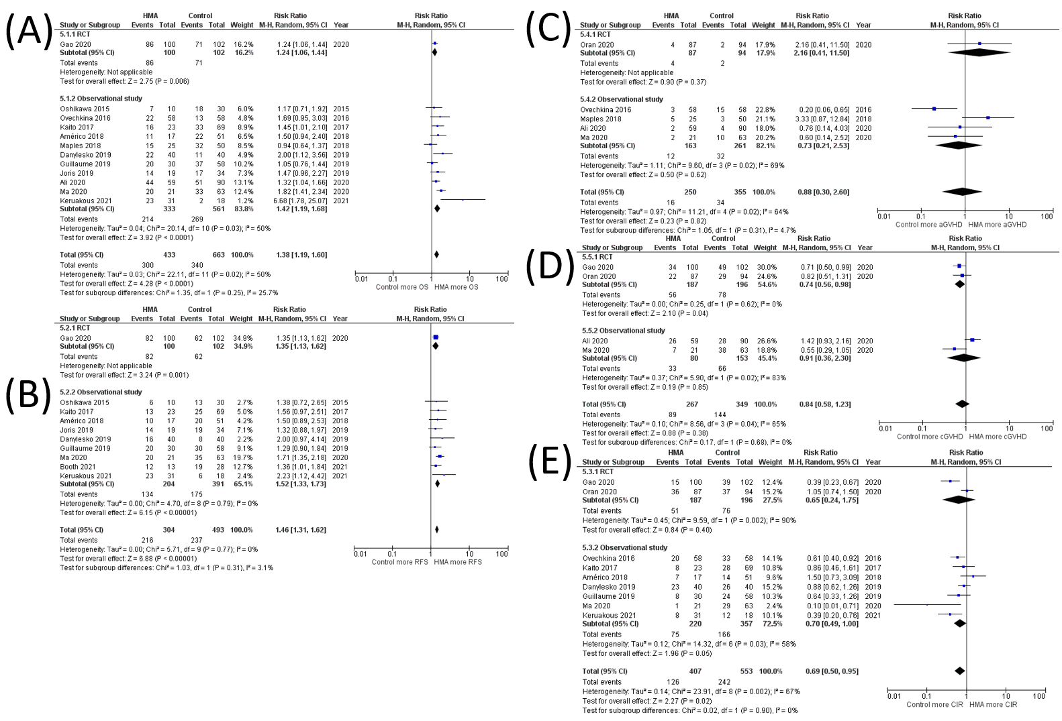
Supplementary Data 4 Subgroup analysis of RCT and observational studies (A) OS rate (B) RFS rate (C) grade III-IV aGVHD rate (D) cGVHD rate (E) CIR

