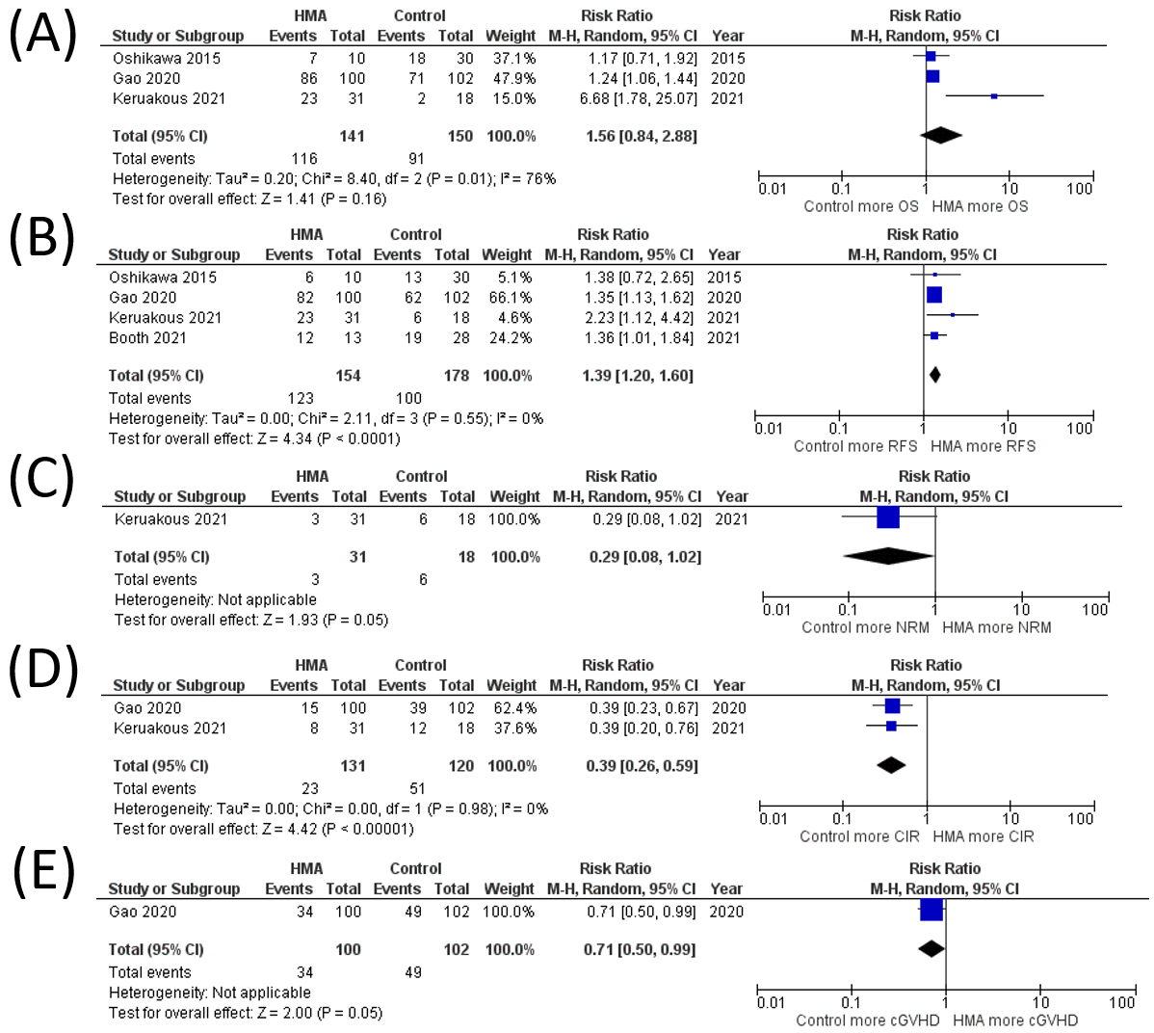
Supplementary Data 5 Sensitivity analysis of studies with HMA maintenance in AML patients (A) OS rate (B) RFS rate (C) NRM rate (D) CIR rate (E) cGVHD rate

