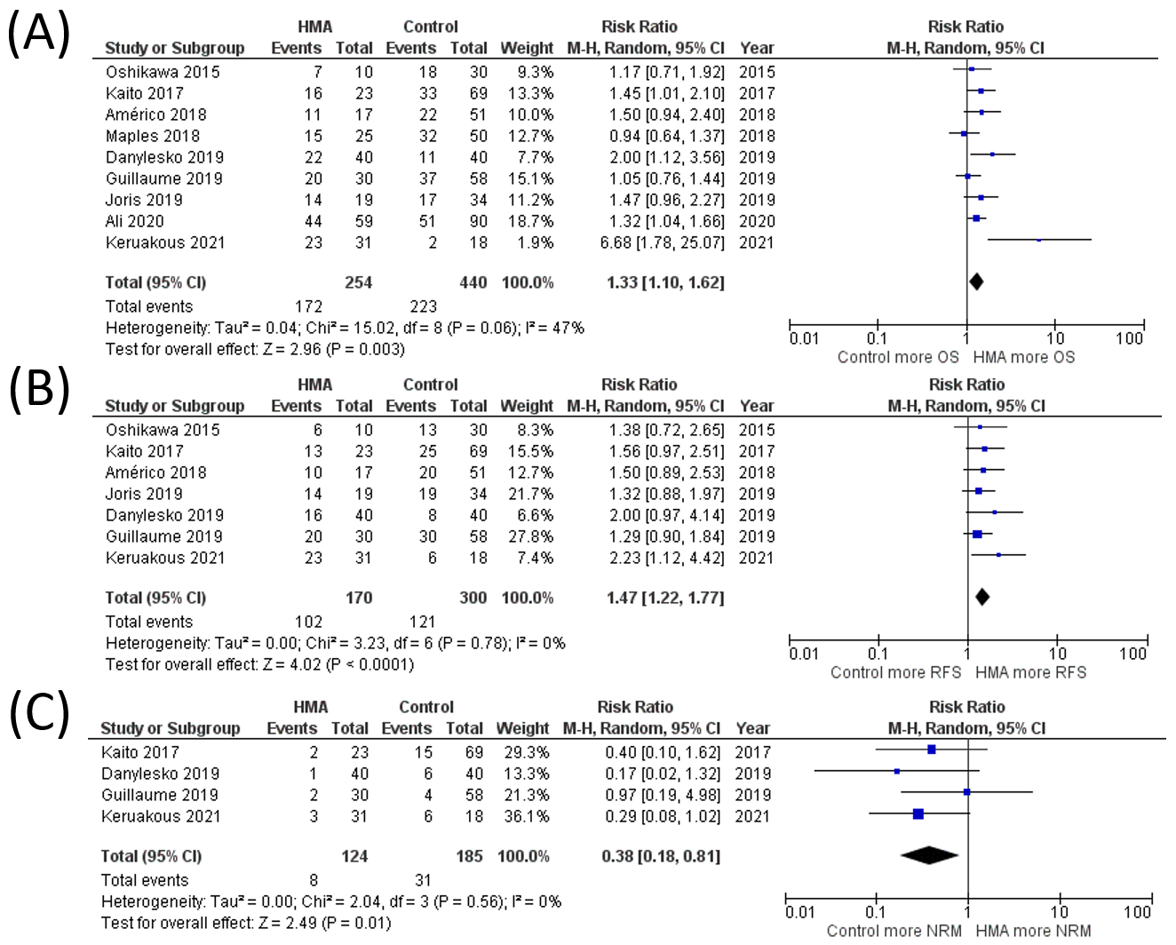
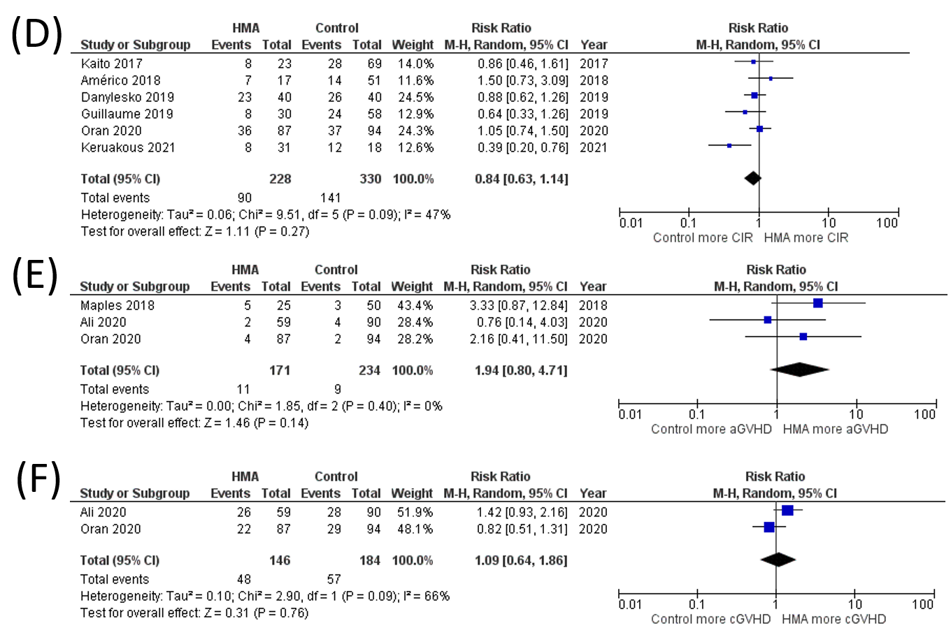
Supplementary Data 6 Sensitivity analysis of studies with only adult patients with HMA maintenance (A) OS rate (B) RFS rate (C) NRM rate (D) CIR rate (E) grade III-IV aGVHD rate (F) cGVHD rate

