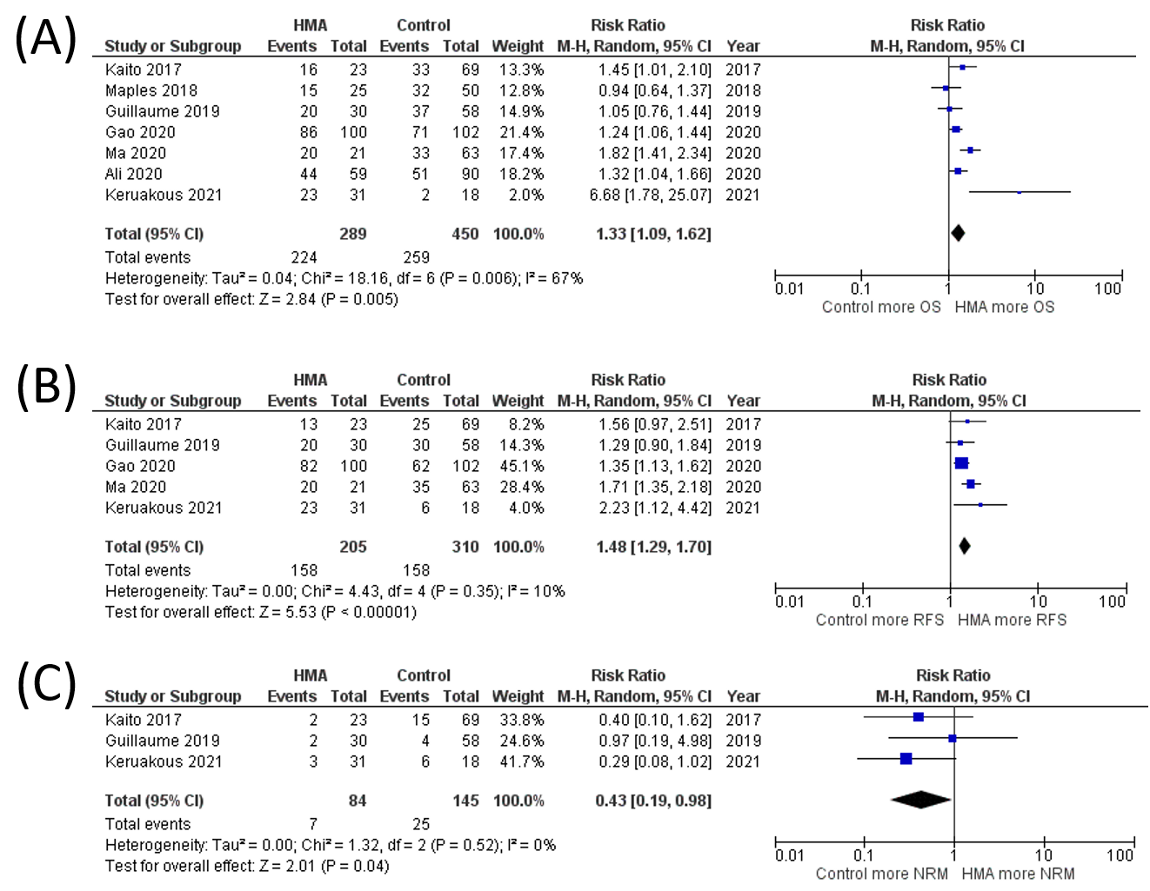
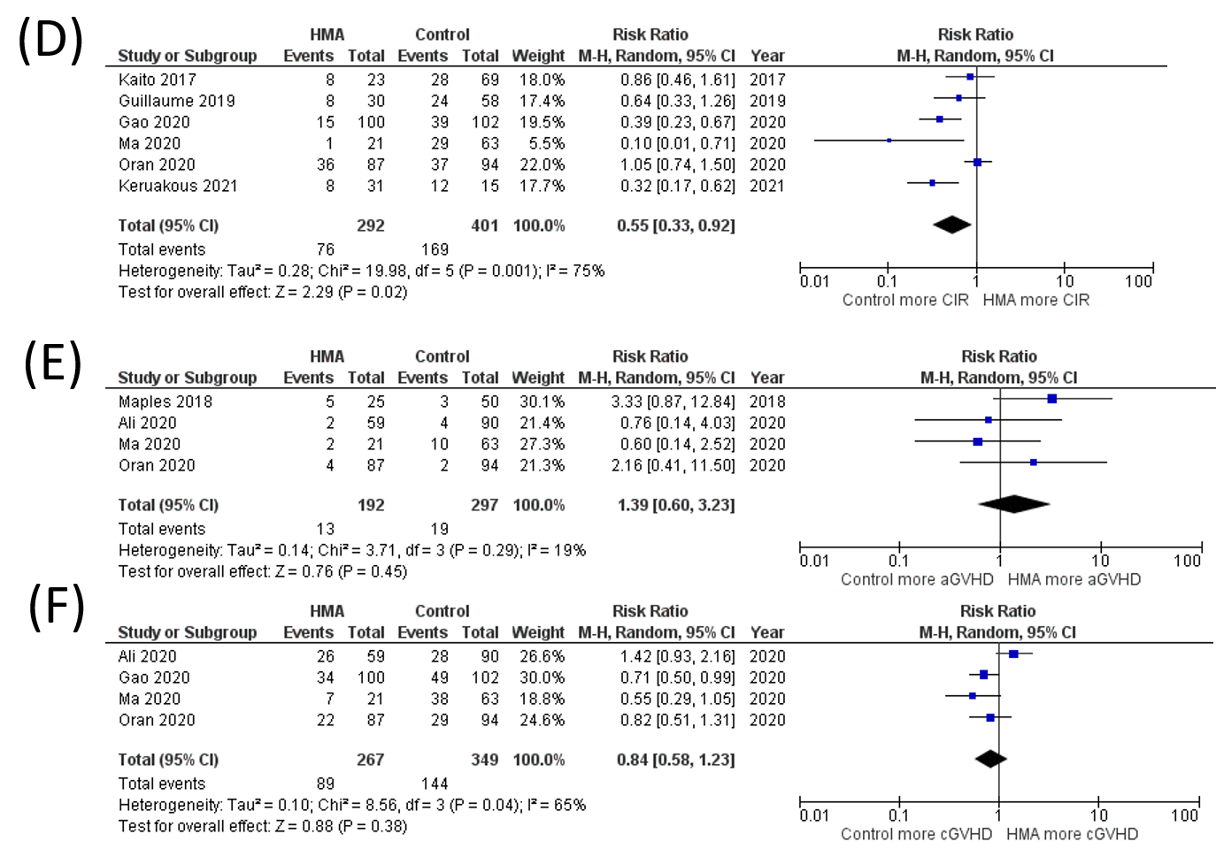
Supplementary Data 7 Sensitivity analysis of studies with low risk of bias (A) OS rate (B) RFS rate (C) NRM rate (D) CIR rate (E) grade III-IV aGVHD rate (F) cGVHD rate

