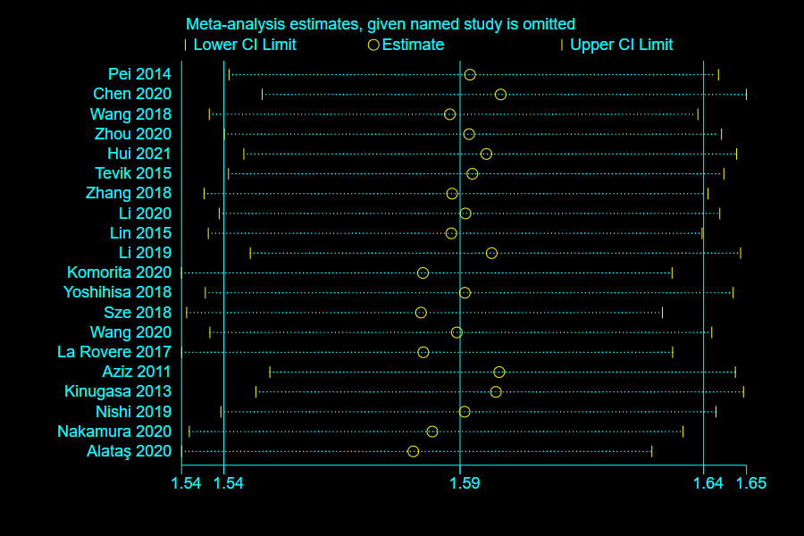
S1 Figure. Literature sensitivity analysis of malnutrition prevalence in patients with chronic heart failure

