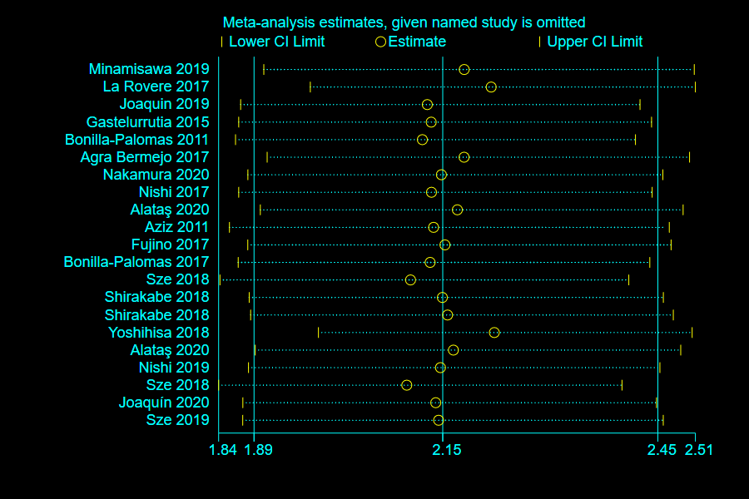
S2 Figure. Literature sensitivity analysis of malnutrition prognosis in patients with chronic heart failure

