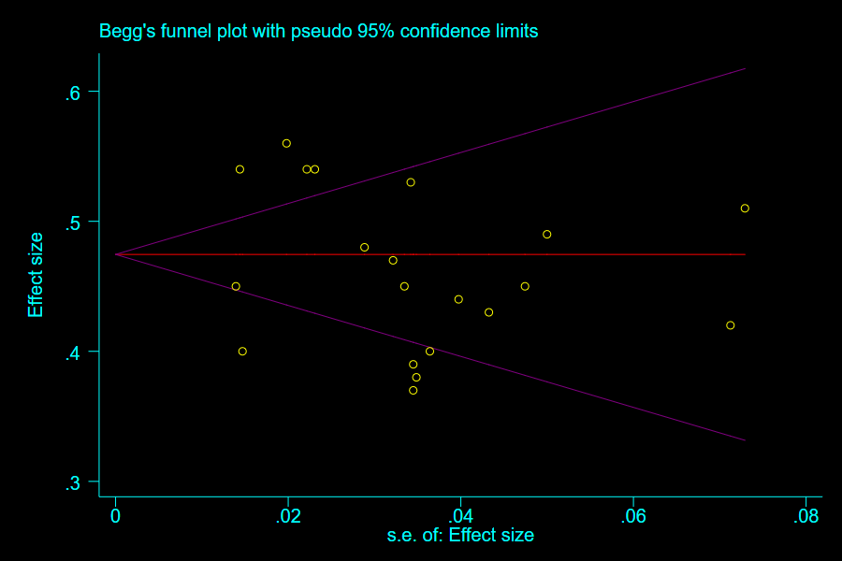
S3 Figure. Funnel plot generated by Begg test (prevalence)

