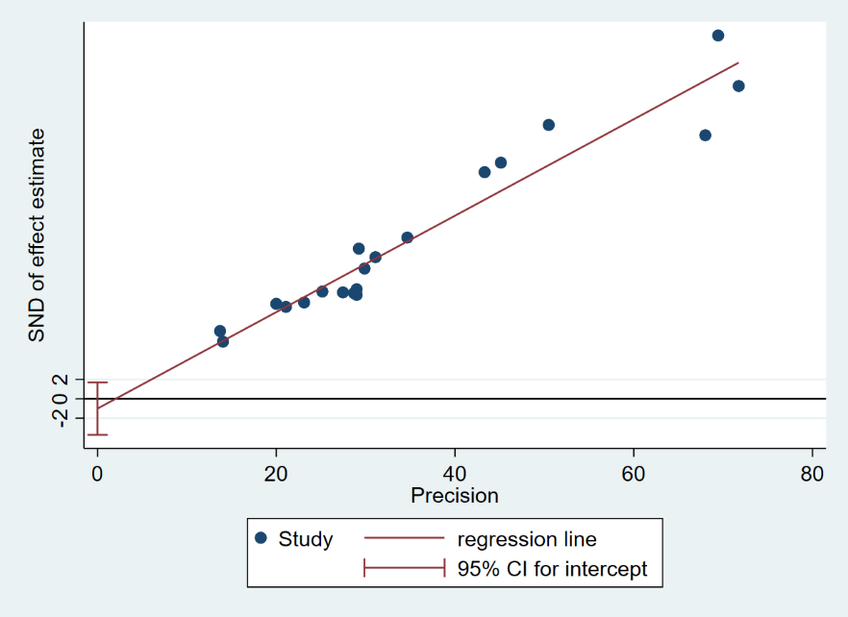
S4 Figure. Funnel plot generated by Egger test (prevalence)

