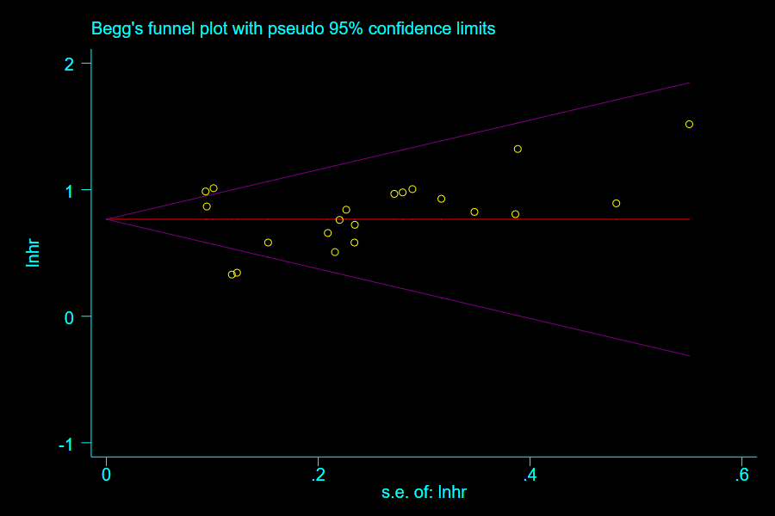
S5 Figure. Funnel plot generated by Begg test (prognosis)

