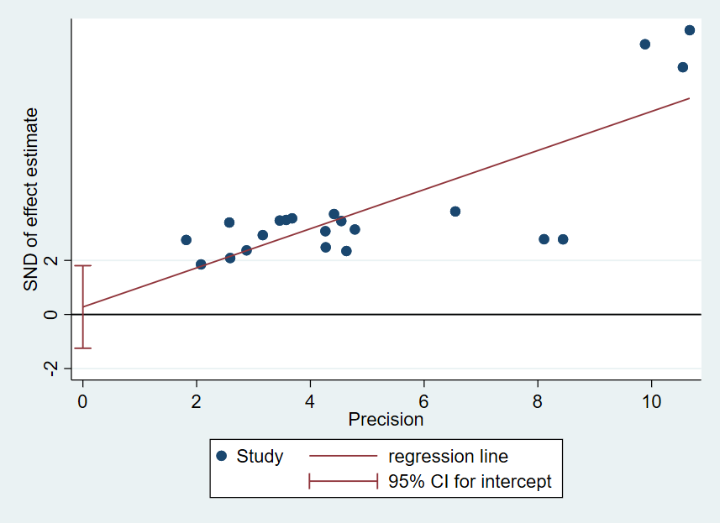
S6 Figure. Funnel plot generated by Egger test（prognosis）

