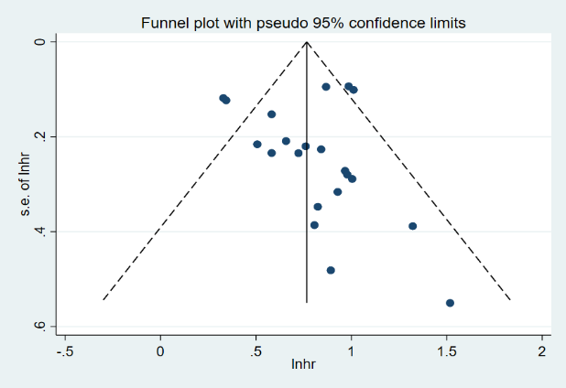
S7 Figure. Funnel plot of literature publication bias on malnutrition prognosis in patients with chronic heart failure

