Supplementary Material 3. Subgroup analyses to explore heterogeneity

3.1 Subgroup Analysis 1 – Sex
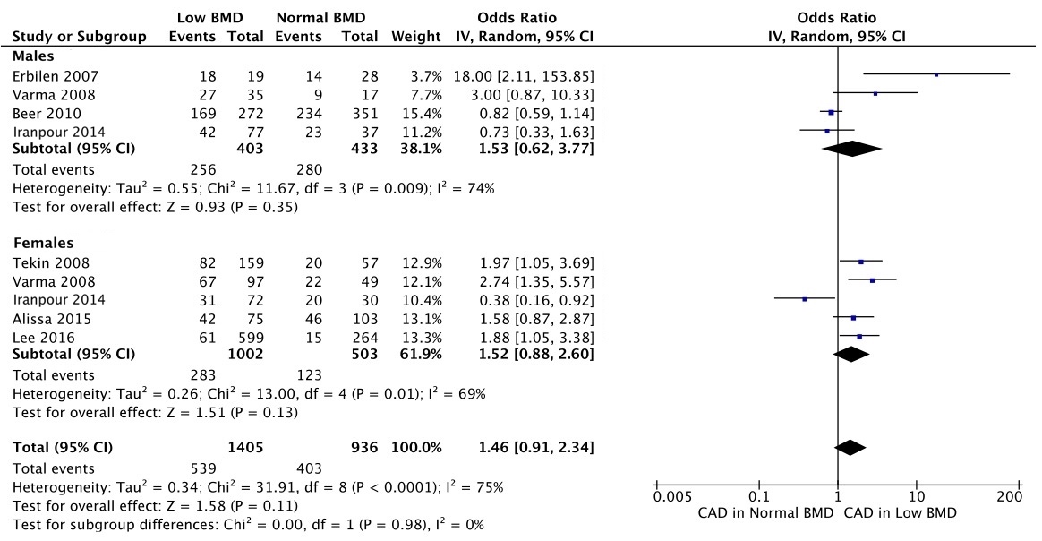

3.2 Subgroup Analysis 2 – Coronary Imaging Modality
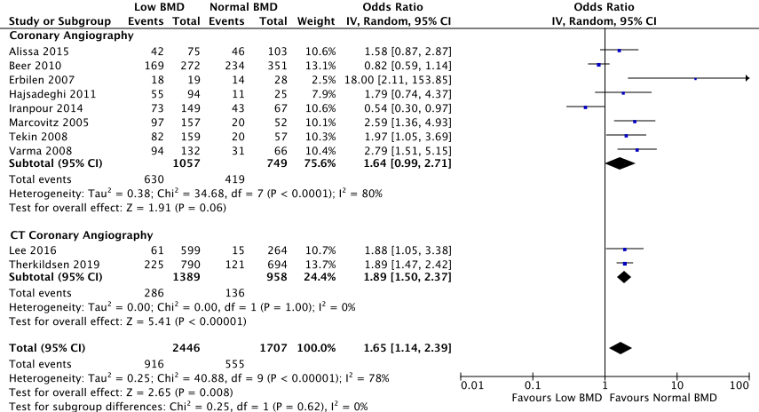

3.3 Subgroup Analysis 3 – Geographical Location


