Mobile interventions targeting common mental disorders among pregnant and postpartum women: An equity-focused systematic review

Appendix VI: Critical appraisal visuals (by outcome)

1. Visual representations of critically appraising results on the severity of depression symptoms
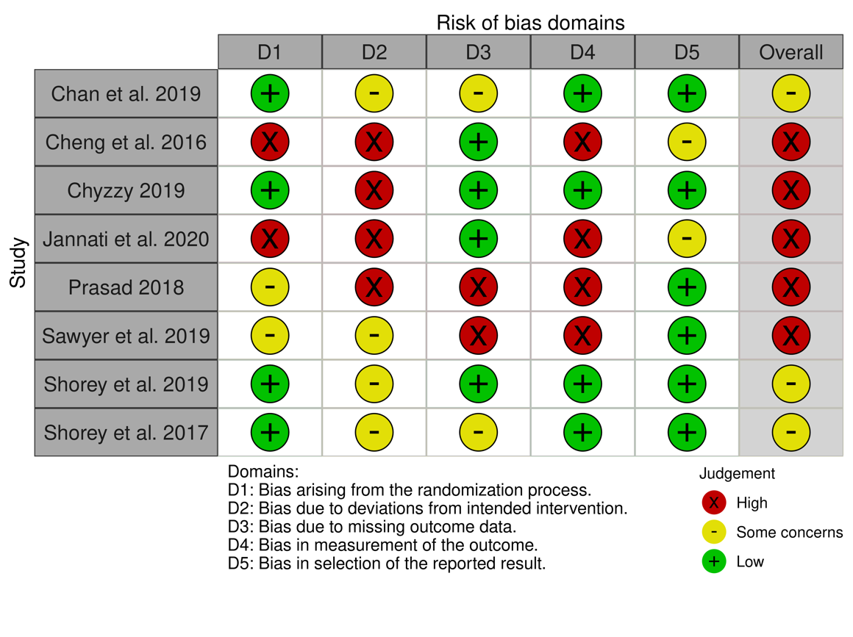

Fig 1. Risk of bias assessments on the severity of depression symptoms from randomized controlled trials of interventions using the Cochrane Risk of Bias 2.0 tool (ROB 2.0) - study level

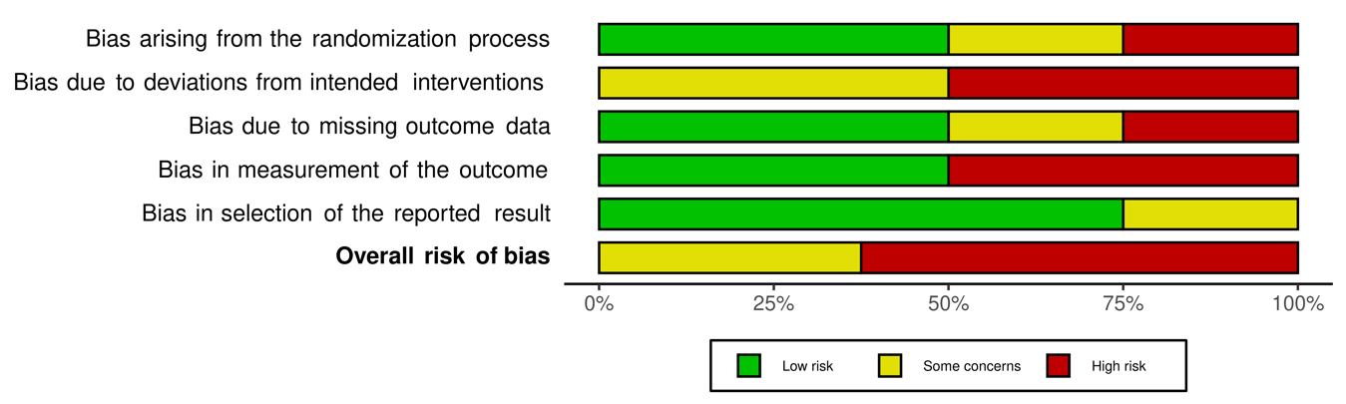

Fig 2. Risk of bias assessments on the severity of depression symptoms from randomized controlled trials of interventions using the Cochrane Risk of Bias 2.0 tool (ROB 2.0) - across studies
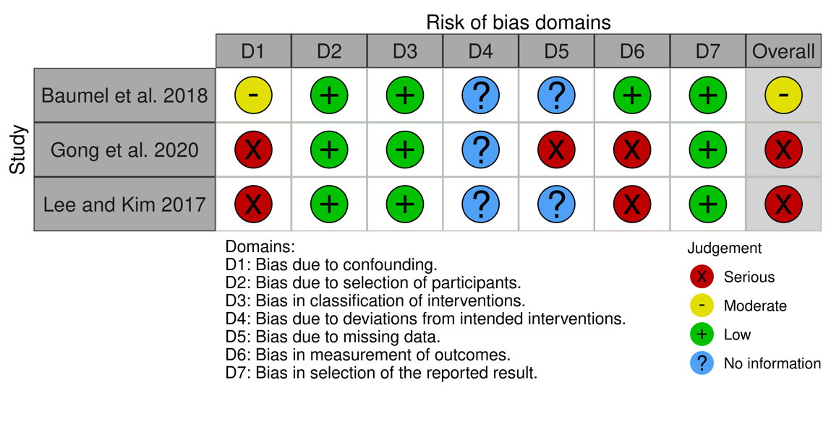

Fig 3. Risk of bias assessments on the severity of depression symptoms from non-randomized controlled studies using the Cochrane Risk of Bias In Non-randomized Studies of Interventions Tool (ROBINS-I) - study level

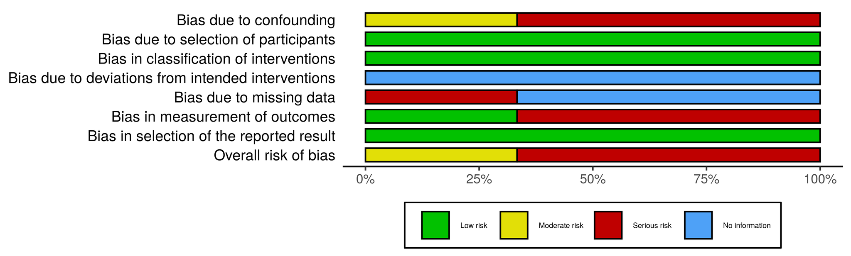

Fig 4. Risk of bias assessments on the severity of depression symptoms from non-randomized controlled studies using the Cochrane Risk of Bias In Non-randomized Studies of Interventions Tool (ROBINS-I) - across studies

2. Visual representations of critically appraising results on the severity of anxiety symptoms
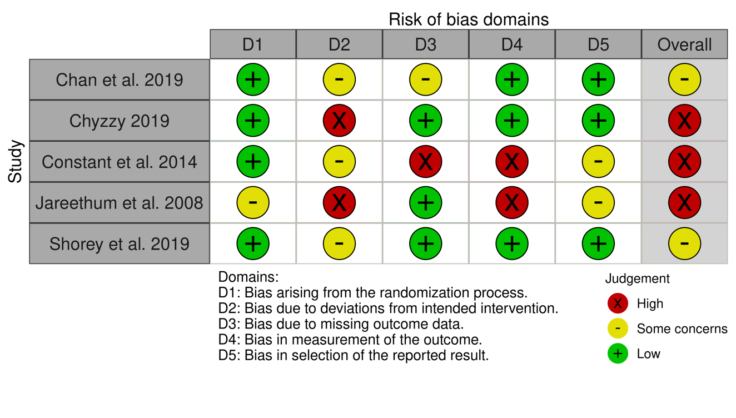

Fig 5. Risk of bias assessments on the severity of anxiety symptoms from randomized controlled trials of interventions using the Cochrane Risk of Bias 2.0 tool (ROB 2.0) - study level

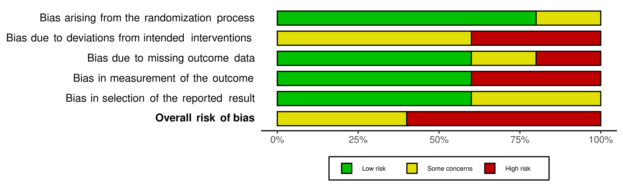

Fig 6. Risk of bias assessments on the severity of anxiety symptoms from randomized controlled trials of interventions using the Cochrane Risk of Bias 2.0 tool (ROB 2.0) - across studies

Note: No results from non-randomized controlled studies were found on the severity of anxiety symptoms

3. Visual representations of critically appraising results on the psychological wellbeing and distress

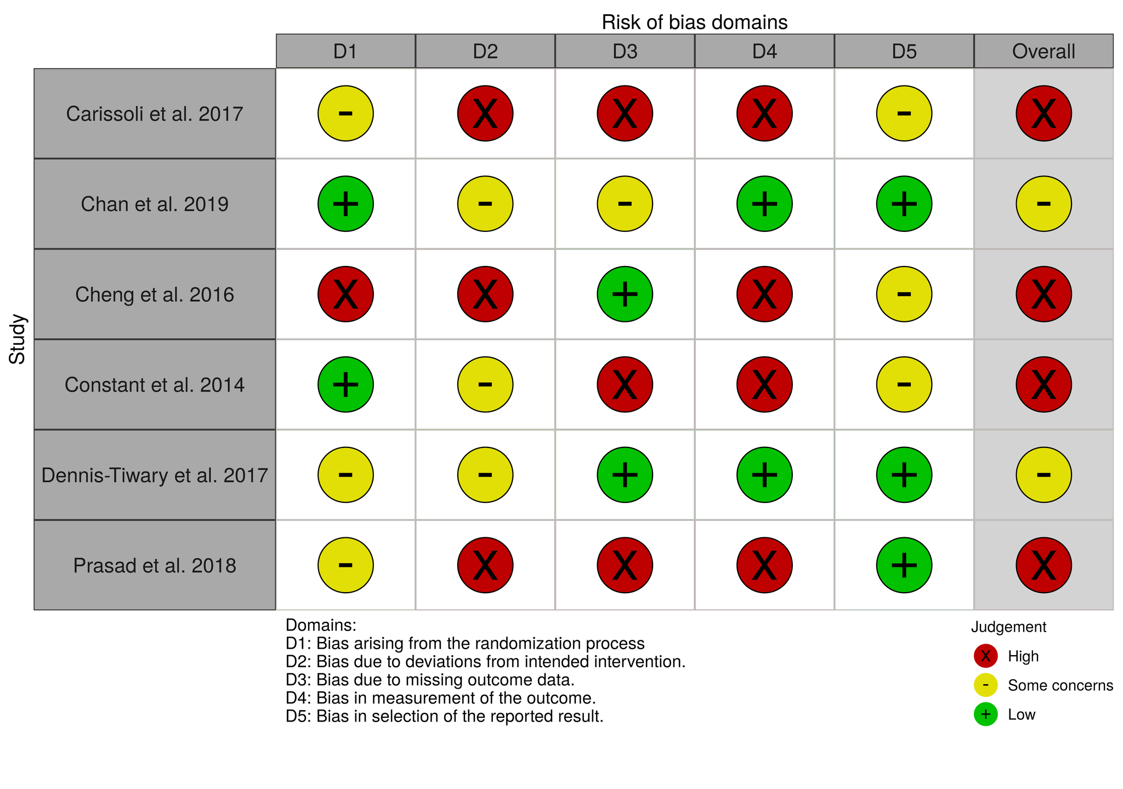
Figure 7: Risk of bias assessments on psychological stress from randomized controlled trials of interventions using the Cochrane Risk of Bias 2.0 tool (ROB 2.0) - study level

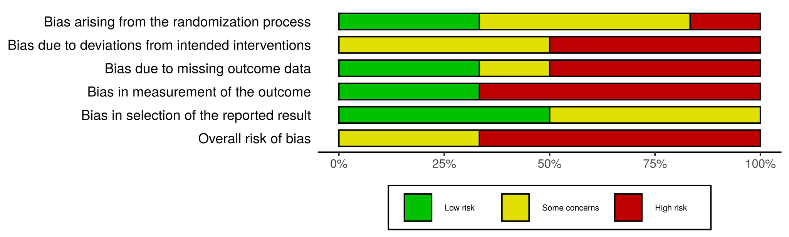
Figure 8: Risk of bias assessments on psychological stress from randomized controlled trials of interventions using the Cochrane Risk of Bias 2.0 tool (ROB 2.0) - across studies

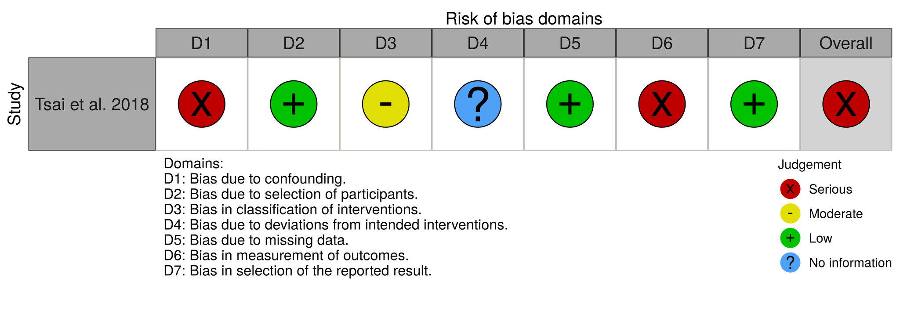
Figure 9: Risk of bias assessments on psychological stress from non-randomized controlled studies using the Cochrane Risk of Bias In Non-randomized Studies of Interventions Tool (ROBINS-I) - study level

4. Visual representations of critically appraising results on the utilization of pregnancy-related and mental health care and services

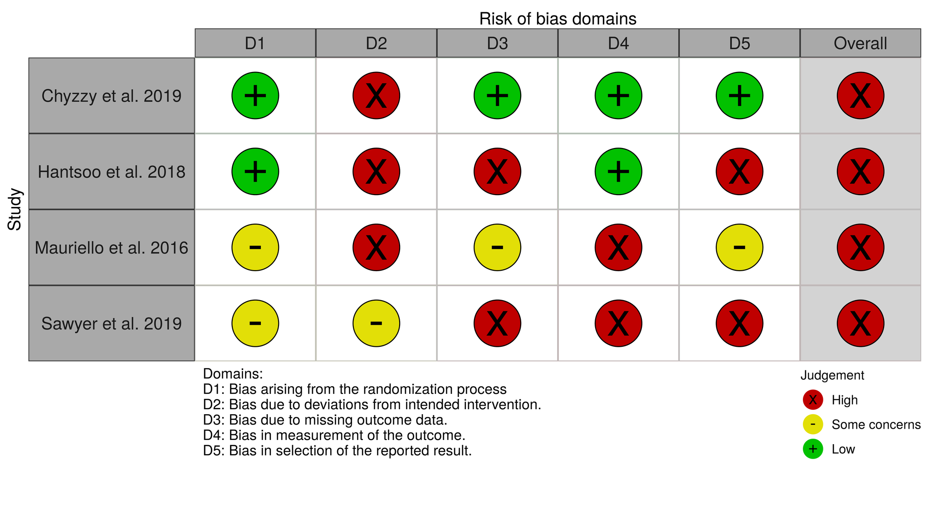
Figure 10: Risk of bias assessments on utilization of pregnancy-related and mental health care and services from randomized controlled trials of interventions using the Cochrane Risk of Bias 2.0 tool (ROB 2.0) - study level

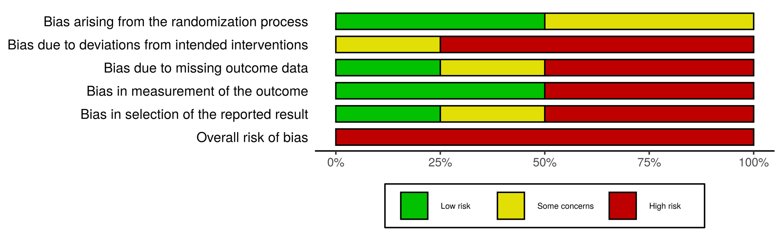
Figure 11: Risk of bias assessments on utilization of pregnancy-related and mental health care and services from randomized controlled trials of interventions using the Cochrane Risk of Bias 2.0 tool (ROB 2.0) - across studies

