eFigure 1a. Quality assessment for studies(Risk of bias graph)
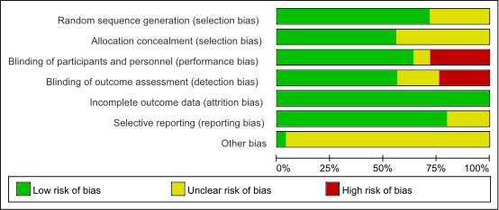

eFigure 1b. Quality assessment for studies(Risk of bias summary)
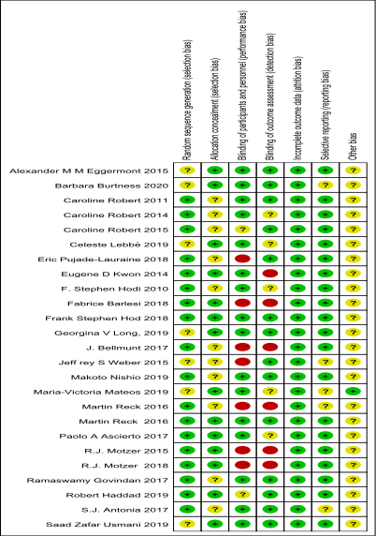

eFigure 2.Forest plot analysis of cardiotoxicity in patients treated with PD-L1 inhibitor(avelumab)；G1–5: grade1–5.

eFigure 3.Forest plot analysis of cardiotoxicity in patients treated with PD-L1 inhibitor(durvalumab)；G1–5: grade1–5.

eFigure 4.Forest plot analysis of cardiotoxicity in patients treated with CTLA-4 inhibitor(ipilimumab)；G1–5: grade1–5.

eFigure 5.Forest plot analysis of cardiotoxicity in patients treated with PD-1 inhibitor(pembrolizumab)；G1–5: grade1–5.

eFigure 6.Forest plot analysis of cardiotoxicity in patients treated with PD-1 inhibitor(nivolumab)；G1–5: grade1–5.

