eFigure 7.Forest plot analysis of cardiotoxicity in patients treated with different doses:ipili 10 mg/kg q3w vs 3 mg/kg q3w:a dose of CTLA-4 inhibitor(ipilimumab) of 10 mg/kg q3w compared with a dose of 3 mg/kg q3w;nivo plus ipili:nivolumab 3 mg/kg plus ipilimumab 1 mg/kg vs ipilimumab 3 mg/kg plus nivolumab 1 mg/kg ;pembroli 10mg/kg q2w vs 10mg/kg q3w:a dose of PD-1 inhibitor(pembrolizumab) of 10mg/kg q2w compared with a dose of 10mg/kg q3w;G1–5: grade1–5.

eFigure 8.Forest plot analysis of cardiotoxicity in patients treated with ICIs in lung cancer
eFigure 9.Forest plot analysis of cardiotoxicity in patients treated with ICIs in melanoma
eFigure 10.Results of publication bias（ funnel plot）
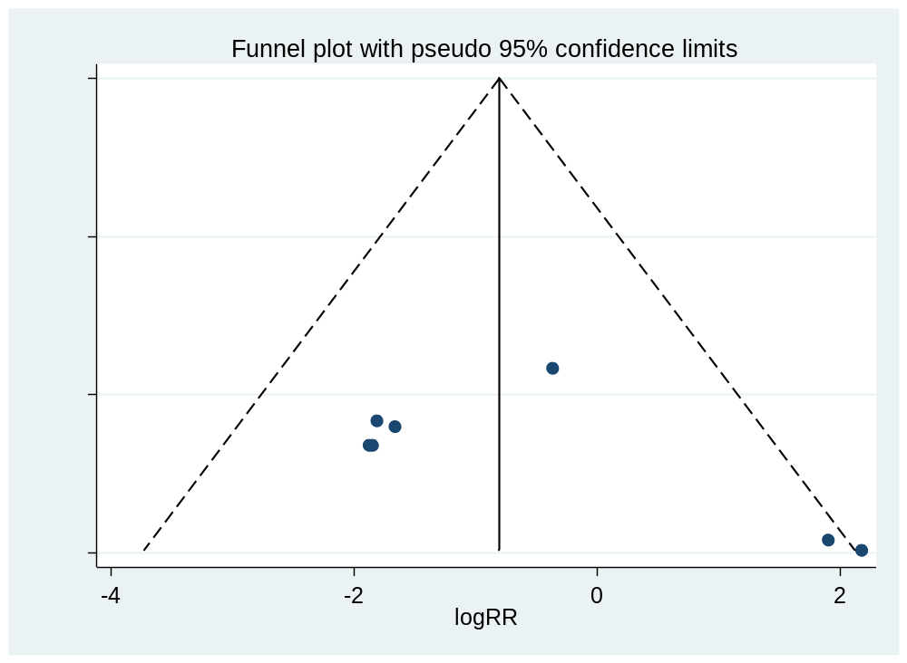
eFigure 11.Results of publication bias（Egger’s Test）


