Supplementary

Table legend
Supplementary Table S1 Risk of bias assessment using the Newcastle-Ottawa Quality Assessment Scale (NOS) (Table S1a) and the Agency for Healthcare Research and Quality (AHRQ) chicks (Table S1b).
Supplementary Table S2 The results of the subgroup analysis based on gender.
Supplementary Table S3 The results of the subgroup analysis based on the study design.
Supplementary Table S4 The results of the subgroup analysis based on effect size.
Supplementary Table S5 The results of the subgroup analysis based on region.

Figure legend

Subgroup analysis
Supplementary Figure S1 Forest plot of gender-subgroup analysis for association between ankylosing spondylitis and PD risk.
Supplementary Figure S2 Forest plot of gender-subgroup analysis for association between Sjögren’s syndrome and PD risk.
Supplementary Figure S3 Forest plot of gender-subgroup analysis for association between rheumatoid arthritis and PD risk.
Supplementary Figure S4 Forest plot of gender-subgroup analysis for association between gout and PD risk.
Supplementary Figure S5 Forest plot of study design’s subgroup analysis for association between ankylosing spondylitis and PD risk.
Supplementary Figure S6 Forest plot of study design’s subgroup analysis for association between Sjögren’s syndrome and PD risk.
Supplementary Figure S7 Forest plot of study design’s subgroup analysis for association between rheumatoid arthritis and PD risk.
Supplementary Figure S8 Forest plot of study design’s subgroup analysis for association between gout and PD risk.
Supplementary Figure S9 Forest plot of effect size’s subgroup analysis for association between ankylosing spondylitis and PD risk.
Supplementary Figure S10 Forest plot of effect size’s subgroup analysis for association between Sjögren’s syndrome and PD risk.
Supplementary Figure S11 Forest plot of effect size’s subgroup analysis for association between rheumatoid arthritis and PD risk.
Supplementary Figure S12 Forest plot of effect size’s subgroup analysis for association between gout and PD risk.
Supplementary Figure S13 Forest plot of region-subgroup analysis for association between ankylosing spondylitis and PD risk.
Supplementary Figure S14 Forest plot of region-subgroup analysis for association between Sjögren’s syndrome and PD risk.
Supplementary Figure S15 Forest plot of region-subgroup analysis for association between rheumatoid arthritis and PD risk.
Supplementary Figure S16 Forest plot of region-subgroup analysis for association between gout and PD risk.

Sensitivity analysis
Supplementary Figure S17 Sensitivity analysis of studies on ankylosing spondylitis for PD risk.
Supplementary Figure S18 Sensitivity analysis of studies on Sjögren’s syndrome for PD risk.
Supplementary Figure S19 Sensitivity analysis of studies on Behcet’s disease for PD risk.
Supplementary Figure S20 Sensitivity analysis of studies on gout for PD risk.
Supplementary Figure S21 Sensitivity analysis of studies on rheumatoid arthritis for PD risk.
Supplementary Figure S22 Sensitivity analysis of studies on systemic lupus erythematosus for PD risk.
Supplementary Figure S23 Sensitivity analysis of studies on polymyalgia rheumatica for PD risk.

Publication bias
Supplementary Figure S24 Publication bias analysis of studies on ankylosing spondylitis for PD risk estimated by Begger’s test.
Supplementary Figure S25 Publication bias analysis of studies on Sjögren’s syndrome for PD risk estimated by Begger’s test.
Supplementary Figure S26 Publication bias analysis of studies on Behcet’s disease for PD risk estimated by Begger’s test.
Supplementary Figure S27 Publication bias analysis of studies on gout for PD risk estimated by Begger’s test.
Supplementary Figure S28 Publication bias analysis of studies on rheumatoid arthritis for PD risk estimated by Begger’s test.
Supplementary Figure S29 Publication bias analysis of studies on systemic lupus erythematosus for PD risk estimated by Begger’s test.
Supplementary Figure S30 Publication bias analysis of studies on polymyalgia rheumatica for PD risk estimated by Begger’s test.

Table S1a Newcastle-Ottawa Quality Assessment Scale for twenty-one studies included in this meta-analysis.
Source | Study Design | Selection | Comparability | Exposure/Outcome | Scores
Alonso et al, 2007 | Case-control | 3 | 2 | 2 | 7
De Vera et al, 2008 | Cohort | 4 | 2 | 3 | 9
Rugbjerg et al, 2009 | Case-control | 3 | 1 | 3 | 7
Li et al, 2012 | Cohort | 3 | 2 | 3 | 8
Schernhammer et al, 2013 | Case-control | 3 | 2 | 2 | 7
Lai et al, 2014 | Case-control | 4 | 1 | 2 | 7
Liu et al, 2015 | Cohort | 4 | 2 | 2 | 8
Pakpoor et al, 2015 | Cohort | 3 | 1 | 2 | 6
Sung et al, 2016 | Cohort | 4 | 2 | 2 | 8
Wu et al, 2017 | Case-control | 4 | 2 | 2 | 8
Chang et al, 2018 | Cohort | 3 | 2 | 2 | 7
Ju et al, 2019 | Cohort | 4 | 2 | 2 | 8
Park et al, 2019 | Cohort | 4 | 2 | 2 | 8
Singh et al, 2019 | Cohort | 3 | 2 | 2 | 7
Hsu et al, 2020 | Cohort | 4 | 2 | 2 | 8
Hu et al, 2020 | Cohort | 4 | 2 | 2 | 8
Yeh et al, 2020 | Cohort | 4 | 2 | 2 | 8
Bacelis et al, 2021 | Case-control | 4 | 1 | 2 | 7
Kim et al, 2021 | Cohort | 4 | 2 | 2 | 8
Yoon et al, 2022 | Cohort | 4 | 2 | 2 | 8
Pou et al, 2022 | Case-control | 4 | 2 | 2 | 8

Table S1b Agency for Healthcare Research and Quality (AHRQ) checklist for one study included in this meta-analysis.
Items | Yes | No | Unclear
1.Define the source of information (survey, record review). | 1
2.List inclusion and exclusion criteria for exposed and unexposed subjects (cases and controls) or refer to previous publications. | 1
3.Indicate time period used for identifying patients. | 1
4.Indicate whether or not subjects were consecutive if not population-based. | 1
5.Indicate if evaluators of subjective components of study were masked to other aspects of the status of the participants. | 1
6.Describe any assessments undertaken for quality assurance purposes (e.g., test/retest of primary outcome measurements). | 1
7.Explain any patient exclusions from analysis. | 1
8.Describe how confounding was assessed and/or controlled. | 1
9.If applicable, explain how missing data were handled in the analysis. |  | 0
10.Summarize patient response rates and completeness of data collection. |  | 0
11.Clarify what follow-up, if any, was expected and the percentage of patients for which incomplete data or follow-up was obtained. |  |  | 0
Total | 8

Table S2 The results of the subgroup analysis based on gender.
Diseases | Subgroups | Number of studies | RR (95% CI) | P-value | I² (%) | P for heterogeneity
Ankylosing spondylitis | Male | 2 | 1.76 (1.39-2.22) | <0.001* | 0.0 | 0.635
Ankylosing spondylitis | Female | 2 | 1.80 (1.35-2.39) | <0.001* | 0.0 | 0.785
Sjögren’s syndrome | Male | 2 | 1.00 (0.87-1.16) | 0.962 | 0.0 | 0.920
Sjögren’s syndrome | Female | 2 | 1.28 (1.21-1.35) | <0.001* | 0.0 | 1.000
Rheumatoid arthritis | Male | 2 | 0.61 (0.49-0.76) | <0.001* | 0.0 | 0.933
 | Female | 2 | 0.58 (0.38-0.89) | 0.013* | 48.4 | 0.164
Gout | Male | 9 | 0.98 (0.89-1.08) | 0.688 | 74.3 | <0.001
Gout | Female | 9 | 1.10 (1.00-1.22) | 0.056 | 44.8 | 0.070
CI, confidence interval; RR, relative risk; * Statistically significant differences

Table S3 The results of the subgroup analysis based on the study design.
Diseases | Subgroups | Number of studies | RR (95% CI) | P-value | I² (%) | P for heterogeneity
Ankylosing spondylitis | Case-control | 1 | 1.20 (0.92-1.57) | 0.181 | NA | NA
Ankylosing spondylitis | Cohort | 3 | 1.75 (1.48-2.08) | <0.001* | 0.00 | 0.843
 | Cross-sectional | 1 | 1.49 (1.05-2.12) | 0.027* | NA | NA
Sjögren’s syndrome | Case-control | 1 | 1.38 (1.15-1.66) | 0.001* | NA | NA
Sjögren’s syndrome | Cohort | 4 | 1.33 (1.20-1.48) | <0.001* | 65.0 | 0.022
Rheumatoid arthritis | Case-control | 2 | 0.60 (0.41-0.88) | 0.009* | 46.0 | 0.174
 | Cohort | 3 | 0.92 (0.63-1.35) | 0.685 | 96.2 | <0.001
Gout | Case-control | 4 | 0.92 (0.79-1.06) | 0.243 | 76.3 | 0.005
Gout | Cohort | 5 | 1.03 (0.94-1.14) | 0.520 | 85.9 | <0.001
CI, confidence interval; RR, relative risk; * Statistically significant differences

Table S4 The results of the subgroup analysis based on effect size.
Diseases | Subgroups | Number of studies | RR (95% CI) | P-value | I² (%) | P for heterogeneity
Ankylosing spondylitis | OR | 2 | 1.30 (1.05-1.61) | 0.016* | 0.00 | 0.339
Ankylosing spondylitis | HR | 2 | 1.78 (1.49-2.13) | <0.001* | 0.00 | 0.832
Ankylosing spondylitis | SIR | 1 | 1.51 (0.86-2.65) | 0.152 | NA | NA
Sjögren’s syndrome | OR | 1 | 1.38 (1.15-1.66) | 0.010* | NA | NA
Sjögren’s syndrome | HR | 3 | 1.32 (1.15-1.52) | <0.001* | 79.1 | 0.008
Sjögren’s syndrome | SIR | 1 | 2.01 (0.73-5.50) | 0.174 | NA | NA
Sjögren’s syndrome | IRR | 1 | 1.37 (1.19-1.57) | <0.001* | NA | NA
Rheumatoid arthritis | OR | 2 | 0.60 (0.41-0.88) | 0.009* | 46.0 | 0.174
 | HR | 2 | 0.86 (0.50-1.49) | 0.594 | 97.9 | <0.001
 | SIR | 1 | 1.07 (0.90-1.27) | 0.446 | NA | NA
Gout | OR | 4 | 0.92 (0.79-1.06) | 0.243 | 76.3 | 0.005
Gout | HR | 3 | 1.06 (0.96-1.16) | 0.230 | 61.5 | 0.075
Gout | RR | 3 | 1.02 (0.76-1.38) | 0.887 | 94.0 | <0.001
Gout | IRR | 1 | 0.98 (0.89-1.07) | 0.067 | NA | NA
CI, confidence interval; RR, relative risk; * Statistically significant differences

Table S5 The results of the subgroup analysis based on region.
Diseases | Subgroups | Number of studies | RR (95% CI) | P-value | I² (%) | P for heterogeneity
Ankylosing spondylitis | Europe | 1 | 1.51 (0.86-2.65) | 0.152 | NA | NA
 | Asia | 4 | 1.55 (1.28-1.89) | 0.001* | 48.9 | 0.118
Sjögren’s syndrome | Europe | 1 | 2.01 (0.73-5.50) | 0.174 | NA | NA
 | Asia | 4 | 1.33 (1.22-1.46) | <0.001* | 64.6 | 0.023
Rheumatoid arthritis | Europe | 3 | 0.74 (0.47-1.15) | 0.183 | 85.0 | 0.001
 | Asia | 2 | 0.86 (0.50-1.49) | 0.594 | 97.9 | <0.001
Gout | Europe | 5 | 0.99 (0.86-1.13) | 0.882 | 90.2 | <0.001
 | Asia | 3 | 1.05 (0.95-1.15) | 0.348 | 68.5 | 0.013
 | North America | 1 | 0.70 (0.59-0.83) | <0.001* | NA | NA
CI, confidence interval; RR, relative risk; * Statistically significant differences

Figure S1 Forest plot of gender-subgroup analysis for association between ankylosing spondylitis and PD risk. CI, confidence interval; RR, relative risk.

Figure S2 Forest plot of gender-subgroup analysis for association between Sjögren’s syndrome and PD risk. CI, confidence interval; RR, relative risk.

Figure S3 Forest plot of gender-subgroup analysis for association between rheumatoid arthritis and PD risk. CI, confidence interval; RR, relative risk.

Figure S4 Forest plot of gender-subgroup analysis for association between gout and PD risk. CI, confidence interval; RR, relative risk.

Figure S5 Forest plot of study design’s subgroup analysis for association between ankylosing spondylitis and PD risk. CI, confidence interval; RR, relative risk.

Figure S6 Forest plot of study design’s subgroup analysis for association between Sjögren’s syndrome and PD risk. CI, confidence interval; RR, relative risk.
Figure S7 Forest plot of study design’s subgroup analysis for association between rheumatoid arthritis and PD risk. CI, confidence interval; RR, relative risk.

Figure S8 Forest plot of study design’s subgroup analysis for association between gout and PD risk. CI, confidence interval; RR, relative risk.
Figure S9 Forest plot of effect size’s subgroup analysis for association between ankylosing spondylitis and PD risk. CI, confidence interval; RR, relative risk; SIR, standardized incidence ratio; OR, odds ratio; HR, hazard ratio.

Figure S10 Forest plot of effect size’s subgroup analysis for association between Sjögren’s syndrome and PD risk. CI, confidence interval; RR, relative risk; SIR, standardized incidence ratio; OR, odds ratio; HR, hazard ratio; IRR, incidence rate ratio.
Figure S11 Forest plot of effect size’s subgroup analysis for association between rheumatoid arthritis and PD risk. CI, confidence interval; RR, relative risk; SIR, standardized incidence ratio; OR, odds ratio; HR, hazard ratio.

Figure S12 Forest plot of effect size’s subgroup analysis for association between gout and PD risk. CI, confidence interval; RR, relative risk; OR, odds ratio; HR, hazard ratio; IRR, incidence rate ratio.
Figure S13 Forest plot of region-subgroup analysis for association between ankylosing spondylitis and PD risk. CI, confidence interval; RR, relative risk.

Figure S14 Forest plot of region-subgroup analysis for association between Sjögren’s syndrome and PD risk. CI, confidence interval; RR, relative risk.
Figure S15 Forest plot of region-subgroup analysis for association between rheumatoid arthritis and PD risk. CI, confidence interval; RR, relative risk.

Figure S16 Forest plot of region-subgroup analysis for association between gout and PD risk. CI, confidence interval; RR, relative risk.
Figure S17 Sensitivity analysis of studies on ankylosing spondylitis for PD risk. CI, confidence interval.
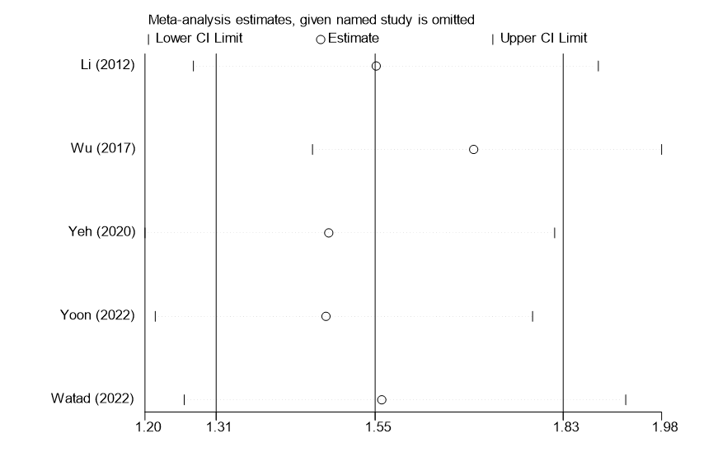

Figure S18 Sensitivity analysis of studies on Sjögren’s syndrome for PD risk. CI, confidence interval.
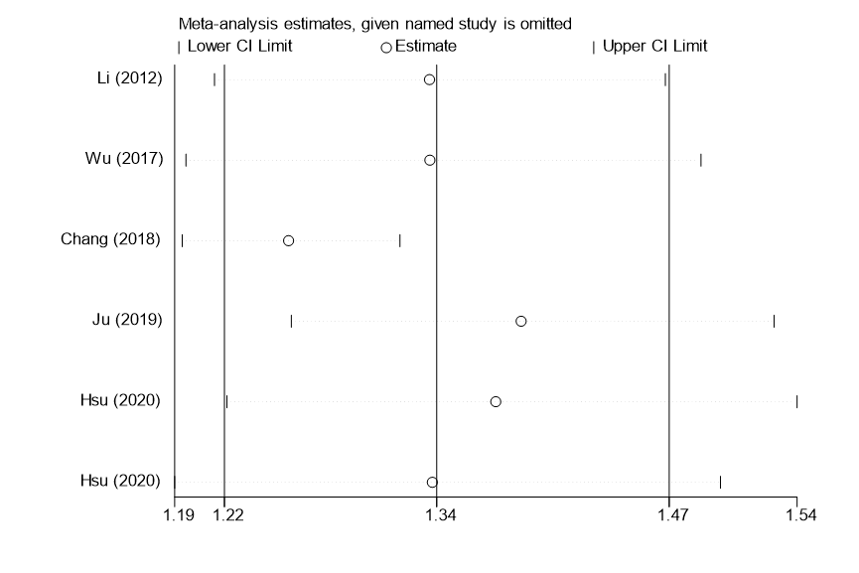

Figure S19 Sensitivity analysis of studies on Behcet’s disease for PD risk. CI, confidence interval.

Figure S20 Sensitivity analysis of studies on gout for PD risk. CI, confidence interval.
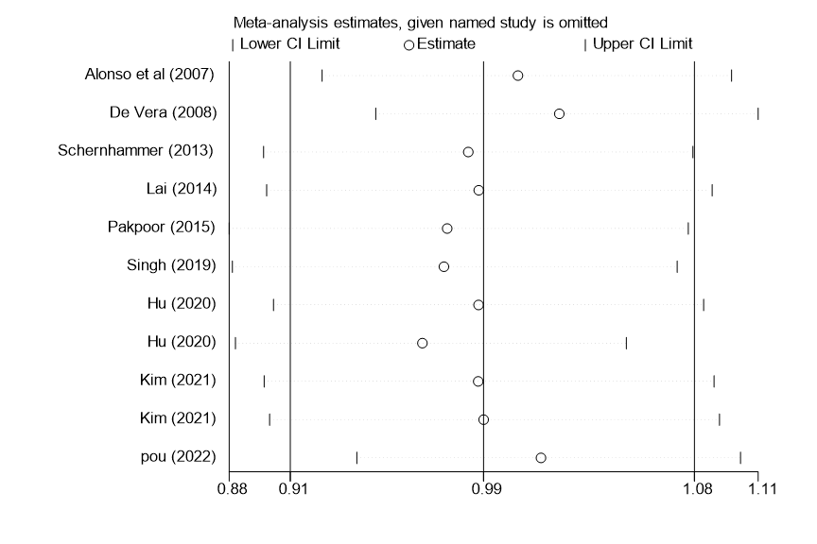

Figure S21 Sensitivity analysis of studies on rheumatoid arthritis for PD risk.CI, confidence interval.

Figure S22 Sensitivity analysis of studies on systemic lupus erythematosus for PD risk. CI, confidence interval.

Figure S23 Sensitivity analysis of studies on polymyalgia rheumatica for PD risk. CI, confidence interval.
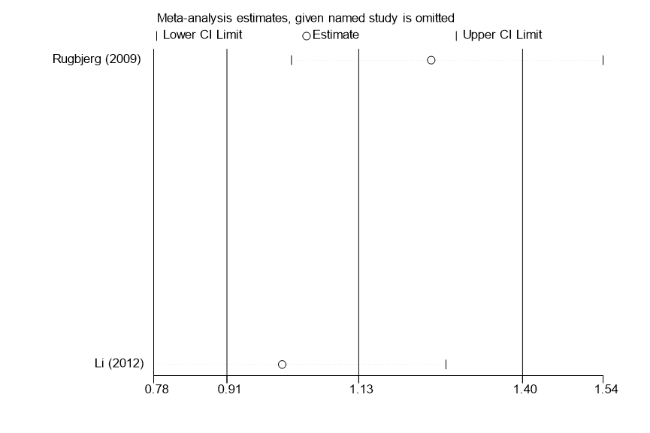

Figure S24 Publication bias analysis of studies on ankylosing spondylitis for PD risk estimated by Begger’s test.

Figure S25 Publication bias analysis of studies on Sjögren’s syndrome for PD risk estimated by Begger’s test.

Figure S26 Publication bias analysis of studies on Behcet’s disease for PD risk estimated by Begger’s test.

Figure S27 Publication bias analysis of studies on gout for PD risk estimated by Begger’s test.

Figure S28 Publication bias analysis of studies on rheumatoid arthritis for PD risk estimated by Begger’s test.

Figure S29 Publication bias analysis of studies on systemic lupus erythematosus for PD risk estimated by Begger’s test.

Figure S30 Publication bias analysis of studies on polymyalgia rheumatica for PD risk estimated by Begger’s test.


