Supplementary table 1: Newcastle-Ottawa quality assessment scale.

Supplementary table 2: Pooled estimate of the incidence of events due to CMV in LT recipients receiving antiviral prophylaxis.

Supplementary table 3: Pooled estimate of the incidence of events due to CMV in LT recipients undergoing preemptive therapy.

Supplementary figure 1: Funnel plots ruling out publication bias.
Figure 1.1 Funnel plot of studies depicts a comparison of the incidence of CMV infection among LT recipients undergoing antiviral prophylaxis and preemptive therapy.
Figure 1.2 Funnel plot of studies depicts a comparison of the incidence of CMV disease among LT recipients undergoing antiviral prophylaxis and preemptive therapy.
Figure 1.3 Funnel plot of studies depicts a comparison of the time to CMV infection among LT recipients undergoing antiviral prophylaxis and preemptive therapy.

Figure 1.4 Funnel plot of studies depicts a comparison of the time to CMV disease among LT recipients undergoing antiviral prophylaxis and preemptive therapy.

Figure 1.5 Funnel plot of studies depicts a comparison of the incidence of opportunistic infection among LT recipients undergoing antiviral prophylaxis and preemptive therapy.

Figure 1.6 Funnel plot of studies depicts a comparison of the incidence of acute antibody-mediated rejection (AMR) among LT recipients undergoing antiviral prophylaxis and preemptive therapy.
Figure 1.7 Funnel plot of studies depicts a comparison of the incidence of graft loss among LT recipients undergoing antiviral prophylaxis and preemptive therapy.

Figure 1.8 Funnel plot of studies depicts a comparison of the incidence of leukopenia among LT recipients undergoing antiviral prophylaxis and preemptive therapy.

Figure 1.9 Funnel plot of studies depicts a comparison of the incidence of neutropenia among LT recipients undergoing antiviral prophylaxis and preemptive therapy.

Figure 1.10 Funnel plot of studies depicts a comparison of the incidence of late onset CMV disease among LT recipients undergoing antiviral prophylaxis and preemptive therapy.

Figure 1.11 Funnel plot of studies depicts a comparison of the incidence of CMV specific neutralizing antibodies among LT recipients undergoing antiviral prophylaxis and preemptive therapy.

Figure 1.12 Funnel plot of studies depicts a comparison of the incidence of mortality among LT recipients undergoing antiviral prophylaxis and preemptive therapy.

Figure 1.13 Funnel plot of studies depicts a comparison of the incidence of CMV-related mortality among LT recipients undergoing antiviral prophylaxis and preemptive therapy.

Figure 1.14 Funnel plot of studies depicts a comparison of the incidence of development of drug-resistance among LT recipients undergoing antiviral prophylaxis and preemptive therapy.
Figure 1.15 Funnel plot of studies depicts a comparison of the incidence of chronic rejection among LT recipients undergoing antiviral prophylaxis and preemptive therapy.
Supplemental figure 2: Incidence of CMV infection
Supplemental figure 2.1 Incidence of CMV infection in the overall LT recipients undergoing antiviral prophylaxis.
Supplemental figure 2.2 Incidence of CMV infection in the overall LT recipients undergoing preemptive therapy.
Supplemental figure 2.3 Incidence of CMV infection in the intermediate-risk group LT recipients undergoing antiviral prophylaxis.
Supplemental figure 2.4 Incidence of CMV infection in the intermediate-risk group LT recipients undergoing preemptive therapy.
Supplemental figure 3 Incidence of CMV disease
Supplemental figure 3.1 Incidence of CMV disease in the overall LT recipients undergoing antiviral prophylaxis.
Supplemental figure 3.2 Incidence of CMV disease in the overall LT recipients undergoing preemptive therapy.
Supplemental figure 3.3 Incidence of CMV disease in the high-risk group LT recipients undergoing antiviral prophylaxis.
Supplemental figure 3.4 Incidence of CMV disease in the high-risk group LT recipients undergoing preemptive therapy.
Supplemental figure 3.5 Incidence of CMV disease in the intermediate-risk group LT recipients undergoing antiviral prophylaxis.
Supplemental figure 3.6 Incidence of CMV disease in the intermediate-risk group LT recipients undergoing preemptive therapy.
Supplemental figure 4: Incidence of opportunistic infection
Supplemental figure 4.1 Incidence of opportunistic infection in the overall LT recipients undergoing antiviral prophylaxis.
Supplemental figure 4.2 Incidence of opportunistic infection in the overall LT recipients undergoing preemptive therapy.
Supplemental figure 4.3 Incidence of opportunistic infection in the high-risk group LT recipients undergoing antiviral prophylaxis.
Supplemental figure 4.4 Incidence of opportunistic infection in the high-risk group LT recipients undergoing preemptive therapy.
Supplemental figure 5: Incidence of acute antibody-mediated rejection (AMR)
Supplemental figure 5.1 Incidence of acute antibody-mediated rejection (AMR) in the overall LT recipients undergoing antiviral prophylaxis.
Supplemental figure 5.2 Incidence of acute antibody-mediated rejection (AMR) in the overall LT recipients undergoing preemptive therapy.
Supplemental figure 5.3 Incidence of acute antibody-mediated rejection (AMR) in the high-risk group LT recipients undergoing antiviral prophylaxis.
Supplemental figure 5.4 Incidence of acute antibody-mediated rejection (AMR) in the high-risk group LT recipients undergoing preemptive therapy.
Supplemental figure 5.5 Incidence of acute antibody-mediated rejection (AMR) in the intermediate-risk group LT recipients undergoing antiviral prophylaxis.
Supplemental figure 5.6 Incidence of acute antibody-mediated rejection (AMR) in the intermediate-risk group LT recipients undergoing preemptive therapy.
Supplemental figure 6: Incidence of graft loss
Supplemental figure 6.1 Incidence of graft loss in the overall LT recipients undergoing antiviral prophylaxis.
Supplemental figure 6.2 Incidence of graft loss in the overall LT recipients undergoing preemptive therapy.
Supplemental figure 6.3 Incidence of graft loss in the intermediate-risk group LT recipients undergoing antiviral prophylaxis.
Supplemental figure 6.4 Incidence of graft loss in the intermediate-risk group LT recipients undergoing preemptive therapy.
Supplemental figure 7: Incidence of leukopenia
Supplemental figure 7.1 Incidence of leukopenia in the overall LT recipients undergoing antiviral prophylaxis.
Supplemental figure 7.2 Incidence of leukopenia in the overall LT recipients undergoing preemptive therapy.
Supplemental figure 7.3 Incidence of leukopenia in the intermediate-risk group LT recipients undergoing antiviral prophylaxis.
Supplemental figure 7.4 Incidence of leukopenia in the intermediate-risk group LT recipients undergoing preemptive therapy.
Supplemental figure 8: Incidence of neutropenia
Supplemental figure 8.1 Incidence of neutropenia in the overall LT recipients undergoing antiviral prophylaxis.
Supplemental figure 8.2 Incidence of neutropenia in the overall LT recipients undergoing preemptive therapy.
Supplemental figure 8.3 Incidence of neutropenia in the intermediate-risk group LT recipients undergoing antiviral prophylaxis.
Supplemental figure 8.4 Incidence of neutropenia in the intermediate-risk group LT recipients undergoing preemptive therapy.
Supplemental figure 9: Incidence of late-onset CMV disease
Supplemental figure 9.1 Incidence of late-onset CMV disease in the overall LT recipients undergoing antiviral prophylaxis.
Supplemental figure 9.2 Incidence of late-onset CMV disease in the overall LT recipients undergoing preemptive therapy.
Supplemental figure 9.3 Incidence of late-onset CMV disease in the high-risk group LT recipients undergoing antiviral prophylaxis.
Supplemental figure 9.4 Incidence of late-onset CMV disease in the high-risk group LT recipients undergoing preemptive therapy.
Supplemental figure 9.5 Incidence of late-onset CMV disease in the intermediate-risk group LT recipients undergoing antiviral prophylaxis.
Supplemental figure 9.6 Incidence of late-onset CMV disease in the intermediate-risk group LT recipients undergoing preemptive therapy.
Supplemental figure 10: Incidence of mortality
Supplemental figure 10.1 Incidence of mortality in the overall LT recipients undergoing antiviral prophylaxis.
Supplemental figure 10.2 Incidence of mortality in the overall LT recipients undergoing preemptive therapy.
Supplemental figure 10.3 Incidence of mortality in the high-risk group LT recipients undergoing antiviral prophylaxis.
Supplemental figure 10.4 Incidence of mortality in the high-risk group LT recipients undergoing preemptive therapy.
Supplemental figure 10.5 Incidence of mortality in the intermediate-risk group LT recipients undergoing antiviral prophylaxis.
Supplemental figure 10.6 Incidence of mortality in the intermediate-risk group LT recipients undergoing preemptive therapy.
Supplemental figure 11: Incidence of CMV related mortality
Supplemental figure 11.1 Incidence of CMV related mortality in the overall LT recipients undergoing antiviral prophylaxis.
Supplemental figure 11.2 Incidence of CMV related mortality in the overall LT recipients undergoing preemptive therapy.
Supplemental figure 12: Incidence of the development of drug resistance
Supplemental figure 12.1 Incidence of the development of drug resistance in the overall LT recipients undergoing antiviral prophylaxis.
Supplemental figure 12.2 Incidence of the development of drug resistance in the overall LT recipients undergoing preemptive therapy.
Supplemental figure 13
Supplemental figure 13.1 Forest plot depicts a comparison of the incidence of CMV specific neutralizing antibodies among LT recipients undergoing antiviral prophylaxis and preemptive therapy.
Supplemental figure 13.2 Forest plot depicts a comparison of the incidence of the development of drug resistance among LT recipients undergoing antiviral prophylaxis and preemptive therapy.
Supplemental figure 13.3 Forest plot depicts a comparison of the incidence of chronic rejection among LT recipients undergoing antiviral prophylaxis and preemptive therapy.

Supplementary table 1: Newcastle-Ottawa quality assessment scale.

 | Selection |  |  |  | Comparability | Outcome
Author, country, year | Representativeness  of Exposed Cohort | Selection of  Non exposed | Ascertainment  of Exposure | Outcome Not  Present at Start  Of study | Comparability of cohorts | Assessment  of Outcome | Adequate  Follow-Up  Length | Adequacy of  Follow-Up | the overall
Singh et al, USA, 2020 | 1 | 1 | 1 | 1 | 2 | 1 | 1 | 1 | 9
Liu et al, USA, 2018 | 1 | 1 | 1 | 1 | 2 | 1 | 1 | 1 | 9
Bodro et al, Spain, 2012 | 1 | 1 | 1 | 1 | 2 | 1 | 1 | 1 | 9
Simon et al, Germany, 2016 | 1 | 1 | 1 | 1 | 2 | 1 | 1 | 1 | 9
Mengelle et al, France, 2015 | 1 | 1 | 1 | 1 | 1 | 1 | 1 | 1 | 8
Scott et al, Australia, 2011 | 1 | 1 | 1 | 1 | 1 | 0 | 1 | 1 | 7
Onor et al, USA, 2013 | 1 | 1 | 1 | 1 | 1 | 1 | 0 | 1 | 7
Lindner et al, Germany, 2016 | 1 | 1 | 1 | 1 | 2 | 1 | 1 | 1 | 9
Nicastro et al, Italy, 2016 | 1 | 1 | 1 | 1 | 1 | 1 | 1 | 1 | 8
Kim et al, Korea, 2012 | 1 | 1 | 1 | 1 | 2 | 1 | 1 | 1 | 9
Lianghui et al, China, 2004 | 1 | 1 | 1 | 1 | 2 | 1 | 1 | 1 | 9

Supplementary table 2: Pooled estimate of the incidence of events due to CMV in LT recipients receiving antiviral prophylaxis.

Outcome | Groups | No. of studies | No. of events  (n) | Total Patients  (n) | Incidence/Prevalence | I² | OR (CI) | p
CMV Infection | Overall  LT recipients | 9 | 129 | 610 | 24.7% | 93.63% | 0.247(0.142-0.352) | <0.001
CMV Infection | Intermediate-risk | 3 | 20 | 137 | 11.9% | 91.05% | 0.119 (-0.034-0.271) | <0.001
CMV Disease | Overall  LT recipients | 10 | 44 | 590 | 6.4% | 72.06% | 0.064 (0.031-0.096) | <0.001
CMV Disease | High-risk | 2 | 25 | 140 | 17.6% | 0% | 0.176 (0.113-0.239) | 0.499
CMV Disease | Intermediate-risk | 3 | 7 | 137 | 4.6% | 0% | 0.046 (0.011-0.080) | 0.655
Opportunistic  infections | Overall  LT recipients | 5 | 109 | 417 | 27.7% | 96.44% | 0.277 (0.099-0.455) | <0.001
Opportunistic  infections | High-risk | 2 | 34 | 140 | 16.9% | 96.51% | 0.169 (-0.111-0.449) | <0.001
Acute antibody-mediated rejection (AMR) | Overall  LT recipients | 8 | 85 | 491 | 18.2% | 76.87% | 0.182 (0.111-0.253) | <0.001
Acute antibody-mediated rejection (AMR) | High-risk | 2 | 32 | 140 | 22.4% | 0% | 0.224 (0.156-0.293) | 0.318
Acute antibody-mediated rejection (AMR) | Intermediate-risk | 2 | 15 | 77 | 16.7% | 61.12% | 0.167 (0.033-0.301) | 0.109
Graft loss | Overall  LT recipients | 5 | 20 | 358 | 5.4% | 69.48% | 0.054 (0.011-0.097) | 0.011
Graft loss | Intermediate-risk | 2 | 12 | 81 | 14.1% | 0% | 0.141 (0.066-0.216) | 0.373
Leukopenia | Overall  LT recipients | 4 | 62 | 158 | 30.5% | 94.06% | 0.305 (0.035-0.575) | <0.001
Leukopenia | Intermediate-risk | 2 | 18 | 81 | 20.9% | 21.98% | 0.209 (0.107-0.311) | 0.258
Neutropenia | the overall  LT recipients | 5 | 22 | 403 | 5.8% | 77.56% | 0.058 (0.010-0.105) | 0.001
Neutropenia | Intermediate-risk | 2 | 4 | 81 | 4% | 0% | 0.040 (-0.002-0.083) | 0.363
Late-onset CMV disease | Overall  LT recipients | 6 | 38 | 434 | 7.7% | 84.72% | 0.077 (0.021-0.133) | <0.001
Late-onset CMV disease | High-risk | 2 | 20 | 140 | 11.5% | 77.86% | 0.115 (0.003-0.227) | 0.034
Late-onset CMV disease | Intermediate-risk | 2 | 2 | 77 | 3.1% | 0% | 0.031 (-0.008-0.069) | 0.747
Mortality | Overall  LT recipients | 10 | 106 | 832 | 10.9% | 82.84% | 0.109 (0.061-0.156) | <0.001
Mortality | High-risk | 2 | 22 | 140 | 12.4% | 83.08% | 0.124 (-0.007-0.255) | 0.015
Mortality | Intermediate-risk | 3 | 30 | 137 | 17.8% | 83.22% | 0.178 (0.032-0.324) | 0.003
CMV-related  mortality | Overall  LT recipients | 4 | 7 | 511 | 1% | 29.71% | 0.010 (-0.001-0.002) | 0.234
Development of drug resistance | Overall LT recipients | 3 | 6 | 134 | 3.1% | 84% | 0.031 (-0.005-0.067) | 0.245

Supplementary table 3: Pooled estimate of the incidence of events due to CMV in LT recipients undergoing preemptive therapy.

Outcome | Groups | No. of studies | No. of events  (n) | Total Patients  (n) | Incidence/Prevalence | I² | OR (CI) | p
CMV Infection | Overall  LT recipients | 10 | 331 | 868 | 40.4% | 98.03% | 0.404 (0.225-0.583) | <0.001
CMV Infection | Intermediate-risk | 3 | 47 | 167 | 23.8% | 97.48% | 0.238 (-0.090-0.566) | <0.001
CMV Disease | Overall  LT recipients | 10 | 71 | 687 | 9.4% | 87.8% | 0.094 (0.050-0.139) | <0.001
CMV Disease | High-risk | 2 | 28 | 139 | 28.2% | 95.42% | 0.282 (-0.107-0.671) | <0.001
CMV Disease | Intermediate-risk | 3 | 22 | 167 | 10.8% | 72.74% | 0.108 (0.022-0.195) | 0.026
Opportunistic  infections | Overall LT recipients | 5 | 117 | 415 | 30.5% | 96.08% | 0.305 (0.106-0.504) | <0.001
Opportunistic  infections | High-risk | 2 | 40 | 139 | 23.1% | 92.96% | 0.231 (-0.021-0.484) | <0.001
Acute antibody-mediated rejection (AMR) | Overall LT recipients | 8 | 145 | 594 | 23.5% | 90.88% | 0.235 (0.133-0.337) | <0.001
Acute antibody-mediated rejection (AMR) | High risk | 2 | 34 | 139 | 22.2% | 66.36% | 0.222 (0.099-0.345) | 0.085
Acute antibody-mediated rejection (AMR) | Intermediate-risk | 2 | 37 | 99 | 27.7% | 96.2% | 0.277 (-0.117-0.672) | <0.001
Graft loss | Overall LT recipients | 5 | 22 | 454 | 4.1% | 0% | 0.041 (0.023-0.059) | 0.433
Graft loss | Intermediate-risk | 2 | 9 | 94 | 9.4% | 0% | 0.094 (0.035-0.153) | 0.684
Leukopenia | Overall LT recipients | 4 | 57 | 242 | 25.5% | 97.51% | 0.255 (0.027-0.484) | <0.001
Leukopenia | Intermediate-risk | 2 | 24 | 94 | 18.5% | 94.75% | 0.185 (-0.108-0.479) | <0.001
Neutropenia | Overall LT recipients | 5 | 25 | 402 | 6.8% | 84.58% | 0.068 (0.012-0.124) | <0.001
Neutropenia | Intermediate-risk | 2 | 4 | 94 | 3.6% | 0% | 0.036 (-0.002-0.073) | 0.397
Late-onset CMV disease | Overall LT recipients | 6 | 7 | 446 | 1% | 21.25% | 0.010 (-0.001-0.022) | 0.274
Late-onset CMV disease | High-risk | 2 | 6 | 139 | 3.4% | 61.33% | 0.034 (-0.013-0.080) | 0.108
Late-onset CMV disease | Intermediate-risk | 2 | 1 | 99 | 1.5% | 0% | 0.015 (-0.009-0.038) | 0.869
Mortality | Overall LT recipients | 10 | 136 | 942 | 13.1% | 90.62% | 0.131 (0.074-0.188) | <0.001
Mortality | High-risk | 2 | 20 | 139 | 14.3% | 14.3% | 0.143 (0.085-0.202) | 0.735
Mortality | Intermediate-risk | 3 | 51 | 166 | 30.2% | 59.27% | 0.302 (0.189-0.415) | 0.086
CMV-related  mortality | Overall LT recipients | 4 | 4 | 505 | 0.7% | 0% | 0.007 (-0.000-0.015) | 0.862
Development of drug resistance | Overall LT recipients | 3 | 2 | 131 | 1.8% | 0% | 0.018 (-0.005-0.041) | 0.934

Supplementary figure 1: Funnel plots ruling out publication bias.

Figure 1.1 Funnel plot of studies depicts a comparison of the incidence of CMV infection among LT recipients undergoing antiviral prophylaxis and preemptive therapy.

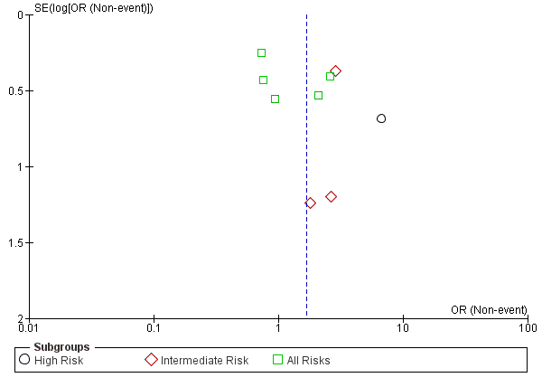

Figure 1.2 Funnel plot of studies depicts a comparison of the incidence of CMV disease among LT recipients undergoing antiviral prophylaxis and preemptive therapy.

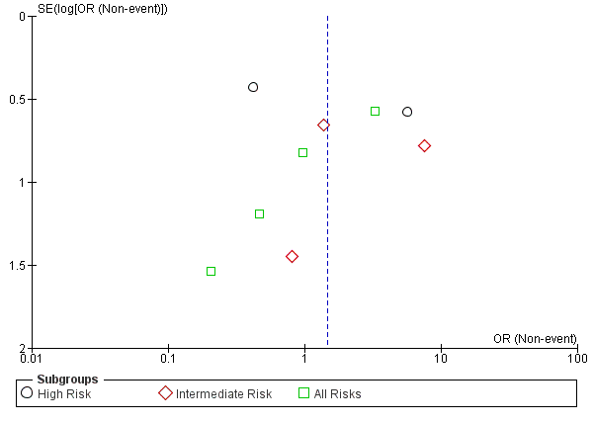

Figure 1.3 Funnel plot of studies depicts a comparison of the time to CMV infection among LT recipients undergoing antiviral prophylaxis and preemptive therapy.

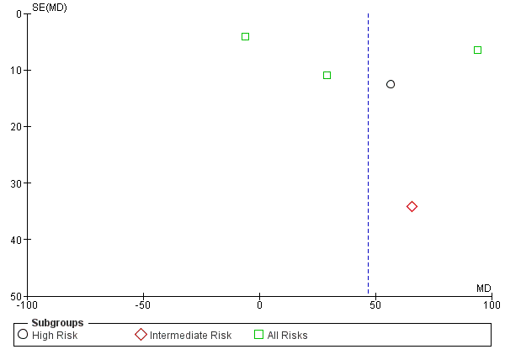

Figure 1.4 Funnel plot of studies depicts a comparison of the time to CMV disease among LT recipients undergoing antiviral prophylaxis and preemptive therapy.

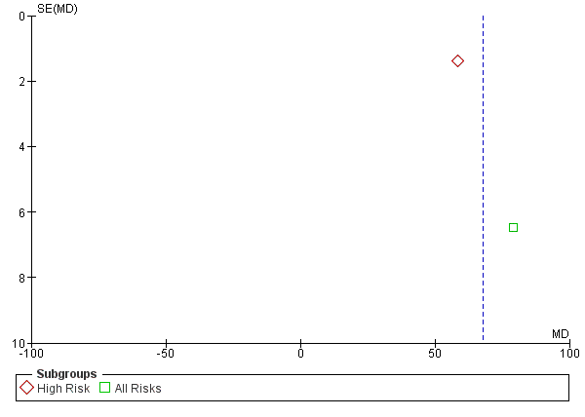

Figure 1.5 Funnel plot of studies depicts a comparison of the incidence of opportunistic infection among LT recipients undergoing antiviral prophylaxis and preemptive therapy.

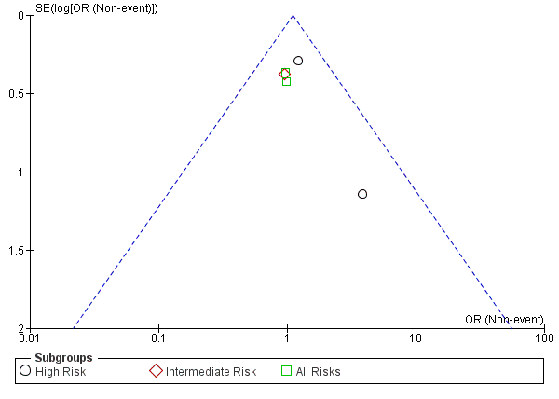

Figure 1.6 Funnel plot of studies depicts a comparison of the incidence of acute antibody-mediated rejection (AMR) among LT recipients undergoing antiviral prophylaxis and preemptive therapy.
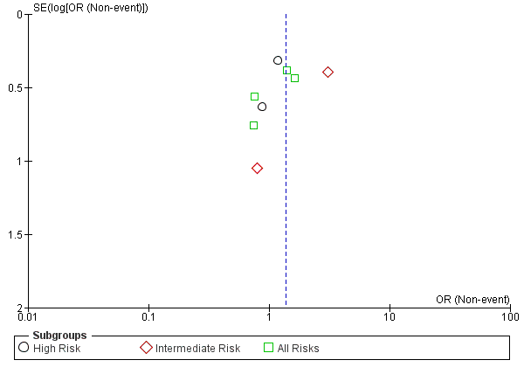

Figure 1.7 Funnel plot of studies depicts a comparison of the incidence of graft loss among LT recipients undergoing antiviral prophylaxis and preemptive therapy.

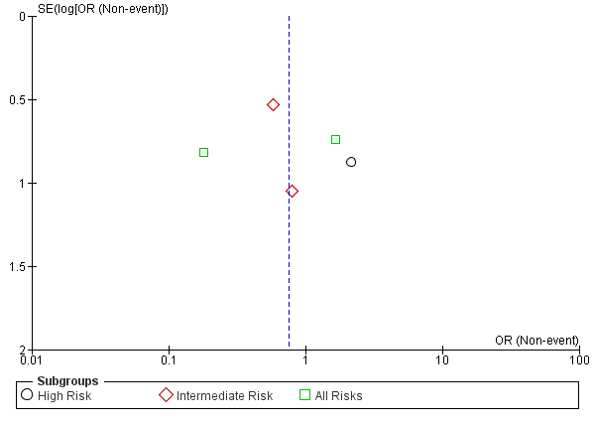

Figure 1.8 Funnel plot of studies depicts a comparison of the incidence of leukopenia among LT recipients undergoing antiviral prophylaxis and preemptive therapy.

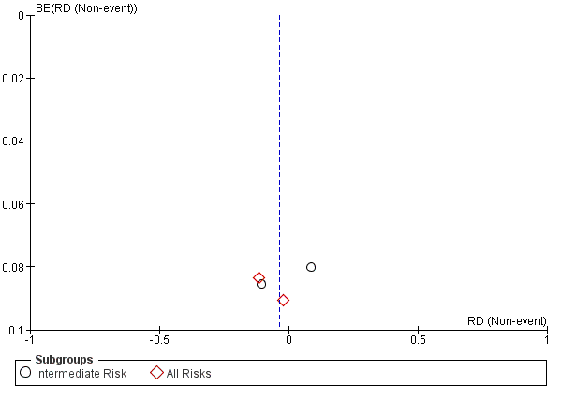

Figure 1.9 Funnel plot of studies depicts a comparison of the incidence of neutropenia among LT recipients undergoing antiviral prophylaxis and preemptive therapy.

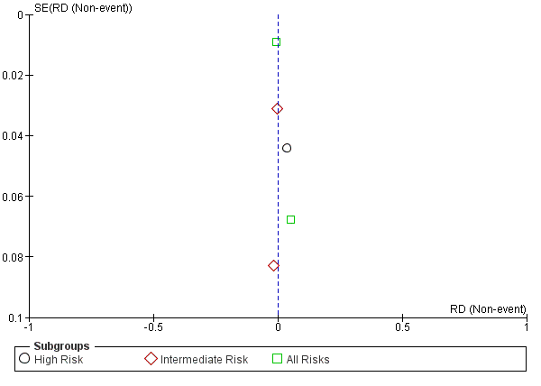

Figure 1.10 Funnel plot of studies depicts a comparison of the incidence of late onset CMV disease among LT recipients undergoing antiviral prophylaxis and preemptive therapy.

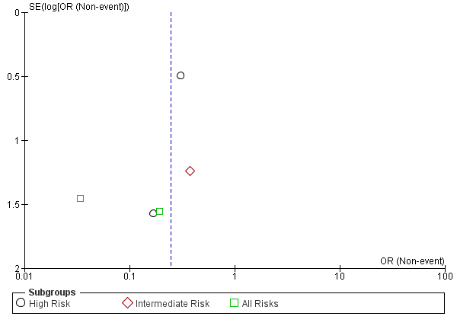

Figure 1.11 Funnel plot of studies depicts a comparison of the incidence of CMV specific neutralizing antibodies among LT recipients undergoing antiviral prophylaxis and preemptive therapy.

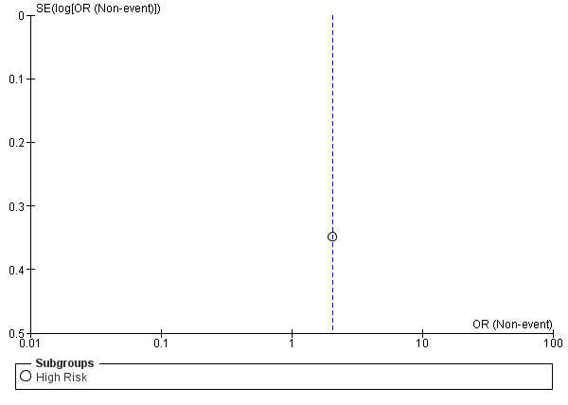

Figure 1.12 Funnel plot of studies depicts a comparison of the incidence of mortality among LT recipients undergoing antiviral prophylaxis and preemptive therapy.

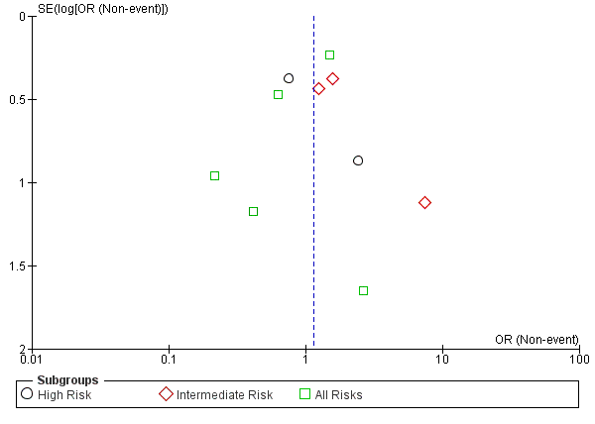

Figure 1.13 Funnel plot of studies depicts a comparison of the incidence of CMV-related mortality among LT recipients undergoing antiviral prophylaxis and preemptive therapy.

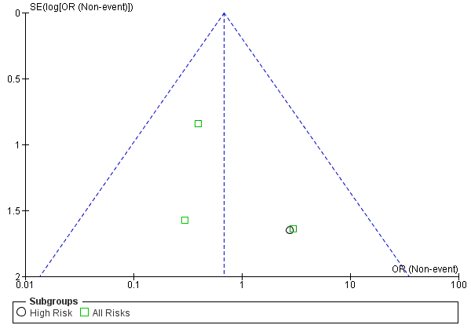

Figure 1.14 Funnel plot of studies depicts a comparison of the incidence of development of drug-resistance among LT recipients undergoing antiviral prophylaxis and preemptive therapy.
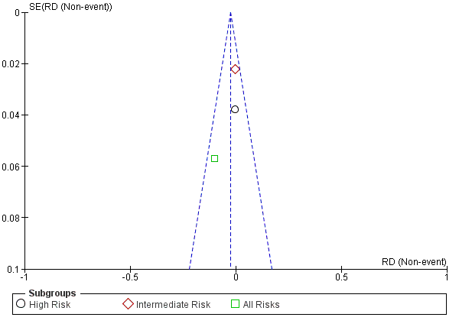

Figure 1.15 Funnel plot of studies depicts a comparison of the incidence of chronic rejection among LT recipients undergoing antiviral prophylaxis and preemptive therapy.

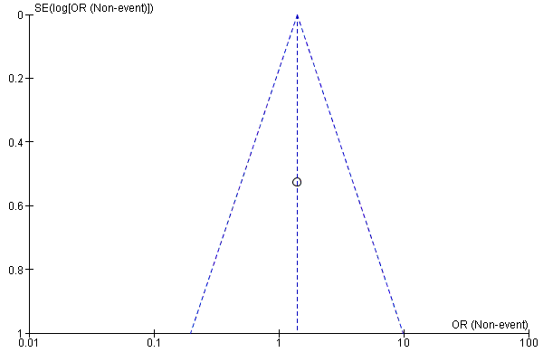

Supplemental figure 2: Incidence of CMV infection

Supplemental figure 2.1 Incidence of CMV infection in the overall LT recipients undergoing antiviral prophylaxis.
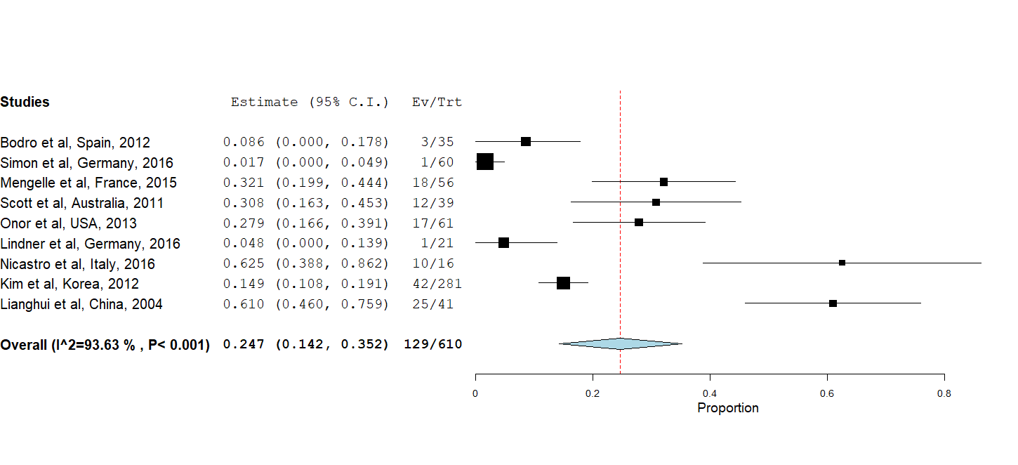

Supplemental figure 2.2 Incidence of CMV infection in the overall LT recipients undergoing preemptive therapy.
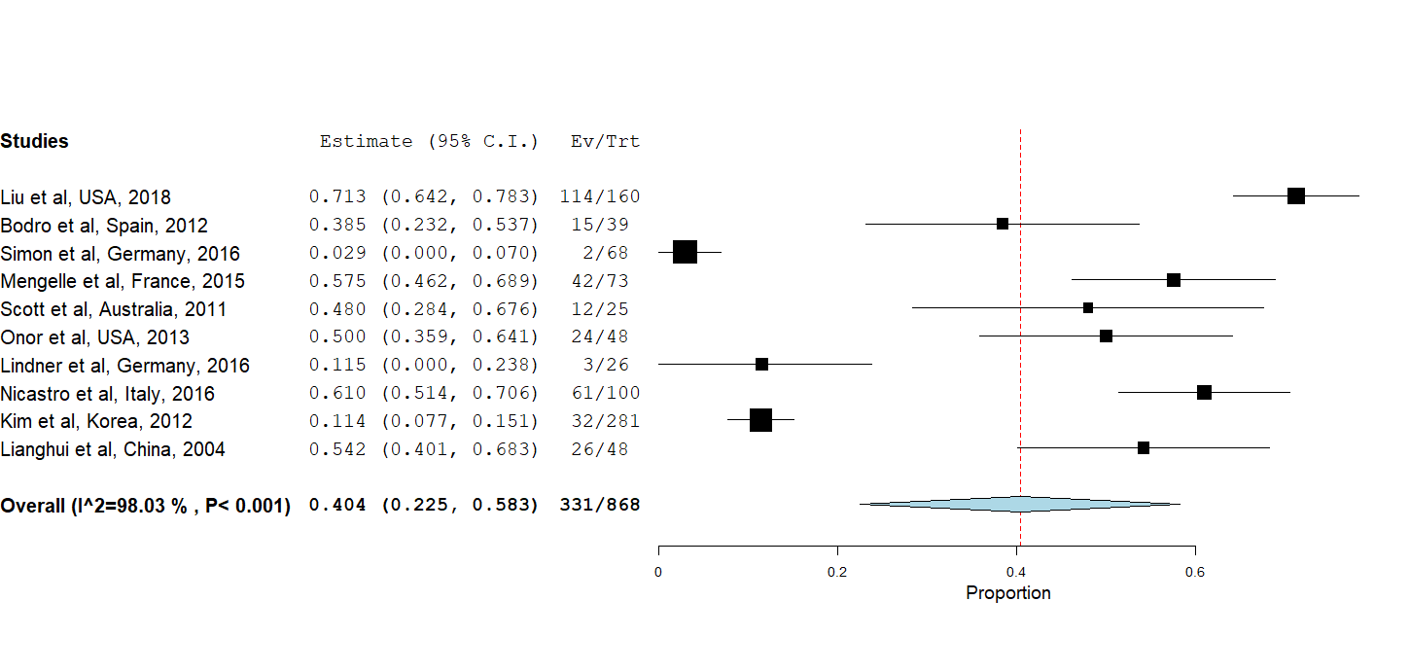

Supplemental figure 2.3 Incidence of CMV infection in the intermediate-risk group LT recipients undergoing antiviral prophylaxis.
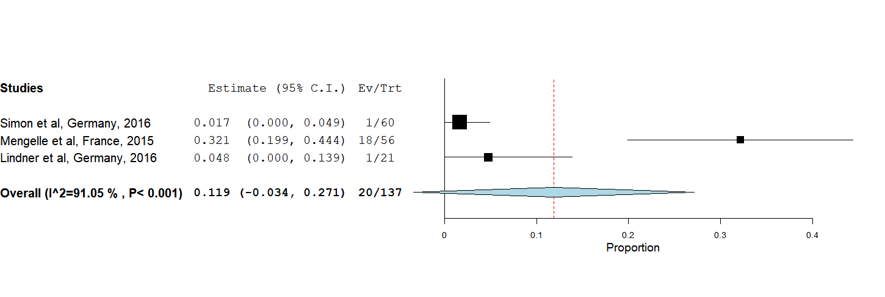

Supplemental figure 2.4 Incidence of CMV infection in the intermediate-risk group LT recipients undergoing preemptive therapy.
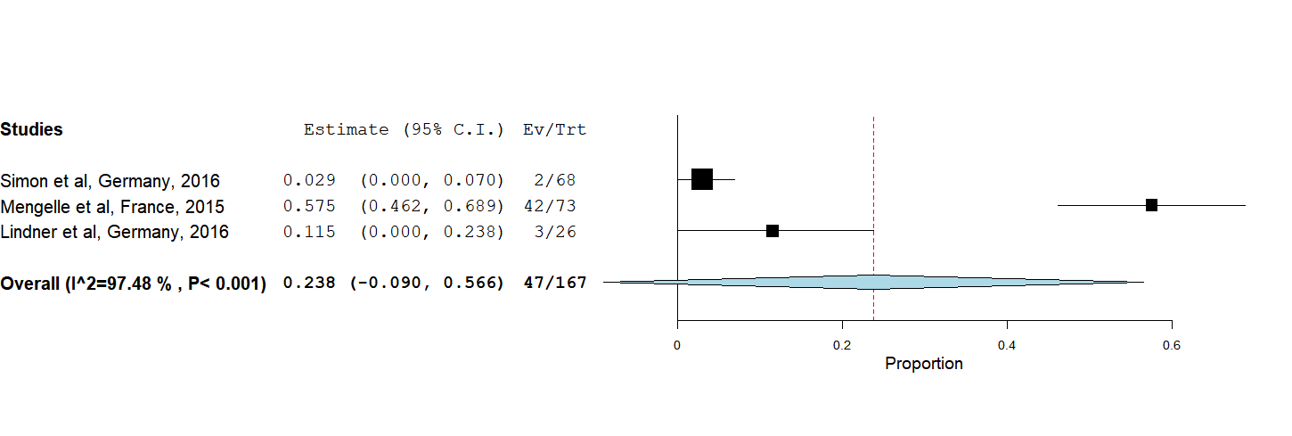

Supplemental figure 3 Incidence of CMV disease

Supplemental figure 3.1 Incidence of CMV disease in the overall LT recipients undergoing antiviral prophylaxis.
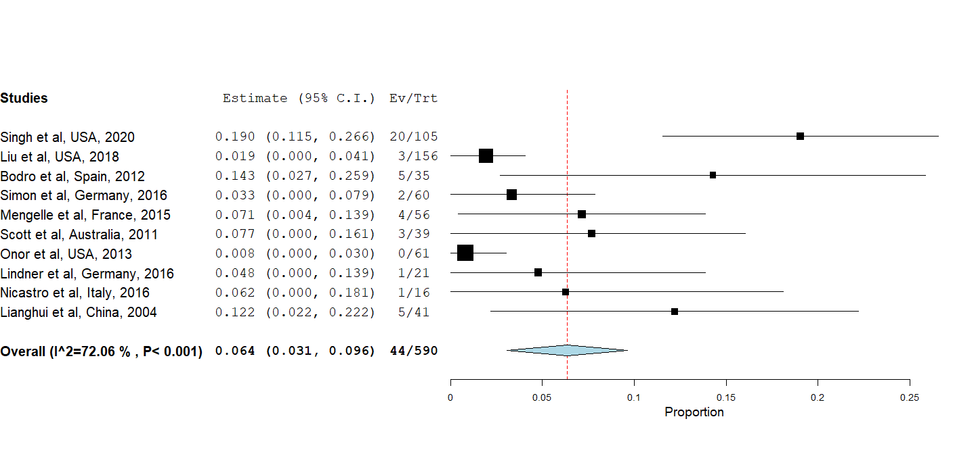

Supplemental figure 3.2 Incidence of CMV disease in the overall LT recipients undergoing preemptive therapy.
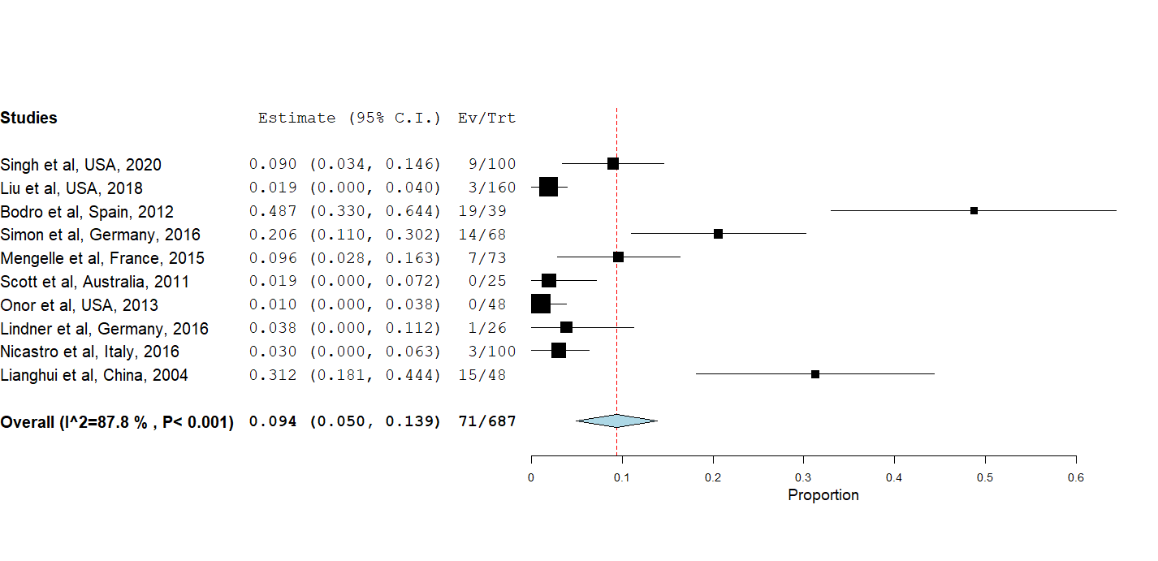

Supplemental figure 3.3 Incidence of CMV disease in the high-risk group LT recipients undergoing antiviral prophylaxis.
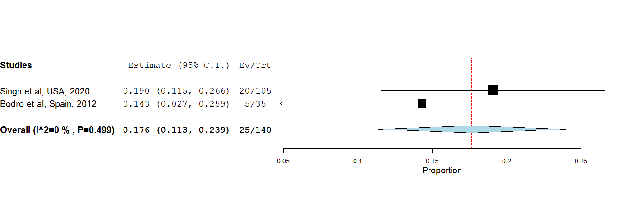

Supplemental figure 3.4 Incidence of CMV disease in the high-risk group LT recipients undergoing preemptive therapy.
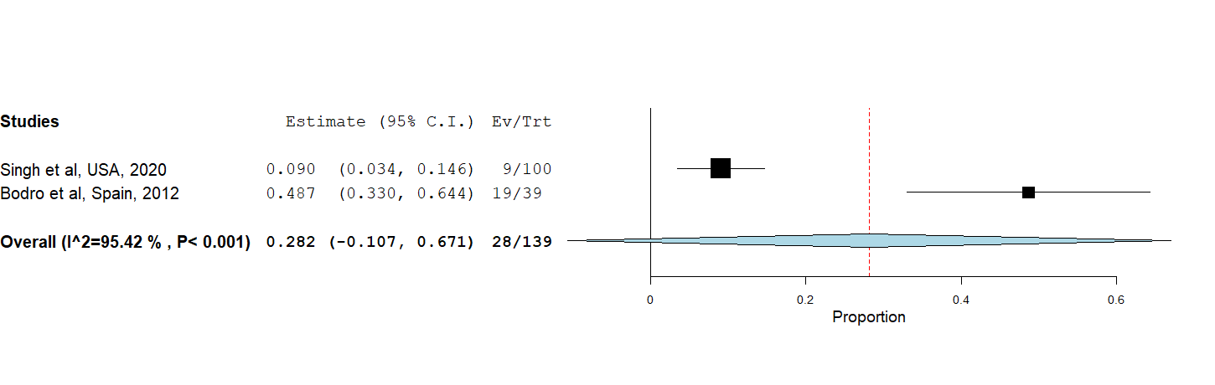

Supplemental figure 3.5 Incidence of CMV disease in the intermediate-risk group LT recipients undergoing antiviral prophylaxis.
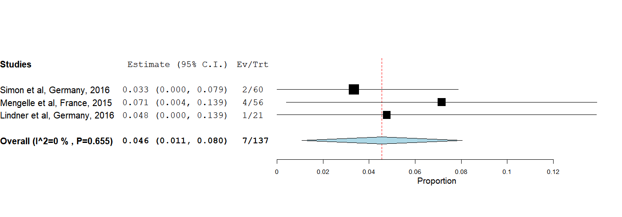

Supplemental figure 3.6 Incidence of CMV disease in the intermediate-risk group LT recipients undergoing preemptive therapy.
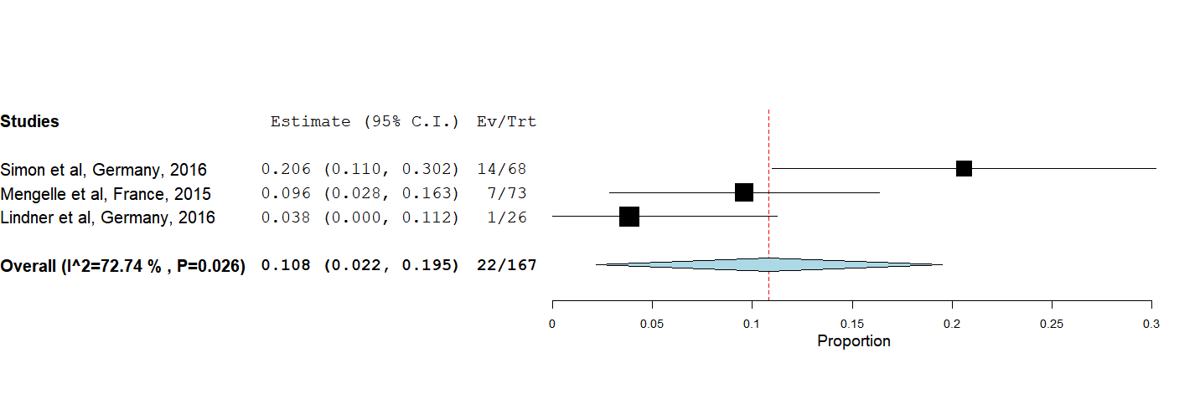

Supplemental figure 4: Incidence of opportunistic infection

Supplemental figure 4.1 Incidence of opportunistic infection in the overall LT recipients undergoing antiviral prophylaxis.
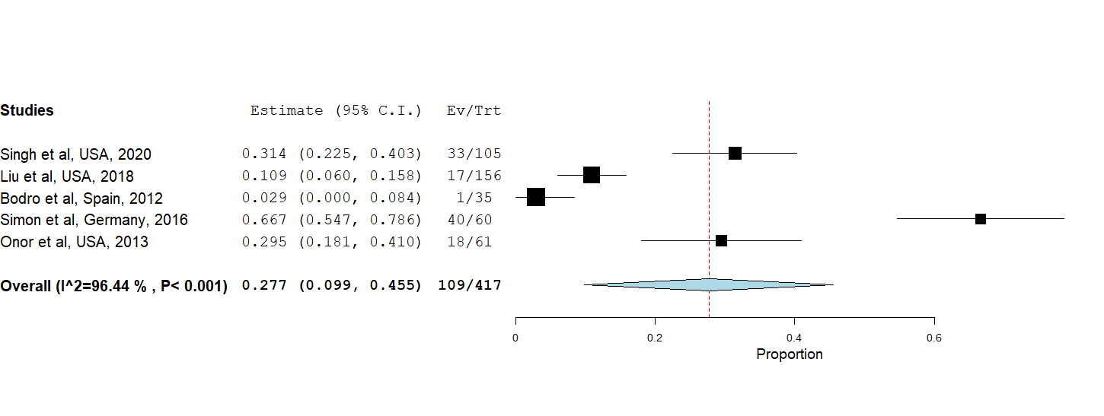

Supplemental figure 4.2 Incidence of opportunistic infection in the overall LT recipients undergoing preemptive therapy.
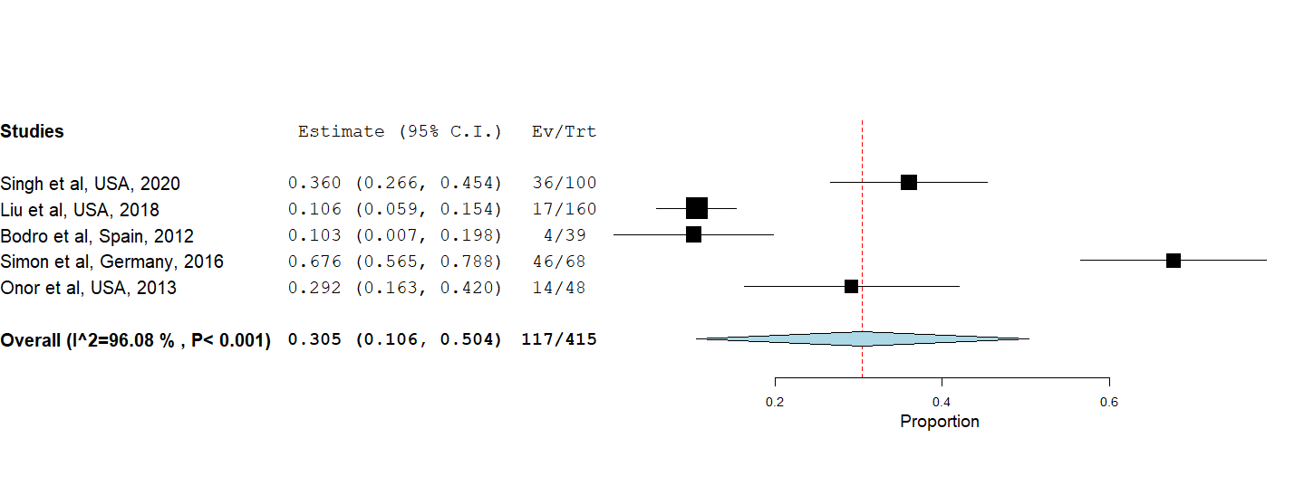

Supplemental figure 4.3 Incidence of opportunistic infection in the high-risk group LT recipients undergoing antiviral prophylaxis.
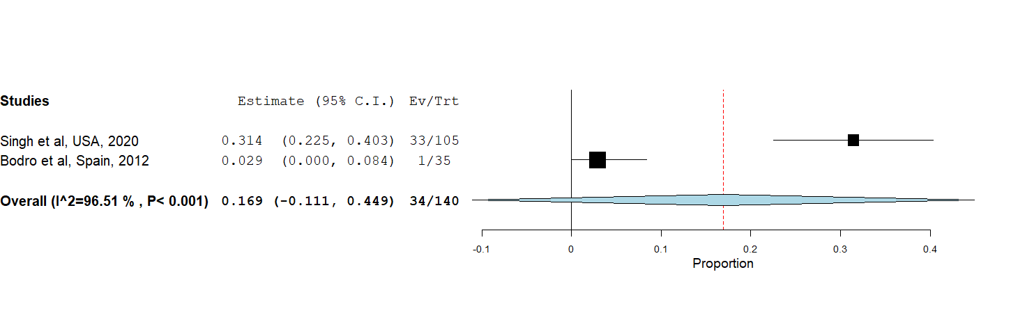

Supplemental figure 4.4 Incidence of opportunistic infection in the high-risk group LT recipients undergoing preemptive therapy.
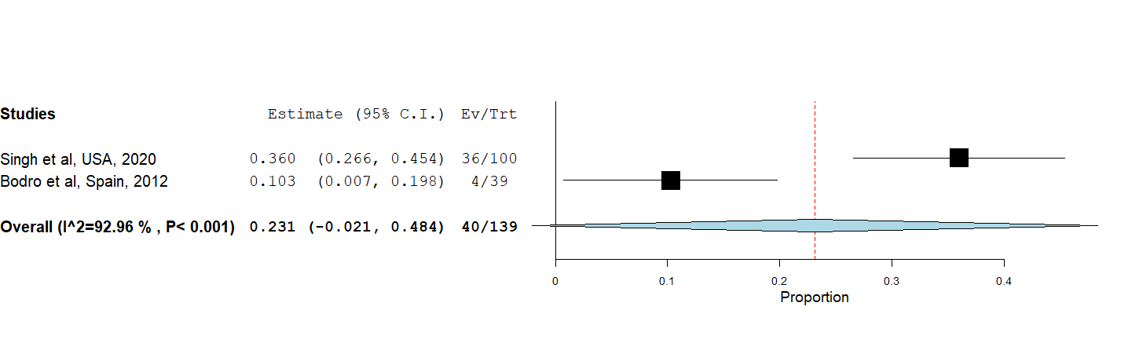

Supplemental figure 5: Incidence of acute antibody-mediated rejection (AMR)

Supplemental figure 5.1 Incidence of acute antibody-mediated rejection (AMR) in the overall LT recipients undergoing antiviral prophylaxis.
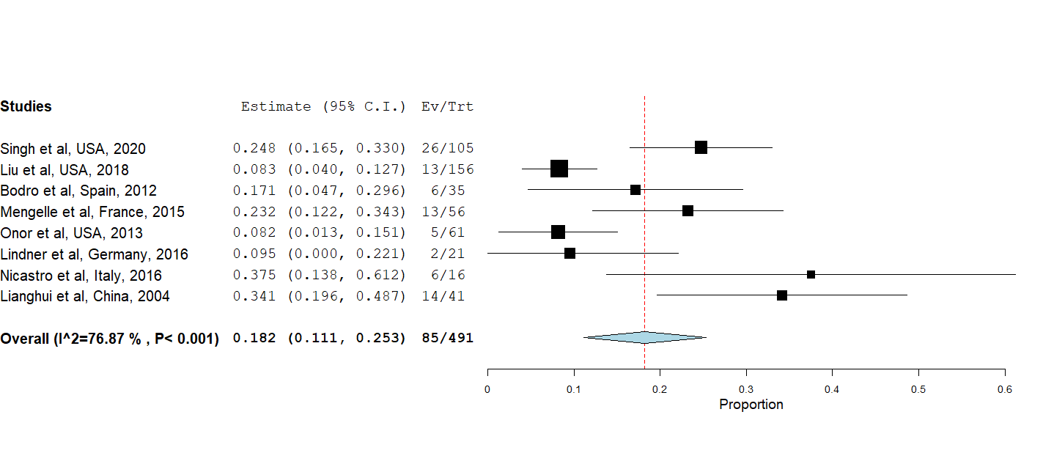

Supplemental figure 5.2 Incidence of acute antibody-mediated rejection (AMR) in the overall LT recipients undergoing preemptive therapy.
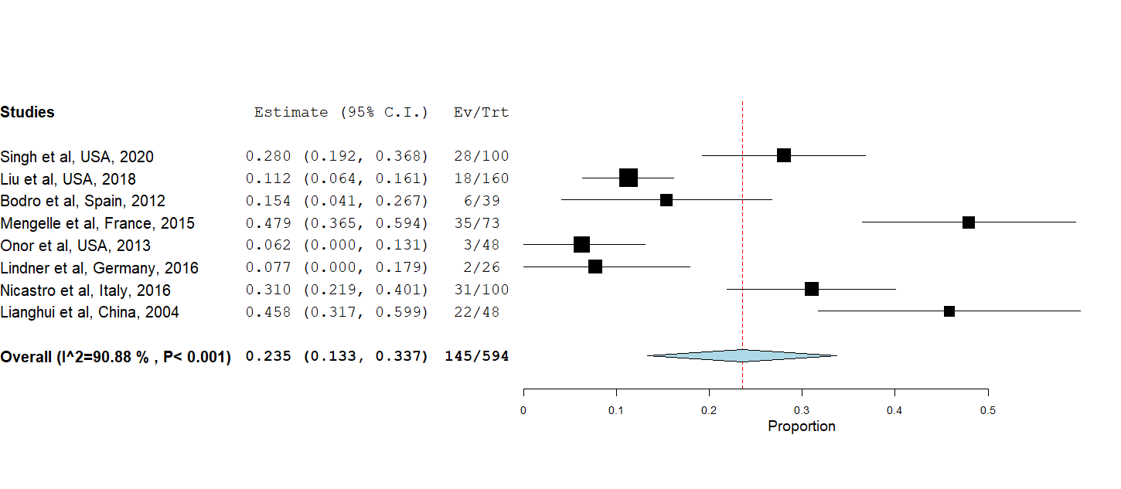

Supplemental figure 5.3 Incidence of acute antibody-mediated rejection (AMR) in the high-risk group LT recipients undergoing antiviral prophylaxis.
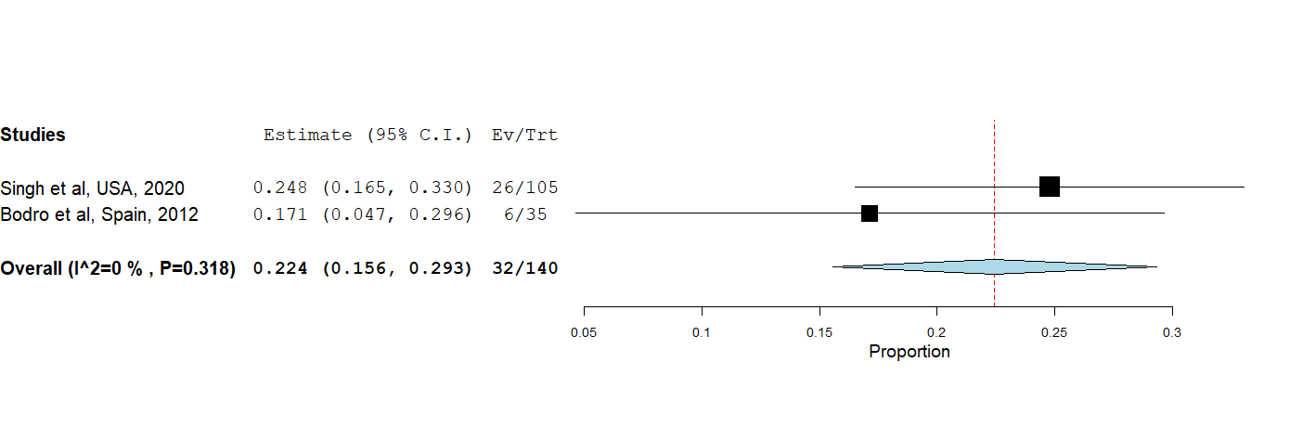

Supplemental figure 5.4 Incidence of acute antibody-mediated rejection (AMR) in the high-risk group LT recipients undergoing preemptive therapy.
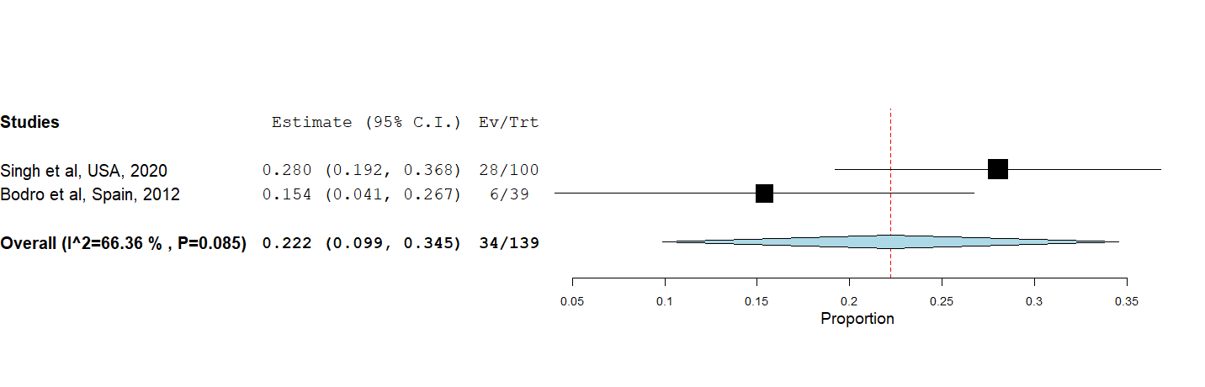

Supplemental figure 5.5 Incidence of acute antibody-mediated rejection (AMR) in the intermediate-risk group LT recipients undergoing antiviral prophylaxis.
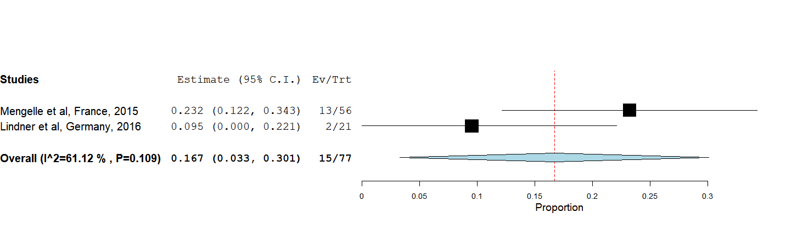

Supplemental figure 5.6 Incidence of acute antibody-mediated rejection (AMR) in the intermediate-risk group LT recipients undergoing preemptive therapy.
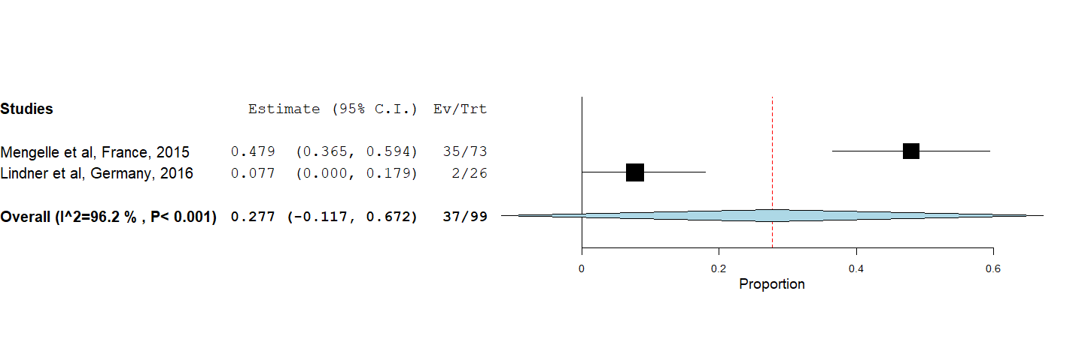

Supplemental figure 6: Incidence of graft loss

Supplemental figure 6.1 Incidence of graft loss in the overall LT recipients undergoing antiviral prophylaxis.
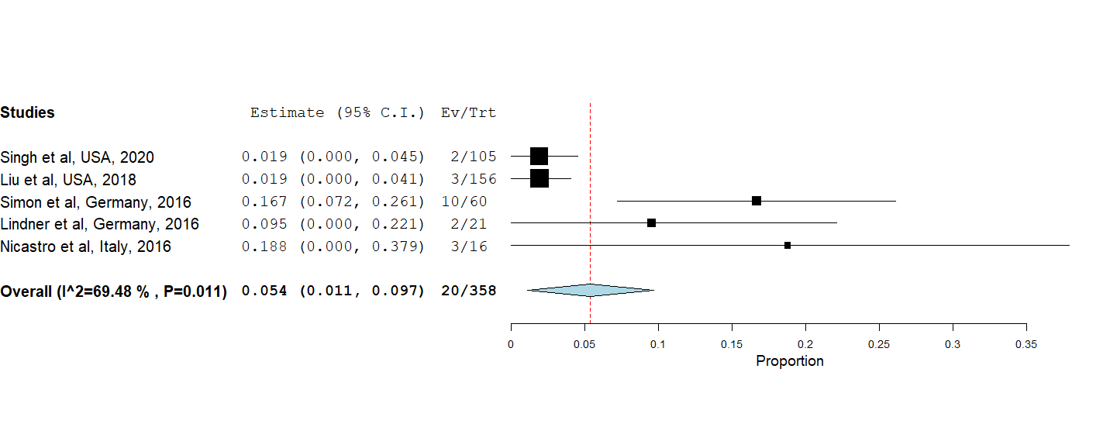

Supplemental figure 6.2 Incidence of graft loss in the overall LT recipients undergoing preemptive therapy.
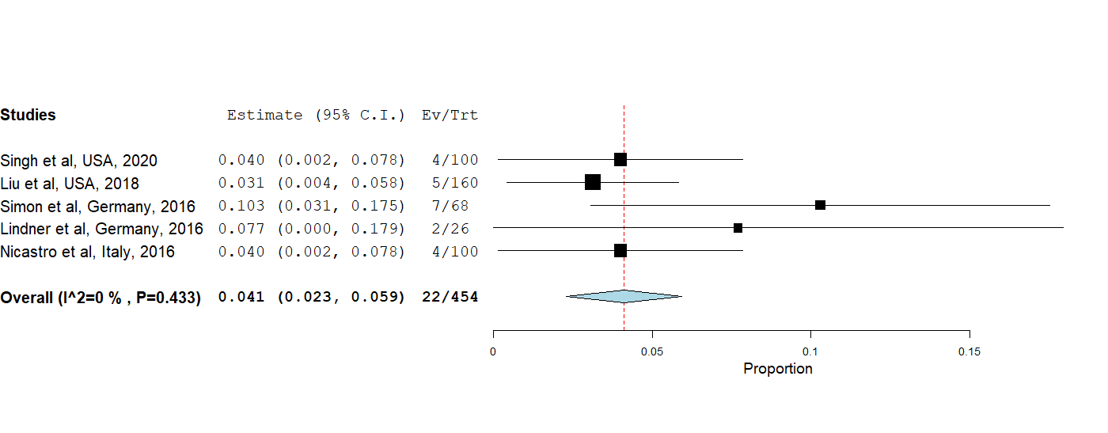

Supplemental figure 6.3 Incidence of graft loss in the intermediate-risk group LT recipients undergoing antiviral prophylaxis.
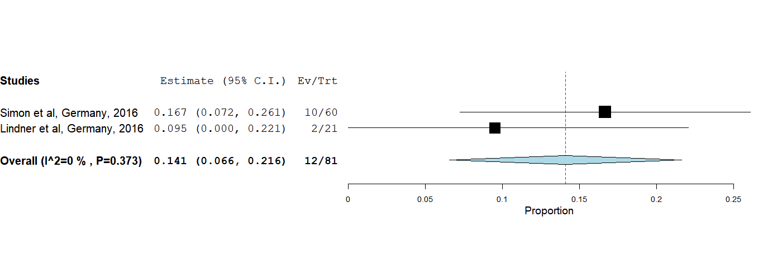

Supplemental figure 6.4 Incidence of graft loss in the intermediate-risk group LT recipients undergoing preemptive therapy.
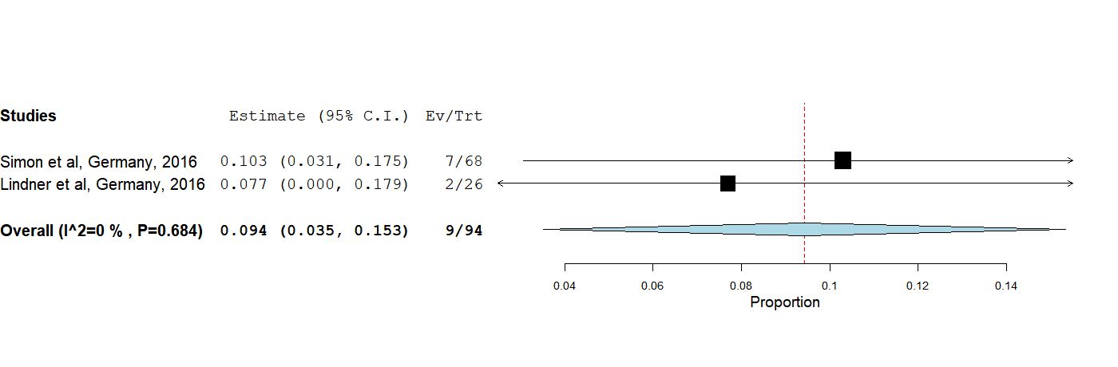

Supplemental figure 7: Incidence of leukopenia

Supplemental figure 7.1 Incidence of leukopenia in the overall LT recipients undergoing antiviral prophylaxis.
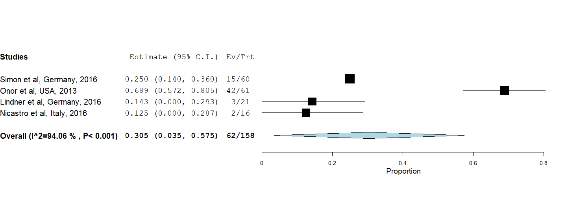

Supplemental figure 7.2 Incidence of leukopenia in the overall LT recipients undergoing preemptive therapy.
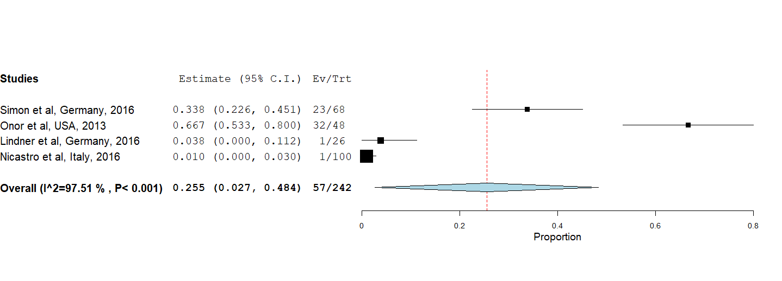

Supplemental figure 7.3 Incidence of leukopenia in the intermediate-risk group LT recipients undergoing antiviral prophylaxis.
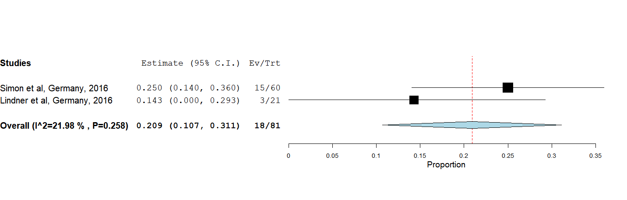

Supplemental figure 7.4 Incidence of leukopenia in the intermediate-risk group LT recipients undergoing preemptive therapy.
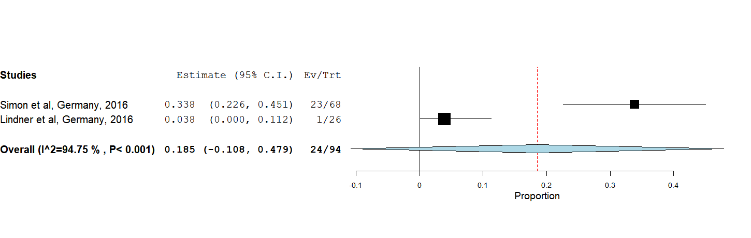

Supplemental figure 8: Incidence of neutropenia

Supplemental figure 8.1 Incidence of neutropenia in the overall LT recipients undergoing antiviral prophylaxis.
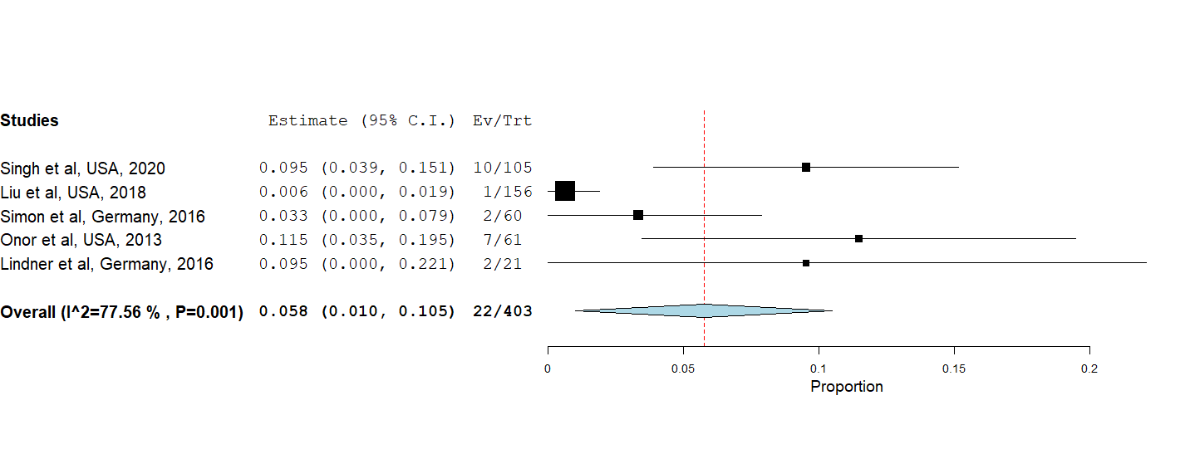

Supplemental figure 8.2 Incidence of neutropenia in the overall LT recipients undergoing preemptive therapy.
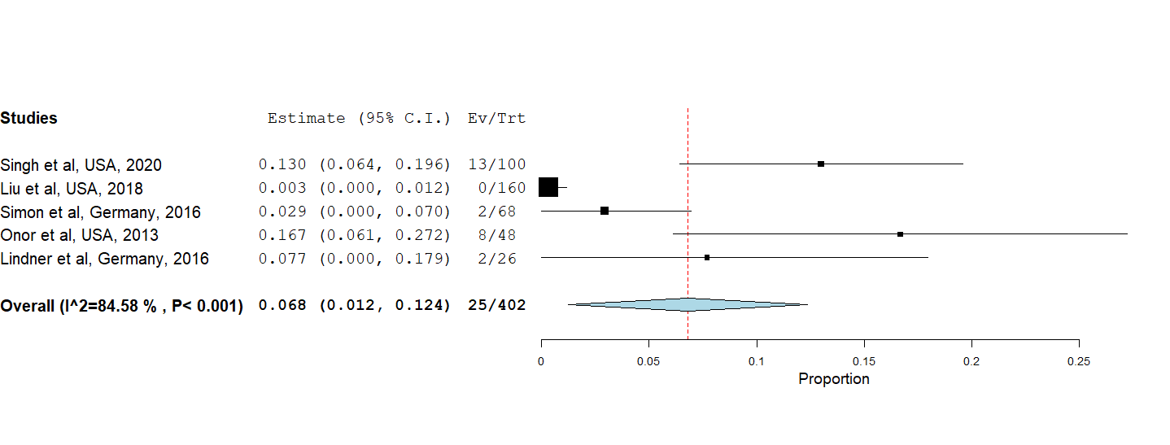

Supplemental figure 8.3 Incidence of neutropenia in the intermediate-risk group LT recipients undergoing antiviral prophylaxis.
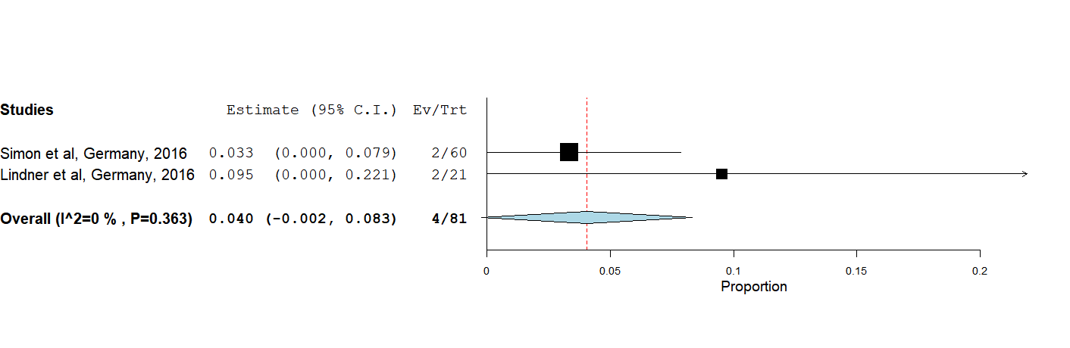

Supplemental figure 8.4 Incidence of neutropenia in the intermediate-risk group LT recipients undergoing preemptive therapy.
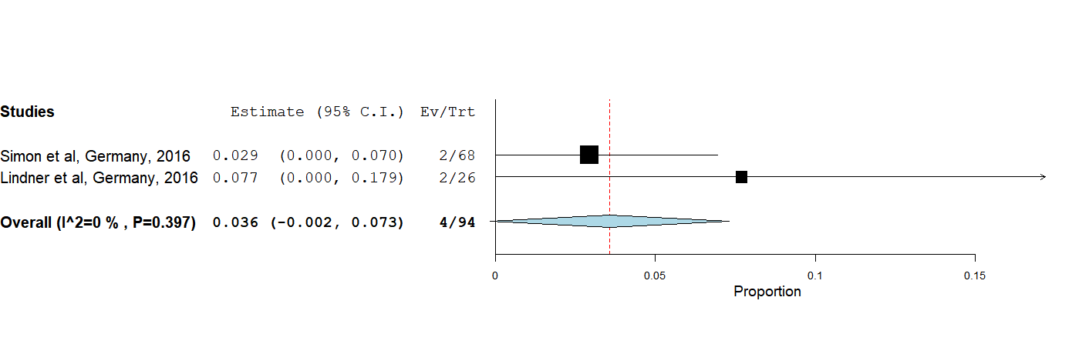

Supplemental figure 9: Incidence of late-onset CMV disease

Supplemental figure 9.1 Incidence of late-onset CMV disease in the overall LT recipients undergoing antiviral prophylaxis.
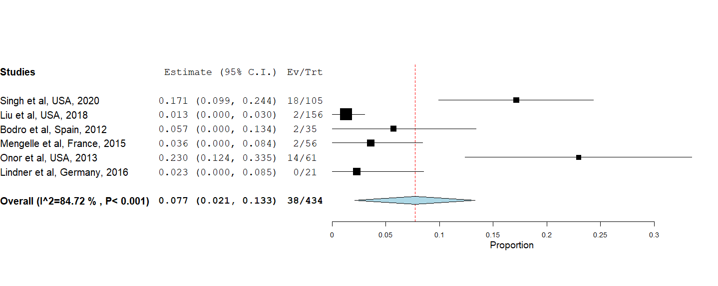

Supplemental figure 9.2 Incidence of late-onset CMV disease in the overall LT recipients undergoing preemptive therapy.
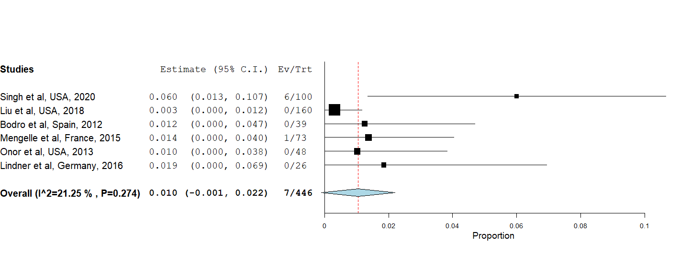

Supplemental figure 9.3 Incidence of late-onset CMV disease in the high-risk group LT recipients undergoing antiviral prophylaxis.
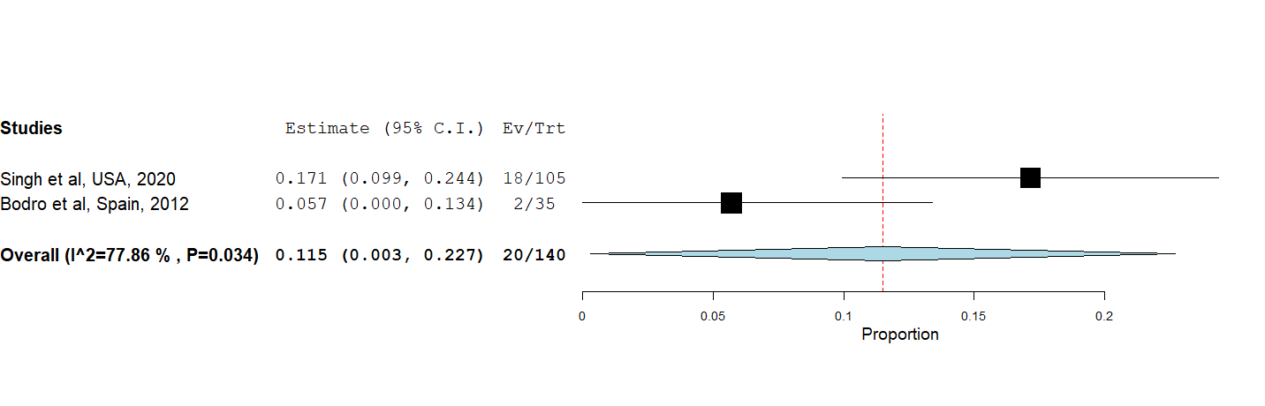

Supplemental figure 9.4 Incidence of late-onset CMV disease in the high-risk group LT recipients undergoing preemptive therapy.
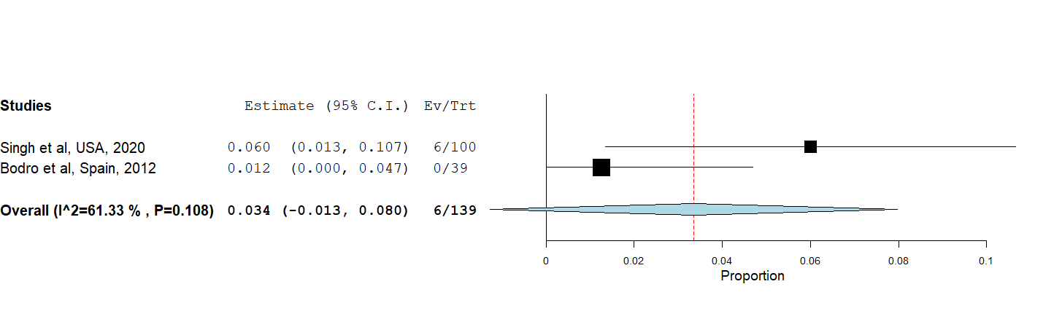

Supplemental figure 9.5 Incidence of late-onset CMV disease in the intermediate-risk group LT recipients undergoing antiviral prophylaxis.
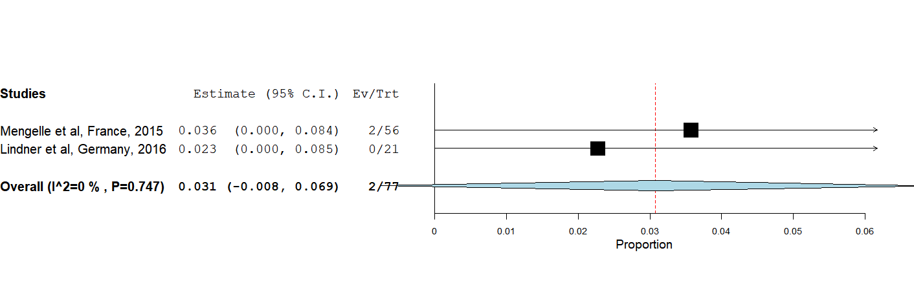

Supplemental figure 9.6 Incidence of late-onset CMV disease in the intermediate-risk group LT recipients undergoing preemptive therapy.

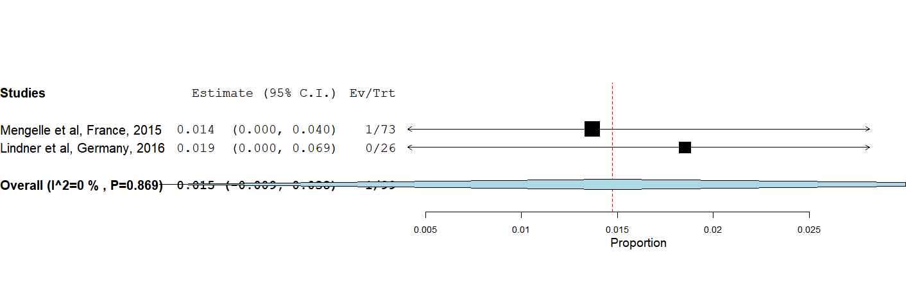

Supplemental figure 10: Incidence of mortality

Supplemental figure 10.1 Incidence of mortality in the overall LT recipients undergoing antiviral prophylaxis.
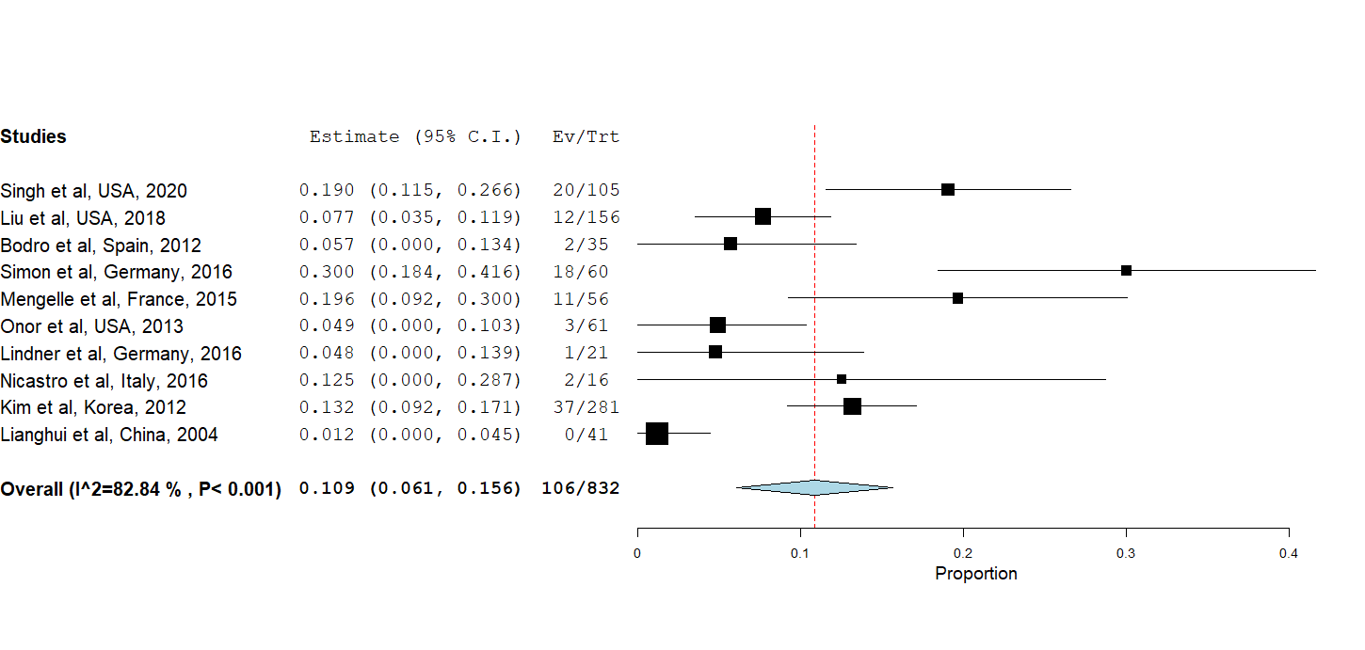

Supplemental figure 10.2 Incidence of mortality in the overall LT recipients undergoing preemptive therapy.
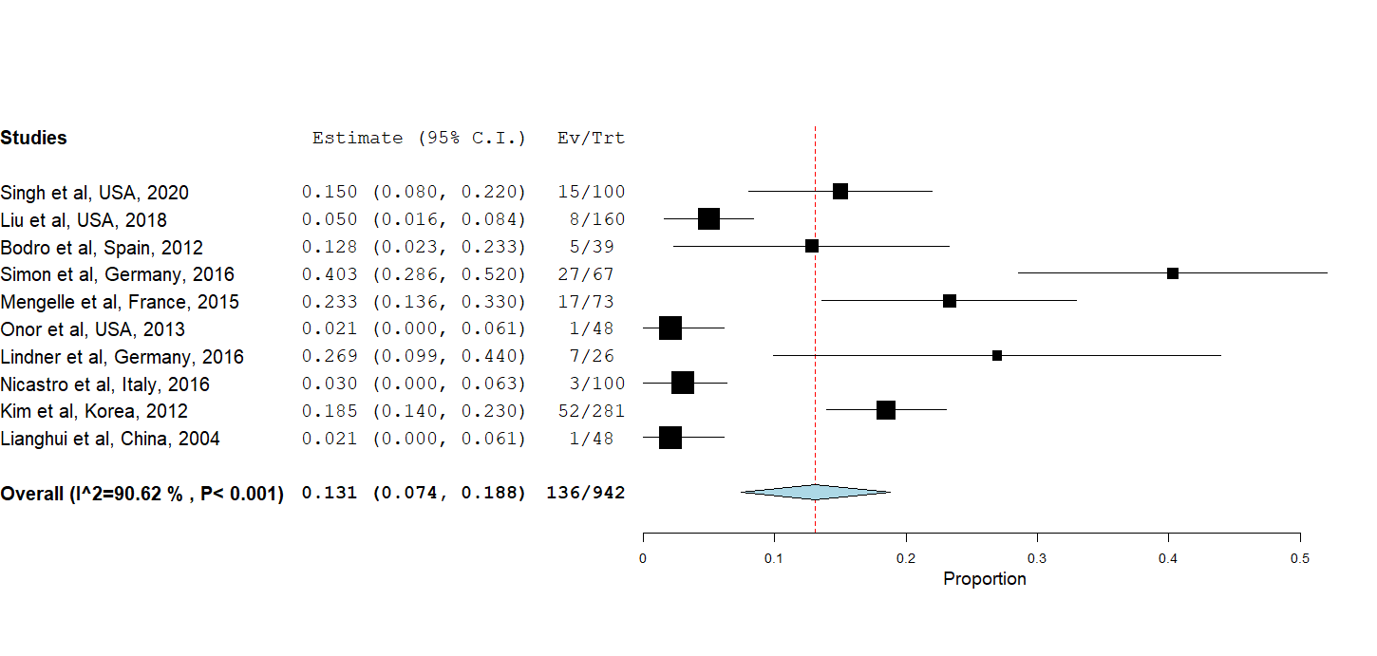

Supplemental figure 10.3 Incidence of mortality in the high-risk group LT recipients undergoing antiviral prophylaxis.
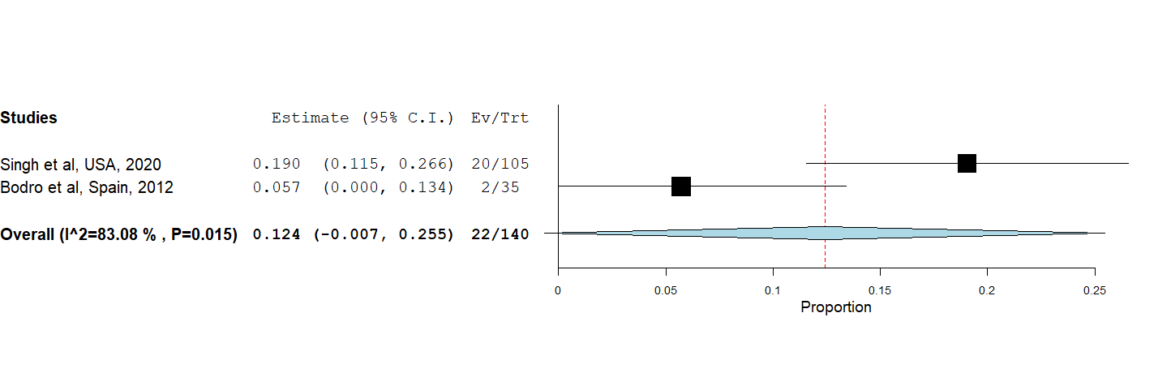

Supplemental figure 10.4 Incidence of mortality in the high-risk group LT recipients undergoing preemptive therapy.
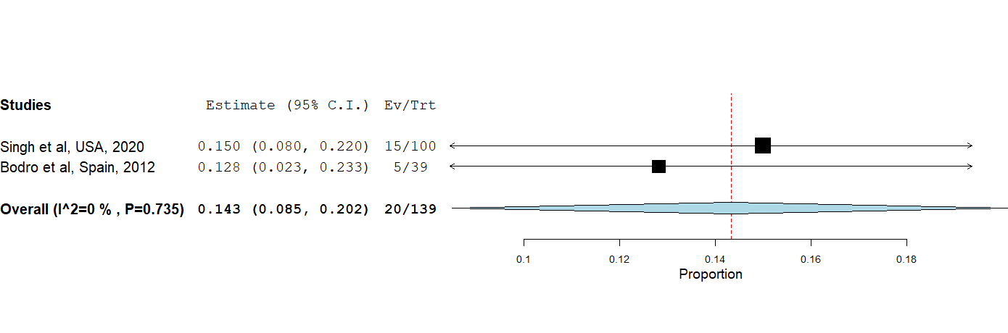

Supplemental figure 10.5 Incidence of mortality in the intermediate-risk group LT recipients undergoing antiviral prophylaxis.
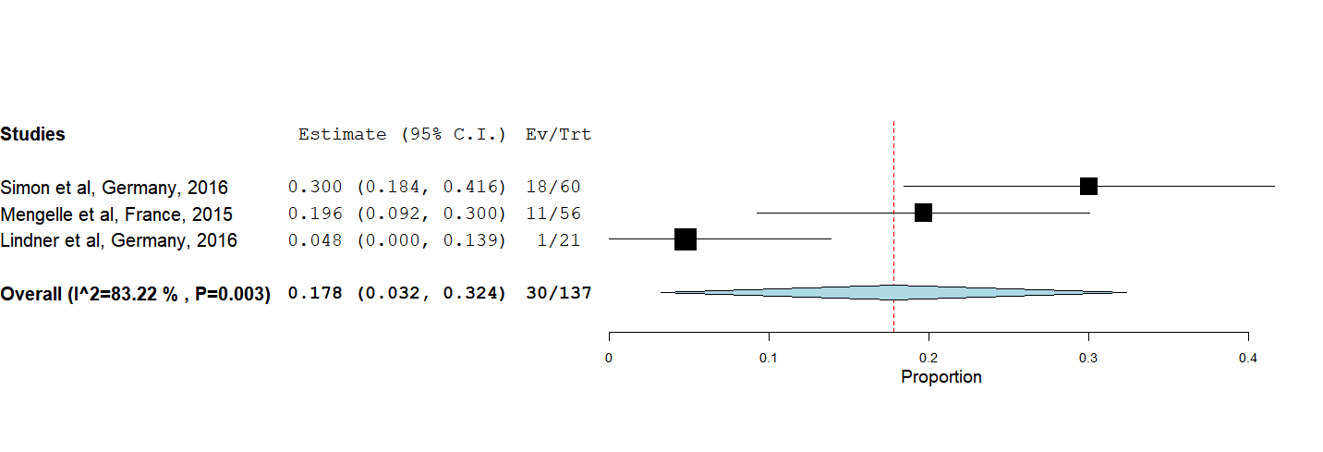

Supplemental figure 10.6 Incidence of mortality in the intermediate-risk group LT recipients undergoing preemptive therapy.
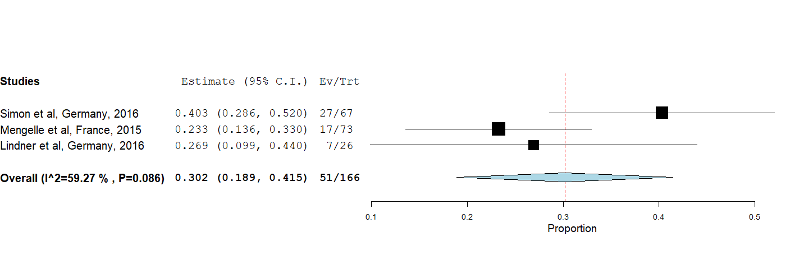

Supplemental figure 11: Incidence of CMV related mortality

Supplemental figure 11.1 Incidence of CMV related mortality in the overall LT recipients undergoing antiviral prophylaxis.
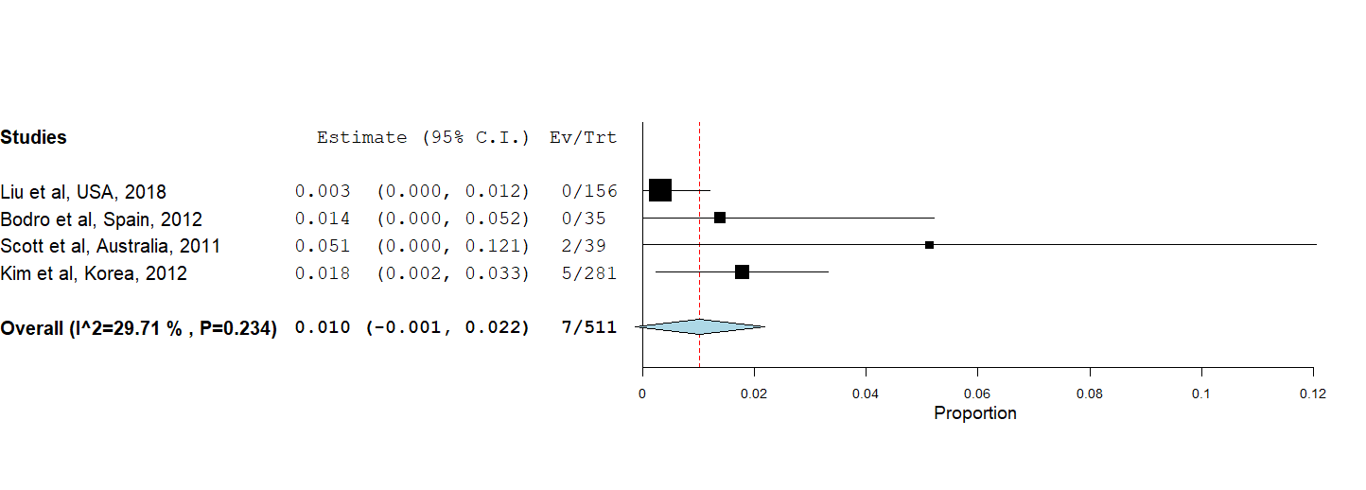

Supplemental figure 11.2 Incidence of CMV related mortality in the overall LT recipients undergoing preemptive therapy.
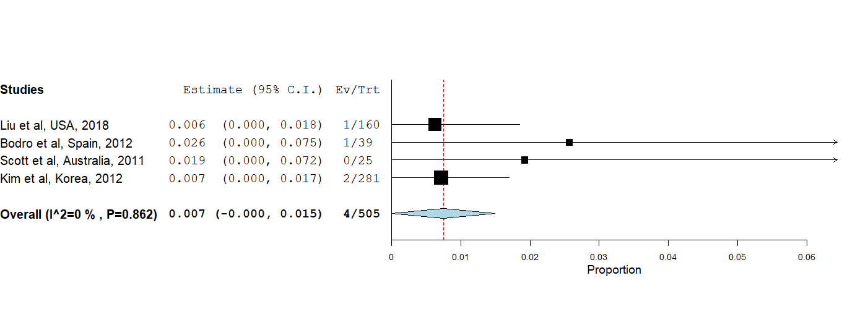

Supplemental figure 12: Incidence of the development of drug resistance

Supplemental figure 12.1 Incidence of drug resistance development in the overall LT recipients undergoing antiviral prophylaxis.
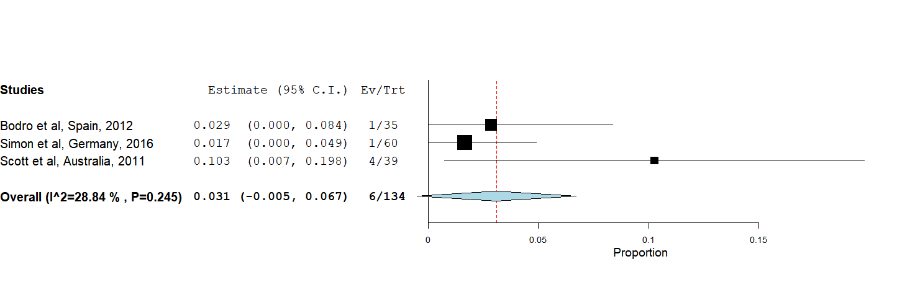

Supplemental figure 12.2 Incidence of the development of drug resistance in the overall LT recipients undergoing preemptive therapy.
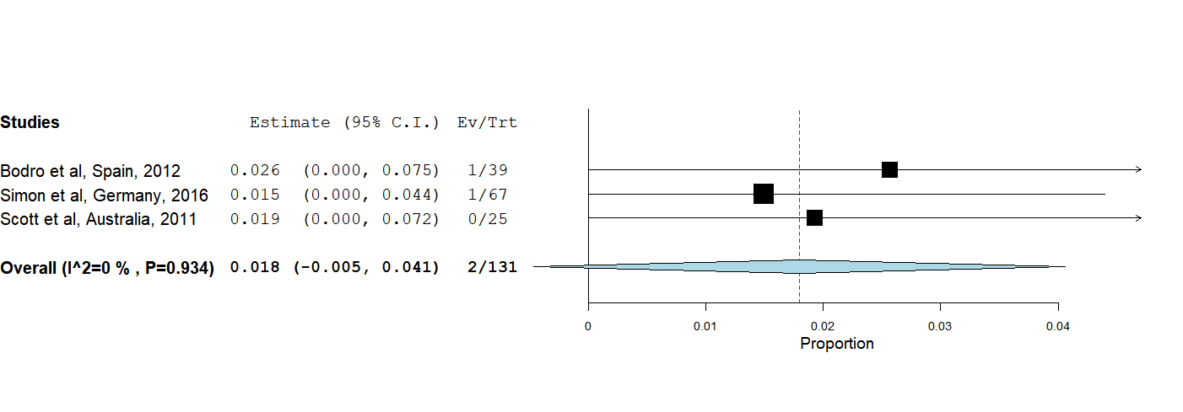

Supplemental figure 13

Supplemental figure 13.1 Forest plot depicts a comparison of the incidence of CMV specific neutralizing antibodies among LT recipients undergoing antiviral prophylaxis and preemptive therapy.

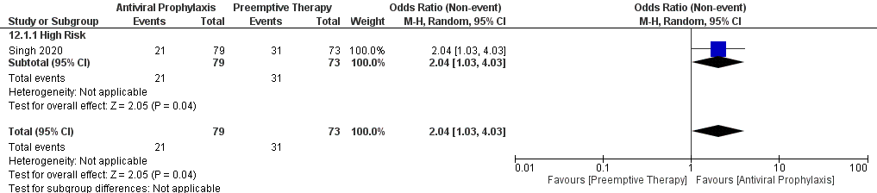

Supplemental figure 13.2 Forest plot depicts a comparison of the incidence of the development of drug resistance among LT recipients undergoing antiviral prophylaxis and preemptive therapy.

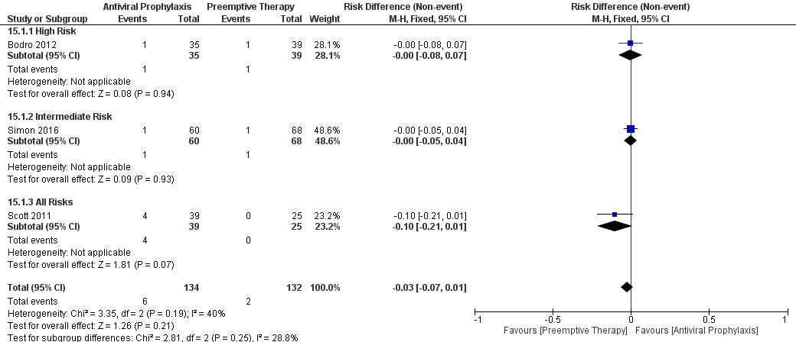

Supplemental figure 13.3 Forest plot depicts a comparison of the incidence of chronic rejection among LT recipients undergoing antiviral prophylaxis and preemptive therapy.



