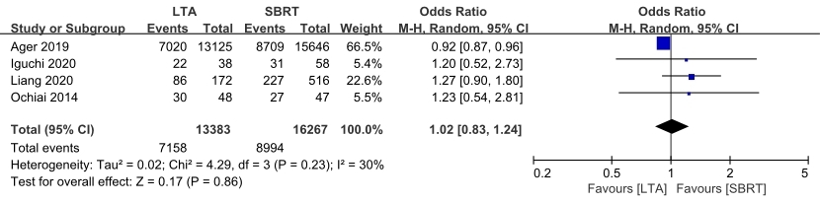

Supplementary Figure 1: Forest plot of 2-year OS for groups of LTA and SBRT. CI: Confidence interval; LTA: Percutaneous local tumor ablation; OS: Overall survival; SBRT: Stereotactic body radiotherapy.

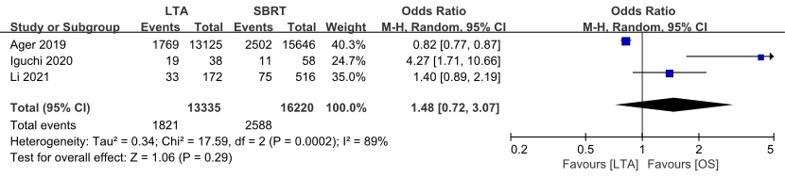
Supplementary Figure 2: Forest plot of 4-year OS for groups of LTA and SBRT. CI: Confidence interval; LTA: Percutaneous local tumor ablation; OS: Overall survival; SBRT: Stereotactic body radiotherapy.

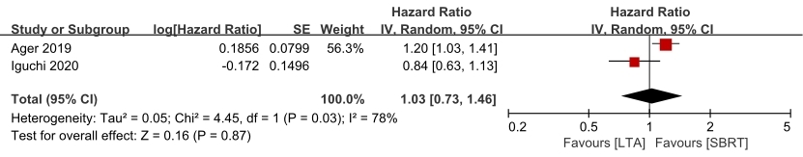
Supplementary Figure 3: Subgroup analysis of OS for groups of LTA and SBRT for adenocarcinoma. CI: Confidence interval; LTA: Percutaneous local tumor ablation; OS: Overall survival; SBRT: Stereotactic body radiotherapy; SE: Standard error.

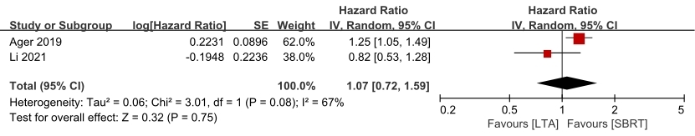
Supplementary Figure 4: Subgroup analysis of OS for groups of LTA and SBRT for squamous cell carcinoma. CI: Confidence interval; LTA: Percutaneous local tumor ablation; OS: Overall survival; SBRT: Stereotactic body radiotherapy; SE: Standard error.

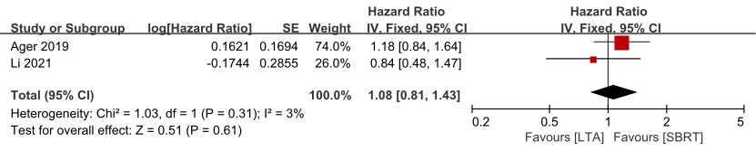
Supplementary Figure 5: Subgroup analysis of OS for groups of LTA and SBRT for patients aged ≤65 years. CI: Confidence interval; LTA: Percutaneous local tumor ablation; OS: Overall survival; SBRT: Stereotactic body radiotherapy; SE: Standard error.

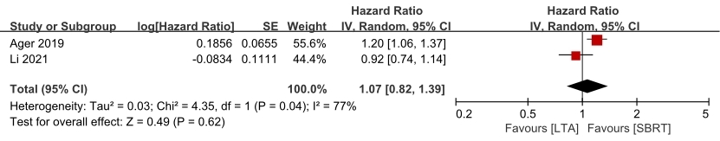
Supplementary Figure 6: Subgroup analysis of OS for groups of LTA and SBRT for patients aged >65 years. CI: Confidence interval; LTA: Percutaneous local tumor ablation; OS: Overall survival; SBRT: Stereotactic body radiotherapy; SE: Standard error.

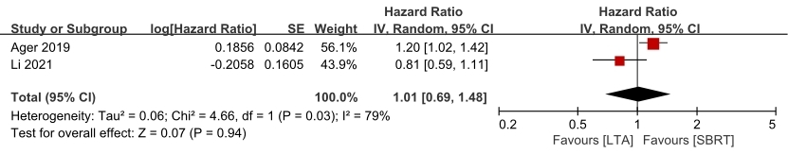
Supplementary Figure 7: Subgroup analysis of OS for groups of LTA and SBRT for male. CI: Confidence interval; LTA: Percutaneous local tumor ablation; OS: Overall survival; SBRT: Stereotactic body radiotherapy; SE: Standard error.

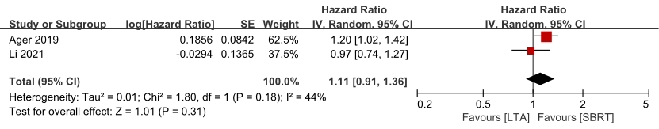
Supplementary Figure 8: Subgroup analysis of OS for groups of LTA and SBRT for female. CI: Confidence interval; LTA: Percutaneous local tumor ablation; OS: Overall survival; SBRT: stereotactic body radiotherapy; SE: Standard error.

