Supplementary Material 2 – Sensitivity analysis

The results summarised here reflect a repeated analysis whereby studies with arms of 18 or fewer people were excluded and where network nodes comprised of therapy approaches with less than three studies were excluded.
Contents
Figure 1. The network structure for PTSD psychotherapies. 1
Table 1. League table for network and direct efficacy estimates. 2
Table 2. League table for network and direct acceptability estimates. 3
Table 3. Ranking of Network estimates of efficacy and acceptability compared to waitlist. 4
Figure 2. Forest plot of NMA estimates compared to waitlist. 5
Figure 4. Ranking of efficacy and acceptability outcomes. 6

Figure 1. The network structure for PTSD psychotherapies.
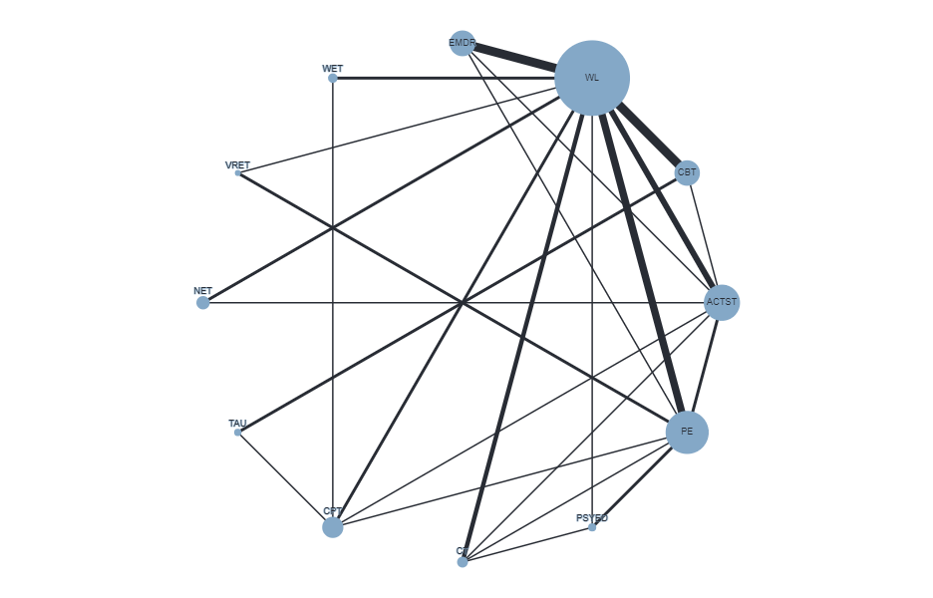
The size of each node is proportional to the number of participants, and the width of the lines is proportional to the number of trials comparing each pair of interventions. ACTST; Active Supportive Therapy (control); BET, Brief Eclectic Therapy; CBT, Cognitive behavioural therapy; CPT, Cognitive Processing Therapy; CT, cognitive therapy; DET, Dialogical Exposure Therapy; EMDR, eye movement desensitization and reprocessing; IPT, Interpersonal Therapy; MCT, Metacognitive Therapy; NET, Narrative Exposure Therapy; PE, Prolonged Exposure; PE-SIT, Prolonged Exposure and Stress Inoculation Training; PSYED, Psychoeducation (control); PDT, Psychodynamic Therapy; SIT, Stress Inoculation Training; STAIR-PE, Skills training in affective and interpersonal regulation followed by prolonged exposure; TARGET, Trauma Affect Regulation: Guide for Education and Therapy; TAU, Treatment as usual; VRET, Virtual Reality Exposure Therapy; WET, Written Exposure Therapy; WL, Waitlist (control).

Table 1. League table for network and direct efficacy estimates.
Standardised mean differences (SMD; 95% CI) of Direct and overall Network Estimates of Efficacy
ACTST | -0.24 (-1.54, 1.06) | 3.09 (1.76, 4.43)** | 0.91 (-0.37, 2.20) | 0.02 (-1.30, 1.34) | -0.02 (-1.21, 1.18) | 0.52 (-0.36, 1.39) |  |  |  |  | -0.82 (-1.45, -0.18)
-0.13 (-0.76, 0.50) | CBT |  |  |  |  |  |  | -0.15 (-1.06, 0.77) |  |  | -0.62 (-1.14, -0.10)
-1.21 (-1.90, -0.52) | -1.08 (-1.81, -0.35) | CPT |  |  |  | -0.38 (-1.61, 0.84) |  | -0.57 (-1.85, 0.71) |  | -0.14 (-1.36, 1.09) | -1.14 (-2.03, -0.24)*
-0.46 (-1.18, 0.25) | -0.33 (-1.12, 0.45) | 0.75 (-0.11, 1.60) | CT |  |  | 0.09 (-1.18, 1.37) | -0.17 (-1.47, 1.12) |  |  |  | -0.87 (-1.61, 0.12)
-0.64 (-1.26, -0.02) | -0.51 (-1.19, 0.17) | 0.57 (-0.19, 1.34) | -0.17 (-0.95, 0.60) | EMDR |  | 0.00 (-1.23, 1.23) |  |  |  |  | -1.25 (-1.78, -0.72)
0.06 (-0.80, 0.93) | 0.19 (-0.75, 1.14) | 1.28 (0.27, 2.28) | 0.53 (-0.49, 1.54) | 0.70 (-0.24, 1.64) | NET |  |  |  |  |  | -0.49 (-1.36, 0.39)
-0.67 (-1.19, -0.12) | -0.53 (-1.17, 0.12) | 0.55 (-0.14, 1.25) | -0.19 (-0.86, 0.48) | -0.02 (-0.63, 0.59) | -0.72 (-1.63, 0.19) | PE | -0.32 (-1.21, 0.57) |  | -0.33 (-1.22, 0.57) |  | -1.29 (-1.86, -0.72)
-0.14 (-0.98, 0.70) | -0.01 (-0.91, 0.89) | 1.07 (0.12, 2.02) | 0.33 (-0.54, 1.19) | 0.50 (-0.39, 1.39) | -0.20 (-1.31, 0.90) | 0.52 (-0.20, 1.24) | PSYED |  |  |  | 0.12 (-1.17, 1.41)
-0.21 (-1.13, 0.72) | -0.08 (-0.86, 0.71) | 1.01 (0.12, 1.89) | 0.26 (-0.78, 1.30) | 0.43 (-0.54, 1.40) | -0.27 (-1.44, 0.90) | 0.45 (-0.48, 1.38) | -0.07 (-1.20, 1.06) | TAU
-0.24 (-1.19, 0.72) | -0.11 (-1.11, 0.89) | 0.97 (-0.08, 2.02) | 0.22 (-0.81, 1.26) | 0.40 (-0.59, 1.39) | -0.30 (-1.50, 0.89) | 0.42 (-0.42, 1.25) | -0.10 (-1.19, 0.99) | -0.03 (-1.25, 1.18) | VRET |  | -0.54 (-1.80, 0.72)
-0.98 (-1.88, -0.07) | -0.85 (-1.77, 0.08) | 0.23 (-0.62, 1.09) | -0.51 (-1.53, 0.50) | -0.34 (-1.27, 0.60) | -1.04 (-2.18, 0.10) | -0.32 (-1.22, 0.58) | -0.84 (-1.94, 0.27) | -0.77 (-1.89, 0.35) | -0.74 (-1.92, 0.45) | WET | -1.43 (-2.43, -0.45)
0.53 (0.07, 0.99) | 0.66 (0.17, 1.14) | 1.74 (1.13, 2.35) | 0.99 (0.36, 1.62) | 1.17 (0.68, 1.65) | 0.46 (-0.35, 1.28) | 1.18 (0.74, 1.63) | 0.67 (-0.10, 1.43) | 0.73 (-0.11, 1.58) | 0.77 (-0.12, 1.65) | 1.50 (0.70, 2.31) | WL
Note. Direct estimates are displayed above the comparison line, NMA estimates sit below. Bold = significant effect (p < .05) with estimates above 0 favouring intervention in the column. *p<.1 **p<.05 for significant inconsistency detected between direct and indirect evidence. ACTST; Active Supportive Therapy (control); BET, Brief Eclectic Therapy; CBT, Cognitive behavioural therapy; CPT, Cognitive Processing Therapy; CT, cognitive therapy; DET, Dialogical Exposure Therapy; EMDR, eye movement desensitization and reprocessing; IPT, Interpersonal Therapy; MCT, Metacognitive Therapy; NET, Narrative Exposure Therapy; PE, Prolonged Exposure; PE-SIT, Prolonged Exposure and Stress Inoculation Training; PSYED, Psychoeducation (control); PDT, Psychodynamic Therapy; SIT, Stress Inoculation Training; STAIR-PE, Skills training in affective and interpersonal regulation followed by prolonged exposure; TARGET, Trauma Affect Regulation: Guide for Education and Therapy; TAU, Treatment as usual; VRET, Virtual Reality Exposure Therapy; WET, Written Exposure Therapy; WL, Waitlist (control).

Table 2. League table for network and direct acceptability estimates.
Odds Ratios (ORs; 95% CI) of Direct and overall Network Estimates of Acceptability
ACTST | 0.14 (0.02, 0.96)** | 0.46 (0.13, 1.64) | 3.33 (0.27, 41.45) | 0.22 (0.02, 2.60) | 8.18 (1.87, 35.75)* | 0.68 (0.29, 1.61) |  |  |  |  | 1.37 (0.44, 4.26)
1.11 (0.48, 2.54) | CBT |  |  |  |  |  |  | 3.02 (1.11, 8.25)* |  |  | 0.97 (0.51, 1.85)**
1.54 (0.70, 3.41) | 1.39 (0.58, 3.33) | CPT |  |  |  | 0.93 (0.27, 3.21) |  | 0.95 (0.22, 4.22)* |  | 10.37 (2.30, 45.63) | 2.32 (0.79, 6.77)
1.24 (0.38, 4.07) | 1.12 (0.32, 3.99) | 0.81 (0.22, 2.93) | CT |  |  | 0.59 (0.11, 3.15) |  |  |  |  | 3.89 (0.69, 22.16)
1.05 (0.45, 2.45) | 0.94 (0.40, 2.24) | 0.68 (0.26, 1.74) | 0.84 (0.24, 3.02) | EMDR |  | 1.96 (0.45, 8.47)* |  |  |  |  | 0.96 (0.49, 1.87)*
0.23 (0.06, 0.84) | 0.21 (0.05, 0.91) | 0.14 (0.03, 0.66) | 0.19 (0.03, 1.03) | 0.22 (0.05, 0.98) | NET |  |  |  |  |  | 2.08 (0.15, 29.03)*
1.62 (0.86, 3.06) | 1.46 (0.66, 3.24) | 1.05 (0.48, 2.30) | 1.30 (0.42, 4.03) | 1.55 (0.70, 3.41) | 7.04 (1.73, 28.61) | PE | 0.67 (0.18, 2.51) |  | 0.86 (0.25, 2.99) |  | 2.35 (1.13, 4.89)
2.06 (0.58, 7.27) | 1.86 (0.50, 6.95) | 1.33 (0.35, 5.07) | 1.66 (0.34, 7.96) | 1.97 (0.53, 7.38) | 8.95 (1.53, 52.53) | 1.27 (0.41, 3.93) | PSYED |  |  |  | 1.62 (0.20,13.46)
0.58 (0.20, 1.74) | 0.53 (0.22, 1.26) | 0.38 (0.14, 1.06) | 0.47 (0.11, 2.04) | 0.56 (0.18, 1.76) | 2.54 (0.49, 13.19) | 0.36 (0.12, 1.06) | 0.28 (0.06, 1.29) | TAU
2.71 (0.77, 9.49) | 2.44 (0.67, 8.94) | 1.76 (0.47, 6.59) | 2.18 (0.46, 10.41) | 2.59 (0.70, 9.52) | 11.77 (2.02, 68.52) | 1.67 (0.54, 5.23) | 1.32 (0.27, 6.39) | 4.64 (1.04, 20.68) | VRET |  | 5.37 (1.35, 21.34)
0.21 (0.05, 0.96) | 0.19 (0.04, 0.89) | 0.14 (0.04, 0.53) | 0.17 (0.03, 1.04) | 0.20 (0.04, 0.98) | 0.91 (0.13, 6.49) | 0.13 (0.03, 0.59) | 0.10 (0.02, 0.65) | 0.36 (0.07, 1.89) | 0.08 (0.01, 0.49) | WET | 0.97 (0.05,19.53)
0.84 (0.44, 1.61) | 0.76 (0.42, 1.38) | 0.55 (0.26, 1.14) | 0.68 (0.22, 2.11) | 0.80 (0.43, 1.51) | 3.65 (0.92, 14.50) | 0.52 (0.29, 0.92) | 0.41 (0.12, 1.34) | 1.44 (0.55, 3.81) | 0.31 (0.10, 1.00) | 4.01 (0.92, 17.39) | WL
Note. Direct estimates are displayed above the comparison line, NMA estimates sit below. Bold = significant effect (p≤.05) with estimates above 1 favouring intervention in the column, *p<.1 **p<.05 for significant inconsistency detected between direct and indirect evidence, ^ means no inconsistency comparison due to lack of indirect evidence. ACTST; Active Supportive Therapy (control); BET, Brief Eclectic Therapy; CBT, Cognitive behavioural therapy; CPT, Cognitive Processing Therapy; CT, cognitive therapy; DET, Dialogical Exposure Therapy; EMDR, eye movement desensitization and reprocessing; IPT, Interpersonal Therapy; MCT, Metacognitive Therapy; NET, Narrative Exposure Therapy; PE, Prolonged Exposure; PE-SIT, Prolonged Exposure and Stress Inoculation Training; PSYED, Psychoeducation (control); PDT, Psychodynamic Therapy; SIT, Stress Inoculation Training; STAIR-PE, Skills training in affective and interpersonal regulation followed by prolonged exposure; TARGET, Trauma Affect Regulation: Guide for Education and Therapy; TAU, Treatment as usual; VRET, Virtual Reality Exposure Therapy; WET, Written Exposure Therapy; WL, Waitlist (control).

Table 3. Ranking of Network estimates of efficacy and acceptability compared to waitlist.
Ranking of Network Estimates of Efficacy and Acceptability compared to waitlist
Efficacy |  |  |  |  | Acceptability
Condition | NMA Estimate (SMD) | CI Lower | CI Upper | Rank Efficacy | Condition | NMA Estimate (OR) | Lower | Upper | Rank
CPT | 1.74 | 1.13 | 2.35 | 1 | WET | 4.01 | 0.92 | 17.39 | 1
WET | 1.50 | 0.70 | 2.31 | 2 | NET | 3.65 | 0.92 | 14.5 | 2
PE | 1.18 | 0.74 | 1.63 | 3 | TAU | 1.44 | 0.55 | 3.81 | 3
EMDR | 1.17 | 0.68 | 1.65 | 4 | ACTST | 0.84 | 0.44 | 1.61 | 4
CT | 0.99 | 0.36 | 1.62 | 5 | EMDR | 0.8 | 0.43 | 1.51 | 5
VRET | 0.77 | -0.12 | 1.65 | 6 | CBT | 0.76 | 0.42 | 1.38 | 6
TAU | 0.73 | -0.11 | 1.58 | 7 | CT | 0.68 | 0.22 | 2.11 | 7
PSYED | 0.67 | -0.10 | 1.43 | 8 | CPT | 0.55 | 0.26 | 1.14 | 8
CBT | 0.66 | 0.17 | 1.14 | 9 | PE | 0.52 | 0.29 | 0.92 | 9
ACTST | 0.53 | 0.07 | 0.99 | 10 | PSYED | 0.41 | 0.12 | 1.34 | 10
NET | 0.46 | -0.35 | 1.28 | 11 | VRET | 0.31 | 0.10 | 1.00 | 11
n.b. Bold and underlined indicates significance p<.05
ACTST; Active Supportive Therapy (control); BET, Brief Eclectic Therapy; CBT, Cognitive behavioural therapy; CPT, Cognitive Processing Therapy; CT, cognitive therapy; DET, Dialogical Exposure Therapy; EMDR, eye movement desensitization and reprocessing; IPT, Interpersonal Therapy; MCT, Metacognitive Therapy; NET, Narrative Exposure Therapy; PE, Prolonged Exposure; PE-SIT, Prolonged Exposure and Stress Inoculation Training; PSYED, Psychoeducation (control); PDT, Psychodynamic Therapy; SIT, Stress Inoculation Training; STAIR-PE, Skills training in affective and interpersonal regulation followed by prolonged exposure; TARGET, Trauma Affect Regulation: Guide for Education and Therapy; TAU, Treatment as usual; VRET, Virtual Reality Exposure Therapy; WET, Written Exposure Therapy; WL, Waitlist (control).

Figure 2. Forest plot of NMA estimates compared to waitlist.
 | NMA estimate (SMD) | CI Lower | CI Upper
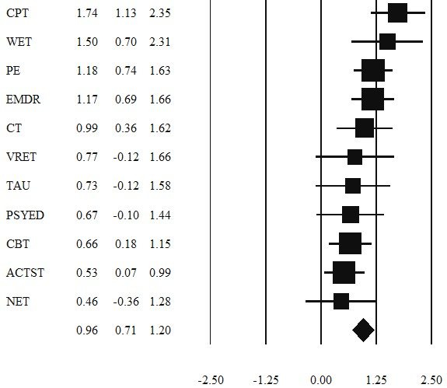

Favours WL Favours intervention
Figure 3 Forest Plot of NMA estimates compared to waitlist.
ACTST; Active Supportive Therapy (control); BET, Brief Eclectic Therapy; CBT, Cognitive behavioural therapy; CPT, Cognitive Processing Therapy; CT, cognitive therapy; DET, Dialogical Exposure Therapy; EMDR, eye movement desensitization and reprocessing; IPT, Interpersonal Therapy; MCT, Metacognitive Therapy; NET, Narrative Exposure Therapy; PE, Prolonged Exposure; PE-SIT, Prolonged Exposure and Stress Inoculation Training; PSYED, Psychoeducation (control); PDT, Psychodynamic Therapy; SIT, Stress Inoculation Training; STAIR-PE, Skills training in affective and interpersonal regulation followed by prolonged exposure; TARGET, Trauma Affect Regulation: Guide for Education and Therapy; TAU, Treatment as usual; VRET, Virtual Reality Exposure Therapy; WET, Written Exposure Therapy; WL, Waitlist (control).

Figure 4. Ranking of efficacy and acceptability outcomes.
Treatment Efficacy (SMD with 95% confidence intervals)
Figure 4. Ranking of efficacy and acceptability outcomes.
ACTST; Active Supportive Therapy (control); CBT, Cognitive behavioural therapy; CPT, Cognitive Processing Therapy; CT, cognitive therapy; EMDR, eye movement desensitization and reprocessing; NET, Narrative Exposure Therapy; PE, Prolonged Exposure; PSYED, Psychoeducation (control); TAU, Treatment as usual; VRET, Virtual Reality Exposure Therapy; WET, Written Exposure Therapy.

