Additional file 2. Individual and synthesised theory of change diagrams for the ‘Self-monitoring’ theory of change grouping

Figure 1. Theory of change diagram for TXT-Auto intervention¹

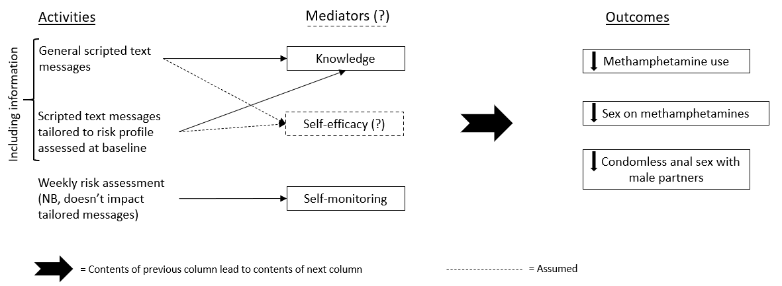

Figure 2. Theory of change diagram for Smartphone Self-Monitoring intervention²

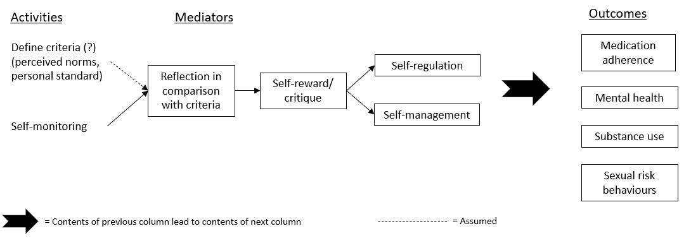

Figure 3. ‘Self-monitoring’ synthesised theory of change diagram

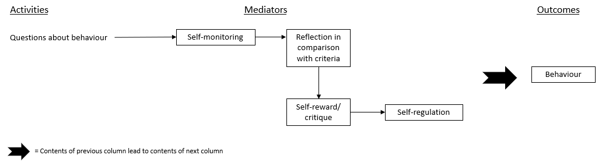

References
1. Reback C, Fletcher J, Swendeman D, Metzner M. Theory‑Based Text‑Messaging to Reduce Methamphetamine Use and HIV Sexual Risk Behaviors Among Men Who Have Sex with Men: Automated Unidirectional Delivery Outperforms Bidirectional Peer Interactive Delivery. AIDS and Behavior. 2019;23(1):11.
2. Swendeman D, Ramanathan C, Baetscher L, et al. Smartphone self-monitoring to support self-management among people living with HIV: Perceived benefits and theory of change from a mixed-methods, randomized pilot study. J Acquir Immune Defic Syndr. 2015;69:12.

