Supplemental Appendix S1. MEDLINE search query
- amiodarone.mp.
- Amiodarone/
- cordarone.tw.
- kordaron.tw.
- or/1-4
- Randomized Controlled Trial/
- exp Randomized Controlled Trials as Topic/
- Randomization/
- Random Allocation/
- Double-Blind Studies/
- Placebos/
- (randomi?ed or trial or randomly or placebo or equivalence or superiority or non-inferiority or noninferiority or pragmatic).ti,kf.
- or/6-12
- 5 and 13

Supplemental Figure S1. Subgroup analysis: Cancer-related death in trials of atrial fibrillation and ventricular arrhythmias.
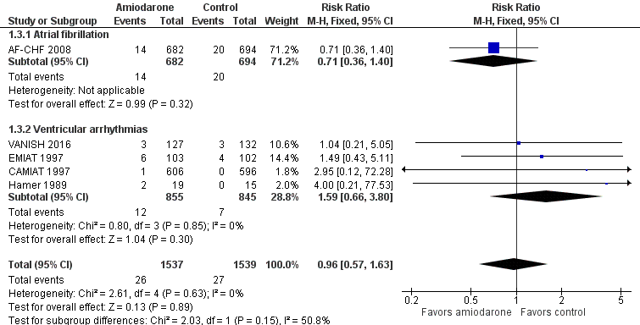
CI: confidence interval; MH: Mantel-Haenszel.

Supplemental Figure S2. Sensitivity analysis: Cancer-related death in trials using amiodarone doses above 200 mg daily, less than or equal to 200 mg daily, or mixed dosing regimen
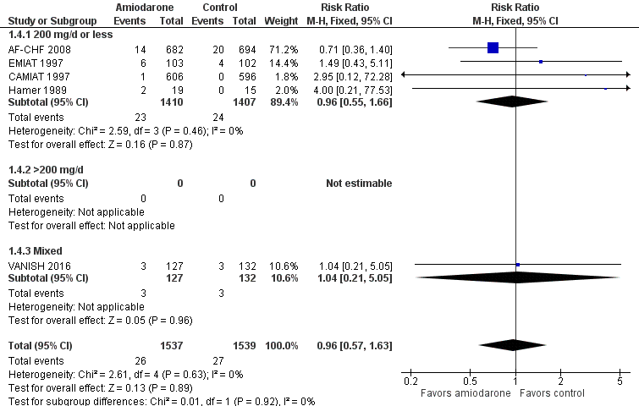
CI: confidence interval; MH: Mantel-Haenszel.

Supplemental Figure S3. Sensitivity analysis: Cancer-related death in trials below and above median trial duration of 22 months
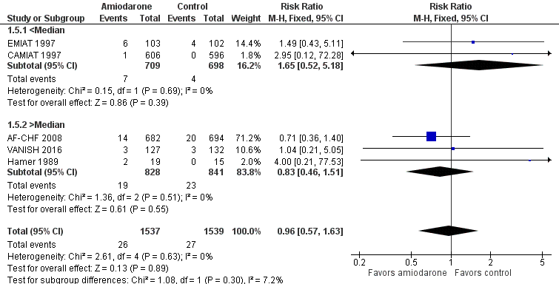
CI: confidence interval; MH: Mantel-Haenszel.

Supplemental Figure S4. Sensitivity analysis: Cancer-related death in trials at low risk of bias compared to trials at high or unclear risk of bias
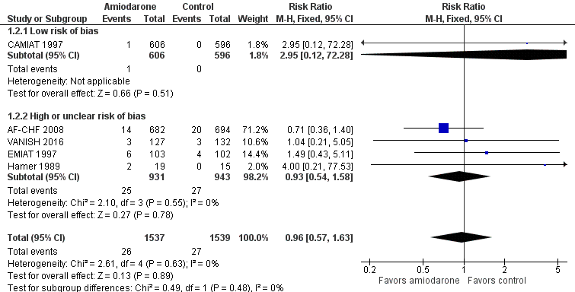
CI: confidence interval; MH: Mantel-Haenszel.

