Supplementary Table S1: Search Terms
Ovid Search Terms (used to search Medline and Embase) | Web of Knowledge Search Terms (used to search Web of Science and BIOSIS Previews)
1. Prostatic Neoplasms/ | 1 TS=(prosta* SAME neoplas*)
2. (prostat* adj3 cancer$).tw | 2 TS=(prostat* SAME tumo$r*)
3. (prostat* adj3 carcinoma$).tw. | 3 TS=(prostat*SAME carcinoma*)
4. (prostat* adj3 tumo?r$).tw. | 4 TS=(prostat* SAME cancer*)
5. (prosta* adj3 neoplas$).tw. | 5 TS=(ob protein)
6. adiponectin/ | 6 TS=(obese protein)
7. adiponectin.tw. | 7 TS=(leptin)
8. GBP.tw. | 8 TS=(acrp30)
9. GBP?28.tw. | 9 TS=(apm1)
10. gelatin binding protein.tw. | 10 TS=(gelatin binding protein)
11. apm1.tw. | 11 TS=(adiponectin)
12. acrp30.tw. | 12 #4 OR #3 OR #2 OR #1
13. leptin/ | 13 #11 OR #10 OR #9 OR #8 OR #7 OR #6 OR #5
14. obese protein.tw. | 14 #13 AND #12
15. leptin.tw.
16. ob protein.tw.
17. 1 or 2 or 3 or 4 or 5
18. 6 or 7 or 8 or 9 or 10 or 11 or 12
19. 13 or 14 or 15 or 16
20. 18 or 19
21. 17 and 20

Supplementary Table S2 Sensitivity Analyses
 |  | Main Analysis |  |  |  | Sensitivity Analysis 1 |  |  |  | Sensitivity Analysis 2 |  |  |  | Sensitivity Analysis 3 |  |  |  |  | Sensitivity Analysis 4
 | No. of Studies | OR | LCI | UCI | I² | OR | LCI | UCI | I² | OR | LCI | UCI | I² | OR | LCI | UCI | I² | No. of Studies | OR | LCI | UCI | I²
LEPTIN
INCIDENCE
Prospective | 9 | 0.97 | 0.95 | 0.99 | 54.9% | 0.98 | 0.95 | 1.00 | 54.6% |  |  |  |  |  |  |  |  | 7 | 0.96 | 0.93 | 0.98 | 51.9%
Cross-Sectional | 7 | 1.19 | 1.13 | 1.26 | 52.5% | 1.18 | 1.12 | 1.25 | 49.1% |  |  |  |  |  |  |  |  | 9 | 1.10 | 1.06 | 1.14 | 73.2%
Overall | 16 | 1.00 | 0.98 | 1.02 | 80.9% | 1.01 | 0.99 | 1.04 | 77.7% |  |  |  |  |  |  |  |  | 16 | 1.00 | 0.98 | 1.02 | 80.9%
AGGRESSIVE
Prospective | 7 | 1.02 | 0.99 | 1.05 | 0.0% | 1.00 | 0.97 | 1.04 | 0.0% | 1.02 | 0.99 | 1.05 | 0.0% | 1.00 | 0.97 | 1.03 | 0.0% | 4 | 1.03 | 0.99 | 1.08 | 0.00%
Cross-Sectional | 8 | 1.09 | 1.03 | 1.16 | 83.6% | 1.09 | 1.03 | 1.16 | 83.6% | 1.10 | 1.04 | 1.17 | 82.8% | 1.10 | 1.04 | 1.17 | 82.8% | 11 | 1.03 | 1.00 | 1.07 | 79.5%
Overall | 15 | 1.03 | 1.01 | 1.06 | 71.7% | 1.02 | 0.99 | 1.05 | 71.9% | 1.03 | 1.01 | 1.06 | 71.2% | 1.02 | 1.00 | 1.05 | 72.8% | 15 | 1.03 | 1.01 | 1.06 | 71.7%
ADIPONECTIN
INCIDENCE
Prospective | 7 | 0.98 | 0.95 | 1.01 | 76.0% | 0.98 | 0.95 | 1.02 | 44.1% |  |  |  |  |  |  |  |  | 3 | 0.97 | 0.93 | 1.02 | 0.0%
Cross-Sectional | 5 | 0.89 | 0.83 | 0.95 | 46.9% | 0.89 | 0.83 | 0.96 | 74.3% |  |  |  |  |  |  |  |  | 9 | 0.95 | 0.91 | 0.99 | 74.9%
Overall | 12 | 0.96 | 0.93 | 0.99 | 67.3% | 0.96 | 0.93 | 1.00 | 65.0% |  |  |  |  |  |  |  |  | 12 | 0.96 | 0.93 | 0.99 | 67.3%
AGGRESSIVE
Prospective | 7 | 0.98 | 0.94 | 1.02 | 29.6% | 0.97 | 0.93 | 1.01 | 67.6% | 0.98 | 0.93 | 1.02 | 49.4% | 0.98 | 0.94 | 1.03 | 0.0% | 3 | 1.01 | 0.91 | 1.11 | 65.0%
Cross-Sectional | 7 | 0.97 | 0.93 | 1.02 | 62.6% | 0.98 | 0.92 | 1.03 | 63.7% | 1.00 | 0.95 | 1.05 | 69.7% | 1.00 | 0.95 | 1.06 | 70.0% | 11 | 0.97 | 0.94 | 1.01 | 45.9%
Overall | 14 | 0.98 | 0.94 | 1.01 | 47.1% | 0.97 | 0.94 | 1.01 | 63.0% | 0.98 | 0.95 | 1.02 | 59.3% | 0.99 | 0.96 | 1.03 | 49.4% | 14 | 0.98 | 0.94 | 1.01 | 47.1%
Notes: Fixed-effects estimates. ORs per 2.5 ng/ml increase in leptin or 2.5 μg/ml increase in adiponectin
Abbreviations: OR, Odds Ratio; LCI, Lower 95% Confidence Interval; UCI, Upper 95% Confidence Interval, I2, I squared statistic (an index of heterogeneity)
Main Analysis: Grade>Stage>Other measures of aggressiveness and Minimally adjusted estimates > maximally adjusted.
Sensitivity Analysis 1: Maximally adjusted estimates>minimally adjusted and Grade>Stage>Other measures of aggressiveness
Sensitivity Analysis 2: Stage>Other measures of aggressiveness>Grade and Minimally adjusted estimates>maximally adjusted
Sensitivity Analysis 3: Stage>Other measures of aggressiveness>Grade and Maximally adjusted estimates > minimally adjusted
Sensitivity Analysis 4: As main analysis, but prospective redefined as blood draw ≥1 year before to diagnosis.
Supplementary Table S3 Subgroup Analyses: Leptin
 | INCIDENCE |  |  |  |  |  | AGGRESSIVE
 | No. Studies | OR | LCI | UCI | % Weight | I² (%) | No. Studies | OR | LCI | UCI | % Weight | I² (%)
Mean Difference
Prospective | 3 | 1.02 | 0.97 | 1.07 | 61.3 | 0.0% | 2 | 1.00 | 0.95 | 1.06 | 58.3 | 0.0%
Cross-Sectional | 4 | 1.17 | 1.10 | 1.24 | 38.7 | 51.0% | 8 | 1.09 | 1.03 | 1.16 | 41.7 | 83.6%
OR
Prospective | 6 | 0.96 | 0.93 | 0.98 | 96.0 | 56.8% | 5 | 1.03 | 0.99 | 1.06 | 100.0 | 0.0%
Cross-Sectional | 3 | 1.32 | 1.17 | 1.49 | 4.0 | 41.7% | 0 | NA
RIA
Prospective | 4 | 0.99 | 0.96 | 1.03 | 83.3 | 75.1% | 2 | 1.01 | 0.96 | 1.06 | 91.7 | 0.0%
Cross-Sectional | 4 | 1.27 | 1.17 | 1.38 | 16.7 | 27.4% | 3 | 1.40 | 1.20 | 1.65 | 8.3 | 85.9%
ELISA
Prospective | 4 | 0.96 | 0.93 | 0.99 | 84.4 | 5.5% | 3 | 1.02 | 0.98 | 1.06 | 75.1 | 0.0%
Cross-Sectional | 3 | 1.14 | 1.06 | 1.23 | 15.6 | 60.8% | 6 | 1.05 | 0.98 | 1.12 | 24.9 | 79.8%
MAP or LTIA
Prospective | 1 | 0.96 | 0.90 | 1.02 | 100.0 | NA | 1 | 1.04 | 0.86 | 1.26 | 100.0 | NA
Cross-Sectional | 0 | NA |  |  |  |  | 0 | NA
Stage
Prospective |  |  |  |  |  |  | 1 | 1.00 | 0.93 | 1.08 | 69.4 | NA
Cross-Sectional |  |  |  |  |  |  | 3 | 1.01 | 0.90 | 1.12 | 30.6 | 92.5%
Grade
Prospective |  |  |  |  |  |  | 6 | 1.02 | 0.99 | 1.05 | 92.8 | 0.0%
Cross-Sectional |  |  |  |  |  |  | 4 | 1.10 | 0.99 | 1.22 | 7.2 | 85.8%
Combination/other
Prospective |  |  |  |  |  |  | 2 | 1.07 | 0.94 | 1.22 | 31.2 | 0.0%
Cross-Sectional |  |  |  |  |  |  | 3 | 1.22 | 1.12 | 1.33 | 68.78 | 0.0%
PSA screen-detected†
Prospective | 2 | 0.96 | 0.93 | 0.98 | 100.0 | 0.0% | 3 | 1.02 | 0.98 | 1.06 | 100.0 | 0.0%
Cross-Sectional | 0 | NA |  |  |  |  | 0 | NA
Not PSA screen-detected
Prospective | 5 | 0.99 | 0.95 | 1.02 | 69.5 | 29.7% | 3 | 1.01 | 0.96 | 1.06 | 70.6 | 0.0%
Cross-Sectional | 6 | 1.21 | 1.14 | 1.28 | 30.5 | 72.5% | 5 | 1.14 | 1.05 | 1.22 | 29.4 | 80.2%
Not reported
Prospective | 2 | 1.04 | 0.91 | 1.18 | 84.6 | 0.0% | 1 | 1.10 | 0.88 | 1.37 | 17.3 | NA
Cross-Sectional | 1 | 0.84 | 0.62 | 1.13 | 15.4 | NA | 3 | 1.02 | 0.92 | 1.13 | 82.7 | 89.9%
Notes: Fixed effects estimates. ORs per 2.5 ng/ml increase in leptin † Cases identified through PSA-screening. Abbreviations: NA, Not Applicable; OR, Odds Ratio; LCI, Lower 95% Confidence Interval; UCI, Upper 95% Confidence Interval, I2, I squared statistic (an index of heterogeneity)
Supplementary Table S4 Subgroup Analyses: Adiponectin
 | INCIDENCE |  |  |  |  |  | AGGRESSIVE
 | No. Studies | OR | LCI | UCI | % Weight | I² (%) | No. Studies | OR | LCI | UCI | % Weight | I² (%)
Mean Difference
Prospective | 4 | 0.98 | 0.94 | 1.03 | 69.0 | 70.2% | 3 | 0.95 | 0.89 | 1.02 | 75.6 | 0.0%
Cross-Sectional | 4 | 0.91 | 0.84 | 0.98 | 31.1 | 71.6% | 5 | 0.88 | 0.78 | 0.99 | 24.4 | 64.2%
OR
Prospective | 3 | 0.97 | 0.93 | 1.02 | 97.4 | 0.0% | 4 | 1.00 | 0.95 | 1.06 | 47.5 | 47.6%
Cross-Sectional | 1 | 0.64 | 0.49 | 0.84 | 2.6 | NA | 2 | 1.00 | 0.94 | 1.06 | 52.5 | 15.5%
RIA
Prospective | 3 | 0.96 | 0.92 | 1.00 | 80.3 | 16.6% | 2 | 0.95 | 0.89 | 1.01 | 96.7 | 33.0%
Cross-Sectional | 3 | 0.83 | 0.76 | 0.90 | 19.7 | 49.1% | 1 | 0.81 | 0.57 | 1.16 | 3.3 | NA
ELISA
Prospective | 2 | 1.07 | 0.96 | 1.21 | 57.3 | 47.8% | 3 | 1.01 | 0.94 | 1.07 | 39.8 | 0.0%
Cross-Sectional | 2 | 1.06 | 0.92 | 1.21 | 42.7 | 71.9% | 6 | 0.98 | 0.93 | 1.03 | 60.2 | 66.8%
MAP or LTIA
Prospective | 2 | 0.99 | 0.93 | 1.05 | 100.0 | 69.5% | 2 | 1.00 | 0.83 | 1.22 | 100.0 | 70.6%
Cross-Sectional | 0 | NA |  |  |  |  | 0 | NA
Stage
Prospective |  |  |  |  |  |  | 1 | 1.00 | 0.93 | 1.08 | 77.6 | NA
Cross-Sectional |  |  |  |  |  |  | 4 | 1.02 | 0.89 | 1.17 | 22.4 | 81.6%
Grade
Prospective |  |  |  |  |  |  | 5 | 0.97 | 0.93 | 1.02 | 57.0 | 31.3%
Cross-Sectional |  |  |  |  |  |  | 5 | 0.97 | 0.92 | 1.03 | 43.0 | 72.8%
Combination/other
Prospective |  |  |  |  |  |  | 2 | 0.95 | 0.85 | 1.05 | 63.8 | 74.3%
Cross-Sectional |  |  |  |  |  |  | 3 | 0.97 | 0.84 | 1.11 | 36.2 | 22.7%
PSA screen-detected †
Prospective | 3 | 0.97 | 0.92 | 1.01 | 100.0 | 62.5% | 3 | 1.00 | 0.93 | 1.07 | 100.0 | 41.2%
Cross-Sectional | 0 | NA |  |  |  |  | 0 | NA
Not PSA screen-detected
Prospective | 2 | 0.97 | 0.93 | 1.02 | 69.8 | 15.2% | 2 | 0.95 | 0.89 | 1.01 | 78.4 | 33.0%
Cross-Sectional | 4 | 0.85 | 0.79 | 0.92 | 30.2 | 47.9% | 4 | 0.89 | 0.79 | 1.01 | 21.6 | 72.0%
Not reported
Prospective | 2 | 1.07 | 0.96 | 1.21 | 76.1 | 47.8% | 2 | 1.02 | 0.90 | 1.15 | 17.7 | 47.9%
Cross-Sectional | 1 | 1.23 | 1.00 | 1.51 | 24.0 | NA | 3 | 0.99 | 0.94 | 1.05 | 82.3 | 34.5%
Notes: Fixed effects estimates. ORs per 2.5 ng/ml increase in leptin † Cases identified through PSA-screening. Abbreviations: NA, Not Applicable; OR, Odds Ratio; LCI, Lower 95% Confidence Interval; UCI, Upper 95% Confidence Interval, I2, I squared statistic (an index of heterogeneity)
Supplementary Figure S1 Subgroup Analysis by mean study-level BMI
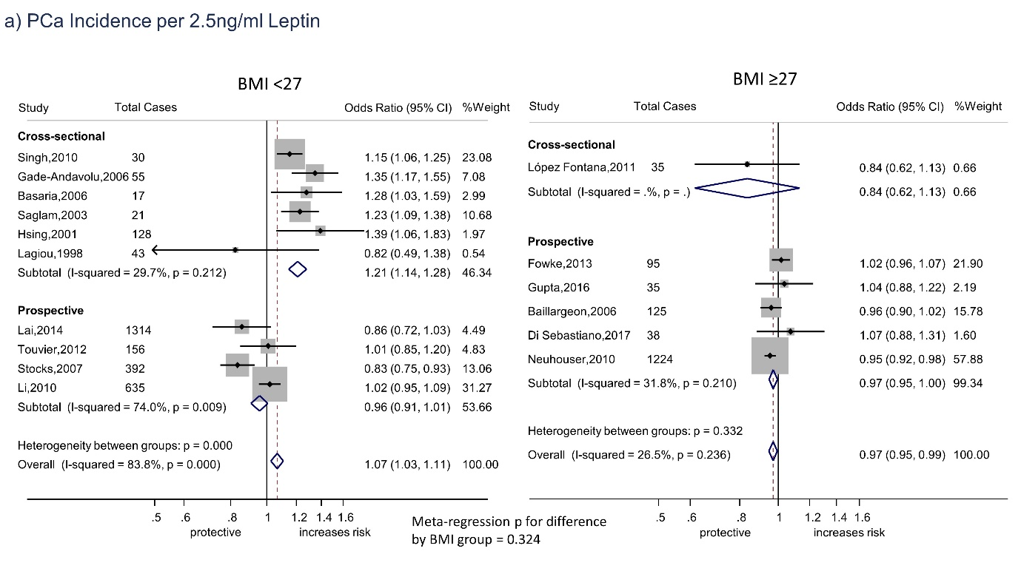

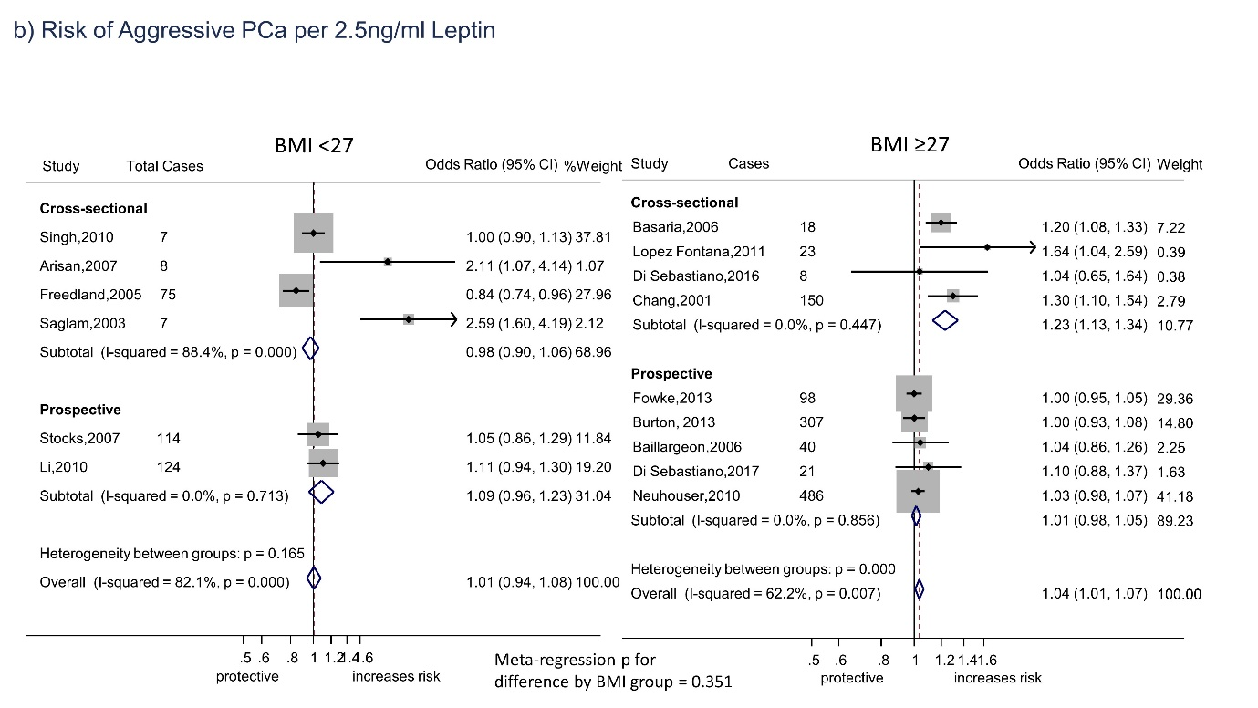

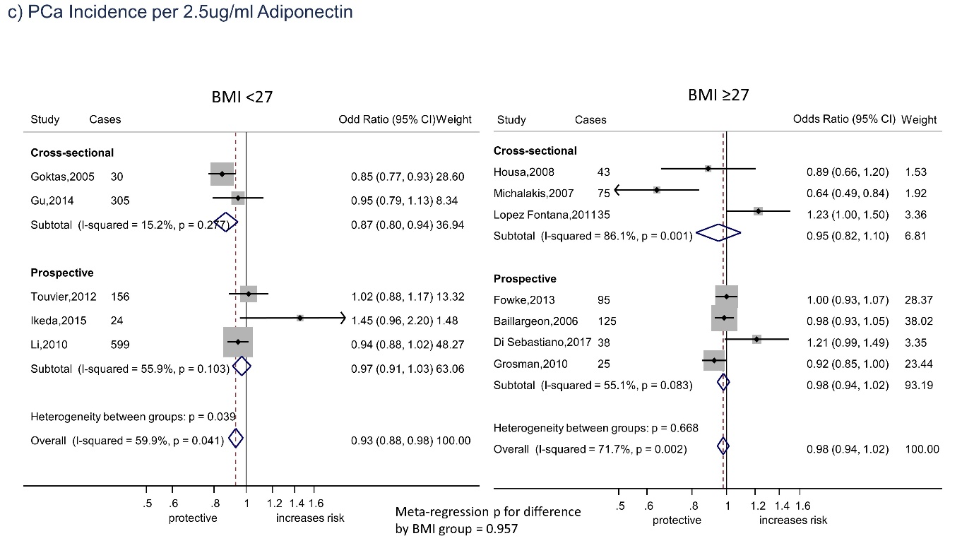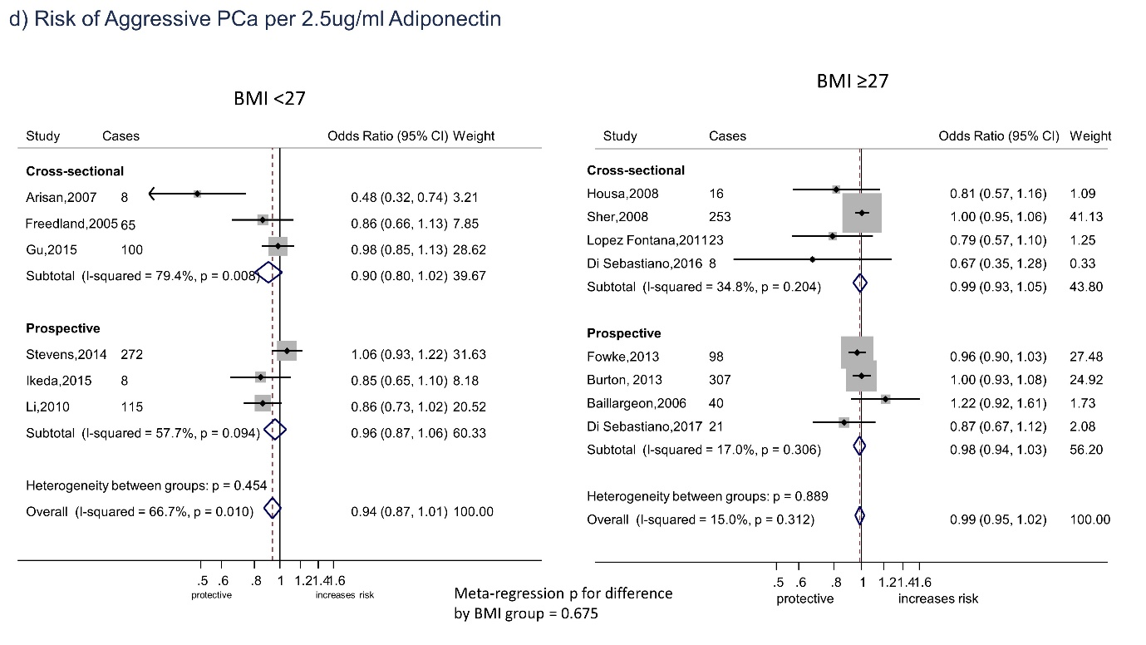

Supplementary Figure S2 Albatross Plots



