Table S7. POST HOC ANALYSES
Forest plot of comparison: 2 Parent-mediated intervention vs no parent-mediated intervention post hoc, outcome: 2.1 Adaptive functioning, parent-rated, lower is better.
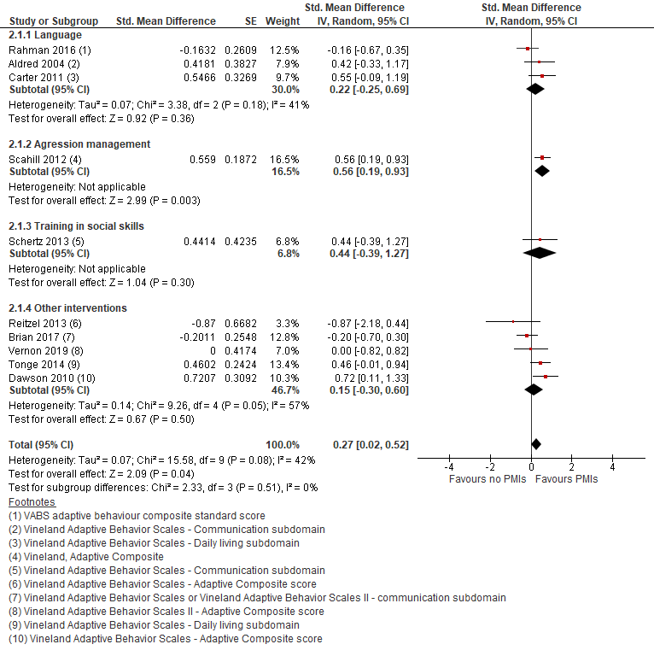
Forest plot of comparison: 2 Parent-mediated intervention vs no parent-mediated intervention post hoc, outcome: 2.5 Autism core-symptoms, clinician-rated.

