SUPPLEMENTAL MATERIAL

eMethods. Search Strategy
eTable 1. Study and patient related variables extracted from included randomized control trials
eTable 2. Study characteristics of included trials
eTable 3. Patient characteristics of included trials
eTable 4. Pairwise analysis for excess weight loss over placebo in all studies, studies conducted only in diabetic participants, and studies in only non-diabetic participants
eTable 5. Certainty of evidence, efficacy
eTable 6. Certainty of evidence, adverse events leading to discontinuation
eFigure 1. Data extraction form
eFigure 2. Study level and overall risk of bias assessment
eFigure 3. Pairwise meta-analysis and forest plot of excess weight loss vs placebo
eFigure 4. Pairwise meta-analysis and forest plot of adverse events leading to discontinuation of study intervention
eFigure 5. Pairwise meta-analysis and forest plot of excess weight loss vs placebo in diabetic participants
eFigure 6. Pairwise meta-analysis and forest plot of excess weight loss vs placebo in non-diabetic participants
eFigure 7. Surface under the cumulative ranking (SUCRA) curves for weight loss by drug-dosage groups
eFigure 8. Surface under the cumulative ranking (SUCRA) curves for adverse events leading to discontinuation of study intervention by drug-dosage groups
eFigure 9. Network maps for trials separated for diabetic and non-diabetic participants
eFigure 10. Surface under the cumulative ranking (SUCRA) curves for weight loss by drug-dosage groups in diabetic participants
eFigure 11. Surface under the cumulative ranking (SUCRA) curves for weight loss by drug-dosage groups in non-diabetic participants
eFigure 12. Pairwise meta-analysis and forest plot of nausea
eFigure 13. Pairwise meta-analysis and forest plot of vomiting
eFigure 14. Funnel plot, publication bias assessment

eMethods
Search strategy

Database(s): Ovid MEDLINE(R) and Epub Ahead of Print, In-Process, In-Data-Review & Other Non-Indexed Citations and Daily <1946 to March 02, 2021 >
Search Strategy:

# |  | Searches | Results
1 |  | obesity.ti,ab,kw. or exp *Obesity/ or exp Obesity Management/ or exp *Anti-Obesity Agents/ | 322957
2 |  | body weight/ or body weight changes/ or overweight/ | 214001
3 |  | (obese or overweight or "over weight" or weight loss).ti,ab,kw. | 240746
4 |  | Body Mass Index/ | 131288
5 |  | 4 or bmi.mp. | 221714
6 |  | 1 or 2 or 3 or 5 | 696210
7 |  | (glp-1 or "glucagon-like peptide*" or albiglutide or dulaglutide or exenatide or liraglutide or lixisenatide or semaglutide).mp. | 20416
8 |  | 6 and 7 | 6315
9 |  | limit 8 to (adaptive clinical trial or clinical trial, all or clinical trial, phase i or clinical trial, phase ii or clinical trial, phase iii or clinical trial, phase iv or clinical trial or comparative study or controlled clinical trial or meta analysis or multicenter study or pragmatic clinical trial or randomized controlled trial or "systematic review" or systematic reviews as topic) [Limit not valid in Ovid MEDLINE(R),Ovid MEDLINE(R) Daily Update,Ovid MEDLINE(R) PubMed not MEDLINE,Ovid MEDLINE(R) In-Process,Ovid MEDLINE(R) Publisher; records were retained] | 1428
10 |  | 8 and ((doubl* or singl* or tripl* or trebl*) adj2 (blind* or mask*)).mp. | 497
11 |  | 8 and placebo*.mp. | 676
12 |  | or/9-11 | 1701

Database(s): EBM Reviews - Cochrane Central Register of Controlled Trials January 2021
Search Strategy:

# | Searches | Results
1 | obesity.ti,ab,kw. or exp *Obesity/ or exp Obesity Management/ or exp *Anti-Obesity Agents/ | 37756
2 | body weight/ or body weight changes/ or overweight/ | 13034
3 | (obese or overweight or "over weight" or weight loss).ti,ab,kw. | 42870
4 | Body Mass Index/ | 10370
5 | 4 or bmi.mp. | 47518
6 | 1 or 2 or 3 or 5 | 89496
7 | (glp-1 or "glucagon-like peptide*" or albiglutide or dulaglutide or exenatide or liraglutide or lixisenatide or semaglutide).mp. | 7182
8 | 6 and 7 | 3094
9 | limit 8 to (adaptive clinical trial or clinical trial, all or clinical trial, phase i or clinical trial, phase ii or clinical trial, phase iii or clinical trial, phase iv or clinical trial or comparative study or controlled clinical trial or meta analysis or multicenter study or pragmatic clinical trial or randomized controlled trial or "systematic review" or systematic reviews as topic) [Limit not valid; records were retained] | 834
10 | 8 and random*.mp. | 2465
11 | 10 and (blind* or mask* or trial*).mp. | 2169
12 | 9 or 11 | 2414
13 | 12 not conference abstract.pt. | 2396
14 | 13 not journal conference abstract.pt. | 1693

Database(s): Embase <1974 to 2021 March 02>
Search Strategy:

# | Searches | Results
1 | obesity.ti,ab,kw. or exp *Obesity/ or exp Obesity Management/ or exp *Anti-Obesity Agents/ | 477001
2 | body weight/ or body weight changes/ or overweight/ | 460792
3 | (obese or overweight or "over weight" or weight loss).ti,ab,kw. | 378694
4 | Body Mass Index/ | 415912
5 | 4 or bmi.mp. | 546056
6 | 1 or 2 or 3 or 5 | 1223745
7 | (glp-1 or "glucagon-like peptide*" or albiglutide or dulaglutide or exenatide or liraglutide or lixisenatide or semaglutide).mp. | 40646
8 | 6 and 7 | 15688
9 | 8 and exp clinical trial/ | 3030
10 | limit 9 to human | 2970
11 | 10 not (conference abstract.pt. or case report/) | 1941
12 | remove duplicates from 11 | 1896

Database(s): Scopus
Search Strategy:
( TITLE-ABS-KEY ( ( "glp-1" OR "glucagon-like peptide*" OR albiglutide OR dulaglutide OR exenatide OR liraglutide OR lixisenatide OR semaglutide ) ) AND TITLE-ABS-KEY ( ( weight* OR obese* OR obesity OR overweight ) AND random* ) ) AND NOT ( INDEX ( pmid ) ) AND NOT ( INDEX ( embase ) ) AND ( LIMIT-TO ( LANGUAGE , "English" ) ) 142 results

eTable 1. List of data extracted from the included randomized clinical trials

Data category | List of variables
Study | Primary author, year of publication, duration of follow-up, total number of patients in intervention and placebo group, obesity related comorbidities in study population (DM type 1/DM type 2/NAFLD/Healthy volunteer)
Patients | Sex, age, race, weight and BMI at baseline
Interventions | Dose and duration of the primary intervention, co-interventions (non-medication/medication dietary therapy, lifestyle interventions and behavioral modifications recommended, and strategies used for implementing them).
Efficacy outcome | Mean of change in weight (in kg), with respective standard deviation from baseline.
Adverse events | Number of participants with adverse events leading to discontinuation of study intervention, number of participants with nausea, number of participants with vomiting, number of participants with serious adverse events.
DM, Diabetes Mellitus; NAFLD, Nonalcoholic fatty liver disease

eTable 2. Characteristics of included randomized controlled studies
Study | PMID | Route/dose/  frequency | Duration of Rx (wks) | Total randomized/ included in weight or BMI analysis/ completers/ attrition rate |  |  | Cointerventions |  |  |  | Study population
 |  |  |  | Intervention | Placebo |  | Diet | Exercise | Beha-vioral | Drug | T1  DM | T2  DM | NAFLD | Non-diabetic
Dulaglutide
Ludvik, et al. 2018 | 29483060 | SC/1.5, 0.75 mg/QW | 24 | 284/284/272/0.04 | 140/140/137/0.02 |  |  |  |  |  |  | ✓
Skrivanek, et al. 2014 | 24762094 | SC/0.25, 0.5, 0.75, 1.0, 1.5, 2.0, 3.0 mg/QW | 26 | 150/131/131/0.13 | 38/33/33/0.13 |  |  |  |  | Met-formin |  | ✓
Grunbergeret al. 2012 | 22804250 | SC/0.1, 0.5, 1.0, 1.5 mg/QW | 12 | 132/132/120/0.09 | 32/32/30/0.06 |  |  |  |  |  |  | ✓
Umpierrez, et al. 2011 | 21251180 | SC/1, 2 mg/QW | 16 | 196/190/172/0.12 | 66/65/60/0.09 |  |  |  |  |  |  | ✓
Frias, et al. 2019 | 31050143 | SC/1.5, 3.0, 4.5 mg /QW | 16 | 236/236/218/0.08 | 82/81/75/0.09 |  |  |  |  |  |  | ✓
Dungan, et al. 2016 | 26799540 | SC/1.5 mg/QW | 18 | 239/239/235/0.02 | 240/60/215/0.1 |  |  |  |  |  |  | ✓
Efpeglenatide
Pratley, et al. 2019 | 31264757 | SC/4, 6, 8 mg/QW & once every two weeks | 20 | 237/235/160/0.32 | 60/60/47/0.22 |  | ✓ | ✓ |  |  |  |  |  | ✓
Del Prato, et al. 2020 | 32128957 | SC/8, 12, 16 mg/QW | 20 | 157/156/116/0.26 | 50/49/40/0.2 |  |  |  |  |  |  | ✓
Rosenstock, et al. 2019 | 31320446 | SC/0.3, 1, 2, 3, 4 mg/QW | 12 | 179/179/148/0.17 | 37/37/33/0.11 |  |  |  |  |  |  | ✓
Exenatide Immediate-Release
Rosenstock, et al. 2018 | 29242349 | SC/20 mcg, 30 mcg/BID | 39 | 306/298/243/0.21 | 154/143/123/0.2 |  |  |  |  |  |  | ✓
Derosa, et al. 2012 | 23984793 | SC/10 mcg/BID | 52 | 86/81/81/0.06 |  | 85/82/82/0.04 | ✓ | ✓ |  |  |  | ✓
Buse, et al. 2011 | 21138825 | SC/10 mcg/BID | 30 | 137/137/111/0.19 | 122/122/100/0.18 |  |  |  |  |  |  | ✓
Apovian, et al. 2010 | 20399326 | SC/5 mcg/BID | 24 | 96/96/70/0.27 | 98/98/72/0.27 |  | ✓ | ✓ |  |  |  | ✓
Gill, et al. 2010 | 20109208 | SC/10 mcg/BID | 12 | 28/28/22/0.21 | 26/26/23/0.12 |  |  |  |  |  |  | ✓
Moretto, et al. 2008 | 18803987 | SC/5, 10 mcg/BID | 24 | 155/155/134/0.14 | 78/77/69/0.12 |  |  |  |  |  |  | ✓
DeFronzo, et al. 2005 | 15855572 | SC/5, 10 mcg/BID | 30 | 223/223/183/0.18 | 113/113/89/0.21 |  |  |  |  |  |  | ✓
Kendall, et al. 2005 | 15855571 | SC/5, 10 mcg/BID | 30 | 486/486/404/0.17 | 247/247/188/0.24 |  |  |  |  |  |  | ✓
Buse, et al. 2004 | 15504997 | SC/5, 10 mcg/BID | 30 | 254/254/186/0.27 | 123/123/74/0.4 |  |  |  |  |  |  | ✓
Scalzo, et al. 2017 | 27884660 | SC/10 mcg/BID | 30 | 11/11/11/0 | 12/12/12/0 |  |  |  |  |  |  | ✓
Joubert, et al. 2020 | 33043591 | SC/10 mcg/BID | 12 | 28/28/NA/NA | 18/18/NA/NA |  | ✓ | ✓ |  |  |  | ✓
Liutkus, et al. 2010 | 20977576 | SC/10 mcg/BID | 26 | 111/111/96/0.14 | 54/54/50/0.07 |  |  |  |  |  |  | ✓
Exenatide extended-release
Kim, et al. 2007 | 17353504 | SC/0.8, 2 mg/QW | 15 | 31/31/NA/NA | 14/12/NA/NA |  |  |  |  |  |  | ✓
Harreiter, et al. 2021 | 33464703 | SC/2 mg/QW | 15 | 16/16/16/0 | 14/14/13/0.07 |  |  |  |  | Dapa-glifozin |  | ✓
Liraglutide
Pratley, et al. 2019* | 31186120 | SC/1.8mg/ QD | 52 | 284/284/248/0.13 | 142/142/125/0.12 |  |  |  |  |  |  | ✓
Nexoe-Larsen, et al. 2018 | 29892986 | SC/3.0 mg/QD | 12 | 26/23/23/0.12 | 26/24/24/0.08 |  | ✓ | ✓ |  |  |  |  |  | ✓
O'Neil, et al. 2018* | 30122305 | SC/3 mg/QD | 52 | 103/103/96/0.07 | 136/136/123/0.1 |  | ✓ | ✓ |  |  |  |  |  | ✓
Halawi, et al. 2017 | 28958851 | SC/3.0 mg/QD | 16 | 19/21/17/0.11 | 21/19/18/0.14 |  | ✓ |  | ✓ |  |  |  |  | ✓
le Roux, et al. 2017 | 28237263 | SC/3.0 mg/QD | 160 | 1505/1472/791/0.47 | 749/738/337/0.55 |  | ✓ | ✓ |  |  |  |  |  | ✓
Mensberg, et al. 2017 | 27717126 | SC/1.8mg/ QD | 16 | 18/17/17/0.06 | 16/16/16/0 |  |  |  |  |  |  | ✓
Smits, et al. 2016 | 27627981 | SC/1.8 mg/QD | 12 | 17/17/17/0 | 17/17/17/0 |  |  |  |  |  |  | ✓
Dejgaard, et al. 2016 | 26656289 | SC/1.8 mg/QD | 24 | 50/50/46/0.08 | 50/50/44/0.12 |  |  |  |  |  | ✓
Armstrong, et al. 2016 | 26608256 | SC/1.8 mg/QD | 48 | 26/23/23/0.12 | 26/22/23/0.12 |  | ✓ | ✓ |  |  |  | ✓ | ✓ | ✓
Davies, et al. 2015 | 26284720 | SC/1.8, 3.0 mg/QD | 56 | 634/615/536/0.15 | 212/211/163/0.23 |  |  |  |  |  |  | ✓
Nandy, et al. 2014 | 25212693 | SC/1.8 mg/QD | 12 | 16/16/16/0 | 16/14/14/0.13 |  |  |  |  |  |  | ✓
Kim, et al. 2013 | 23835684 | SC/1.8 mg/QD | 14 | 24/24/13/0.46 | 33/27/27/0.18 |  | ✓ |  |  |  |  |  |  | ✓
Wadden, et al. 2013 | 23812094 | SC/3 mg/QD | 56 | 212/212/207/0.02 | 210/210/206/0.02 |  | ✓ | ✓ |  |  |  |  |  | ✓
Astrup, et al. 2009 | 19853906 | SC/1.2, 1.8, 2.4, 3.0 mg/QD | 20 | 371/368/314/0.15 | 98/98/79/0.19 |  | ✓ | ✓ |  |  |  |  |  | ✓
Russell-Jones, et al. 2009 | 19688338 | SC/1.8 mg/QD | 26 | 230/230/207/0.1 | 114/114/96/0.16 |  |  |  |  | Met-formin |  | ✓
Zinman, et al. 2009 | 19289857 | SC/1.2, 1.8 mg/QD | 26 | 374/366/304/0.19 | 100/177/44/0.56 |  |  |  |  | Met-formin |  | ✓
Nauck, et al. 2009 | 18931095 | SC/0.6, 1.2, 1.8 mg/QD | 26 | 725/724/596/0.18 | 100/121/52/0.48 |  |  |  |  |  |  | ✓
Wägner, et al. 2018 | 30223083 | SC/1.8 mg/QD | 26 | 12/12/12/0 | 12/12/11/0.08 |  |  |  |  |  |  | ✓
Dejgaard, et al. 2019 | 31696598 | SC/1.8 mg/QD | 24 | 22/22/20/0.09 | 22/22/22/0 |  |  |  |  |  | ✓
Ghanim, et al. 2020 | 32424935 | SC/1.8mg/QD | 26 | 37/37/32/0.14 | 42/27/27/0.36 |  |  |  |  |  | ✓
Gudbergsen, et al. 2021 | 33471039 | SC/3 mg/QD | 26 | 80/80/67/0.16 | 80/76/66/0.18 |  | ✓ |  | ✓ |  |  |  |  | ✓
Lingvay, et al. 2018* | 30026333 | SC/0.3, 0.6, 1.2, 1.8 mg/QD | 44 | 257/257/215/0.16 | 129/129/95/0.26 |  |  |  |  |  |  | ✓
Vanderheiden, et al. 2016 | 27273731 | SC/1.8 mg/QD | 26 | 35/35/32/0.09 | 36/36/34/0.06 |  |  |  |  |  |  | ✓
Pi-Sunyer, et al. 2015 | 26132939 | SC/3.0 mg /QD | 24 | 2487/2437/1789/0.28 | 1244/1225/801/0.36 |  | ✓ | ✓ |  |  |  |  |  | ✓
Lind, et al. 2015 | 26512041 | SC/1.8 mg/QD | 56 | 64/63/63/0.02 | 60/59/59/0.02 |  |  |  |  |  |  | ✓
Hygum, et al. 2019 | 31870634 | SC/1.8 mg daily/QD | 24 | 30/30/30/0 | 30/30/30/0 |  |  |  |  |  |  | ✓
van Eyk, et al. 2019 | 32127340 | SC/1.8 mg/QD | 26 | 23/22/22/0.04 | 26/25/26/0 |  |  |  |  |  |  | ✓
Lixisenatide
Pinget, et al. 2013 | 23627775 | SC/20 mcg/QD | 26 | 323/323/288/0.11 | 161/161/137/0.15 |  |  |  |  |  |  | ✓
Bolli, et al. 2013 | 24117597 | SC/20 mcg/QD | 24 | 322/322/291/0.1 | 160/160/151/0.06 |  |  |  |  |  |  | ✓
Semaglutide
O'Neil, et al. 2018* | 30122305 | SC/0.05, 0.1, 0.2, 0.3, 0.4, 0.3 FE, 0.4 FE mg /QW | 52 | 718/718/673/0.06 | 68/68/62/0.09 |  | ✓ | ✓ |  |  |  |  |  | ✓
Davies, et al. 2017 | 29049653 | PO/2.5, 5, 10, 20, 40 mg/QD | 26 | 490/419/374/0.24 | 71/71/65/0.08 |  |  |  |  |  |  | ✓
Sorli, et al. 2017 | 28110911 | SC/0.5, 1.0 mg/QW | 30 | 259/258/242/0.07 | 129/129/117/0.09 |  |  |  |  |  |  | ✓
Nauck, et al. 2016 | 26358288 | SC/0.1, 0.2, 0.4, 0.8, 0.8 DE, 1.6 DE mg/QW | 12 | 270/270/213/0.21 | 46/46/45/0.02 |  |  |  |  |  |  | ✓
Lingvay, et al. 2018* | 30026333 | SC/0.05, 0.1, 0.2, 0.3 mg/QW | 12 | 575/255/534/0.07 | 65/65/48/0.26 |  |  |  |  |  |  | ✓
Friedrichsen, et al. 2020 | 33269530 | SC/2.4 mg/QW | 26 | 36/35/35/0.03 | 36/35/35/0.03 |  |  |  |  |  |  |  |  | ✓
Wadden, et al. 2021 | 33755728 | SC/2.4 mg/QW | 20 | 407/407/376/0.08 | 204/204/191/0.06 |  | ✓ | ✓ |  |  |  |  |  | ✓
Wilding, et al. 2021 | 33567185 | SC/2.4 mg/QW | 68 | 1306/1306/1240/0.05 | 655/655/609/0.07 |  | ✓ | ✓ |  |  |  |  |  | ✓
Davies, et al. 2021 | 33667417 | SC/1.0, 2.4 mg/QW | 68 | 807/768/711/0.12 | 403/376/347/0.14 |  | ✓ | ✓ |  |  |  | ✓
Pratley, et al. 2019* | 31186120 | PO/14 mg/QD | 52 | 285/285/241/0.15 | 71/71/62/0.13 |  |  |  |  |  |  | ✓
Zinman, et al. 2019 | 30833170 | SC/1.0 mg/QW | 52 | 151/151/147/0.03 | 151/151/147/0.03 |  |  |  |  |  |  | ✓
Aroda, et al. 2019 | 31186300 | PO/3, 7, 14 mg/QD | 30 | 525/525/471/0.1 | 178/178/159/0.11 |  |  |  |  |  |  | ✓
Rodbard, et al. 2018 | 29688502 | SC/0.5, 1.0 mg/QW | 26 | 264/263/254/0.04 | 133/133/126/0.05 |  |  |  |  |  |  | ✓
Newsome, et al. 2021 | 33185364 | SC/0.1 , 0.2, 0.4 mg /QW | 30 | 240/239/225/0.06 | 80/80/77/0.04 |  | ✓ | ✓ |  |  | ✓ | ✓ | ✓ | ✓
Taspoglutide
Bergenstal, et al. 2012 | 23138449 | SC/10, 20mg/QW | 24 | 546/369/527/0.03 | 93/90/83/0.11 |  |  |  |  |  |  | ✓
BID, twice daily; NAFLD, nonalcoholic fatty liver disease; QD: once daily; QW, once weekly; Rx treatment; SC, subcutaneous; T1DM, type 1 diabetes mellitus; T2DM, type 2 diabetes mellitus; wk=weeks

* Trial tested weight loss effect of two different types of GLP-1 agonists vs placebo. Trial is listed two times in two different rows in the table, and values of control group are repeated in the both rows.

eTable 3. Baseline patient characteristics in included randomized controlled studies
Study | PMID | Female, No. (%) |  | White race/ethnicity, No. (%) |  | Age, mean ± SD, yr |  | Weight, mean ± SD, kg |  | BMI, mean ± SD, kg/m²
 |  | Intervention | Placebo | Intervention | Placebo | Intervention | Placebo | Intervention | Placebo | Intervention | Placebo
Dulaglutide
Ludvik, et al. 2018 | 29483060 | 137 (48.2) | 74 (52.9) | 251 (88.4) | 127 (90.7) | 57.8 ± 9.4 | 56.2 ± 9.3 | 92 ± 20.3 | 90.5 ± 19.5 | 32.8 ± 6 | 32.4 ± 5
Skrivanek, et al. 2014 | 24762094 | 92 (61.3) | 26 (68.4) | 68 (45.3) | 15 (39.5) | 53.9 ± 10.1 | 53 ± 10 | N/A | N/A | 32 ± 4.9 | 32 ± 4
Grunberger, et al. 2012 | 22804250 | 76 (57.6) | 14 (43.8) | 132 (100) | 32 (100) | 57 ± 8.7 | 55 ± 9.3 | 87.6 ± 18.5 | 90.9 ± 18.9 | 32.1 ± 4.7 | 32.1 ± 5.2
Umpierrez, et al. 2011 | 21251180 | 141 (71.9) | 56 (84.8) | 115 (58.7) | 36 (54.5) | 56.7 ± 11.8 | 56 ± 12 | 96.7 ± 17.5 | 94.7 ± 15 | 33.9 ± 4.5 | 33.9 ± 4.3
Frias, et al. 2019 | 31050143 | 126 (53.4) | 33 (40.2) | 185 (78.4) | 59 (72) | 56.9 ± 10 | 56.5 ± 8.9 | 91 ± 19.8 | 94.5 ± 22.9 | 32.9 ± 5.5 | 33.2 ± 6
Dungan, et al. 2016 | 26799540 | 135 (56.5) | 32 (53.3) | 202 (84.5) | 47 (78.3) | 57.7 ± 10.2 | 58.2 ± 7.4 | 84.5 ± 16.4 | 89.5 ± 18.6 | 30.9 ± 5.2 | 32.4 ± 5.9
Efpeglenatide
Pratley, et al. 2019 | 31264757 | 181 (76.4) | 44 (73.3) | 162 (68.4) | 39 (65) | 43.3 ± 11.7 | 43.7 ± 11.8 | 97.5 ± 12.1 | 97.5 ± 12.1 | 35.6 ± 4.4 | 34.9 ± 3.2
Del Prato, et al. 2020 | 32128957 | 85 (54.1) | 27 (54) | 133 (84.7) | 43 (86) | 56.4 ± 9 | 54.7 ± 9.9 | 90.7 ± 16.7 | 91.8 ± 19.2 | 31.9 ± 4.5 | 32.4 ± 4.2
Rosenstock, et al. 2019 | 31320446 | 77 (43) | 21 (56.8) | 149 (83.2) | 33 (89.2) | 55.4 ± 9.9 | 55 ± 9 | 91.2 ± 18.5 | 86 ± 18 | 31.8 ± 5 | 30.3 ± 4.2
Exenatide Immediate-Release
Rosenstock, et al. 2018 | 29242349 | 126 (41.2) | 62 (40.3) | 254 (83) | 126 (81.8) | 55.1 ± 9.9 | 54.7 ± 9.1 | 97.2 ± 18.4 | 98.2 ± 21.9 | 33.5 ± 5.2 | 33.7 ± 5.5
Derosa, et al. 2012 | 23984793 | 43 (50) | 44 (51.8) | 86 (100) | 85 (100) | 57.3 ± 7.7 | 56.7 ± 7.3 | 89 ± 9.7 | 90.5 ± 10.3 | 31.9 ± 1.7 | 31.7 ± 1.5
Buse, et al. 2011 | 21138825 | 67 (48.9) | 44 (36.1) | 103 (75.2) | 98 (80.3) | 59 ± 9 | 59 ± 10 | 95.4 ± 20.4 | 93.4 ± 21.2 | 33.8 ± 5.8 | 33.1 ± 6.2
Apovian, et al. 2010 | 20399326 | 60 (62.5) | 61 (62.2) | N/A | N/A | 54.5 ± 10 | 55.1 ± 9 | 94.9 ± 16.5 | 96.2 ± 15.6 | 33.6 ± 3.7 | 33.9 ± 4.3
Gill, et al. 2010 | 20109208 | 9 (32.1) | 15 (57.7) | 24 (85.7) | 25 (96.2) | 57 ± 11 | 54 ± 10 | 91.6 ± 15.2 | 85.9 ± 12.2 | 29.5 ± 3.4 | 30.1 ± 3.9
Moretto, et al. 2008 | 18803987 | 67 (43.2) | 35 (44.9) | 106 (68.4) | 51 (65.4) | 54.5 ± 10 | 53 ± 9 | 85.5 ± 15.5 | 86 ± 16 | 31.5 ± 5 | 32 ± 5
DeFronzo, et al. 2005 | 15855572 | 98 (43.9) | 46 (40.7) | 175 (78.5) | 82 (72.6) | 52.5 ± 11 | 54 ± 9 | 100.5 ± 21 | 100 ± 19 | 34 ± 6 | 34 ± 6
Kendall, et al. 2005 | 15855571 | 198 (40.7) | 109 (45.2) | 329 (67.7) | 169 (70.1) | 55 ± 9.5 | 56 ± 10 | 97.5 ± 20 | 99 ± 19 | 33.5 ± 6 | 34 ± 5
Buse, et al. 2004 | 15504997 | 106 (41.7) | 46 (37.4) | 154 (60.6) | 82 (66.7) | 55.5 ± 10.5 | 55 ± 11 | 95 ± 20 | 99 ± 18 | 33 ± 6 | 34 ± 5
Scalzo, et al. 2017 | 27884660 | 7 (63.6) | 4 (33.3) | N/A | N/A | 64 ± 23.2 | 64 ± 3.5 | 101.7 ± 17.6 | 87.9 ± 11.4 | 33.9 ± 3.3 | 31.3 ± 4.2
Joubert, et al. 2020 | 33043591 | 17 (60.7) | 9 (50) | N/A | N/A | 61 ± 7 | 58 ± 8 | 95 ± 16.7 | 99.3 ± 17.7 | 35.5 ± 4.2 | 35.1 ± 4.4
Liutkus, et al. 2010 | 20977576 | 44 (39.6) | 23 (42.6) | 63 (56.8) | 33 (61.1) | 55 ± 8 | 54 ± 9 | 94.5 ± 17.8 | 92.6 ± 18 | 34 ± 6 | 33 ± 5
Exenatide extended-release
Kim, et al. 2007 | 17353504 | 9 (29) | 9 (64.3) | 19 (61.3) | 9 (64.3) | 53.1 ± 11.5 | 55 ± 9 | 108.5 ± 20.6 | 101 ± 20 | 35.5 ± 5.9 | 36 ± 6
Harreiter, et al. 2021 | 33464703 | 6 (37.5) | 4 (28.6) | 15 (93.8) | 14 (100) | 59.4 ± 8.5 | 60.9 ± 7.4 | 99.1 ± 20.6 | 93.5 ± 14.2 | 31.9 ± 4.6 | 30.7 ± 3.5
Liraglutide
Pratley, et al. 2019* | 31186120 | 135 (47.5) | 68 (47.9) | 212 (74.6) | 99 (69.7) | 56 ± 10 | 56 ± 10 | 95.5 ± 21.9 | 93.2 ± 20 | 33.4 ± 6.7 | 32.9 ± 6.1
Nexoe-Larsen, et al. 2018 | 29892986 | 13 (50) | 13 (50) | N/A | N/A | N/A | N/A | 98.2 ± 17 | 99.8 ± 14.7 | 32.5 ± 3.6 | 32.6 ± 3.3
O'Neil, et al. 2018* | 30122305 | 67 (65) | 88 (64.7) | 88 (85.4) | 97 (71.3) | 47 ± 13 | 46 ± 13 | 108.7 ± 21.9 | 114.2 ± 25.4 | 38.6 ± 6.6 | 40.1 ± 7.2
Halawi, et al. 2017 | 28958851 | N/A | N/A | N/A | N/A | 42 ± 14.1 | 37 ± 18.5 | 101.8 ± 17.8 | 100.2 ± 16.8 | 37.4 ± 5.9 | 35.7 ± 4.4
le Roux, et al. 2017 | 28237263 | 1141 (75.8) | 573 (76.5) | 1256 (83.5) | 628 (83.8) | 47.5 ± 11.7 | 47.3 ± 11.8 | 107.5 ± 21.6 | 107.9 ± 21.8 | 38.8 ± 6.4 | 39 ± 6.3
Mensberg, et al. 2017 | 27717126 | 4 (22.2) | 6 (37.5) | N/A | N/A | 56.5 ± 9 | 55.6 ± 12 | 101 ± 14.5 | 96.8 ± 17.4 | 32.5 ± 3.7 | 32.4 ± 5.2
Smits, et al. 2016 | 27627981 | 5 (29.4) | 4 (23.5) | N/A | N/A | 60.8 ± 1.8 | 65.8 ± 1.4 | 103.2 ± 13.2 | 95.8 ± 9.9 | 32.8 ± 4.1 | 30.6 ± 2.9
Dejgaard, et al. 2016 | 26656289 | 20 (40) | 15 (30) | 50 (100) | 50 (100) | 47 ± 13 | 49 ± 12 | 92.4 ± 14.2 | 94 ± 12.5 | 30.3 ± 3.5 | 29.8 ± 3.1
Armstrong, et al. 2016 | 26608256 | 8 (30.8) | 13 (50) | 23 (88.5) | 23 (88.5) | 50 ± 11 | 52 ± 12 | 101 ± 18 | 108 ± 18 | 34.2 ± 4.7 | 37.7 ± 6.2
Davies, et al. 2015 | 26284720 | 306 (48.3) | 115 (54.2) | 530 (83.6) | 175 (82.5) | 55 ± 10.8 | 54.7 ± 9.8 | 105.7 ± 21.6 | 106.5 ± 21.3 | 37.1 ± 6.6 | 37.4 ± 7.1
Nandy, et al. 2014 | 25212693 | 6 (37.5) | 6 (37.5) | 16 (100) | 16 (100) | 57.7 ± 9 | 60.3 ± 7.3 | 95.1 ± 13.1 | 90.6 ± 13.5 | 32.7 ± 4.5 | 31.6 ± 4.2
Kim, et al. 2013 | 23835684 | 16 (66.7) | 17 (63) | 18 (75) | 17 (63) | 58 ± 7 | 58 ± 8 | 88.4 ± 11.2 | 88.7 ± 11.2 | 31.9 ± 2.7 | 31.9 ± 3.5
Wadden, et al. 2013 | 23812094 | 178 (84) | 166 (79) | 170 (80.2) | 185 (88.1) | 45.9 ± 11.9 | 46.5 ± 11 | 100.4 ± 20.8 | 98.7 ± 21.2 | 36 ± 5.9 | 35.2 ± 5.9
Astrup, et al. 2009 | 19853906 | 282 (76) | 73 (74.5) | N/A | N/A | 45.9 ± 10.6 | 45 ± 10.3 | 97.5 ± 13.2 | 97.3 ± 12.3 | 34.9 ± 2.7 | 34.9 ± 2.8
Russell-Jones, et al. 2009 | 19688338 | 99 (43) | 58 (50.9) | N/A | N/A | 57.6 ± 9.5 | 57.5 ± 9.6 | 85.5 ± 19.4 | 85.7 ± 16.7 | 30.4 ± 5.3 | 31.3 ± 5
Zinman, et al. 2009 | 19289857 | 164 (43.9) | 67 (37.9) | 289 (77.3) | 149 (84.2) | 55 ± 10.5 | 55 ± 10 | N/A | N/A | 33.4 ± 5.2 | 33.9 ± 5.2
Nauck, et al. 2009 | 18931095 | 302 (41.7) | 49 (40.2) | 627 (86.5) | 106 (86.9) | 56.7 ± 9.7 | 56 ± 9 | N/A | N/A | 30.8 ± 4.7 | 31.6 ± 4.4
Wägner, et al. 2018 | 30223083 | 8 (66.7) | 7 (58.3) | N/A | N/A | 53.2 ± 9.7 | 52.6 ± 13.8 | 93.2 ± 21 | 97.3 ± 14.8 | 34.1 ± 6.6 | 35.9 ± 6
Dejgaard, et al. 2019 | 31696598 | 15 (68.2) | 15 (68.2) | N/A | N/A | 50 ± 14 | 43 ± 12 | 85 ± 10 | 88 ± 14 | 30 ± 2 | 29 ± 3
Ghanim, et al. 2020 | 32424935 | 24 (64.9) | 16 (59.3) | N/A | N/A | 47 ± 10.4 | 45 ± 18.2 | 94.2 ± 18.9 | 83.3 ± 17.7 | 33.3 ± 7.3 | 29.5 ± 6.8
Gudbergsen, et al. 2021 | 33471039 | 52 (65) | 49 (64.5) | N/A | N/A | 59.2 ± 10.8 | 59.3 ± 9.7 | 96.3 ± 18.2 | 90.8 ± 14.3 | N/A | N/A
Lingvay, et al. 2018* | 30026333 | 129 (50.2) | 57 (44.2) | 211 (82.1) | 103 (79.8) | 56.5 ± 10.5 | 57.1 ± 9.2 | 92.5 ± 16.9 | 94 ± 17.8 | 32.8 ± 4.3 | 32.8 ± 4.2
Vanderheiden, et al. 2016 | 27273731 | 23 (65.7) | 22 (61.1) | 15 (42.9) | 11 (30.6) | 52.8 ± 8.1 | 55.5 ± 6.6 | 114.6 ± 21.4 | 116.1 ± 26.6 | 40.7 ± 6.7 | 41.6 ± 10.4
Pi-Sunyer, et al. 2015 | 26132939 | 1957 (78.7) | 971 (78.1) | 2107 (84.7) | 1061 (85.3) | 45.2 ± 12.1 | 45 ± 12 | 106.2 ± 21.2 | 106.2 ± 21.7 | 38.3 ± 6.4 | 38.3 ± 6.3
Lind, et al. 2015 | 26512041 | 24 (37.5) | 20 (33.3) | 62 (96.9) | 59 (98.3) | 63.8 ± 8.2 | 63.6 ± 7.7 | 98.9 ± 14 | 100 ± 14.8 | 33.7 ± 4.3 | 33.5 ± 4
Hygum, et al. 2019 | 31870634 | 14 (46.7) | 16 (53.3) | N/A | N/A | 62 ± 8.4 | 64 ± 8.4 | 98.2 ± 18 | 91.6 ± 18 | 33 ± 5.9 | 31.3 ± 5.9
van Eyk, et al. 2019 | 32127340 | 9 (39.1) | 11 (42.3) | N/A | N/A | 59.9 ± 6.2 | 59.2 ± 6.8 | 98.4 ± 13.8 | 94.5 ± 13.1 | 32.6 ± 4.4 | 31.6 ± 3.4
Lixisenatide
Pinget, et al. 2013 | 23627775 | 47 (14.6) | 49 (30.4) | 276 (85.4) | 132 (82) | 56 ± 9.5 | 55.3 ± 9.5 | 92.9 ± 22.9 | 96.7 ± 25.6 | 33.7 ± 6.7 | 34.4 ± 7
Bolli, et al. 2013 | 24117597 | 111 (34.5) | 55 (34.4) | 179 (55.6) | 93 (58.1) | 55 ± 8.9 | 58.2 ± 9.8 | 93.4 ± 15.7 | 87.9 ± 17.3 | 32.6 ± 5.3 | 32.4 ± 5.5
Semaglutide
O'Neil, et al. 2018* | 30122305 | 464 (64.6) | 88 (64.7) | 515 (71.7) | 97 (71.3) | 46.6 ± 12.4 | 46 ± 13 | 111.4 ± 23.2 | 114.2 ± 25.4 | 39.3 ± 7.1 | 40.1 ± 7.2
Davies, et al. 2017 | 29049653 | 183 (37.3) | 31 (43.7) | 353 (72) | 57 (80.3) | 56.7 ± 10.5 | 58.9 ± 10.3 | 92 ± 16.4 | 93.8 ± 18.1 | 31.5 ± 4.3 | 32.6 ± 4.5
Sorli, et al. 2017 | 28110911 | 118 (45.6) | 59 (45.7) | 171 (66) | 78 (60.5) | 53.6 ± 11.5 | 53.9 ± 11 | 93.4 ± 24.5 | 89.1 ± 22.2 | 33.2 ± 8.1 | 32.4 ± 6.9
Nauck, et al. 2016 | 26358288 | 97 (35.9) | 18 (39.1) | 206 (76.3) | 35 (76.1) | 55.2 ± 9.7 | 55.3 ± 10.6 | 86.5 ± 14.1 | 90.5 ± 13 | 30.7 ± 4.4 | 31.7 ± 3.8
Lingvay, et al. 2018* | 30026333 | 252 (43.8) | 57 (44.2) | 194 (33.7) | 103 (79.8) | 57.1 ± 9.8 | 57.1 ± 9.2 | 94.7 ± 17.8 | 94 ± 17.8 | 32.6 ± 4.6 | 32.8 ± 4.2
Friedrichsen, et al. 2020 | 33269530 | 12 (33.3) | 16 (44.4) | 35 (97.2) | 36 (100) | 40.7 ± 12.2 | 45 ± 9.5 | 106.2 ± 16.2 | 104.9 ± 14 | 34.2 ± 3 | 34.6 ± 3.1
Wadden, et al. 2021 | 33755728 | 315 (77.4) | 180 (88.2) | 307 (75.4) | 158 (77.5) | 46 ± 13 | 46 ± 13 | 106.9 ± 22.8 | 103.7 ± 22.9 | 38.1 ± 6.7 | 37.8 ± 6.9
Wilding, et al. 2021 | 33567185 | 955 (73.1) | 498 (76) | 973 (74.5) | 499 (76.2) | 46 ± 13 | 47 ± 12 | 105.4 ± 22.1 | 105.2 ± 21.5 | 37.8 ± 6.7 | 38 ± 6.5
Davies, et al. 2021 | 33667417 | 426 (52.8) | 190 (47.1) | 237 (29.4) | 242 (60) | 55 ± 11 | 55 ± 11 | 99.9 ± 22.5 | 100.5 ± 20.9 | 35.9 ± 6.4 | 35.9 ± 6.5
Pratley, et al. 2019* | 31186120 | 138 (48.4) | 68 (47.9) | 208 (73) | 99 (69.7) | 57 ± 10 | 56 ± 10 | 92.9 ± 20.6 | 93.2 ± 20 | 32.5 ± 5.9 | 32.9 ± 6.1
Zinman, et al. 2019 | 30833170 | 62 (41.1) | 64 (42.4) | 100 (66.2) | 109 (72.2) | 57.5 ± 8.9 | 56 ± 10.1 | 89.6 ± 19.5 | 93.8 ± 22.3 | 31.1 ± 6.2 | 32.7 ± 6.9
Aroda, et al. 2019 | 31186300 | 257 (49) | 89 (50) | 396 (75.4) | 132 (74.2) | 55 ± 11 | 54 ± 11 | 88 ± 21.6 | 88.6 ± 23.4 | 31.7 ± 6.4 | 32.2 ± 6.9
Rodbard, et al. 2018 | 29688502 | 112 (42.4) | 62 (46.6) | 206 (78) | 101 (75.9) | 58.8 ± 12.9 | 58.8 ± 16.8 | N/A | N/A | 32.4 ± 7.8 | 31.8 ± 7
Newsome, et al. 2021 | 33185364 | 150 (62.5) | 44 (55) | 186 (77.5) | 62 (77.5) | 55.8 ± 10.4 | 52.4 ± 10.8 | 97.4 ± 21 | 101.3 ± 23.3 | 35.6 ± 6.4 | 36.1 ± 6.6
Taspoglutide
Bergenstal, et al. 2012 | 23138449 | 133 (24.4) | 48 (53.3) | 296 (54.2) | 69 (76.7) | 56.1 ± 9.2 | 56.1 ± 10.1 | 92.7 ± 19.2 | 91.1 ± 19 | 32.5 ± 5.1 | 32.5 ± 5.5
N/A, not available; BMI, body mass index
* Trial tested weight loss effect of two different types of GLP-1 agonists vs placebo. Trial is listed two times in two different rows in the table, and values of control group are repeated in the both rows.
eTable 4. Pairwise analysis for excess weight loss over placebo in all studies, studies conducted only in diabetic participants, and studies in only non-diabetic participants
GLP-1 agents and dosage | All studies |  | Studies on diabetic participants |  | Studies on non-diabetic participants
 | # of trials  (# of com-parisons) | Weighted mean difference, kg (95% CI) | # of trials  (# of com-parisons) | Weighted mean difference, kg (95% CI) | # of trials  (# of com-parisons) | Weighted mean difference, kg (95% CI)
Dulaglutide <1.5 mg | 4 | -0.48  (-1.24 to 0.28) | 3 | -0.48  (-1.24 to 0.28) | 0 | N/A
Dulaglutide ≥1.5 mg | 6 | -1.44  (-2.14 to -0.74) | 6 | -1.44  (-2.14 to -0.74) | 0 | N/A
Exenatide  I Release | 12 | -1.82  (-2.42 to -1.23) | 12 | -1.82  (-2.42 to -1.23) | 0 | N/A
Exenatide  E Release | 2 | -2.20  (-4.31 to -0.08) | 2 | -2.2  (-4.31 to -0.08) | 0 | N/A
Efpeg-lenatide | 3 | -3.20  (-6.53 to 0.15) | 2 | -1.45  (-2.56 to -0.34) | 1 | -6.75  (-8.05 to -5.45)
Liraglutide ≤1.8mg | 20 | -2.72  (-3.35 to -2.09) | 17 | -2.61  (-3.3 to -1.93) | 2 | -2.99  (-4.11 to -1.86)
Liraglutide >1.8mg | 9 | -4.49  (-5.26 to -3.72) | 1 | -4 (-5.32 to -2.68) | 8 | -4.55  (-5.39 to -3.72)
Lixisenatide | 2 | -0.62  (-1.22 to -0.02) | 2 | -0.62  (-1.22 to -0.02) | 0 | N/A
Semaglutide <2.4mg | 9 | -4.33  (-5.71 to -3.00) | 7 | -3.3  (-4.45 to -2.15) | 1 | -9.78  (-12.24 to -7.32)
Semaglutide 2.4mg | 4 | -9.88  (-13.17 to -6.59) | 1 | -6.2  (-7.57 to -4.83) | 3 | -11.3  (-13.11 to -9.5)
Semaglutide oral | 3 | -2.73  (-4.81 to -0.65) | 3 | -2.73  (-4.81 to -0.65) | 0 | N/A
Taspo-  glutide | 1 | -1.71  (-2.64 to -0.78) | 1 | -1.71  (-2.64 to -0.78) | 0 | N/A
Total | 65 (75) | -3.11  (-3.64 to -2.57) | 50 (57) | -2.19  (-2.56 to -1.83) | 13 (15) | -6.09  (-7.62 to -4.57)

eTable 5. Certainty of evidence, efficacy

Comparison | Direct comparison | CoE | Indirect comparison | CoE ^{g} | NMA com-parison | CoE ^{h}  Final  NMA
Dulaglutide <1.5 mg vs. Placebo | -0.48 (-1.24, 0.28) | Moderateª | -0.43 (-2.0, 1.13) | High | -0.41 (-1.89, 1.06) | Moderate
Dulaglutide <1.5 mg vs. Dulaglutide ≥1.5 mg | -1.04 (-2.59, 0.52) | Moderateª | -0.74 (-5.96, 4.46) | High | -1.01(-2.49, 0.46) | Moderate
Dulaglutide <1.5 mg vs. Exanatide IR | ------- | N/A | -1.36(-3.14, 0.41) | High | -1.36(-3.14, 0.41) | Moderate
Dulaglutide <1.5 mg vs. Exanatide ER | ------- | N/A | -1.78(-4.97, 1.42) | High | -1.78(-4.97, 1.42) | Moderate
Dulaglutide <1.5 mg vs. Efpeglanatide | ------- | N/A | -2.74(-5.10, -0.38) | Moderate | -2.74(-5.10, -0.38) | Low
Dulaglutide <1.5 mg vs. Liraglutide ≤1.8mg | ------- | N/A | -2.20(-3.86, -0.53) | High | -2.20(-3.86, -0.53) | Moderate
Dulaglutide <1.5 mg vs. Liraglutide >1.8mg | ------- | N/A | -3.78(-5.60, -1.96) | High | -3.78(-5.60, -1.96) | High
Dulaglutide <1.5 mg vs. Lixisenatide | ------- | N/A | -0.31(-2.93, 2.32) | High | -0.31(-2.93, 2.32) | Moderate
Dulaglutide <1.5 mg vs. Semaglutide <2.4mg | ------- | N/A | -4.08(-5.89, -2.26) | Moderate | -4.08(-5.89, -2.26) | Moderate
Dulaglutide <1.5 mg vs. Semaglutide 2.4mg | ------- | N/A | -9.31(-11.50,-7.13) | High | -9.31(-11.50,-7.13) | High
Dulaglutide <1.5 mg vs. Semaglutide Oral | ------- | N/A | -2.38 (-4.58, -0.19) | High | -2.38 (-4.58, -0.19) | Moderate
Dulaglutide <1.5 mg vs. Taspoglutide | ------- | N/A | -1.29(-4.72, 2.13) | High | -1.29(-4.72, 2.13) | Moderate
Dulaglutide ≥1.5 mg vs. Placebo | -1.44 (-2.14, -0.74) | Moderateª | ------- | N/A | -1.43(-2.70, -0.15) | Moderate
Dulaglutide ≥1.5 mg vs. Exanatide IR | ------- | N/A | -0.35(-1.95, 1.26) | High | -0.35(-1.95, 1.26) | Moderate
Dulaglutide ≥1.5 mg vs. Exanatide ER | ------- | N/A | -0.76(-3.87, 2.35) | High | -0.76(-3.87, 2.35) | Moderate
Dulaglutide ≥1.5 mg vs. Efpeglanatide | ------- | N/A | -1.72(-3.96, 0.51) | Moderate | -1.72(-3.96, 0.51) | Low
Dulaglutide ≥1.5 mg vs. Liraglutide ≤1.8mg | ------- | N/A | -1.18(-2.67, 0.30) | High | -1.18(-2.67, 0.30) | Moderate
Dulaglutide ≥1.5 mg vs. Liraglutide >1.8mg | ------- | N/A | -2.77(-4.42, -1.11) | High | -2.77(-4.42, -1.11) | High
Dulaglutide ≥1.5 mg vs. Lixisenatide | ------- | N/A | 0.71(-1.81, 3.23) | High | 0.71(-1.81, 3.23) | Moderate
Dulaglutide ≥1.5 mg vs. Semaglutide <2.4mg | ------- | N/A | -3.06(-4.72, -1.41) | Moderate | -3.06(-4.72, -1.41) | Moderate
Dulaglutide ≥1.5 mg vs. Semaglutide 2.4mg | ------- | N/A | -8.30(-10.35,-6.24) | High | -8.30(-10.35,-6.24) | High
Dulaglutide ≥1.5 mg vs. Semaglutide Oral | ------- | N/A | -1.37(-3.43, 0.69) | High | -1.37(-3.43, 0.69) | Moderate
Dulaglutide ≥1.5 mg vs. Taspoglutide | ------- | N/A | -0.28(-3.63, 3.07) | High | -0.28(-3.63, 3.07) | Moderate
Exanatide IR vs. Placebo | -1.82 (-2.42, -1.23) | High^{b,c,} | ------- | N/A | -1.77 (-2.75, -0.79) | Moderate
Exanatide IR vs. Exanatide ER | ------- | N/A | -0.41 (-3.41, 2.59) | High | -0.41 (-3.41, 2.59) | Moderate
Exanatide IR vs. Efpeglanatide | ------- | N/A | -1.37(-3.46, 0.71) | Moderate | -1.37(-3.46, 0.71) | Low
Exanatide IR vs. Liraglutide ≤1.8mg | ------- | N/A | -0.83(-2.08, 0.41) | High | -0.83(-2.08, 0.41) | Moderate
Exanatide IR vs. Liraglutide >1.8mg | ------- | N/A | -2.42(-3.87, -0.97) | High | -2.42(-3.87, -0.97) | Moderate
Exanatide IR vs. Lixisenatide | ------- | N/A | 1.06(-1.32, 3.44) | High | 1.06(-1.32, 3.44) | Moderate
Exanatide IR vs. Semaglutide <2.4mg | ------- | N/A | -2.72(-4.16, -1.27) | Moderate | -2.72(-4.16, -1.27) | Moderate
Exanatide IR vs. Semaglutide 2.4mg | ------- | N/A | -7.95(-9.84, -6.06) | High | -7.95(-9.84, -6.06) | High
Exanatide IR vs. Semaglutide Oral | ------- | N/A | -1.02(-2.92, 0.87) | High | -1.02(-2.92, 0.87) | Moderate
Exanatide IR vs. Taspoglutide | ------- | N/A | 0.07(-3.18, 3.31) | High | 0.07(-3.18, 3.31) | Moderate
Exanatide ER vs. Placebo | -2.20 (-4.31, -0.08) | Moderate ^{d} | ------- | N/A | -2.19(-5.02, 0.65) | Moderate
Exanatide ER vs. Efpeglanatide | ------- | N/A | -0.96(-4.34, 2.42) | Moderate | -0.96(-4.34, 2.42) | Low
Exanatide ER vs. Liraglutide ≤1.8mg | ------- | N/A | -0.42(-3.36, 2.51) | High | -0.42(-3.36, 2.51) | Moderate
Exanatide ER vs. Liraglutide >1.8mg | ------- | N/A | -2.01(-5.04, 1.02) | High | -2.01(-5.04, 1.02) | Moderate
Exanatide ER vs. Lixisenatide | ------- | N/A | 1.47(-2.10, 5.04) | High | 1.47(-2.10, 5.04) | Moderate
Exanatide ER vs. Semaglutide <2.4mg | ------- | N/A | -2.30(-5.33, 0.72) | Moderate | -2.30(-5.33, 0.72) | Low
Exanatide ER vs. Semaglutide 2.4mg | ------- | N/A | -7.54(-10.80,-4.27) | High | -7.54(-10.80,-4.27) | High
Exanatide ER vs. Semaglutide Oral | ------- | N/A | -0.61(-3.87, 2.66) | High | -0.61(-3.87, 2.66) | Moderate
Exanatide ER vs. Taspoglutide | ------- | N/A | 0.48(-3.72, 4.68) | High | 0.48(-3.72, 4.68) | Moderate
Efpeglanatide vs. Placebo | -3.20 (-6.53, 0.15) | Low ^{a,e} | ------- | N/A | -3.15(-4.99, -1.31) | Moderate
Efpeglanatide vs. Liraglutide ≤1.8mg | ------- | N/A | 0.54(-1.45, 2.53) | Moderate | 0.54(-1.45, 2.53) | Low
Efpeglanatide vs. Liraglutide >1.8mg | ------- | N/A | -1.05(-3.17, 1.08) | Moderate | -1.05(-3.17, 1.08) | Low
Efpeglanatide vs. Lixisenatide | ------- | N/A | 2.43(-0.41, 5.28) | Moderate | 2.43(-0.41, 5.28) | Low
Efpeglanatide vs. Semaglutide <2.4mg | ------- | N/A | -1.34(-3.46, 0.78) | Moderate | -1.34(-3.46, 0.78) | Low
Efpeglanatide vs. Semaglutide 2.4mg | ------- | N/A | -6.57(-9.02, -4.13) | Moderate | -6.57(-9.02, -4.13) | Moderate
Efpeglanatide vs. Semaglutide Oral | ------- | N/A | 0.35(-2.10, 2.81) | Moderate | 0.35(-2.10, 2.81) | Low
Efpeglanatide vs. Taspoglutide | ------- | N/A | 1.44(-2.16, 5.04) | Moderate | 1.44(-2.16, 5.04) | Low
Liraglutide ≤1.8mg vs. Placebo | -2.72 (-3.35, -2.09) | High ^{b,c} | -1.29 (-4.5, 1.94) | High | -2.61(-3.38, -1.84) | High
Liraglutide ≤1.8mg vs. Liraglutide >1.8mg | -1.74 (-3.98, 0.48) | Moderate ª | -1.39 (-2.88, 0.09) | High | -1.59 (-2.82, -0.35) | Moderate
Liraglutide ≤1.8mg vs. Lixisenatide | ------- | N/A | 1.89(-0.41, 4.19) | High | 1.89(-0.41, 4.19) | Moderate
Liraglutide ≤1.8mg vs. Semaglutide <2.4mg | -3.36 (-6.38, -0.33) | Moderate ª | -1.48 (-2.84, -0.11) | High | -1.88 (-3.14,-0.63) | Moderate
Liraglutide ≤1.8mg vs. Semaglutide 2.4mg | ------- | N/A | -7.11(-8.89, -5.33) | High | -7.11(-8.89, -5.33) | High
Liraglutide ≤1.8mg vs. Semaglutide Oral | -1.30 (-4.33, 3.03) | Moderate ª | 0.45 (-1.64, 2.55) | High | -0.19(-1.91, 1.54) | Moderate
Liraglutide ≤1.8mg vs. Taspoglutide | ------- | N/A | 0.90(-2.29, 4.09) | High | 0.90(-2.29, 4.09) | Moderate
Liraglutide >1.8mg vs. Placebo | -4.49 (-5.26, -3.72) | High | -1.64 (-5.10, 1.81) | High | -4.19(-5.26, -3.13) | High
Liraglutide >1.8mg vs. Lixisenatide | ------- | N/A | 3.48 (1.06, 5.90) | High | 3.48 (1.06, 5.90) | Moderate
Liraglutide >1.8mg vs. Semaglutide <2.4mg | -4.31 (-7.71, -0.91) | Moderate ª | 0.52 (-0.99, 2.03) | Moderate | -0.30(-1.74, 1.15) | Low ^{f}
Liraglutide >1.8mg vs. Semaglutide 2.4mg | ------- | N/A | -5.53 (-7.45, -3.60) | High | -5.53 (-7.45, -3.60) | High
Liraglutide >1.8mg vs. Semaglutide Oral | ------- | N/A | 1.40(-0.52, 3.32) | High | 1.40(-0.52, 3.32) | Moderate
Liraglutide >1.8mg vs. Taspoglutide | ------- | N/A | 2.49(-0.78, 5.76) | High | 2.49(-0.78, 5.76) | Moderate
Lixisenatide vs. Placebo | -0.62 (-1.22, -0.02) | Moderateª | ------- | N/A | -0.72(-2.89, 1.46) | Moderate
Lixisenatide vs. Semaglutide <2.4mg | ------- | N/A | -3.77(-6.19, -1.36) | Moderate | -3.77(-6.19, -1.36) | Moderate
Lixisenatide vs. Semaglutide 2.4mg | ------- | N/A | -9.01(-11.71,-6.30) | High | -9.01(-11.71,-6.30) | High
Lixisenatide vs. Semaglutide Oral | ------- | N/A | -2.08(-4.79, 0.63) | High | -2.08(-4.79, 0.63) | Moderate
Lixisenatide vs. Taspoglutide | ------- | N/A | -0.99(-4.77, 2.79) | High | -0.99(-4.77, 2.79) | Moderate
Semaglutide <2.4mg vs. Placebo | -4.33 (-5.71, -3.00) | Moderate ^{e} | -8.34 (-11.4, -5.29) | Moderate | -4.49(-5.55, -3.43) | Moderate
Semaglutide <2.4mg vs. Semaglutide 2.4mg | -2.79 (-5.89, 0.29) | Moderateª | -6.44 (-8.63, -4.24) | Moderate | -5.23(-7.06, -3.41) | Modrate
Semaglutide <2.4mg vs. Semaglutide Oral | 1.84 (-1.40, 5.08) | Moderateª | 1.61 ( -0.66, 3.88) | Moderate | 1.69(-0.13, 3.52) | Low
Semaglutide <2.4mg vs. Taspoglutide | ------- | N/A | 2.78(-0.49, 6.05) | Moderate | 2.78(-0.49, 6.05) | Low
Semaglutide 2.4mg vs. Placebo | -9.88 (-13.17,-6.59) | High | -8.17(-14.16, -2.17) | High | -9.72(-11.34,-8.11) | High
Semaglutide 2.4mg vs. Semaglutide Oral | ------- | N/A | 6.93 (4.66, 9.20) | High | 6.93 (4.66, 9.20) | High
Semaglutide 2.4mg vs. Taspoglutide | ------- | N/A | 8.02 (4.53, 11.51) | High | 8.02 (4.53, 11.51) | High
Semaglutide Oral vs. Placebo | -2.73 (-4.81, -0.65) | Moderate ª | -3.18 (-7.33, 0.96) | High | -2.79(-4.42, -1.17) | High
Semaglutide Oral vs. Taspoglutide | ------- | N/A | 1.09(-2.40, 4.58) | High | 1.09(-2.40, 4.58) | Moderate
Taspoglutide vs. Placebo | -1.71 (-2.64, -0.78) | Moderate ª | ------- | N/A | -1.71(-4.80, 1.39) | Moderate
COE: certainty of evidence; NA: not available; NMA: network meta-anlysis

a. Serious imprecision: although sample size > 500, the confidence interval is wide and suggests no clinically significant benefit on one end and some clinical benefit on the other side (MID 1kg)
b. I² is >50% however the all the point estimates were similar and mostly with overlapping confidence intervals; therefore, the heterogeneity is not considered serious to the extent of rating down
c. Did not rate down for imprecision as the information size is adequate (>500) and the confidence interval does not cross MID
d. Serious imprecision due to a very low sample size
e. Serious inconsistency with a lack of overlap between confidence intervals; which is unexplained by differences between study populations or interventions.
f. Rated down NMA estimate for incoherence (inconsistency) between the direct and indirect estimates
g. We used lowest certainty rating of the first order loop but without considering imprecision
h. When direct and indirect estimates were coherent, we used the highest certainty rating and then evaluated imprecision

eTable 6. Certainty of evidence, adverse events
Comparison | Direct comparison | CoE | Indirect comparison (NMA) | CoE ^{e} | Direct comparison (NMA) | CoE  Final NMA ^{f}
Dulaglutide <1.5 mg vs. Placebo | 0.50 (0.16, 1.52) | Moderateª | 1.44 (0.02, 78,91) | High | 0.81 (0.26, 2.46) | Moderate
Dulaglutide <1.5 mg vs. Dulaglutide ≥1.5 mg | 2.51 (0.94, 6.65) | Moderate^{d} | 4.76 (0.07, 305.3) | High | 2.57 (0.98, 6.71) | Moderate
Dulaglutide <1.5 mg vs. Exanatide IR | ------- | N/A | 2.54 (0.74, 8.75) | High | 2.54 (0.74, 8.75) | Moderate
Dulaglutide <1.5 mg vs. Exanatide ER | ------- | N/A | 0.36 (0.02, 5.63) | High | 0.36 (0.02, 5.63) | Low
Dulaglutide <1.5 mg vs. Efpeglanatide | ------- | N/A | 2.36 (0.57, 9.73) | High | 2.36 (0.57, 9.73) | Moderate
Dulaglutide <1.5 mg vs. Liraglutide ≤1.8mg | ------- | N/A | 2.40 (0.73, 7.89) | High | 2.40 (0.73, 7.89) | Moderate
Dulaglutide <1.5 mg vs. Liraglutide >1.8mg | ------- | N/A | 2.87 (0.87, 9.44) | High | 2.87 (0.87, 9.44) | Moderate
Dulaglutide <1.5 mg vs. Lixisenatide | ------- | N/A | 2.23 (0.53, 9.40) | High | 2.23 (0.53, 9.40) | Moderate
Dulaglutide <1.5 mg vs. Semaglutide <2.4mg | ------- | N/A | 2.63 (0.78, 8.88) | High | 2.63 (0.78, 8.88) | Moderate
Dulaglutide <1.5 mg vs. Semaglutide 2.4mg | ------- | N/A | 2.60 (0.71, 9.55) | High | 2.60 (0.71, 9.55) | Moderate
Dulaglutide <1.5 mg vs. Semaglutide Oral | ------- | N/A | 1.80 (0.48, 6.78) | High | 1.80 (0.48, 6.78) | Moderate
Dulaglutide <1.5 mg vs. Taspoglutide | ------- | N/A | 4.79 (0.84, 27.35) | High | 4.79 (0.84, 27.35) | Moderate
Dulaglutide ≥1.5 mg vs. Placebo | 4.14 (1.66 to 10.33) | Moderateª | ------- | N/A | 2.07 (0.84, 5.11) | Moderate
Dulaglutide ≥1.5 mg vs. Exanatide IR | ------- | N/A | 0.99 (0.35, 2.82) | High | 0.99 (0.35, 2.82) | Moderate
Dulaglutide ≥1.5 mg vs. Exanatide ER | ------- | N/A | 0.14 (0.01, 2.02) | High | 0.14 (0.01, 2.02) | Low
Dulaglutide ≥1.5 mg vs. Efpeglanatide | ------- | N/A | 0.92 (0.26, 3.22) | High | 0.92 (0.26, 3.22) | Moderate
Dulaglutide ≥1.5 mg vs. Liraglutide ≤1.8mg | ------- | N/A | 0.93 (0.35, 2.50) | High | 0.93 (0.35, 2.50) | Moderate
Dulaglutide ≥1.5 mg vs. Liraglutide >1.8mg | ------- | N/A | 1.12 (0.41, 3.01) | High | 1.12 (0.41, 3.01) | Moderate
Dulaglutide ≥1.5 mg vs. Lixisenatide | ------- | N/A | 0.87 (0.24, 3.11) | High | 0.87 (0.24, 3.11) | Moderate
Dulaglutide ≥1.5 mg vs. Semaglutide <2.4mg | ------- | N/A | 1.02 (0.37, 2.83) | High | 1.02 (0.37, 2.83) | Moderate
Dulaglutide ≥1.5 mg vs. Semaglutide 2.4mg | ------- | N/A | 1.01 (0.33, 3.12) | High | 1.01 (0.33, 3.12) | Moderate
Dulaglutide ≥1.5 mg vs. Semaglutide Oral | ------- | N/A | 0.70 (0.22, 2.21) | High | 0.70 (0.22, 2.21) | Moderate
Dulaglutide ≥1.5 mg vs. Taspoglutide | ------- | N/A | 1.87 (0.37, 9.36) | High | 1.87 (0.37, 9.36) | Moderate
Exanatide IR vs. Placebo | 2.01 (1.36 to 2.96) | Moderate^{a,c} | ------- | N/A | 2.05 (1.21, 3.48) | Moderate
Exanatide IR vs. Exanatide ER | ------- | N/A | 0.14 (0.01, 1.85) | High | 0.14 (0.01, 1.85) | Low
Exanatide IR vs. Efpeglanatide | ------- | N/A | 0.93 (0.34, 2.57) | High | 0.93 (0.34, 2.57) | Moderate
Exanatide IR vs. Liraglutide ≤1.8mg | ------- | N/A | 0.94 (0.49, 1.84) | High | 0.94 (0.49, 1.84) | Moderate
Exanatide IR vs. Liraglutide >1.8mg | ------- | N/A | 1.13 (0.58, 2.21) | High | 1.13 (0.58, 2.21) | Moderate
Exanatide IR vs. Lixisenatide | ------- | N/A | 0.88 (0.31,2.51) | High | 0.88 (0.31,2.51) | Moderate
Exanatide IR vs. Semaglutide <2.4mg | ------- | N/A | 1.04 (0.51, 2.11) | High | 1.04 (0.51, 2.11) | Moderate
Exanatide IR vs. Semaglutide 2.4mg | ------- | N/A | 1.02 (0.44, 2.40) | High | 1.02 (0.44, 2.40) | Moderate
Exanatide IR vs. Semaglutide Oral | ------- | N/A | 0.71 (0.29, 1.72) | High | 0.71 (0.29, 1.72) | Moderate
Exanatide IR vs. Taspoglutide | ------- | N/A | 1.89 (0.45,7.94) | High | 1.89 (0.45,7.94) | Moderate
Exanatide ER vs. Placebo | 0.29 (0.03 to 3.25) | Low ^{b} | ------- | N/A | 0.29 (0.02, 3.58) | Low
Exanatide ER vs. Efpeglanatide | ------- | N/A | 6.60 (0.46, 94.62) | High | 6.60 (0.46, 94.62) | Low
Exanatide ER vs. Liraglutide ≤1.8mg | ------- | N/A | 6.70 (0.52, 85.79) | High | 6.70 (0.52, 85.79) | Low
Exanatide ER vs. Liraglutide >1.8mg | ------- | N/A | 8.00 (0.62, 102.67) | High | 8.00 (0.62, 102.67) | Low
Exanatide ER vs. Lixisenatide | ------- | N/A | 6.22 (0.43, 90.35) | High | 6.22 (0.43, 90.35) | Low
Exanatide ER vs. Semaglutide <2.4mg | ------- | N/A | 7.34 (0.57, 95.22) | High | 7.34 (0.57, 95.22) | Low
Exanatide ER vs. Semaglutide 2.4mg | ------- | N/A | 7.25 (0.54, 98.14) | High | 7.25 (0.54, 98.14) | Low
Exanatide ER vs. Semaglutide Oral | ------- | N/A | 5.04 (0.37, 68.92) | High | 5.04 (0.37, 68.92) | Low
Exanatide ER vs. Taspoglutide | ------- | N/A | 13.38 (0.77, 231.4) | High | 13.38 (0.77, 231.4) | Low
Efpeglanatide vs. Placebo | 2.49 (1.06 to 5.86) | Moderateª | ------- | High | 1.91 (0.80, 4.53) | Moderate
Efpeglanatide vs. Liraglutide ≤1.8mg | ------- | N/A | 1.02 (0.39, 2.64) | High | 1.02 (0.39, 2.64) | Moderate
Efpeglanatide vs. Liraglutide >1.8mg | ------- | N/A | 1.21 (0.46, 3.17) | High | 1.21 (0.46, 3.17) | Moderate
Efpeglanatide vs. Lixisenatide | ------- | N/A | 0.94 (0.27, 3.30) | High | 0.94 (0.27, 3.30) | Moderate
Efpeglanatide vs. Semaglutide <2.4mg | ------- | N/A | 1.11 (0.41, 2.99) | High | 1.11 (0.41, 2.99) | Moderate
Efpeglanatide vs. Semaglutide 2.4mg | ------- | N/A | 1.10 (0.37, 3.28) | High | 1.10 (0.37, 3.28) | Moderate
Efpeglanatide vs. Semaglutide Oral | ------- | N/A | 0.76 (0.25, 2.34) | High | 0.76 (0.25, 2.34) | Moderate
Efpeglanatide vs. Taspoglutide | ------- | N/A | 2.03 (0.41 to 9.96) | High | 2.03 (0.41 to 9.96) | Moderate
Liraglutide ≤1.8mg vs. Placebo | 2.12 (1.44 to 3.12) | High^{c} | 4.87 (1.38, 17.1) | High | 1.93 (1.29, 2.89) | High
Liraglutide ≤1.8mg vs. Liraglutide >1.8mg | 1.26 (0.56, 2.85) | Moderate ^{d} | 1.13 (0.57, 2.25) | High | 1.19 (0.72, 1.99) | Moderate
Liraglutide ≤1.8mg vs. Lixisenatide | ------- |  | 0.93 (0.34, 2.50) | High | 0.93 (0.34, 2.50) | Moderate
Liraglutide ≤1.8mg vs. Semaglutide <2.4mg | 1.22 (0.39, 3.77) | Moderate ^{d} | 1.05 (0.53, 2.06) | High | 1.10 (0.62, 1.93) | Moderate
Liraglutide ≤1.8mg vs. Semaglutide 2.4mg | ------- |  | 1.08 (0.50, 2.35) | High | 1.08 (0.50, 2.35) | Moderate
Liraglutide ≤1.8mg vs. Semaglutide Oral | 0.55 (0.15, 2.06) | Moderate ^{d} | 0.86 (0.33, 2.22) | High | 0.75 (0.35, 1.62) | Moderate
Liraglutide ≤1.8mg vs. Taspoglutide | ------- |  | 2.00 (0.50, 8.06) | High | 2.00 (0.50, 8.06) | Moderate
Liraglutide >1.8mg vs. Placebo | 2.32 (1.49 to 3.63) | High | 2.42 (1.55, 3.78) | High | 2.31 (1.53, 3.49) | High
Liraglutide >1.8mg vs. Lixisenatide | ------- |  | 0.78 (0.29, 2.10) | High | 0.78 (0.29, 2.10) | Moderate
Liraglutide >1.8mg vs. Semaglutide <2.4mg | 1.39 (0.43, 4.42) | Moderate ^{d} | 0.79 (0.40, 1.56) | High | 0.92 (0.51, 1.64) | Moderate
Liraglutide >1.8mg vs. Semaglutide 2.4mg | ------- |  | 0.91 (0.42, 1.97) | High | 0.91 (0.42, 1.97) | Moderate
Liraglutide >1.8mg vs. Semaglutide Oral | ------- |  | 0.63 (0.28, 1.40) | High | 0.63 (0.28, 1.40) | Moderate
Liraglutide >1.8mg vs. Taspoglutide | ------- |  | 1.67 (0.41, 6.76) | High | 1.67 (0.41, 6.76) | Moderate
Lixisenatide vs. Placebo | 1.74 (0.86 to 3.51) | Moderateª | ------- | High | 1.80 (0.73, 4.44) | Moderate
Lixisenatide vs. Semaglutide <2.4mg | ------- |  | 1.18 (0.43, 3.28) | High | 1.18 (0.43, 3.28) | Moderate
Lixisenatide vs. Semaglutide 2.4mg | ------- |  | 1.17 (0.38, 3.60) | High | 1.17 (0.38, 3.60) | Moderate
Lixisenatide vs. Semaglutide Oral | ------- |  | 0.81 (0.26, 2.56) | High | 0.81 (0.26, 2.56) | Moderate
Lixisenatide vs. Taspoglutide | ------- |  | 2.15 (0.43, 10.81) | High | 2.15 (0.43, 10.81) | Moderate
Semaglutide <2.4mg vs. Placebo | 2.56 (1.44 to 4.58) | High | 2.63 (0.73, 9.35) | High | 2.12 (1.32, 3.41) | High
Semaglutide <2.4mg vs. Semaglutide 2.4mg | 1.24 (0.41, 3.72) | Moderate ^{d} | 0.78 (0.26, 2.29) | High | 0.99 (0.47, 2.09) | Moderate
Semaglutide <2.4mg vs. Semaglutide Oral | 1.1 (0.37, 3.27) | Moderate ^{d} | 0.45 (0.16, 1.25) | High | 0.69 (0.33, 1.45) | Moderate
Semaglutide <2.4mg vs. Taspoglutide | ------- |  | 1.82 (0.44, 7.52) | High | 1.82 (0.44, 7.52) | Moderate
Semaglutide 2.4mg vs. Placebo | 1.98 (1.32 to 2.98) | Moderateª | 4.78 (0.52, 44.04) | High | 2.09 (1.07, 4.09) | High
Semaglutide 2.4mg vs. Semaglutide Oral | ------- |  | 0.70 (0.27, 1.80) | High | 0.70 (0.27, 1.80) | Moderate
Semaglutide 2.4mg vs. Taspoglutide | ------- |  | 1.85 (0.41, 8.22) | High | 1.85 (0.41, 8.22) | Moderate
Semaglutide Oral vs. Placebo | 2.55 (1.24 to 5.24) | Moderateª | 3.22 (0.68, 15.17) | High | 1.45 (0.72, 2.95) | Moderate
Semaglutide Oral vs. Taspoglutide | ------- |  | 2.66 (0.59, 12.04) | High | 2.66 (0.59, 12.04) | Moderate
Taspoglutide vs. Placebo | 3.87 (1.44 to 10.35) | Moderateª | ------- | N/A | 3.86 (1.02, 14.68) | Moderate
COE: certainty of evidence. NA: not available

a. Serious imprecision because of small number of events (< 200)
b. Very serious imprecision due to very small number of events
c. Although there was a concern for attrition bias in the some of the studies, the largest studies with most events were at low risk of bias; thus we did not rate down for risk of bias
d. Serious imprecision because confidence interval ranges from more harm in one intervention arm to more harm in the other intervention arm
e. We used lowest certainty rating of the first order loop but without considering imprecision
f. When direct and indirect estimates were coherent, we used the highest certainty rating and then evaluated imprecision

eFigure 1. Data extraction form

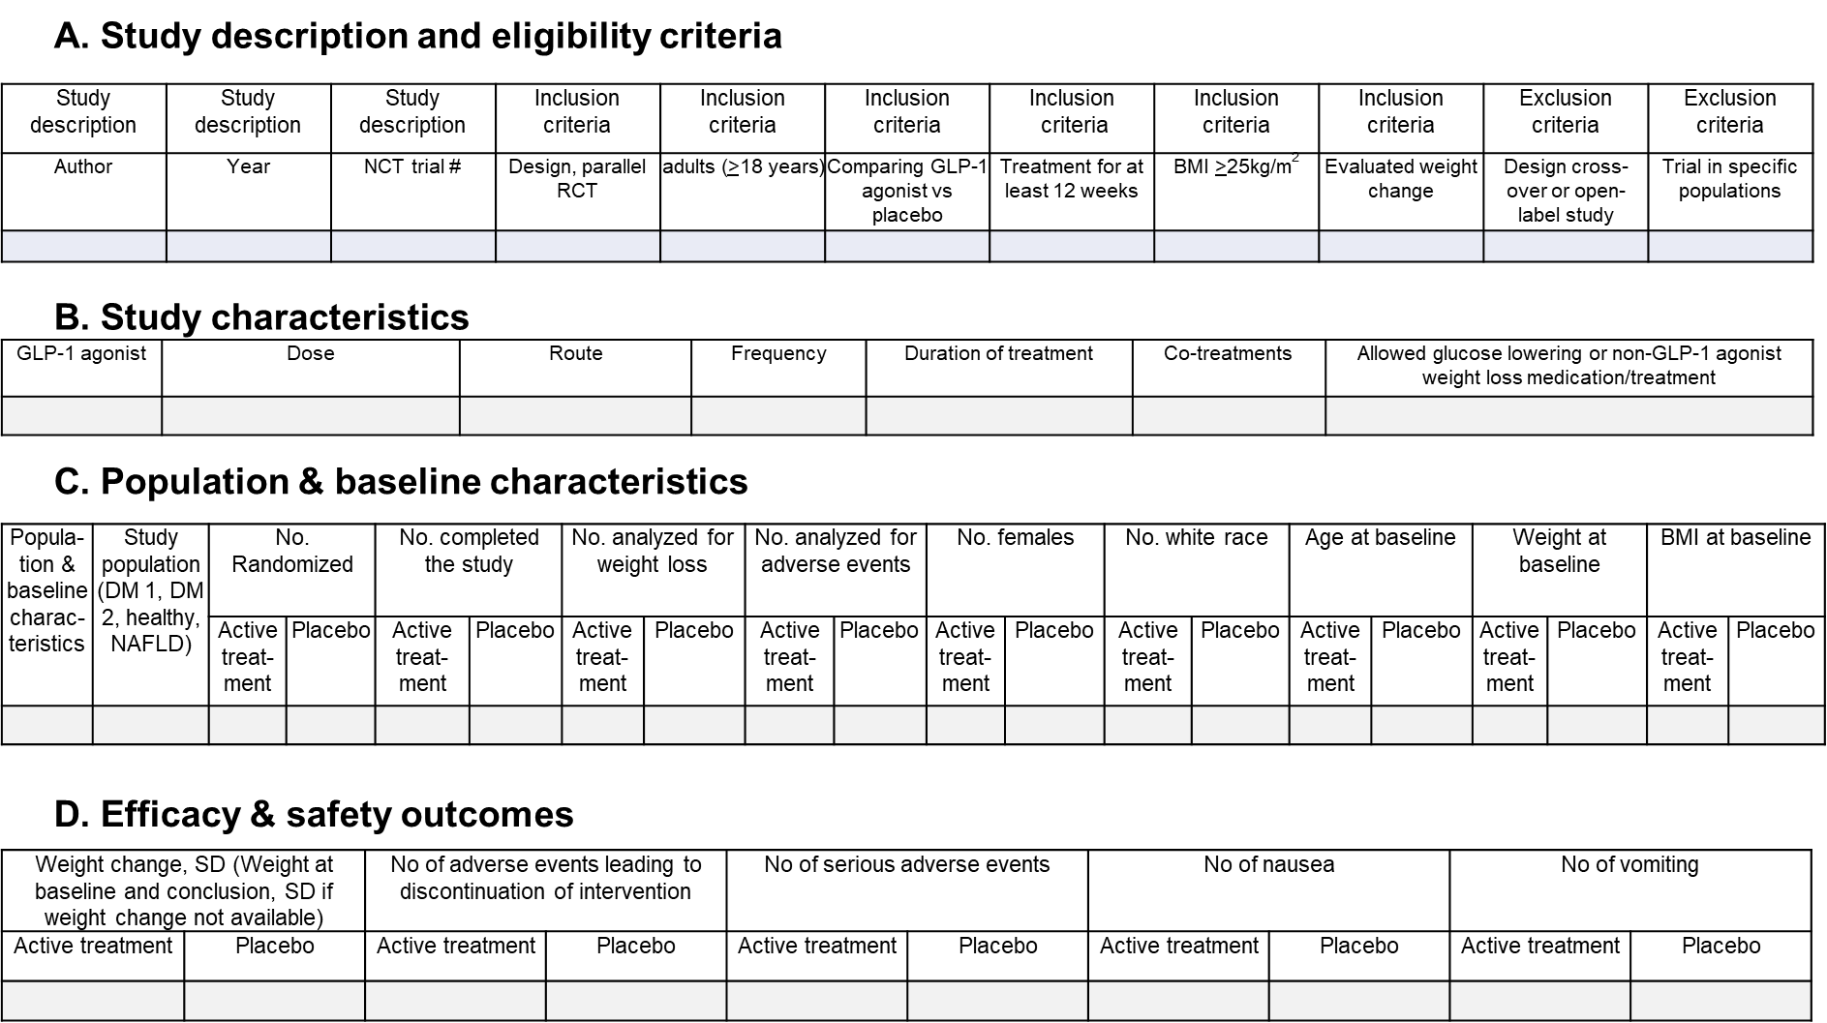

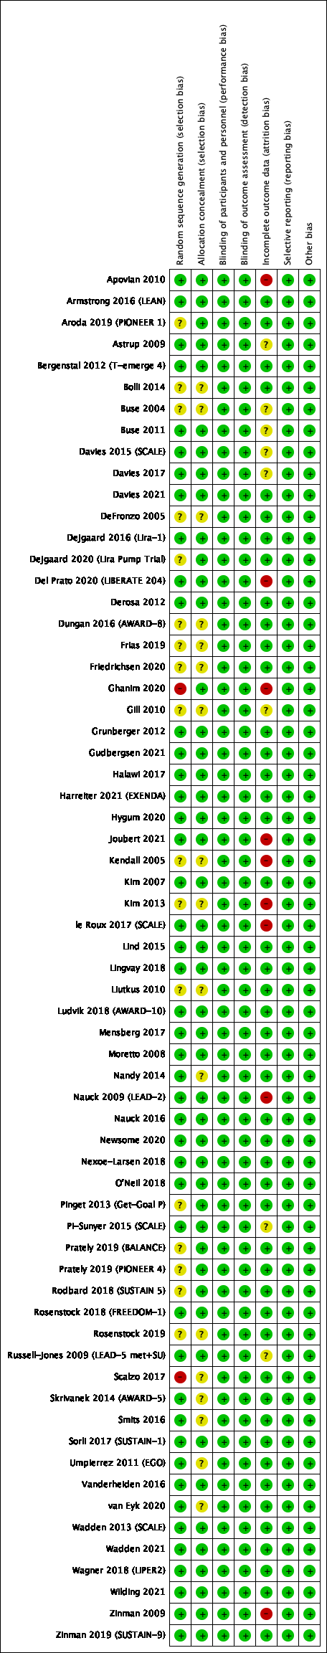
eFigure 2. (A) Study level risk of bias assessment using Cochrane collaboration’s tool for assessing risk of bias of randomized clinical trials. (B) Overall risk of bias presented as percentage of each risk of bias item across all included studies. KEY: (+)/Green = Low risk (−)/Red = High risk (?)/Yellow = Unclear.
A.

B.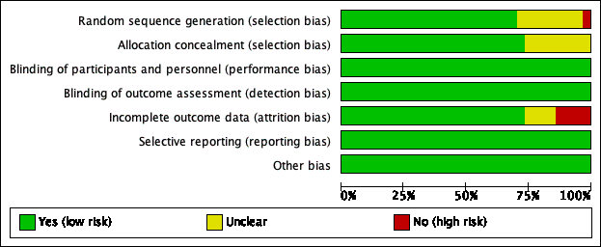

eFigure 3. Pairwise meta-analysis of excess weight loss, subdivided by drug-dosage groups using random effect model

eFigure 4. Pairwise meta-analysis of adverse events leading to discontinuation of study intervention, subdivided by drug-dosage groups, using random effect model

eFigure 5. Pairwise meta-analysis and forest plot of excess weight loss vs placebo in diabetic participants
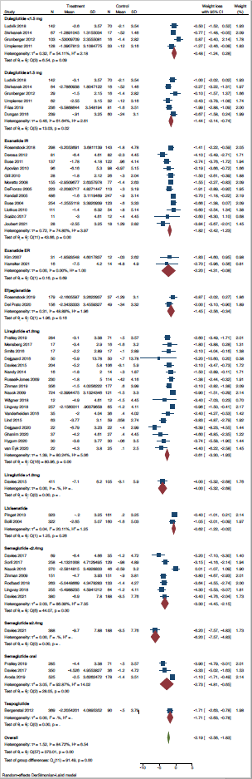
eFigure 6. Pairwise meta-analysis and forest plot of excess weight loss vs placebo in non-diabetic participants
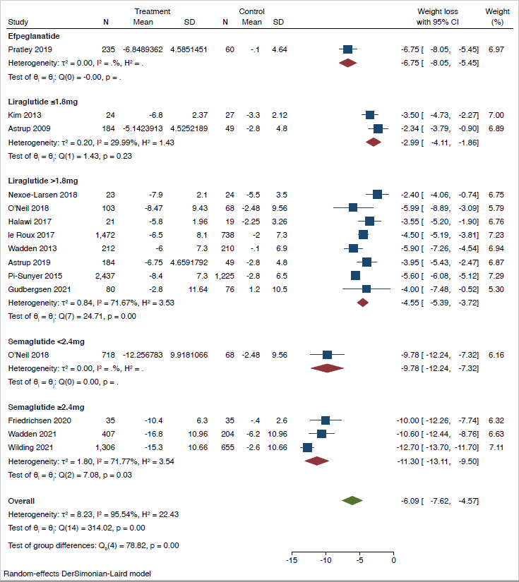
eFigure 7. Surface under the cumulative ranking (SUCRA) curves for excess weight loss. Higher surface under the curve reflects higher probability of association with weight loss.

Dulaglutide_high, dulaglutide ≥1.5mg; dulaglutide_low, dulaglutide <1.5mg; exenatide_ER, exenatide extended release; exenatide_IR, exenatide immediate release; liraglutide_high, liraglutide >1.8mg; liraglutide_low, liraglutide ≤1.8mg; semaglutide_sq_high (=semaglutide 2.4mg); semaglutide_sq_low (=semaglutide <2.4mg)

eFigure 8. Surface under the cumulative ranking (SUCRA) curves for adverse events leading to discontinuation of study intervention. Lower surface under the curve reflects higher probability of being discontinued because of adverse event.

Dulaglutide_high, dulaglutide ≥1.5mg; dulaglutide_low, dulaglutide <1.5mg; exenatide_ER, exenatide extended release; exenatide_IR, exenatide immediate release; liraglutide_high, liraglutide >1.8mg; liraglutide_low, liraglutide ≤1.8mg; semaglutide_sq_high (=semaglutide 2.4mg); semaglutide_sq_low (= semaglutide <2.4mg)

eFigure 9. Network maps for trials separated for diabetic (left) and non-diabetic (right) participants. Colors of the comparison lines show the average estimated risk of bias for each direct comparison: green reflects low risk and yellow reflects unclear risk of bias. Numbers above lines indicate numbers of trials for each comparison.

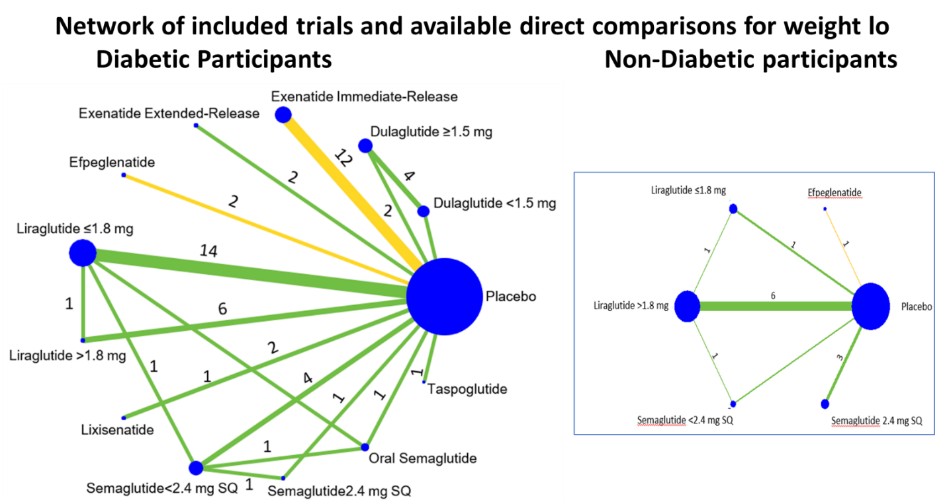

eFigure 10. Surface under the cumulative ranking (SUCRA) curves for weight loss by drug-dosage groups in diabetic participants

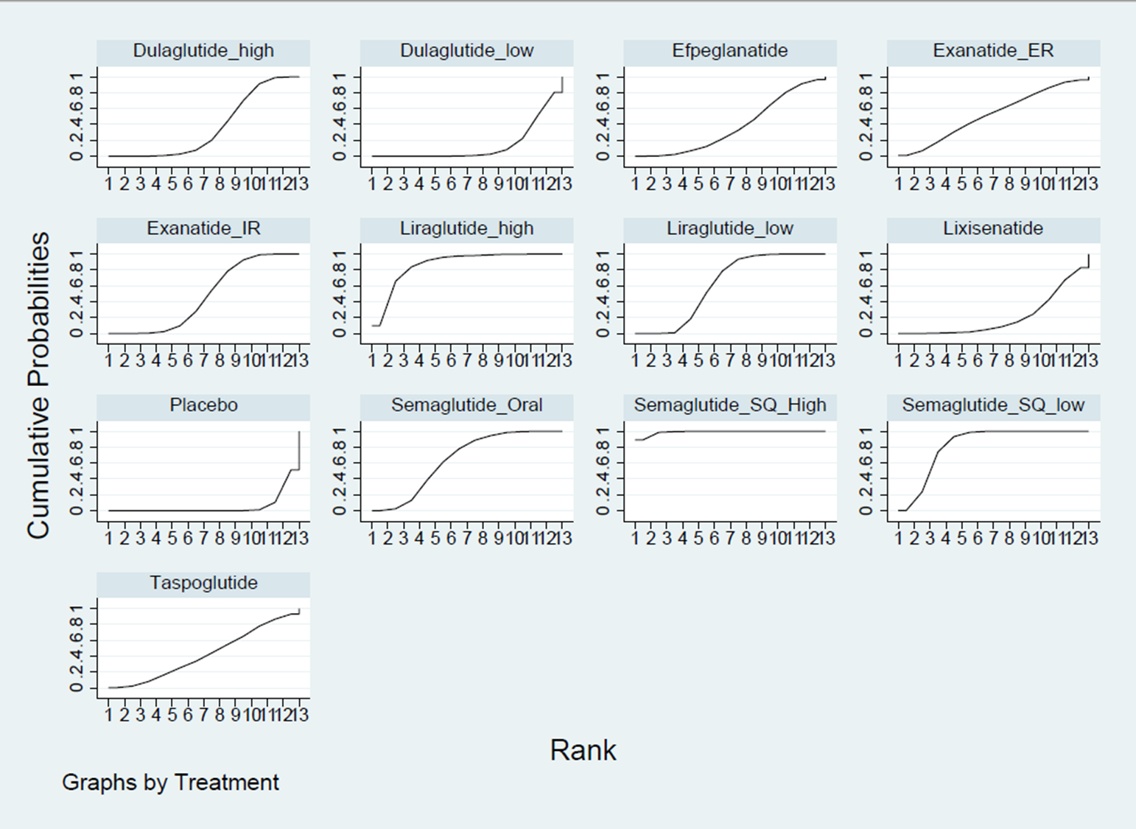
eFigure 11. Surface under the cumulative ranking (SUCRA) curves for weight loss by drug-dosage groups in non-diabetic participants

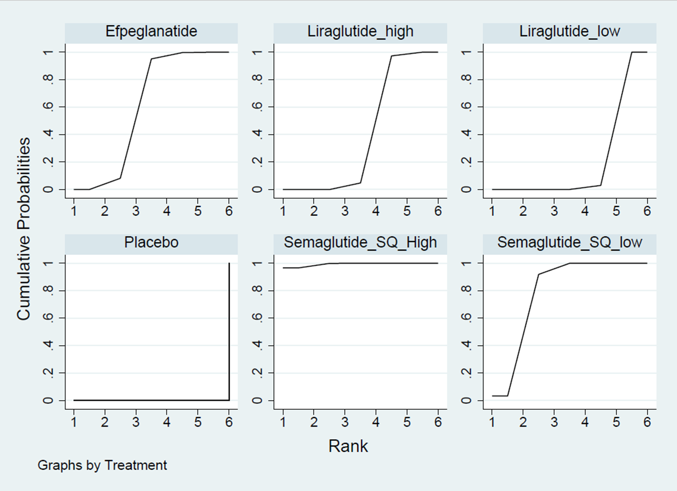

eFigure 12. Pairwise meta-analysis of nausea adverse event subdivided by drug-dosage groups, using random effect model

eFigure 13. Pairwise meta-analysis of vomiting adverse event subdivided by drug-dosage groups, using random effect model

eFigure 14. Differences between the estimates derived from small and large studies were evaluated by funnel plot.

Section and Topic | Item # | Checklist item | Location where item is reported
TITLE
Title | 1 | Identify the report as a systematic review. | Title
ABSTRACT
Abstract | 2 | See the PRISMA 2020 for Abstracts checklist. | Pages 2-3
INTRODUCTION
Rationale | 3 | Describe the rationale for the review in the context of existing knowledge. | Pages 5-6
Objectives | 4 | Provide an explicit statement of the objective(s) or question(s) the review addresses. | Page 6
METHODS
Eligibility criteria | 5 | Specify the inclusion and exclusion criteria for the review and how studies were grouped for the syntheses. | Pages 7-8
Information sources | 6 | Specify all databases, registers, websites, organisations, reference lists and other sources searched or consulted to identify studies. Specify the date when each source was last searched or consulted. | Page 7 and eTable 1
Search strategy | 7 | Present the full search strategies for all databases, registers and websites, including any filters and limits used. | Page 8 and e Methods
Selection process | 8 | Specify the methods used to decide whether a study met the inclusion criteria of the review, including how many reviewers screened each record and each report retrieved, whether they worked independently, and if applicable, details of automation tools used in the process. | Page 8
Data collection process | 9 | Specify the methods used to collect data from reports, including how many reviewers collected data from each report, whether they worked independently, any processes for obtaining or confirming data from study investigators, and if applicable, details of automation tools used in the process. | Pages 8,9
Data items | 10a | List and define all outcomes for which data were sought. Specify whether all results that were compatible with each outcome domain in each study were sought (e.g. for all measures, time points, analyses), and if not, the methods used to decide which results to collect. | Pages 9,10
Data items | 10b | List and define all other variables for which data were sought (e.g. participant and intervention characteristics, funding sources). Describe any assumptions made about any missing or unclear information. | eTables 1-3
Study risk of bias assessment | 11 | Specify the methods used to assess risk of bias in the included studies, including details of the tool(s) used, how many reviewers assessed each study and whether they worked independently, and if applicable, details of automation tools used in the process. | Page 9
Effect measures | 12 | Specify for each outcome the effect measure(s) (e.g. risk ratio, mean difference) used in the synthesis or presentation of results. | Pages 9,10
Synthesis methods | 13a | Describe the processes used to decide which studies were eligible for each synthesis (e.g. tabulating the study intervention characteristics and comparing against the planned groups for each synthesis (item #5)). | Page 7
Synthesis methods | 13b | Describe any methods required to prepare the data for presentation or synthesis, such as handling of missing summary statistics, or data conversions. | N/A
Synthesis methods | 13c | Describe any methods used to tabulate or visually display results of individual studies and syntheses. | Page 10
Synthesis methods | 13d | Describe any methods used to synthesize results and provide a rationale for the choice(s). If meta-analysis was performed, describe the model(s), method(s) to identify the presence and extent of statistical heterogeneity, and software package(s) used. | Pages 10-11
Synthesis methods | 13e | Describe any methods used to explore possible causes of heterogeneity among study results (e.g. subgroup analysis, meta-regression). | Pages 9,10
Synthesis methods | 13f | Describe any sensitivity analyses conducted to assess robustness of the synthesized results. | N/A
Reporting bias assessment | 14 | Describe any methods used to assess risk of bias due to missing results in a synthesis (arising from reporting biases). | Page 9
Certainty assessment | 15 | Describe any methods used to assess certainty (or confidence) in the body of evidence for an outcome. | Page 9
RESULTS
Study selection | 16a | Describe the results of the search and selection process, from the number of records identified in the search to the number of studies included in the review, ideally using a flow diagram. | Pages 8,9 and Figure 1
Study selection | 16b | Cite studies that might appear to meet the inclusion criteria, but which were excluded, and explain why they were excluded. | eTable 1 and Figure 1
Study characteristics | 17 | Cite each included study and present its characteristics. | eTables 2 and 3 and page 11
Risk of bias in studies | 18 | Present assessments of risk of bias for each included study. | eFigure 2 and page 13
Results of individual studies | 19 | For all outcomes, present, for each study: (a) summary statistics for each group (where appropriate) and (b) an effect estimate and its precision (e.g. confidence/credible interval), ideally using structured tables or plots. | Pages 13-16, Tables 1 and 2, Figure 2, eFigures 4-13
Results of syntheses | 20a | For each synthesis, briefly summarise the characteristics and risk of bias among contributing studies. | Page 16, and eFigure 14
Results of syntheses | 20b | Present results of all statistical syntheses conducted. If meta-analysis was done, present for each the summary estimate and its precision (e.g. confidence/credible interval) and measures of statistical heterogeneity. If comparing groups, describe direction of effect. | Pages 13-16, Tables 1 and 4, Figure 3, eFigures 3-6, 12,13
Results of syntheses | 20c | Present results of all investigations of possible causes of heterogeneity among study results. | Page 14
Results of syntheses | 20d | Present results of all sensitivity analyses conducted to assess the robustness of the synthesized results. | N/A
Reporting biases | 21 | Present assessments of risk of bias due to missing results (arising from reporting biases) for each synthesis assessed. | N/A
Certainty of evidence | 22 | Present assessments of certainty (or confidence) in the body of evidence for each outcome assessed. | Pages 11,12 and eTables 5 and 6
DISCUSSION
Discussion | 23a | Provide a general interpretation of the results in the context of other evidence. | Pages 17,18
Discussion | 23b | Discuss any limitations of the evidence included in the review. | Page 19
Discussion | 23c | Discuss any limitations of the review processes used. | Page 19
Discussion | 23d | Discuss implications of the results for practice, policy, and future research. | Page 19
OTHER INFORMATION
Registration and protocol | 24a | Provide registration information for the review, including register name and registration number, or state that the review was not registered. | Not registered
Registration and protocol | 24b | Indicate where the review protocol can be accessed, or state that a protocol was not prepared. | Protocol not prepared
Registration and protocol | 24c | Describe and explain any amendments to information provided at registration or in the protocol. | N/A
Support | 25 | Describe sources of financial or non-financial support for the review, and the role of the funders or sponsors in the review. | Page 19
Competing interests | 26 | Declare any competing interests of review authors. | Page 20
Availability of data, code and other materials | 27 | Report which of the following are publicly available and where they can be found: template data collection forms; data extracted from included studies; data used for all analyses; analytic code; any other materials used in the review. | Supplemental Materials eMethods and eFigure 1

From: Page MJ, McKenzie JE, Bossuyt PM, Boutron I, Hoffmann TC, Mulrow CD, et al. The PRISMA 2020 statement: an updated guideline for reporting systematic reviews. BMJ 2021;372:n71. doi: 10.1136/bmj.n71
For more information, visit: http://www.prisma-statement.org/

