Additional file 6) Subgroup analysis

Figure AD1 Forest plot of subgroup analysis on type of diabetes
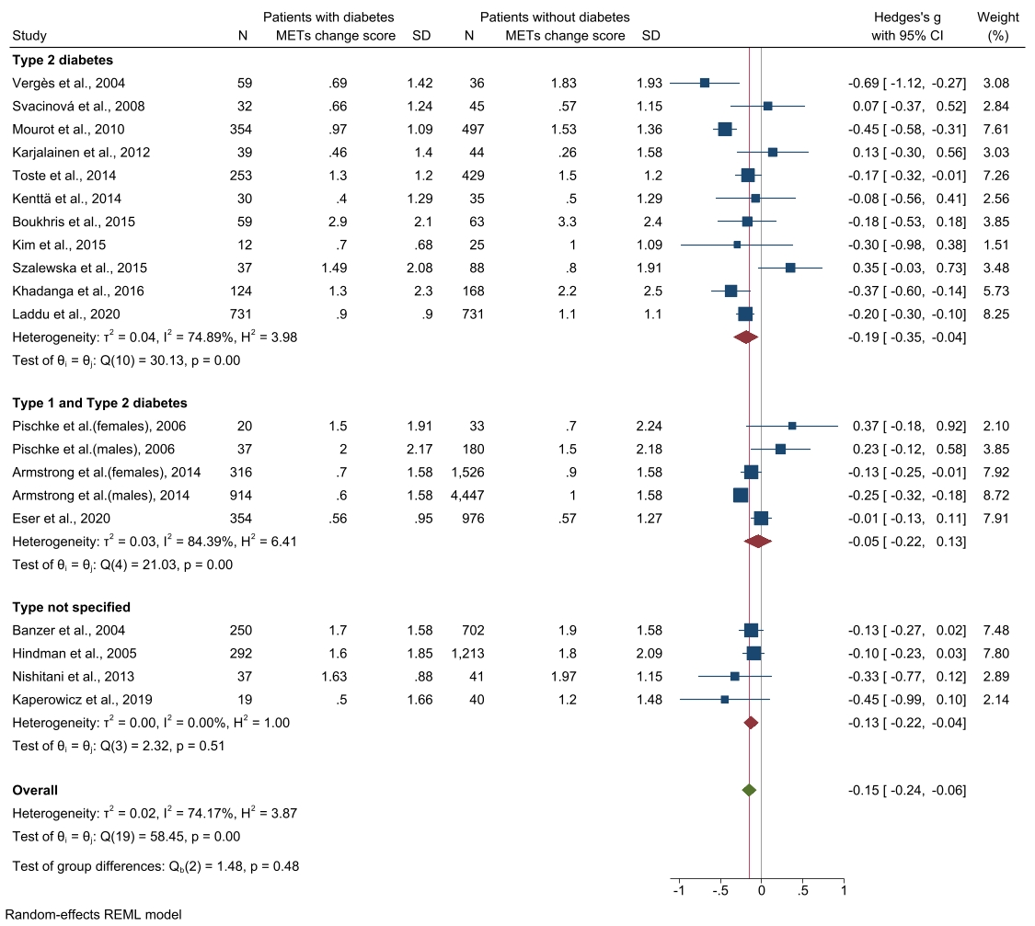

Figure AD2 Subgroup analysis on type of intervention
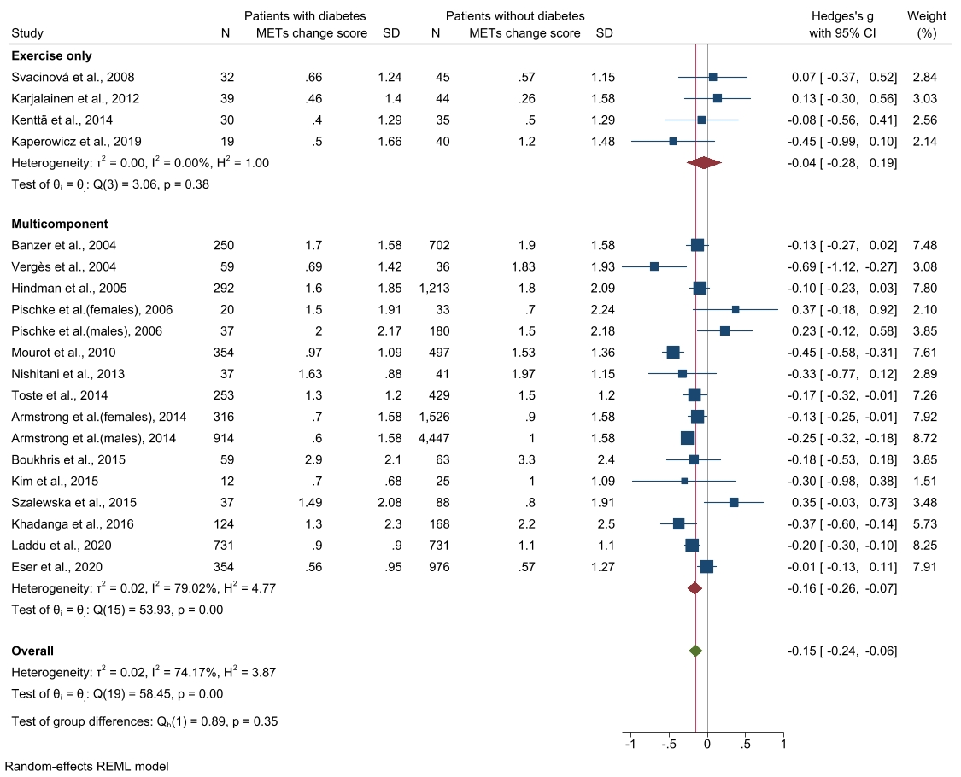

Figure AD3 Subgroup analysis on length of trial follow up

Figure SM6.4 Funnel plot for assessing publication bias from start of CR to end of intervention

Figure AD6.5 Funnel plot for assessing publication.bias

