Supplementary file 1
 |  | GRADE Quality assessment |  |  |  |  |  |  | Quality
No of studies | Design |  | Risk of bias | Inconsistency | Indirectness | Imprecision | Publication Bias | Other considerations
Morphine consumption at 24h post-operatively
6 | RCTs |  | None¹ | Serious² | None | None³ | Undetected ⁴ | None | ⊕⊕⊕◯  MODERATE
Pain intensity at 24 h post-operatively
6 | RCTs |  | None⁵ | Serious⁶ | None | Very serious⁷ | Undetected⁸ | None | ⊕◯◯◯  VERY LOW
Fentanyl/Remifentanil maintenance dosage
4 | RCTs |  | None⁹ | Serious¹⁰ | None | Serious¹¹ | Undetected¹² | None | ⊕⊕◯◯  LOW
Intraoperative hypertension
5 | RCTs |  | None¹³ | None¹⁴ | None | Very Serious¹⁵ | Undetected¹⁶ |  | ⊕⊕◯◯  LOW
Intraoperative bradycardia
4 | RCTs |  | None¹⁷ | None¹⁸ | None | Very serious¹⁹ | Undetected ²⁰ |  | ⊕⊕◯◯  LOW
Extubation time
7 | RCTs |  | None²¹ | Serious²² | None | Very serious²³ | Undetected²⁴ |  | ⊕◯◯◯  VERY LOW
Time to follow commands
5 | RCTs |  | None²⁵ | Serious²⁶ | None | Very serious²⁷ | None²⁸ |  | ⊕◯◯◯  VERY LOW
Time to orientation
4 | RCTs |  | None²⁹ | None³⁰ | None | Serious³¹ | None³² |  | ⊕⊕⊕◯  MODERATE
Postoperative nausea and vomiting
7 | RCTs |  | None³³ | None³⁴ | None | None³⁵ | None³⁶ |  | ⊕⊕⊕⊕  HIGH

Table A. Quality of evidence of the included trials assessed by GRADE approach

Footnotes
1.Six studies were included. Most studies had clear descriptions of randomization, allocation concealment, blinding. All studies had clear descriptions of complete outcome assessment in terms of drop-outs and ITT analysis. Similarity of baseline characteristic, cointervention, timing of assessment was clearly described in all studies. Five studies did not have clear descriptions of selective reporting.
2. I²=95%, P < 0.01, high heterogeneity.
3.Total number of participants is 403. The 95% CI did not include the no effect.
4. Publication bias was not found by funnel plot; though publication bias may present, we did not downgrade this item.
5.Six studies were included. Most studies had clear descriptions of randomization and patient blinding. All studies had clear descriptions of complete outcome assessment in terms of drop-outs and ITT analysis. Similarity of baseline characteristic, cointervention, timing of assessment was clearly described in all studies. Three studies did not have clear descriptions of assessor blinding, and four studies did not have clear descriptions of selective reporting.
6.I²=61%, P < 0.01, moderate heterogeneity.
7.Total number of participants is 309. The 95% CI included the no effect.
8. Publication bias was not found by funnel plot; though publication bias may present, we did not downgrade this item.
9.Four studies were included. The overall risk of bias is low, except that two studies did not have clear descriptions of assessor blinding and two studies did not have clear descriptions of selective reporting.
10.I²=94%, P < 0.01, high heterogeneity.
11.Total number of participants is 237. The 95% CI did not include the no effect.
12. Publication bias was not found by funnel plot; though publication bias may present, we did not downgrade this item.
13.Three studies were included. The overall risk of bias is low.
14.I²=0%, P=0.73, ignorable heterogeneity.
15.Total number of participants is 175. The 95% CI included the no effect.
16.Publication bias was not found by funnel plot; though publication bias may present, we did not downgrade this item.
17.Three studies were included. The overall risk of bias is low.
18.I²=21%, P=0.28, ignorable heterogeneity.
19.Total number of participants is 191. The 95% CI included the no effect.
20. Publication bias was not found by funnel plot; though publication bias may present, we did not downgrade this item.
21.Six studies were included. The overall risk of bias is low.
22.I²=95%, P < 0.01, high heterogeneity.
23.Total number of participants is 315. The 95% CI included the no effect.
24. Publication bias was not found by funnel plot; though publication bias may present, we did not downgrade this item.
25.Five studies were included. Most studies had clear descriptions of randomization and provider blinding. All studies had clear descriptions of patients blinding as well as complete outcome assessment in terms of drop-outs and ITT analysis. Similarity of baseline characteristic, cointervention, timing of assessment was clearly described in all studies. Three studies did not have clear descriptions of allocation concealment, and four studies did not have clear descriptions of assessor blinding and three studies did not have clear descriptions of selective reporting.
26.I²=91%, P < 0.01, high heterogeneity.
27.Total number of participants is 244. The 95% CI included the no effect.
28. Publication bias was not found by funnel plot; though publication bias may present, we did not downgrade this item.
29.The overall risk of bias is low, except that three studies did not have clear descriptions of provider blinding, and three studies did not have clear descriptions of selective reporting.
30.I²=0%, P =0.53, ignorable heterogeneity.
31.Total number of participants is 206. The 95% CI did not include the no effect.
32. Publication bias was not found by funnel plot; though publication bias may present, we did not downgrade this item.
33.Six studies were included. The overall risk of bias is low, except that five studies did not have clear descriptions of selective reporting.
34.I²=0%, P =0.81, ignorable heterogeneity.
35.Total number of participants is 325. The 95% CI did not include the no effect.
36. Publication bias was not found by funnel plot; though publication bias may present, we did not downgrade this item.

Assessment tool | Domain | Author year  Questions | Altan 2005. | Dehkordy 2020 | Delavari 2019 | Demiroglu 2016 | Etezadi 2020 | Ghaffaripour 2016 | Göral 2011 | Jabbour 2014 | Levaux 2003 | Martin 2018 | Oguzhan 2008 | Reena 2017 | Srivastava 2016 | Telci 2002 | Tsaousi 2020
Cochrane Sources of Risk of Bias  (Yes/No/Unsure) | Selection | Was the method of randomization adequate? | Unsure | Yes | Yes | Unsure | Yes | Yes | Yes | Yes | Yes | Unsure | Yes | Yes | Yes | Unsure | Yes
Cochrane Sources of Risk of Bias  (Yes/No/Unsure) | Selection | Was the treatment allocation concealed? | Unsure | Yes | Unsure | Unsure | Unsure | Yes | Yes | Yes | Yes | Unsure | Yes | Yes | Unsure | Unsure | Yes
Cochrane Sources of Risk of Bias  (Yes/No/Unsure) | Performance | Was the patient blinded to the intervention? | Yes | Yes | Yes | Unsure | Unsure | Yes | Yes | Yes | Yes | Yes | Yes | Yes | Yes | Yes | Yes
Cochrane Sources of Risk of Bias  (Yes/No/Unsure) | Performance | Was the care provider blinded to the intervention? | Yes | Yes | Yes | Unsure | Unsure | Yes | Yes | Yes | Yes | Unsure | Yes | Yes | Yes | Yes | Yes
Cochrane Sources of Risk of Bias  (Yes/No/Unsure) | Detection | Was the outcome assessor blinded to the intervention? | Unsure | Yes | Unsure | Unsure | Unsure | Yes | Yes | Yes | Unsure | Unsure | Yes | Unsure | Unsure | Unsure | Yes
Cochrane Sources of Risk of Bias  (Yes/No/Unsure) | Attrition | Was the drop-out rate described and acceptable? | Yes | Yes | Yes | Yes | Yes | Yes | Yes | Yes | Yes | Yes | Yes | Yes | Yes | Yes | Yes
Cochrane Sources of Risk of Bias  (Yes/No/Unsure) | Attrition | Were all randomized participants analyzed in the group to which they were allocated? | Yes | Yes | Yes | Yes | Yes | Yes | Yes | Yes | Yes | Yes | Yes | Yes | Yes | Yes | Yes
Cochrane Sources of Risk of Bias  (Yes/No/Unsure) | Reporting | Are reports of the study free of suggestion of selective outcome reporting? | Unsure | Unsure | Unsure | Unsure | Unsure | Yes | Unsure | Unsure | Unsure | Yes | Unsure | Unsure | Yes | Unsure | Yes
Cochrane Sources of Risk of Bias  (Yes/No/Unsure) | Selection | Were the groups similar at baseline regarding the most important prognostic indicators? | Yes | Yes | Yes | Yes | Yes | Yes | Yes | Yes | Yes | Yes | Yes | Yes | Yes | Yes | Yes
Cochrane Sources of Risk of Bias  (Yes/No/Unsure) | Performance | Were cointerventions avoided or similar? | Yes | Yes | Yes | Yes | Yes | Yes | Yes | Yes | Yes | Yes | Yes | Yes | Yes | Yes | Yes
Cochrane Sources of Risk of Bias  (Yes/No/Unsure) | Performance | Was the compliance acceptable in all groups? | Yes | Yes | Yes | Yes | Yes | Yes | Yes | Yes | Yes | Yes | Yes | Yes | Yes | Yes | Yes
Cochrane Sources of Risk of Bias  (Yes/No/Unsure) | Detection | Was the timing of the outcome assessment similar in all groups? | Yes | Yes | Yes | Yes | Yes | Yes | Yes | Yes | Yes | Yes | Yes | Yes | Yes | Yes | Yes
Cochrane Sources of Risk of Bias  (Yes/No/Unsure) | Other | Are other sources of potential bias unlikely? | Yes | Yes | Yes | Yes | Yes | Yes | Yes | Yes | Yes | Yes | Yes | Yes | Yes | Yes | Yes
Jaded scale | Randomization | If randomization is mentioned/appropriate? | 1 | 2 | 2 | 1 | 2 | 2 | 2 | 2 | 2 | 1 | 2 | 2 | 2 | 1 | 2
Jaded scale | Blinding | If blinding is mentioned/appropriate? | 1 | 2 | 1 | 0 | 0 | 2 | 2 | 2 | 1 | 1 | 2 | 2 | 1 | 1 | 2
Jaded scale | An account of all patients | If the fate of all patients in the trial is known or the reason of no data the is stated. | 1 | 1 | 1 | 1 | 1 | 1 | 1 | 1 | 1 | 1 | 1 | 1 | 1 | 1 | 1
 |  | In total | 3 | 5 | 4 | 2 | 2 | 5 | 5 | 5 | 4 | 3 | 5 | 5 | 4 | 3 | 5

Table B. Quality assessment of included studies by CBN Group risk of bias tools and Jadad scale.

Figure A. Assessment of publication bias by funnel plots (left); and sensitivity analysis by omitting trials one by one (right) of pain intensity scale at 24 h postoperatively.
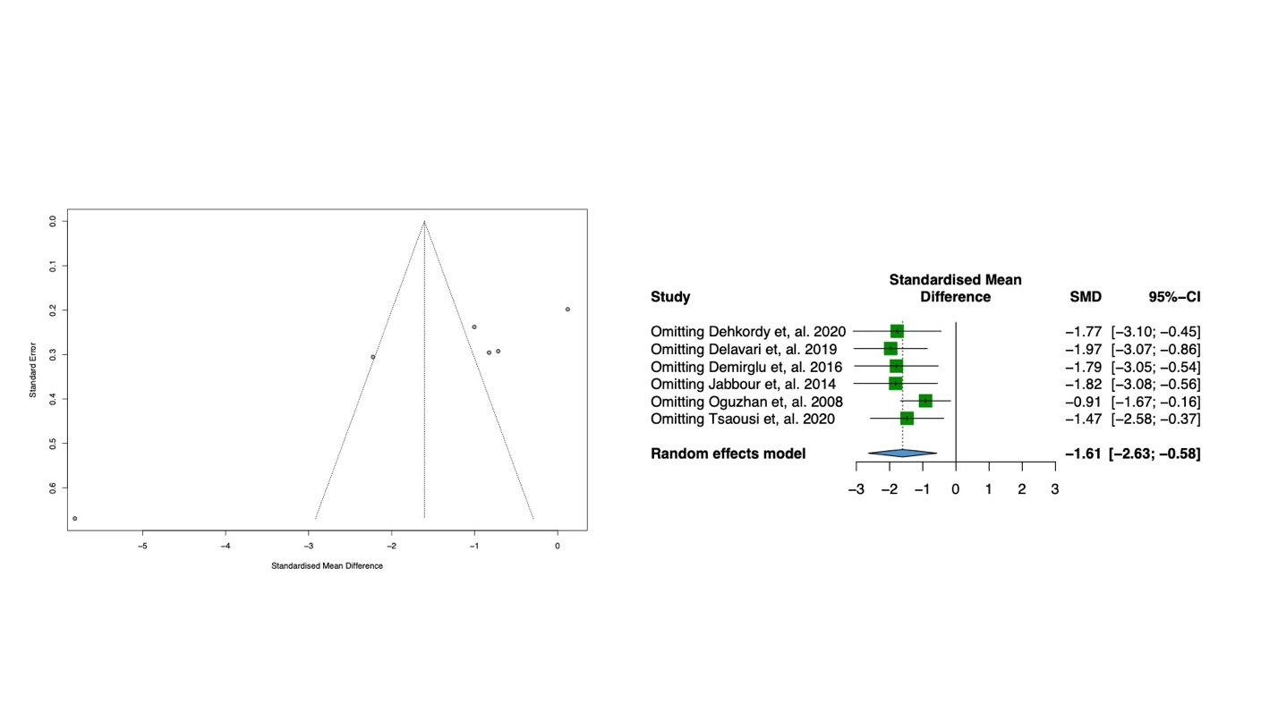
Figure B. Assessment of publication bias by funnel plots (left); and sensitivity analysis by omitting trials one by one (right) of analgesic consumption at 24 h postoperatively.
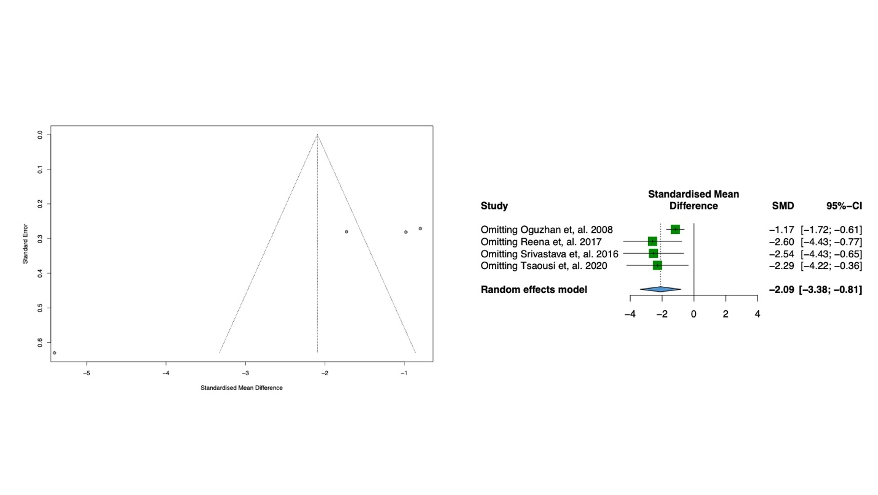
Figure C. Assessment of publication bias by funnel plots (left); and sensitivity analysis by omitting trials one by one (right) of intraoperative remifentanil requirements.
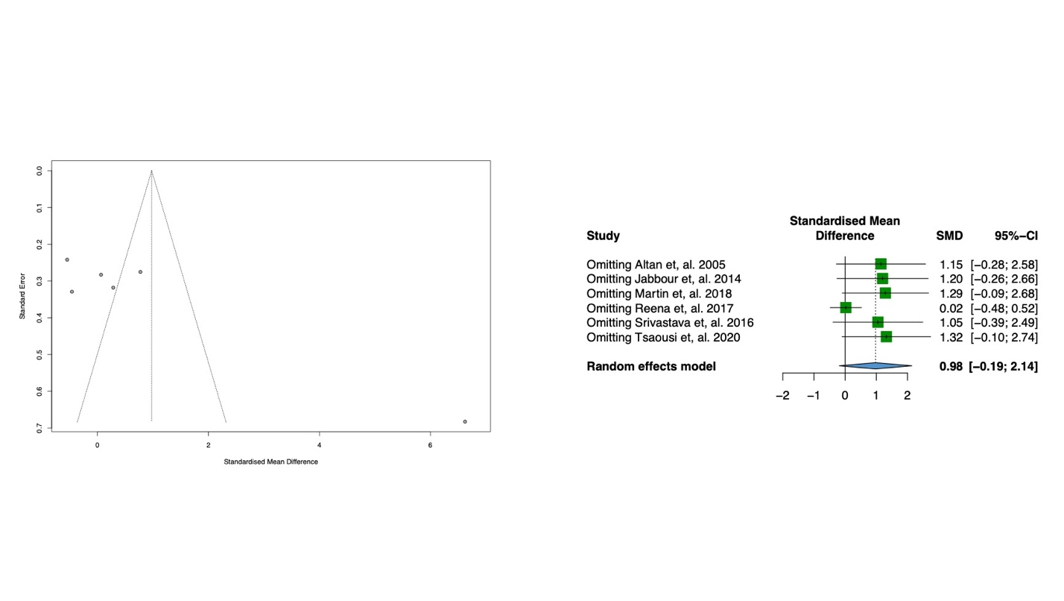
Figure D. Assessment of publication bias by funnel plots (left); and sensitivity analysis by omitting trials one by one (right) of extubation time.
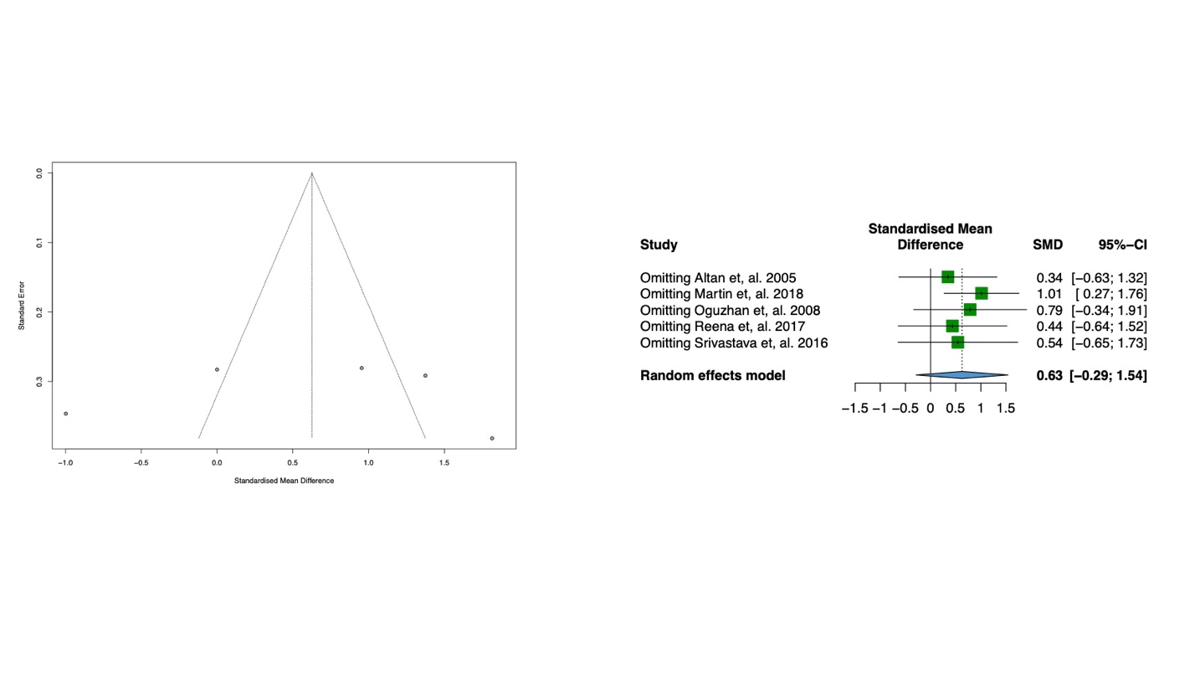
Figure E. Assessment of publication bias by funnel plots (left); and sensitivity analysis by omitting trials one by one (right) of time to follow commands.
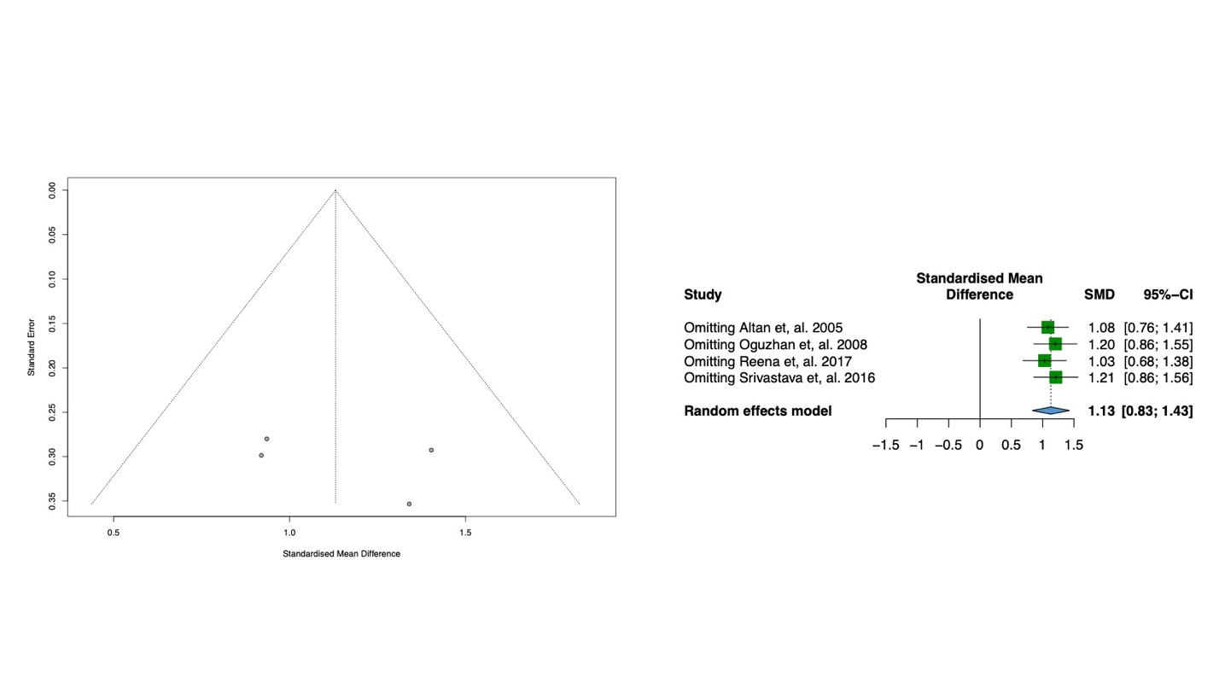
Figure F. Assessment of publication bias by funnel plots (left); and sensitivity analysis by omitting trials one by one (right) of orientation time.
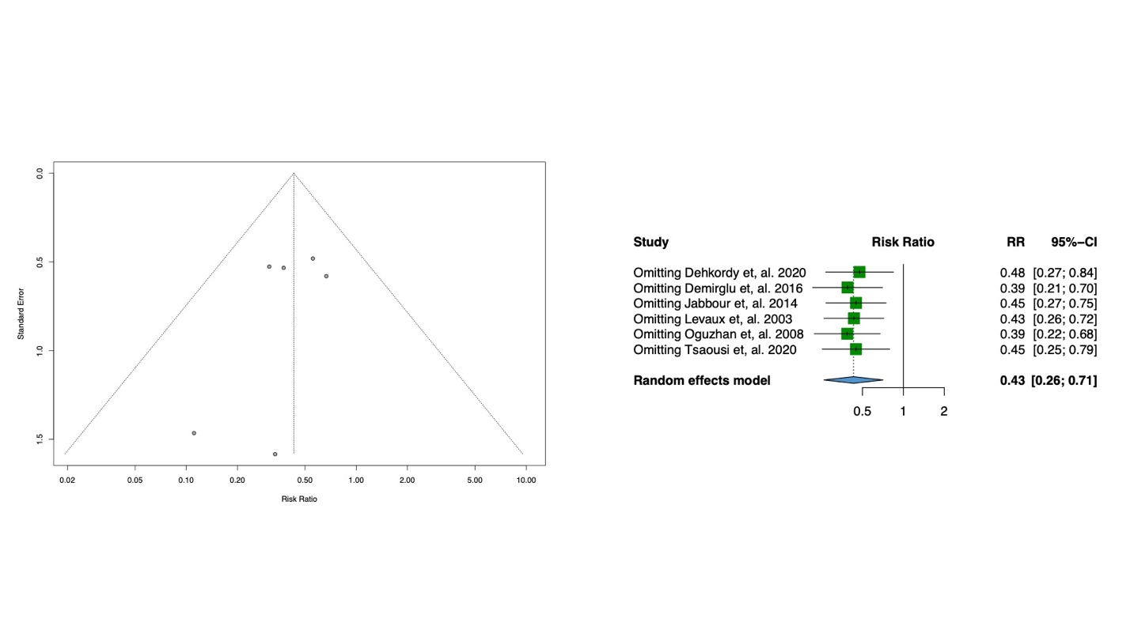
Figure G. Assessment of publication bias by funnel plots (left); and sensitivity analysis by omitting trials one by one (right) of postoperative nausea and vomiting.
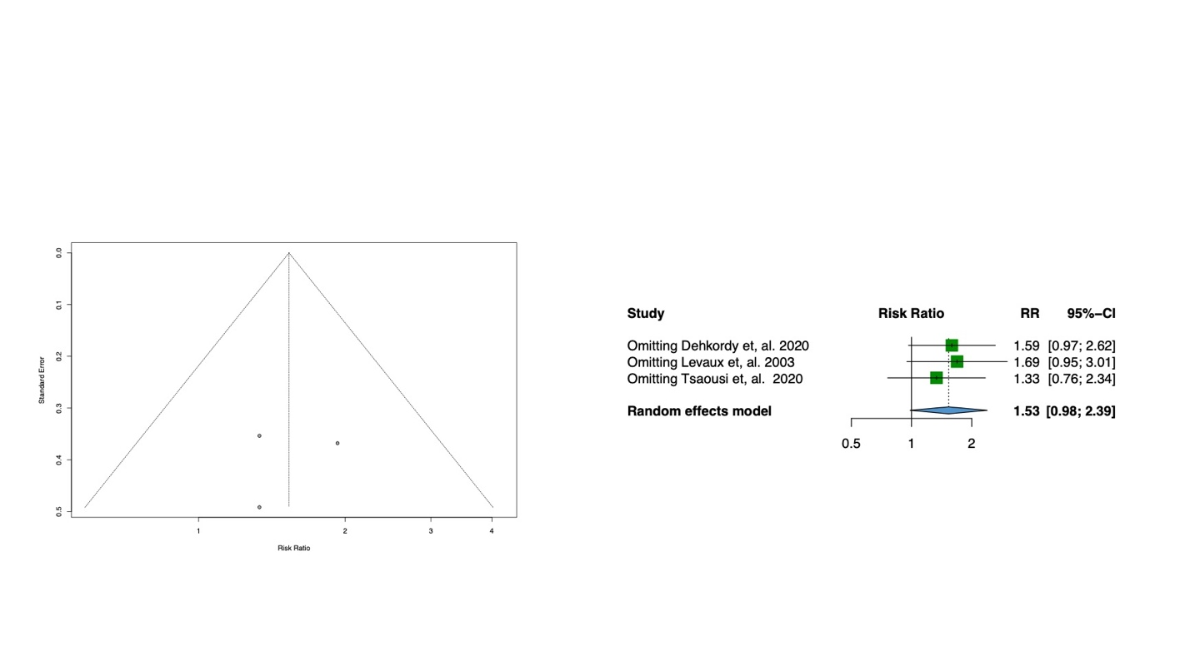
Figure H. Assessment of publication bias by funnel plots (left); and sensitivity analysis by omitting trials one by one (right) of intraoperative hypotension.
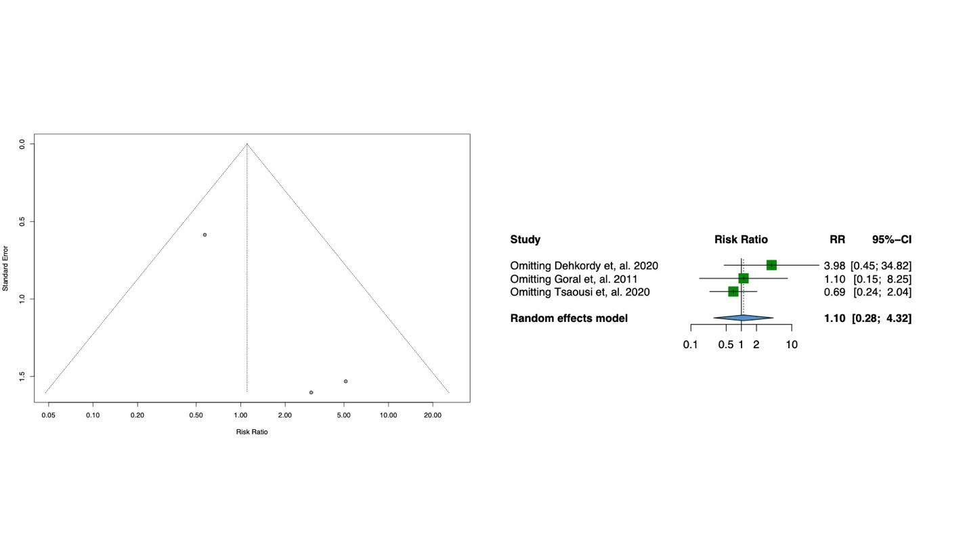
Figure I. Assessment of publication bias by funnel plots (left); and sensitivity analysis by omitting trials one by one (right) of bradycardia.

