Supplemental Appendix

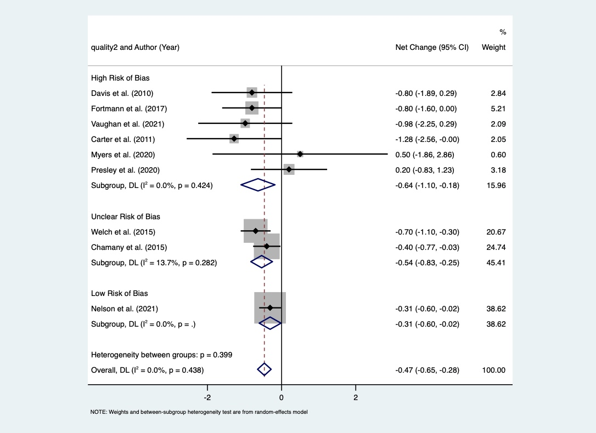
Supplemental Appendix Figure A. Subgroup analysis of reduction of HbA1c based on study quality

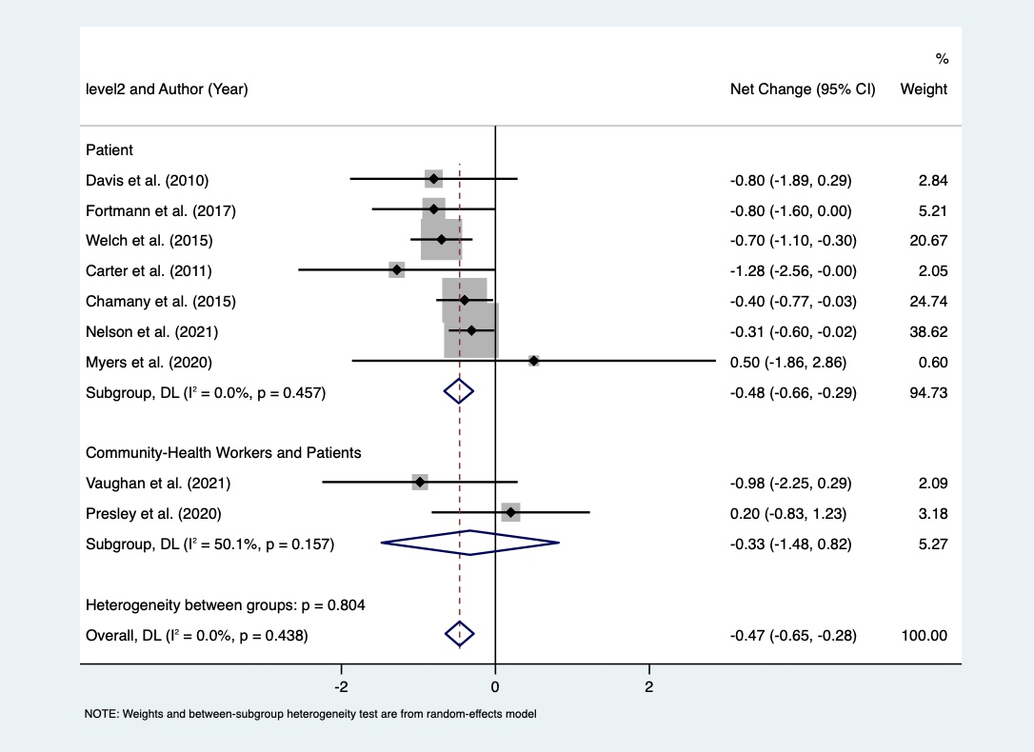
Supplemental Appendix Figure B. Subgroup analysis of reduction of HbA1c based on intervention level

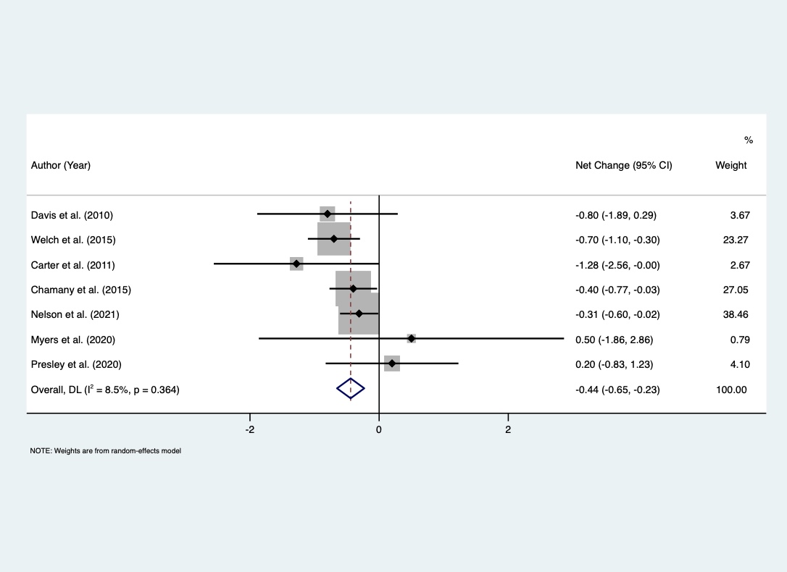
Supplemental Appendix Figure C. Sensitivity analysis of reduction of HbA1c in Black/Black and Hispanic participants studies

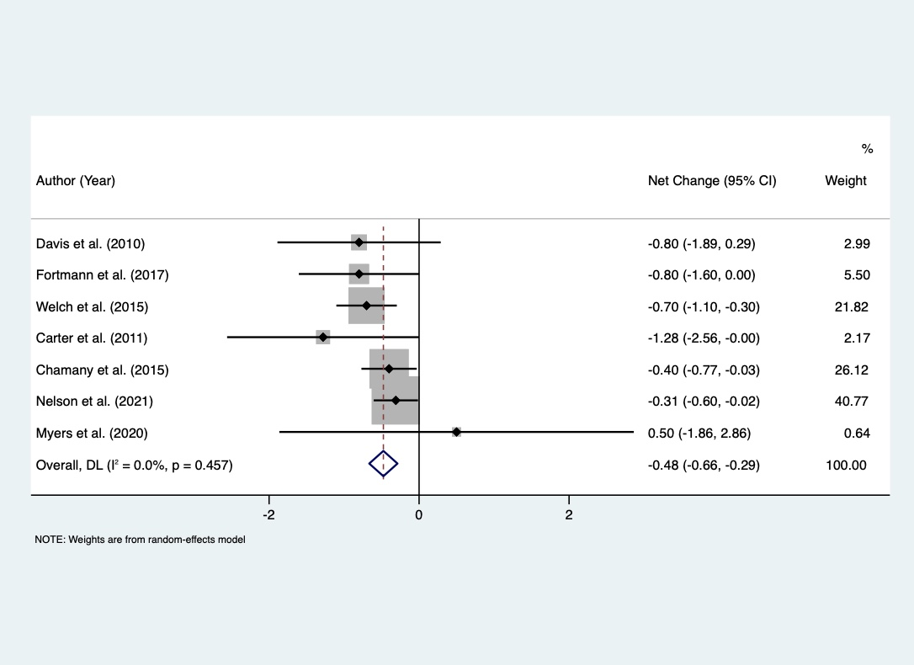
Supplemental Appendix Figure D. Sensitivity analysis of reduction of HbA1c for patient level interventions

Figure 4: Trim and fill method test of publication bias
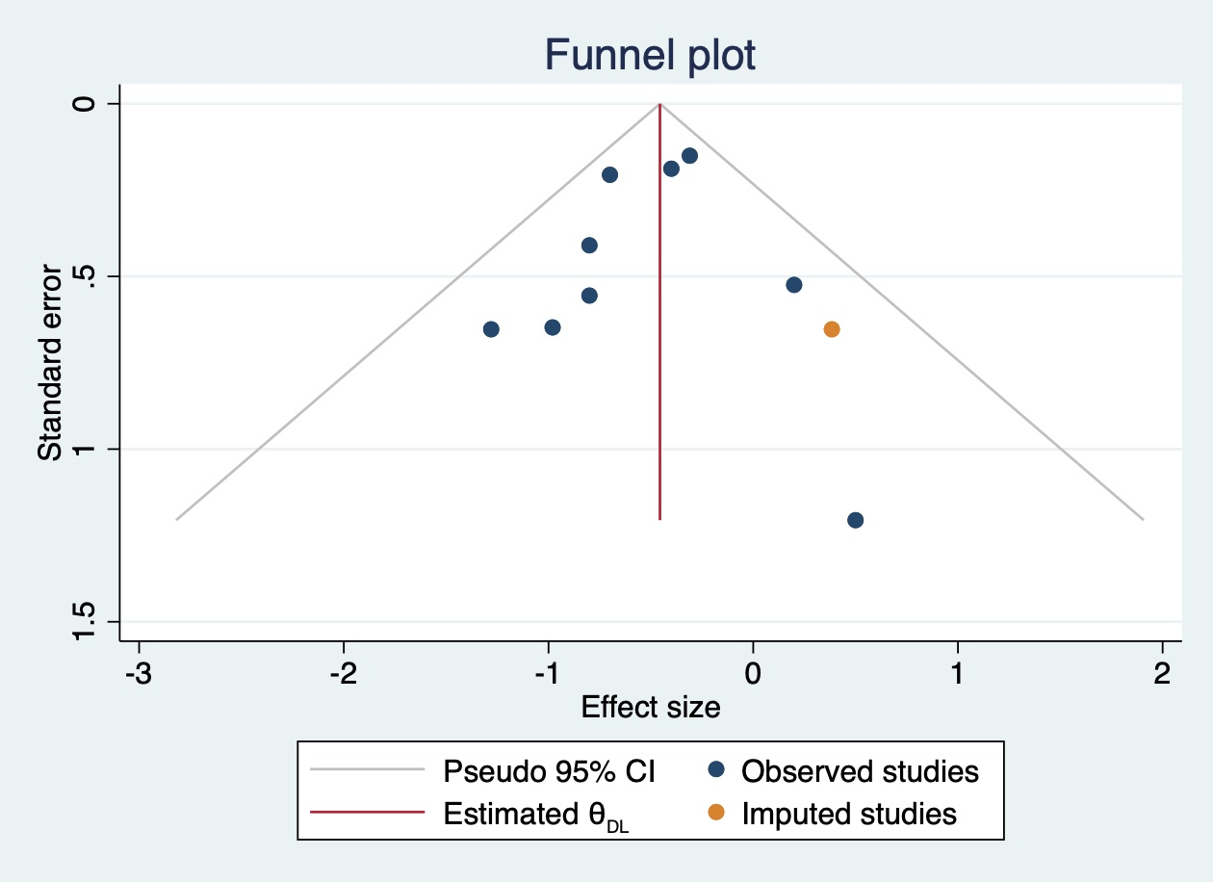

Figure 5: Test of publication bias
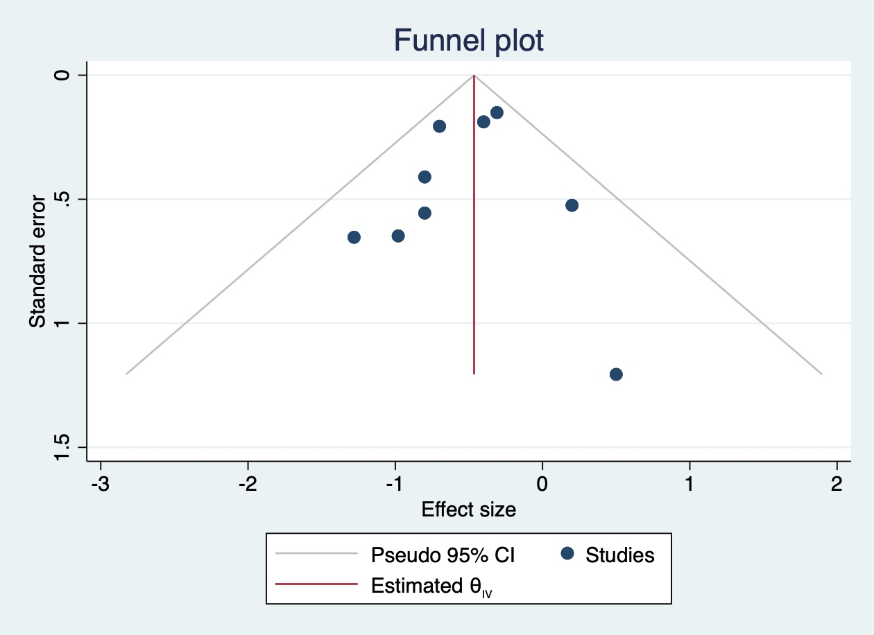

Figure 6: Egger test of publication bias graph


