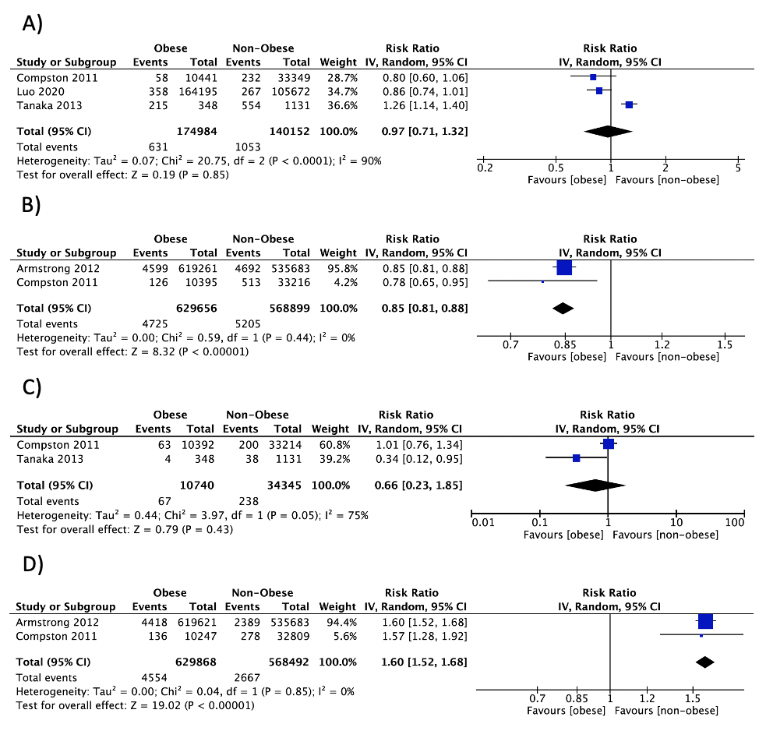
S1 Fig. Forest plot of pooled effect size for the risk of A) clinical vertebral fracture, B) wrist fracture, C) forearm fracture and D) ankle fracture in postmenopausal women with vs. without obesity, using a random-effect model.

