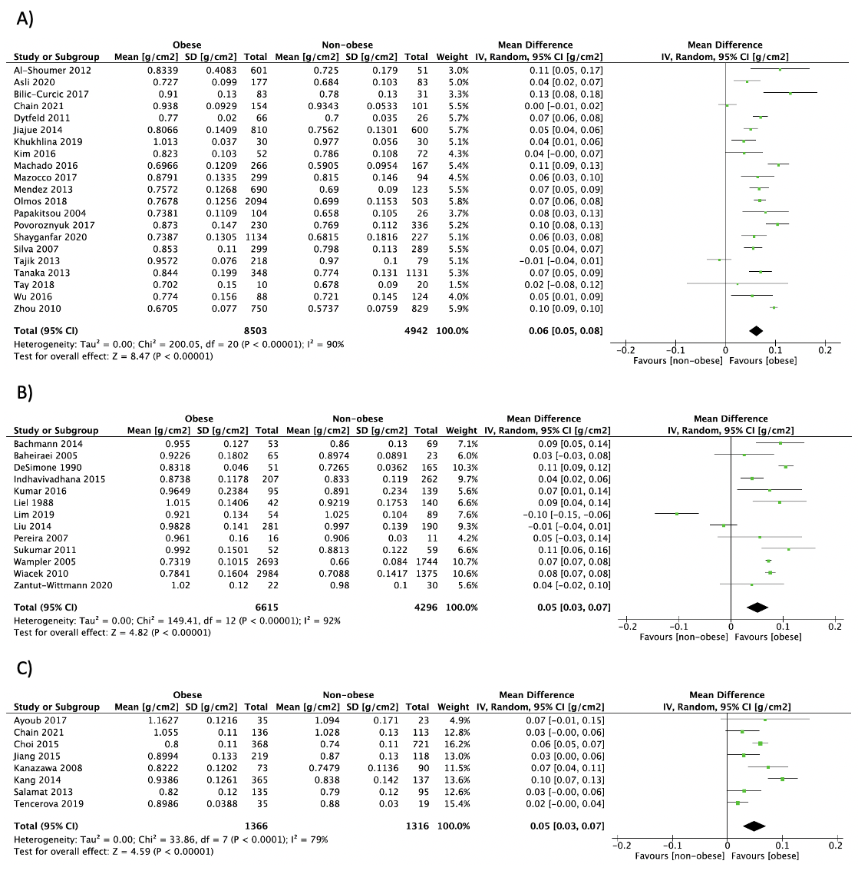

S2 Fig. Forest plot of pooled effect size for the femoral neck aBMD by DXA mean difference between A) postmenopausal women, B) premenopausal women and C) men with vs. without obesity, using a random-effect model.

