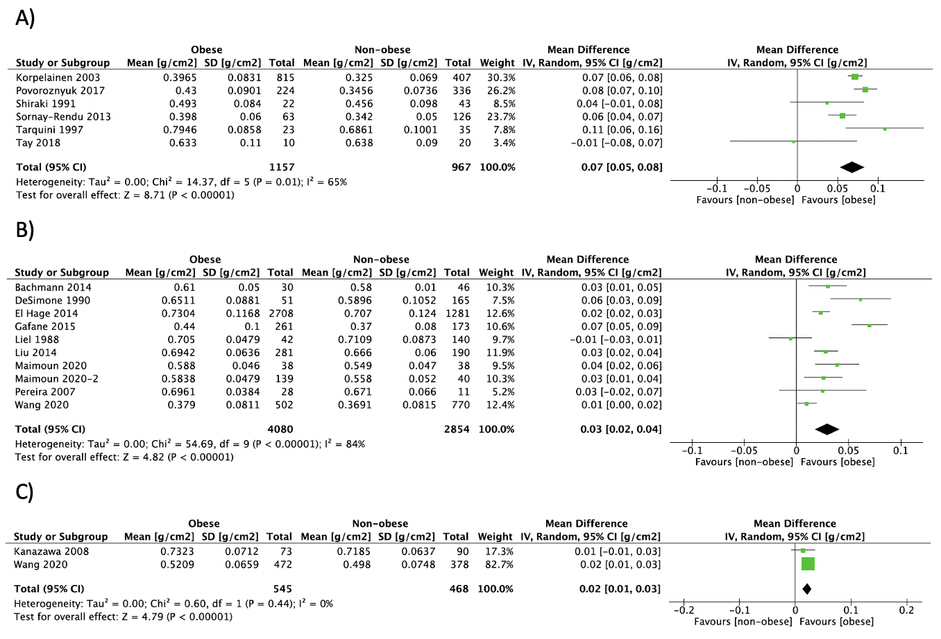
S4 Fig. Forest plot of pooled effect size for the radius aBMD by DXA mean difference between A) postmenopausal women, B) premenopausal women and C) men with vs. without obesity, using a random-effect model.

