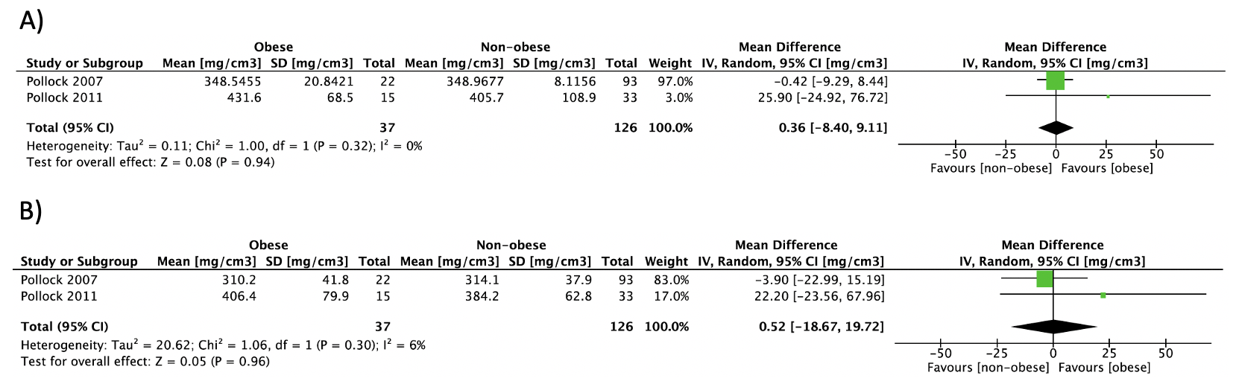
S5 Fig. Forest plot of pooled effect size for the A) radius vBMD and B) tibia vBMD by pQCT mean difference between premenopausal women with vs. without obesity, using a random-effect model.

