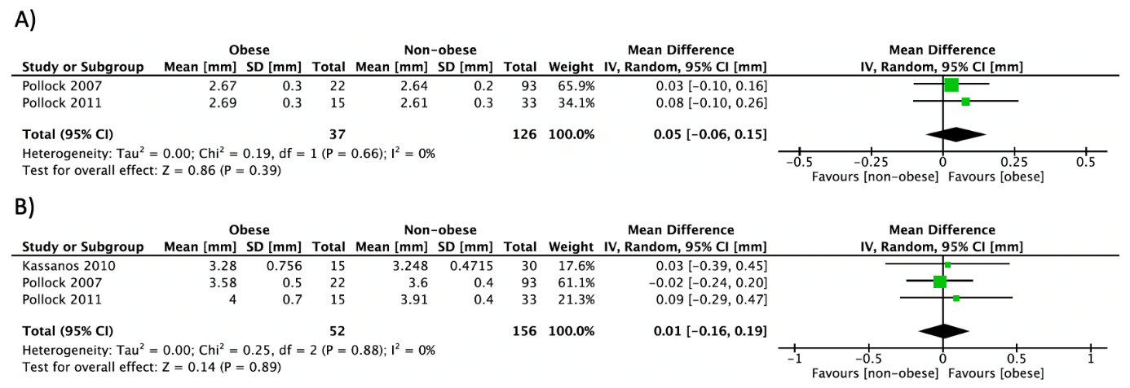
S6 Fig. Forest plot of pooled effect size for the A) radius cortical thickness and B) tibia cortical thickness by pQCT mean difference between premenopausal women with vs. without obesity, using a random-effect model.

