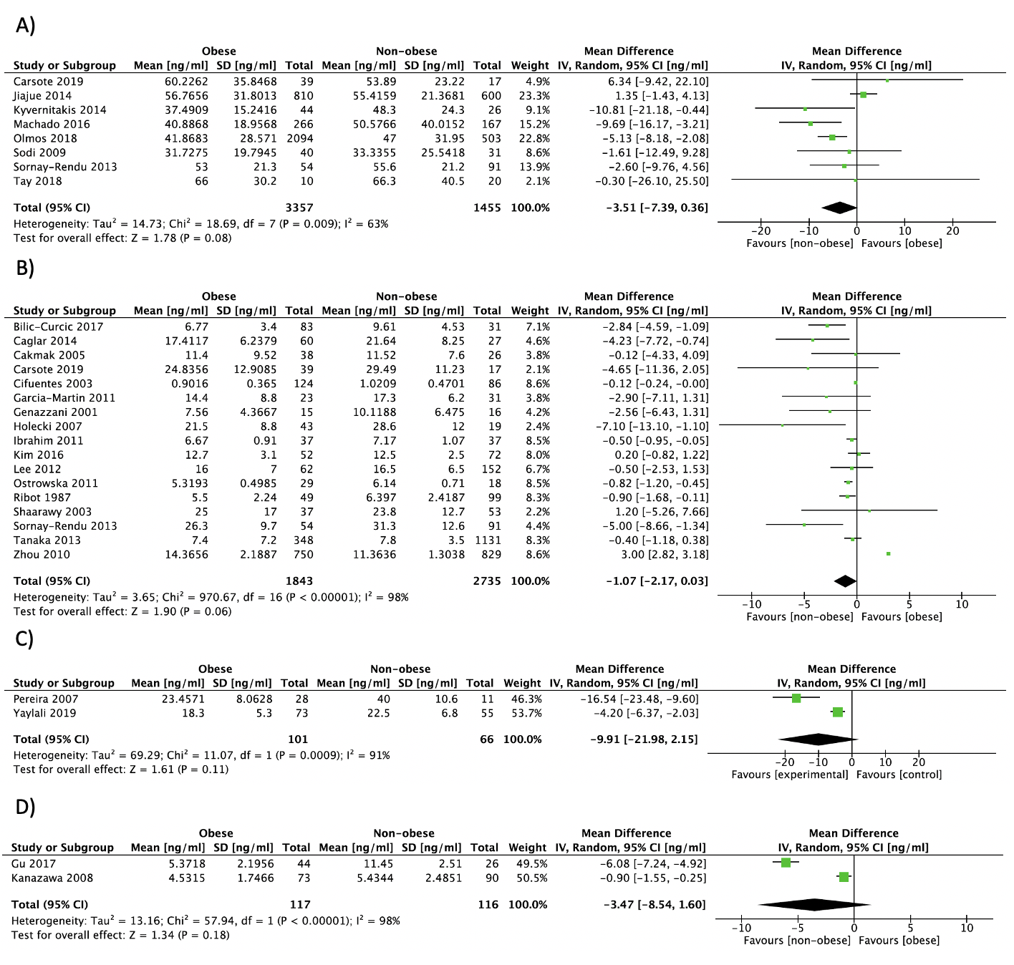
S7 Fig. Forest plot of pooled effect size for A) P1NP levels mean difference between postmenopausal women with vs. without obesity, and total osteocalcin levels mean difference between B) postmenopausal women, C) premenopausal women and D) men with vs. without obesity, using a random-effect model.

