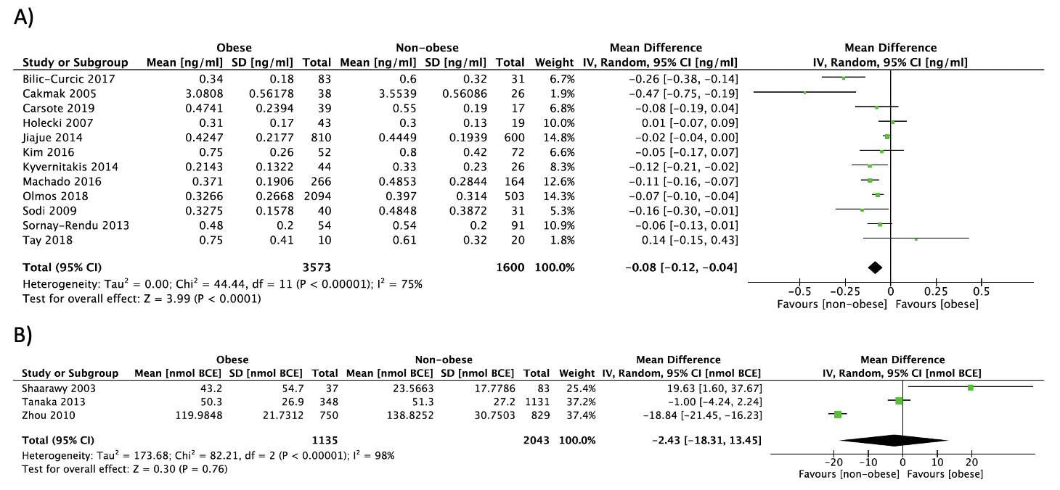

S8 Fig. Forest plot of pooled effect size for A) CTX levels and B) NTX levels mean difference between postmenopausal women with vs. without obesity, using a random-effect model.

