Appendix 1. MEDLINE (via PubMed) search strategy
#1 Search: (((Lung Neoplasms[MeSH Terms]) OR (Lung Cancer[Title/Abstract])) OR (Pulmonary Neoplasms[Title/Abstract])) OR (Lung Cancer[Title/Abstract])

#2 Search: (((((Pulmonary Disease, Chronic Obstructive[MeSH Terms]) OR (Airflow Obstruction, Chronic[Title/Abstract])) OR (COAD[Title/Abstract])) OR (Chronic Obstructive Airway Disease[Title/Abstract])) OR (Chronic Obstructive Pulmonary Diseases[Title/Abstract])) OR (Chronic Obstructive Lung Disease[Title/Abstract])

#3 Search: ((((((Physical Therapy Modalities[MeSH Terms]) OR (Group Physiotherapy[Title/Abstract])) OR (Neurological Physiotherapy[Title/Abstract])) OR (Neurophysiotherapy[Title/Abstract])) OR (Physical Therapy[Title/Abstract])) OR (Physical Therapy Techniques[Title/Abstract])) OR (Physiotherapy[Title/Abstract])

#4 Search: ((((((rehabilitation[MeSH Terms]) OR (pulmonary rehabilitation[Title/Abstract])) OR (respiratory rehabilitation[Title/Abstract])) OR (lung rehabilitation[Title/Abstract])) OR (lung therapy[Title/Abstract])) OR (pulmonary treatment[Title/Abstract])) OR (rehabilitation program[Title/Abstract])

#5 #3 OR #4

#6 #1 AND #2 AND #5

Appendix 2. Cochrane Library search strategy
#1 MeSH descriptor Lung Neoplasms, this term only
#2 MeSH descriptor Carcinoma, Non-Small-Cell Lung, this term only
#3 (lung cancer*):ti,ab,kw
#4 (non-small cell):ti,ab
#5 (small cell):ti,ab
#6(#1 OR #2 OR #3 OR #4 OR #5)
#7 (Chronic obstructive pulmonary disease)：ti,ab
#8 (COPD)：ti,ab
#9 (Chronic obstructive airway disease)：ti,ab
#10(Chronic obstructive respiratory disease)：ti,ab,
#11 MeSH descriptor Pulmonary Disease, Chronic Obstructive, this term only
#12 (#7 OR #8 OR #9 OR #10 OR #11)
#13 (rehabilitat*):ti,ab
#14 (lung therapy):ti,ab
#15 (pulmonary treatment):ti,ab
#16 MeSH descriptor Physical Therapy Modalities，this term only
#17 (#13 OR #14 OR#15 OR #16)
#18 (#6 AND #12 AND #17)

Appendix 3. Embase search search strategy
#1. 'lung cancer':ti,ab,kw
#2 'non-small cell':ti,ab,kw
#3 'small cell':ti,ab,kw
#4 'lung tumor'/exp
#5 #1 OR #2 OR #3 OR #4
#6 'chronic obstructive pulmonary disease':ti,ab,kw
#7 'copd':ti,ab,kw
#8 'chronic obstructive airway disease':ti,ab,kw
#9 'chronic obstructive respiratory disease':ti,ab,kw
#10 'chronic obstructive lung disease'/exp
#11 #6 OR #7 OR #8 OR #9 OR #10
#12 'rehabilitat*':ti,ab,kw
#13 'lung therapy':ti,ab,kw
#14 'pulmonary treatment':ti,ab,kw
#15 'chronic obstructive respiratory disease':ti,ab,kw
#16 'physiotherapy'/exp
#17 #12 OR #13 OR #14 OR #15 OR #16
#18 #5 AND #11 OR #17

Appendix 4. Science Citation Index search strategy
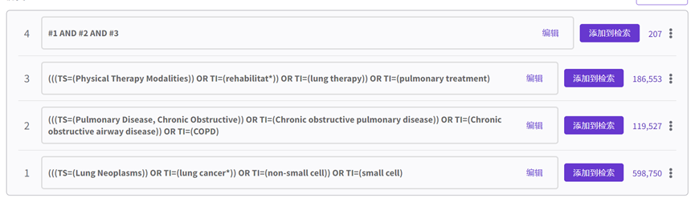

Appendix 5. Chinese National Knowledge Infrastructure search strategy
(SU=肺疾病，慢性阻塞性 OR SU=慢性阻塞性肺疾病)AND(SU=肺肿瘤 OR SU=癌，非小细胞 OR SU=癌，小细胞 OR KY=肺癌 OR TI=肺癌)484

AND（SU=肺切除术 OR TI=肺癌术后）AND（SU=物理治疗方法 OR SU=康复）

Appendix 6. WANFANG Database search strategy
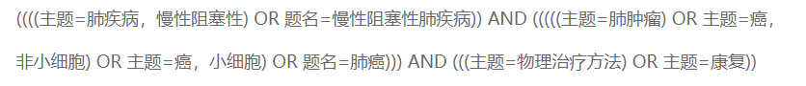
OR 
Appendix 7. Risk of bias
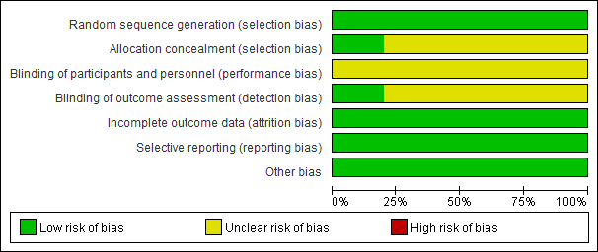
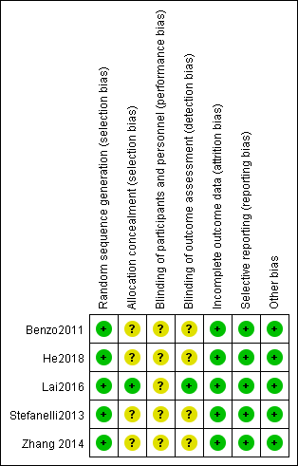
Newcastle–Ottawa Scale for CT
Studies | Research object selection | Inter group comparability | Result factor measurement | Score
Saito 2017 | 4 | 1 | 3 | 8
Mujovic2015 | 4 | 1 | 2 | 7
Sekine2005 | 4 | 1 | 2 | 7
Meng 2018 | 4 | 1 | 2 | 7

